HEALTH INFORMATICS IN AI HEALTHCARE
Prajakta Shahare¹ and Hiren Dand²
Student¹ and Head², Department of Information Technology, Mulund College of Commerce, University of Mumbai, Mumbai
Abstract
AI offers various favorable circumstances over customary analytics and furthermore in social insurance it has demonstrated the most guarantee in diagnostics. Learning algorithms can turn out to be increasingly exact and precise as they associate with training information, enabling people to gain remarkable bits of knowledge into diagnostics, care forms, treatment fluctuation, and patient results. AI will give a lot to that development by fueling prescient investigation and clinical decision bolster devices that hint suppliers into issues well before they may somehow or another perceive the need to act. This paper provides information about how health informatics can be effectively used for healthcare using AI algorithms which are being used to minimize the time it takes to diagnose genuine illnesses and describes the limitations of health informatics.
Index Terms – AI, analytics, algorithm, clinical data, diagnosis, doctor, genomic-data, healthcare, health informatics, health-record, legal ,medicines , Naïve-bayes ,neural-networks, National institutes of Health, patient, precision, TF-IDF , technical , word vectors
NOMENCLATURE
AI-Artificial Intelligence
EHR-Electronic Health Records
HL7-Health Level 7
FHIR-Fast Health Interoperability Resources
CAD-Coronary Artery Disease
1.0 INTRODUCTION
Health informatics, at times known as healthcare informatics, has grown as an advancing science with the extension of electronic health records system and health data investigation systems. It has additionally grown with the foundation of health data trade guidelines, for example, HL7 and FHIR (Fast Health Interoperability Resources) and clinical health phrasing sets like SNOMED CT.
Health care data refers to a wide information pertaining to patients, specialists and health care systems. The way toward gathering data on points, for example, understanding results, protection and specialist appraisals can serve to improve health care systems through the expert examination of huge data sets to reach inferences and advance productivity Health informatics is the practice of acquiring, studying and managing health data and applying therapeutic ideas related to health data innovation systems to assist clinicians with giving better healthcare.
AI describes the ability of a machine to become familiar with the manner in which a human learns, for instance, through picture acknowledgment and finding designs in complex circumstances. AI in is changing the manner in which data gets gathered, investigated and produced for patient care.
AI is changing the patient experience. Some of the examples of AI in health informatics use algorithms to diagnose diseases , Machine learning and radiology ,Automating Administrative tasks , Reducing Operational costs .The essential aim of wellbeing related AI applications is to break down connections between anticipation or treatment procedures and patient outcomes.AI programs have been developed and applied to practices such as treatment convention advancement, customized prescription, and patient treatment . Moreover, clinics are looking to AI solutions to help operational activities that expansion cost sparing, improve patient fulfillment, and fulfill their staffing and workforce needs. Companies are creating prescient examination solutions that help healthcare directors improve business tasks through expanding usage, diminishing patient boarding, lessening length of remain and upgrading staffing levels.
AI in healthcare is the utilization of complex algorithms and programming to copy human comprehension in the investigation of muddled medical information. In particular,. AI is changing the way information gets collected, analyzed and developed for patient care. What recognizes AI technology from conventional advancements in medicinal services is the ability to gain data, process it and give a well-characterized output to the client, for which agorithms are used .These algorithms can perceive designs in conduct and make its own rationale. So as to diminish the room for give and take, AI algorithms should be tried more than once.AI algorithms carry on uniquely in contrast to humans in two different ways: (1) algorithms are exacting: in the event that you set an objective, the calculation can't change itself and just comprehend what it has been told expressly, (2) and algorithms are secret elements; algorithms can anticipate incredibly exact, however not the reason.
Artificial intelligence (AI) is quickly entering medicinal services and serving significant roles, from computerizing tedious tasks and routine tasks in medical practice to overseeing patients and medical assets. As designers make AI systems to perform tasks, a few risks and difficulties rise, including the risk of wounds to patients from AI system mistakes, the risk to persistent security of data obtaining and AI deduction, and that's only the tip of the iceberg. Potential arrangements are perplexing however include interest in foundation for top notch, delegate data, changes to medical instruction that will get ready suppliers for moving roles in an advancing system.
2.0 REVIEW OF LITERATURE
Keith J. Dreyer, DO, PhD J. Raymond Gees, MD (2017)
Artificial intelligence (AI), machine learning are terms presently observed all time, all of which refer computer algorithm that change as they are presented to more information. Huge numbers of these algorithms are shockingly great at perceiving objects in pictures. The blend of a lot of machine-consumable computerized information, expanded and less expensive processing power, and progressively advanced factual models join to empower machines to discover designs in information in manners that are financially as well as possibly past people's capacities. Building an AI algorithms can be simple. Understanding the related information structures and insights, then again, is regularly troublesome and cloud. Changing over the algorithm into a refined item that works reliably in wide, general clinical use is mind boggling and deficiently comprehended. To show how these AI items decrease costs and improve results will require clinical interpretation and mechanical evaluation reconciliation into routine work process. Radiology gets the opportunity to use AI to turn into a focal point of wisely totaled, quantitative, demonstrative data. Centaur radiologists, shaped as a cooperative energy of human in addition to PC, will give translations utilizing information separated from pictures by people and picture investigation computer algorithms, just as the electronic record, genomics, and other different sources. These understandings will shape the establishment of exactness human services, or care tweaked to an individual patient.
In this paper author has mentioned the future scope as AI applications will eventually be used to identify patients at risk for disease in disease detection and quantification, and for medical management. For radiologists, one of the first applications will be AI for screening detection. AI will expand the exactness of CAD, possibly diminishing bogus positive outcomes essentially and expanding CAD’s power. With the progress of AI in healthcare using algorithms AI can be used efficiently in enhancing its applications in medical field for patient’s welfare using health informatics for predictive analysis of diseases and risk factors associated with it and can prove useful for further development in healthcare. Thus when AI combined with health informatics can help to diagnose predictive analysis of medicines, risk factors of diseases, treatment associated to particular diseases. This requires feed information to AI so that it can perform faster analysis based on the given data.
3.0 SHARING HEALTH INFORMATICS WITH AI TECHNOLOGY
Data is the foundation of all AI applications. During the Roundtable, participants distinguished various high-esteem health data types that can be used for AI advancement. Expanding on the master input assembled at the Roundtable and consequent research, this area gives a rundown of six significant health data types and the challenges related with their utilization.
Clinical Data is a broad term that encompasses different sorts of data produced in a clinical setting and constrained by a clinician, instead of a patient or parental figure.
Genomic Data can incorporate various characteristics, ranging from full DNA successions to singular DNA variations. Late advances have made it conceivable to investigate and store data on an individual's whole genome succession. Genomic data is considered exceptionally touchy and must be shared and utilized under deliberately controlled conditions.
Persistent Generated Data incorporates "health-related data made and recorded from patients outside of the clinical setting to answer health concern." This data type is getting progressively common through the making of versatile health applications and wearable health gadgets.
Social Determinants Health Data speak to "conditions in the situations in which individuals are conceived, live, learn, [and] work...that influence a wide scope of health, working, and personal satisfaction results and dangers." Instances of these social determinants incorporate access to transportation, training, and openings for work just as the accessibility of nourishment and lodging choices. Social determinants of health data can emerge out of numerous sources inside and outside of government, and can be utilized to all the more likely comprehend populace health.
Observation Data is a broad term that encompasses the "continuous, orderly assortment, examination, and translation of health-related data fundamental to arranging, usage, and assessment of general health practice.
3.1 USING HEALTH INFORMATICS IN AI HEALTHCARE
AI can use to diagnose serious diseases at early stage itself as AI processes information rapidly arrives at likely causes of symptoms for diagnosis and treatment for many patients ,this is achieved through deep learning; machine learning algorithms to minimize the time it takes to diagnose critical diseases. Health informatics can reduce medical errors as doctors and physicians no longer manually report and analyze diagnoses. Rather they record and evaluate patient in electronic format which eliminates collection of false data which may happen due to misdiagnoses and wrong prescription dosages or false information about their current health state. Medical records provide information to doctors about a patient’s health condition, surgeries and current prescriptions .Health informatics helps in the medical record retrieval process . EHR ( electronic health record) systems allow providers to access a patient ‘s medical history in real- time from any healthcare facility using EHRs .The accumulating data generated in clinics and stored in electronic medical records through regular tests and medical imaging takes into consideration more applications of AI and superior data-driven medication. These applications have changed and will keep on changing the manner in which the two specialists and analysts approach clinical critical thinking. AI algorithms perform tasks that require human intelligence to complete, for example discourse acknowledgment, image analysis, and decision-making. In any case, humans need to expressly tell the computer precisely what they would search for the image they provide for a calculation, for instance. So, AI algorithms are extraordinary for computerizing laborious tasks, and in some cases can beat humans in the tasks they are trained to do.
So as to generate an effective AI algorithm, computer systems are first fed data which is normally organized, implying that every data point has a name or explanation that is recognizable to the algorithm. After the algorithm is presented to enough arrangements of data points and their names, the presentation is broke down to guarantee precision, much the same as exams are given to students. There are algorithms that can learn from data. Applications of AI in medication is some kind of data, either numerical (such as heart rate or blood pressure) or picture based (such as MRI sweeps or Images of Biopsy Tissue Samples) as an information. The algorithms at that point learn from the data and produce either a likelihood or a characterization. For instance, the significant outcome could be the likelihood of having a blood vessel clump ,blood pressure data, or the naming of an imaged tissue test as harmful or non-dangerous. In medical applications an algorithm’s diagnostic performance task is compared to a physician’s performance to determine its ability and value in the clinic.
3.2 AI IN SUPPORTING DOCTORS
AI can be used to know common allergic medications for adults and children: Allergies happen when the body's resistant framework reacts to a substance it considers an invader. Substances that incite the immune system into a hypersensitive reaction are known as allergens. There is nothing of the sort as an all-inclusive allergen. What may trigger a hazardous unfavorably susceptible reaction in one individual may cause definitely no mischief in another. Health informatics represents intersection of IT and the design, health care services delivery and latest health care technologies combined, so a wealth of data becomes available to help professionals provide quality care to patients. This data can be used for diagnosing allergies Patients have from a particular medicine by analyzing their health record and treatment a patient went through, like this by analyzing patients health information common drugs stimulating allergic conditions such that when given to patient in a particular disease can lead to side- effect and endanger patients’ lives can be determined .
3.3 ALGORITHMS THAT CAN BE USED FOR PREDICTIVE ANALYSIS OF ALLERGIC MEDICATIONS
Neural networks: In neural networks, the relation between the output and the input variables are depicted through hidden layer blends of prespecified functional. The objective is to assess the loads through input and output information so that the normal mistake between the actual output and the expected output is minimized.Neural networks are effectively applied to different zones of medication, for example, diagnostic frameworks, biochemical examination, image analysis, and medication advancement, with the common case of bosom malignant growth expectation from mammographic pictures.
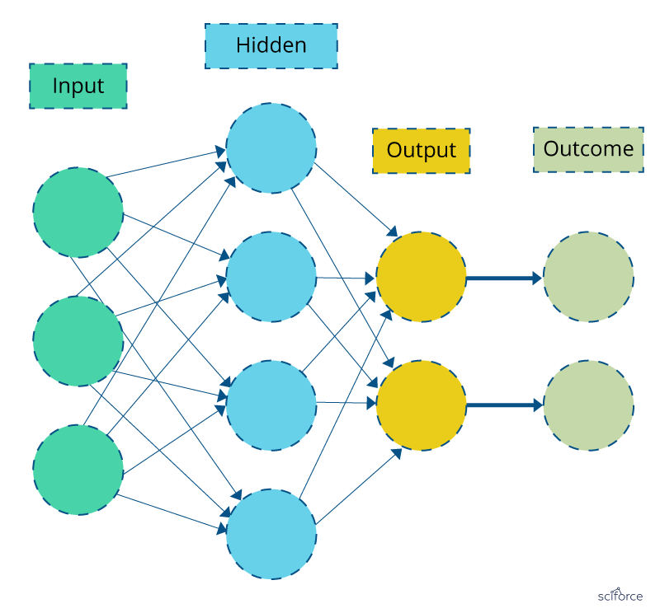
TF-IDF: Basic algorithm for taking out keywords. The TF-IDF weight is a statistical measure of a word importance to a document in an assortment or corpus. The importance builds relatively to the occasions a word shows up in the document yet is balanced by the frequency of the word in the corpus.
TF-IDF is used for finding patients’ similar behavior patterns in observational studies as well as in discovering diseases correlations from medical reports for finding sequence patterns in databases.
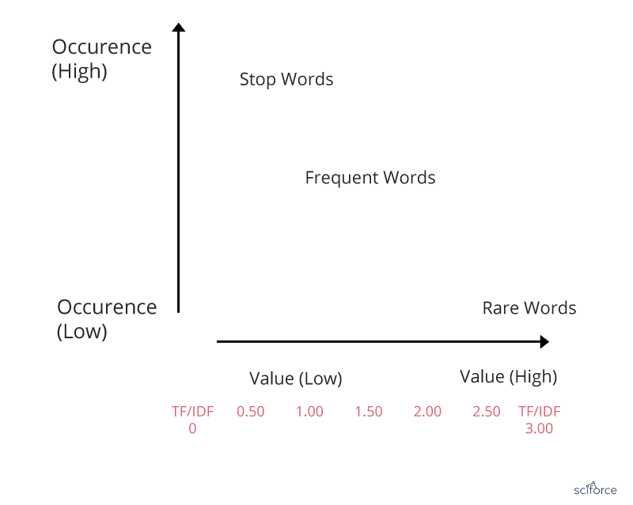
Naïve Bayes: Naive Bayes classifier is a method for content arrangement, the issue of making a decision about archives as belonging to one category or the other. Naive Bayes classifier expects that the presence of a specific feature in a class is not related to the other feature presented. Regardless of whether these features are related, these properties autonomously add to the likelihood of belonging to a specific category.
It remains one of the effective and efficient classification algorithm which has been successfully applied to many medical problems like classification of medical reports and articles of journals .
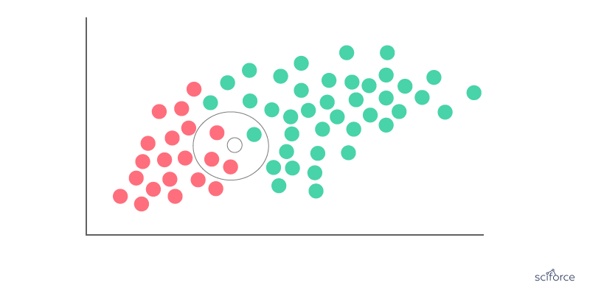
Word Vectors: Considered to be a breakthrough in NLP, word vectors, or word2vec, is a gathering of associated models that are utilized to deliver word embedding’s. In their embodiment, word2vec models are not so deep and are two-layer neural systems that reproduce etymological words. Word2vec produces a multidimensional vector space out of a book, with every remarkable word having a relating vector. Word vectors are in the vector space such that words that offer contexts are situated in closeness to each other.
Word vectors are used for “biomedical language processing”, includes similarity finding ,medical terms standardization also discovering new aspects of diseases.
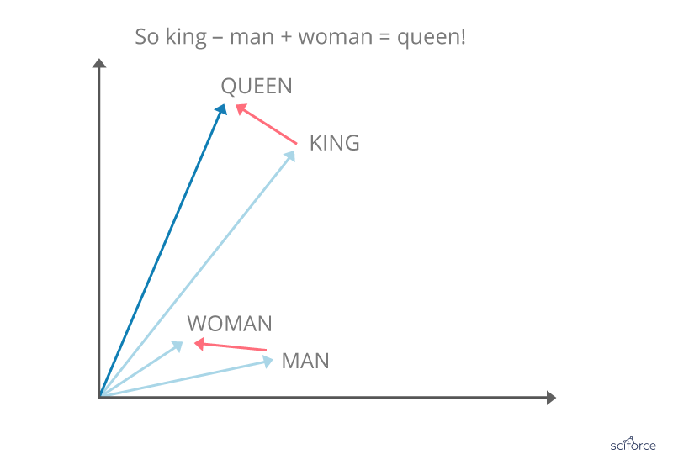
3.4 DISEASE PREDICTION BASED ON AI SOLUTION:
First AI systems were basically knowledge-based decision support systems and first machine learning strategies were utilized for deriving arrangement rules from marked datasets. These first systems had great execution. Be that as it may, they were never utilized routinely on genuine patients. One explanation was that these systems were independent systems, not associated with tolerant electronic
Health records (EHRs). Another explanation was that, because of the subjectivity of the aptitude communicated in the knowledge bases of these master systems, the systems created here were not acknowledged there, and the greater part of them ended up being more valuable for educating than for clinical practice.
As new AI methods come,one normally becomes worried about the degree of control we are getting when inspecting the speed at which new AI methods are being acquainted and the pressure to quickly adopt them. AI with new machine learning methods focusing around complex Deep Learning through the generation of “deeper” and multi-layered connectionist artificial neural networks. One of the areas where AI has shown the most progress is in diagnostics. Early diagnosis significant factor in a result of a patient's care. Deep-learning algorithms are being used to minimize the time it takes to diagnose diseases . The manner in which AI quickly processes a lot data and arrives at likely causes for symptoms can drastically decrease the diagnosis and treatment work for some patients .
Combining clinical decision support frameworks with patient self-management, population health management can likewise profit by AI. Utilizing prescient investigation with patient populations, healthcare suppliers will have the option to make preventative move, decrease health hazard, and spare pointless expenses. The probability of aggregating, breaking down and activating health information from a huge number of consumers will empower medical clinics to perceive how financial, social, hereditary and clinical elements associate and can offer more focused on, preventative healthcare outside the four dividers of the hospital.
3.5 DEVELOPING TREATMENT PLANS USING PRECISION MEDICINE:
Precision medicine is an emerging for disease treatment and prevention which considers singular fluctuation in qualities, condition, and way of life for every person. This approach will enable specialists and analysts to anticipate all the more precisely which treatment and prevention strategies for a specific disease will work in which gatherings of individuals. Precision medicine is dependent on large databases that contain genetic and clinical information can be studied to develop treatment plans that will be more effective for particular patients. Advances in genetic information for diagnosis and treatment will have implications for medical education and postgraduate training.
In the area of PHM, big data sources such as EHRs and charging claims are being utilized in the United States to recognize patients with different conditions who are in danger of high frequency health care use and who may benefit from mediations such as longer care coordination. The potential for Canada has been represented by crafted by Woodchips and partners, who have demonstrated that in Ontario in 2007 the top 1% (regarding frequency of utilization) of patients utilized 34% of freely subsidized health resources.
3.6 USING ELECTRONIC HEALTH RECORD INTO RELIABLE RISK PREDICTOR:
EHR analytics have produced numerous fruitful risk scoring and stratification tools, particularly when specialists utilize profound learning strategies to distinguish novel associations between apparently irrelevant datasets. Be that as it may, guaranteeing that those algorithms don't affirm hidden bias in the information is pivotal for sending tools that will genuinely improve clinical consideration.
Artificial intelligence will provide much for the development by driving prescient investigation and clinical choice support apparatuses that educate providers to issues some time before they may somehow or another perceive the need to act. Artificial intelligence can provide before alerts for conditions like seizures or sepsis, which regularly require serious examination of exceptionally complex datasets. Machine learning can likewise help support choices around whether to proceed with care for basically sick patients, for example, the individuals who have entered a trance like state after heart failure, says Brandon Westover, MD, PhD, Director of the MGH Clinical Data Animation Center. Normally, providers should outwardly examine EEG data from these patients, he clarified. The procedure is tedious and emotional, and the outcomes may fluctuate with the ability and experience of the individual clinician.
If you have an AI algorithm and lots of data from many patients, it’s easier to match patterns and may detect subtle improvements that would impact your decisions around healthcare. EHRs are essential part of patient information but analyzing that wealth of information in an accurate, timely manner has been a continual challenge for developers. Leveraging AI for clinical decision support, risk scoring, and early alerting is challenging area of development for this changing approach to data analysis.
3.7 LIMITATIONS
Legal challenges
Inconsistent limitations on data use: Among the legal challenges, participants noticed that health data types have distinctive legal and administrative requirements on their utilization. For instance, managerial and claims data, clinical data, and specific types of observation data, such as study data, can incorporate delicate, singular level data. The utilization of these data types is regularly confined under existing security systems such as HIPAA. Tolerant produced data, such as data gathered from portable applications and wearable gadgets, can likewise contain delicate data about people extending from fruitfulness medications to emotional wellness conditions. In any case, there are generally hardly any legal rules that shield this developing data type from abuse.
Concerns about intellectual property: Roundtable participants also discussed the challenges of using and sharing proprietary data and algorithms. Data collected in drug development trials, through private-sector health surveys, or in other ways could benefit researchers and organizations in the health sector developing AI applications, and proprietary AI models could be developed for greater accuracy if the algorithms they use were shared. But while all parties stand to benefit from sharing data and algorithms, it is difficult to balance that benefit against companies’ need to protect their intellectual property for competitive advantage.
Technical challenges
● Limited technical capacity for data the board and investigation: Roundtable participants inside and outside of government noticed the need for more staff with data science preparing. Specifically, both government and the private part need more specialists in AI and its application to wellbeing data and issues.
● Inadequate IT framework for facilitating and investigating large datasets: Artificial intelligence applications require large amounts of data, and large computational capacity, to prepare and test calculations. The expanding interest for continuous data adds to these technical prerequisites. Both HHS and the partners that work with the division may need to update their infrastructure to address these difficulties.
● Poor data interoperability: Roundtable participants hailed various challenges identified with joining what's more, joining wellbeing datasets. Over the social insurance framework, large measures of data are organized in various ways, keeping partners from effectively trading and coordinating this data. Participants ascribed these challenges to an absence of normal data benchmarks and issues with requirement where models do exist.
3.8 CONCLUSION AND FUTURE SCOPE:
AI in healthcare is changing the manner in which information gets collected, analyzed and created for persistent consideration. Advances in AI in healthcare are on the whole exciting, especially for health informatics. AI could help get scatters, chance factors quicker which PC vision algorithms can be trained to spot, regardless of how unobtrusive. AI is demonstrating to be viable in medicine, including diagnosis, arranging and even treatment with more health information availability and the ongoing advancements of effective and improved AI algorithms, there is a restored for AI in medicine.
Informatics helps in not simply supporting the needs of doctors, medical attendants and caregivers, however the needs of patients too. The fundamental reason for informatics to gather health data and make the data usable so it tends to be broke down and controlled to improve the present care process. Health care has developed from a paper-based framework and today, it has gotten only electronic/PC based. At present, health care utilizes modern PC tools like EHRs, CDSS; electronic solutions and so on to propel the nature of care gave to patients. Informatics could likewise be utilized to run NLP tools to identify examples and concentrate significant data. Slowly and consistently, health data is anticipated to possess a greater amount of the market for advancement and innovation improvement. Since data has been the key, headways in health care are tilting towards creating tools that produce data at a steady pace that stays aware of the individual (tolerant or non-persistent). Wearable advances, sensors and NLP tools to identify examples and data mining used to remove important data are a portion of the regions of fast headway. With data accessible to health suppliers, health care can make progresses in proof based care, customized made medications for patient's particular conditions, pre-ID of side effects and more .Health data science helps emergency clinics around the world to surf through all accessible health information and identify patterns that could give experiences on the health state of populaces and care forms. This information recovered utilizing PC frameworks is useful for caregivers when they select the most suitable treatment/drug customized to a person's condition. Informatics in health care can possibly propel the manner in which health care is conveyed. Someone who practices informatics have empowered the utilization of telemedicine to improve remote finding, remote checking of patients and producing health training and mindfulness among patients. Informatics has likewise begun to utilize advancements like expanded reality and computer generated reality to prepare health experts. To outline Someone who practices informatics create better information and information dependent on data which can additionally prompt better patient care.
REFERENCES
1] Y. Cao et al., “Improving tuberculosis diagnostics using deep learning and mobile health technologies among resource-poor and marginalized communities,” in IEEE Connected Health, Appl., Syst. Eng. Technol., 2016, pp. 274–281.
2] R. Caruana, Y. Lou, J. Gehrke, P. Koch, M. Sturm, and N. Elhadad, “Intelligible models for healthcare: Predicting pneumonia risk and hospital 30-day readmission,” in Proceedings of the 21th ACM SIGKDD International Conference on Knowledge Discovery and Data Mining, 2015, pp. 1721– 1730.
3] K. Fiveash, “Google AI given access to health records of 1.6 million english patients,” ArsTechnica, https://arstechnica.com/information-technology/2016/05/ google-deepmind-ai-nhs-data-sharing-controversy/, 2016.
4] G. Ateniese, L. V. Mancini, A. Spognardi, A. Villani, D. Vitali, and G. Felici, “Hacking smart machines with smarter ones: How to extract meaningful data from machine learning classifiers,” International Journal of Security and Networks, vol. 10, no. 3, pp. 137–150, 2015.
5] V. Nikolaenko, U. Weinsberg, S. Ioannidis, M. Joye, D. Boneh, and N. Taft, “Privacy-preserving ridge regression on hundreds of millions of records,” in 2013 IEEE Symposium on Security and Privacy. IEEE Computer Society Press, May 2013, pp. 334–348.
6] A. Nguyen, J. Yosinski, and J. Clune, “Deep neural networks are easily fooled: High confidence predictions for unrecognizable images,” in Proceedings of the IEEE Conference on Computer Vision and Pattern Recognition, 2015, pp. 427–436.
7] O. Oyelade, J. Soyemi, I. Isewon, and O. O. Obembe, "Bioinformatics, healthcare informatics and analytics: an imperative for improved healthcare system," International Journal of Applied Information Systems, vol. 8, pp. 1-6, 2015.
IOT FOR KIDS
Meghna Praful Chavan¹ and Hiren Dand²
Student¹ and Head², Department of Information Technology, Mulund College of Commerce, University of Mumbai, Mumbai
Abstract
One of the trending technologies in the modern world is the (IOT). The transformation of the normal real world objects to the virtual world object is the main and interesting feature of the IoT. It makes them smarter, more efficient and more useful. The IoT is very useful for automating, controlling and tracking systems throughout the industry. The aim of this research paper is to study the application of IoT to benefit children. Right now, they're very trendy and they're doing a lot of research on the IoT, how they can use their application to better develop the world. The paper's main goal is to study the IoT's vital role in the child's life. For ex. We can monitor the new born babies (3-9 month). Activities such as baby’s health, diets, growth, medicines. The paper, however, will enable researchers to have a good understanding of the Internet of Things and effectively promote the development of information.
Keywords: IoT for kids, Kinsa Smart Thermometer, Self-installing car seat, Owlet Smart sock 2 Baby monitor, Wearable tracker.
1.0 INTRODUCTION
The Internet of Things is also termed as IOT devices. It is an extensive network of connected devices. Such tools collect and share data on how they are used and how they are operated in the environment. It’s all done using multiple component such as.
• Circuit board
• Sensors (heart of IOT devices)
• Other parts of the devices based on its use
• Power source
• User interface: s/w
• Connection to local n/w, cloud etc.
• Database
Let have clear understanding on the “Internet of Things”. By using sensor, which are embedded in every physical device. It can be our cell phone, electrical appliances, vehicle almost everything we come across in day to day life. Such sensors emit data on the working status of the systems continuously, which gather at the IOT platform security then IOT platform integrates the collected data, further analytics is conducted on the data to extract the valuable information as per requirement. Finally, the result is shared with other devices for better user experience Automation and improving efficiencies. IOT redefines our lifestyle, health and how we communicate with technology. The future of IOT will push forward with more accurate information. Research of business insider estimates that 24 billion IoT systems will be deployed by 2020.
2.0 IOT FOR KIDS
Every parent is working hard to ensure that their children are safe and well looked after by the babysitter for happiness and health. For any new parents, the first stages of baby life can be the most troubling. Because there's so much to keep up with, and give the baby highest level of care [2]. As the technology evolved, IoT technology offered helpful products to support families. From devices we can empower parents with the modern tracking, facilities communication or measure body temperature, or even impact force-it’s all out there. IOT device feature is not only for baby, the benefit can be given to senior’s citizens who are less able to live without assistance device is great for those senior citizen suffering from Alzheimer’s or dementia, it will be sent alert pop-up to the family member if there is any serious condition. And these IoT devices are wearable like cloth, shoes, glass, etc and all these devices contribute significantly to the optimize the life of people with special need.

3.0 Application of IoT for Kids
3.1 Kinsa Smart Thermometer
When someone in the family gets sick, we want to give them the highest level of care. With the Kinsa Thermometer device [2], We can do that alone. Through the earbud socket, this super smart heat sensor is interfaced with our phone and synchronized with the Kinsa app. With the app, we can log and keep track of our babies’ temperature, and even their symptoms. Kinsa is easy to use on baby, and even provides a bubble-popping game to keep children entertained while testing their temperature. Another useful aspect is that we can monitor the temperature and symptoms of more than one member of the household at a time and keep up with the well-being of all. The Kinsa smart thermometer may be just what we need during the flu season. This device is use to keep babies healthy during such season.
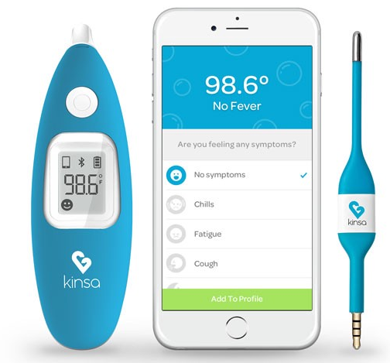
Fig-1: Kinsa Smart Thermometer
3.2 Self Installing Car Seats
According to research 80% car seats are fitted incorrectly. Unless we get someone to fit it for us. But how do we know the installation and fitting went well? The Self-Installing Car Seat checks the tension and levels by the sensor and response according to our car, before verifying it’s safe to use. After installation, its twenty sensors monitor its status and send error alerts to our phone. In fact, the car seat not only follows current safety requirements, it also meets the new side impact protection standard. We will drive safely in the awareness that our child is cocooned in a protective bubble with its steel reinforcement and aluminium crash bars. [3].

Fig-2: Self Installing Car Seats
3.3 Owlet Smart Sock 2 Baby Monitor
For new parents, the first stages of a baby's life may be the most appalling. There's so much to keep up, track, and worry about. These [2] IOT devices help to ease some of these concerns. Owlet is like a little bootie that our baby can wear, measuring her heart rate, oxygen levels, sleep quality, and sleep place, so we no longer have to worry at night. All this is accomplished with a built-in wireless (sensor) oximeter, and then all information is stored in the cloud. This helps us to access the information of our child on any device at any time. Owlet is completely harmless and comfortable for our child, and it is also waterproof and easily washable.

Fig-3: Owlet smart sock 2 Baby Monitor
3.4 Wearable tracker (Children Tracker for Parents)
Children’s tracking is the world’s most important and commonly used method. Every parent is very happy if the child is safe now. The IoT devices make child tracking devices possible and continue to evolve. The machines can be found in different shops and sizes. The child tracking devices ' weight is distinctive and easy to use.
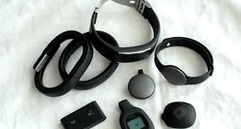
Fig.4: -Wearable device for Kids
4.0 Conclusion
In this paper, we talk about the current trending technology, IOT for the kids care. In the Introduction part we seen how Internet of things evolve and how it is impacting our daily life. And in the second part we talk about (IOT) Application for the kids care, how it is helping parent to keep their babies safe and health. As we know technology are booming every day, so the standard of the IoT are increasing and its capabilities are also evolving it mean the IoT devices will provide more precise data which will help the organization to develop and create more and more IoT devices for the kids and the senior citizen.
5.0 Reference
- AkashMoodbidri, Hamid Shahnasser (Jan 2017) ‘Child safety wearable device’, International Journal for Research in Applied Science & Engineering Technology, Vol. 6 Issue II, IEEE, pp. 438- 444.
- Muruganandham, ‖Real TimeWeb based Vehicle Tracking using GPS‖,World Academy of Science, Engineering and Techonogy, 37, 2010
- Akash Moodbidri and Hamid Shahnasser, Child Security Wearable Device, IEEE paper, 2017.
- Smart IOT Device for Child Safety and Tracking M Nandini Priyanka, S Murugan, K N H Srinivas, T D S Sarveswararao, E Kusuma Kumari.
- Chitra, jewel jose, sandeep, shirinidhishetty, A. (2018) ‘smart safety jacket for smallbaby’ yenepoya institute of technology, moodbidr.
- Kok Sun Wong, Wei Lun Ng, Jin Hui Chong, CheeKyun Ng, AduwatiSali, Nor KamariahNoordin, (15 -17) December 2009) ‘GPS Based Child Care System using RSSI Technique’, Proceedings of the Malaysia International Conference on Communications. pp. 899-904
- Bradley J. Rhodes, Nelson Minar and Josh Weaver (Aug. 4, 1999) ‘Wearable Computing Meets Ubiquitous Computing’, pp. 471-475

IoT Secured Home Door
Puja Kiran Nadgouda¹ and Abhijeet Kale²
Student¹ and Head², Department of Information Technology, B. N. Bandodkar College of Science, University of Mumbai, Thane
ABSTRACT
In this paper, I have proposed a Smart Door Lock. A Smart Door Lock accepts inputs through secret code, smart card (RFID or NFCs), retina recognition, palm recognition, iris recognition, fingerprint etc. as the method for authentication instead of manual lock and key system. In my proposed system, I have used three factor authentications i.e., RFID keys, user password and OTP and this is connected to a controller raspberry pi, which will control the locking and unlocking of the door. The purpose behind this research paper is to make fully automated and secured smart door-lock application running on raspberry pi. Raspberry pi will automate the locking and unlocking of the door. We have used bio-metrics for giving inputs to smart door-lock. We have programed whole system using python IDLE for Raspberry pi operations.
Keywords: Internet of Things [IoT], Raspberry Pi, RFID Key, Password, OTP, Home security
INTRODUCTION
Today safety and security are becoming more and more popular day by day and it is getting improved and we are using it on daily basis. We have integrated technology in our life, that’s why we can’t ignore security.
This research paper is focusing on developing fully functional automated smart door-lock system which provide mechanism for the locking and unlocking of the door in secure way for home. This system requires RFID key which will be given to every individual of the house. Whenever an individual will produce the RFID key near the reader the system will record it.
When individual gets recognized the system asks for the password that is unique for each individual and an OTP is sent for further process to the individual mobile number. This proposed work is sent to the individual’s mobile. The system decides that whether the permission should be grant to the individual or not. This project requires proper network connection between raspberry pi and other at end user.
LITERATURE REVIEW
Optimized door locking and unlocking using IoT is very secure solution for locking and unlocking the door within the network range. This system simplifies the task of unlocking the smart-doorlock with providing inputs on touch-screen display and by using rfid based tag for authentication purpose. The raspberry pi then process the inputs taken from touchscreen and rfid tags and then it will decide whether granting access to user. This system gives ability to user for locking and unlocking door withing given network range. All the data including door unlocking time and unlocker information is available on protected google spreadsheet.
For that purpose raspberry pie constantly updates the record in database,and we can export particular record to spreadsheet.
For send otp raspberry pi uses online sms notification platform. After registration of user,user phone no gets linked on sms notification platform.Then system will send otp via sms after authentication of user. We are using Raspberry Pi-3 Model B which was released in February 2016. For connectivity purpose it has built-in Wi-Fi, Bluetooth and USB. It is enabled with USb Boot capabilities.For processing it has an ARM based processor(CPU) and integrated GPU for handling graphics related tasks.
SYSTEM ARCHITECTURE
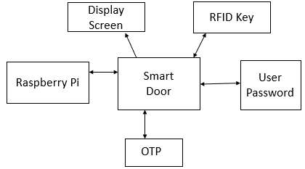
Fig-1: Proposed System
In above Fig 1, system rely on components and different technologies likely, RFID Key, User Password, OTP, Display Screen, Raspberry Pi. Essentially the system promotes security for home. Raspberry pi uses 5v DC supply which has in-build Wi-Fi module. RFID reader senses the RFID key presented by the individual and if it is correct then the display screen will display the individual’s detail and ask for is password and then an OTP will be sent to the individual but the presented RFID key is not correct then the door will be locked till the correct RFID key is presented.
This system requires following components:
• Raspberry Pi-3 Model B
• RFID Reader
• RFID Key
• LCD display
- Raspberry Pi-3 Model B: This is third generation of Raspberry Pi. This is a low-cost single board computer running modified version of Debian Linux on it, which is Optimized for the ARM architecture. This minicomputer system is the main part of home automation. It has Broadcom based BCM2837B0, Cortex-A53 cores 64- bit SoC running on frequency @ 1.4GHz in its processor. It has 1GB LPDDR2 SDRAM as its memory. It has connectivity of wireless LAN of 2.4GHz and 5GHz IEEE 802.11.b/g/n/ac, Bluetooth of 4.2, BLE gigabit Ethernet over USB 2.0. It has extended 40-pin GPIO header. For video and audio it has full size HDMI, MIPI DSI display ports, with MIPI CSI camera port, 4 pole stereo output and composite video part. This board supports H.264, MPEG-4 decode, H.264 encode, OpenGL ES 1.1, 2.0 Graphics for graphics calculations. Board has built in Micro SD reader for loading operating system and data storage in SD card. Operating Temperature, 0-50oC is the environment needed for the Raspberry Pi to work.

Fig-2: Raspberry Pi
- RFID READER: This reader falls in HX203D RFID family. It has frequency of 125KHz. It has sensing distance of about 5-15cm. It has USB model Interface. 9600 bps is the speed of the information transformed in the communication channel i.e., known as baud rate. Current required is <120mA to make the reader working. Power requirement is USB and working temperature is -10oC to +70oC.

Fig-3: RFID Reader
- RFID KEY: This key has 8kbit storage capacity. It has 13.56MHz frequency. The read and write distance for this key is 2.5-10 cm.

Fig-4: RFID Key
- LCD DISPLAY: The display is designed for Raspberry Pi, with 320x480 resolution. It is supported by any version of Raspberry Pi. It is directly pluggable. It has drivers provided that works with Raspbian/Ubuntu environment directly. It supports software keyboard (system interaction without keyboard/mouse).
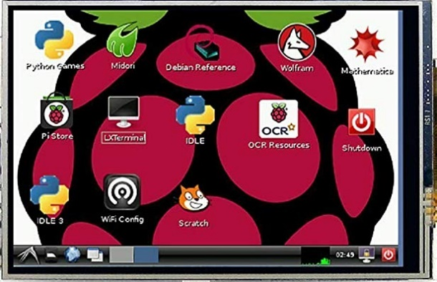
Fig-5: LCD Display
FLOWCHART AND ALGORITHM
Working of system and flow of the system is given below:
Steps include:
I. Start
II. Show RFID Key/tag.
III. If RFID Key matches then password is asked.
IV. If password matches then OTP is generated.
V. OTP is sent.
VI. If all the steps are properly executed then the door unlocks.
VII. Stop.
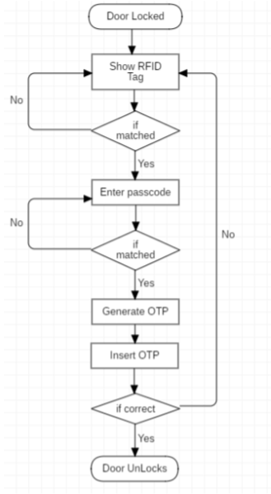
Fig-6: Flowchart
CONCLUSION
This system designed, which is based on Three factor Authentication which integrates the security to our home from unauthorized person or strangers. It implements all the features and function that are necessary for security All the planned functions were implemented in the system: RFID getting read by RFID reader, prompting for user pin, generating OTP and sending on our registered mobile number and entering OTP to get access to the door. For future we can put retina scanner, fingerprint, face recognition etc. in the system.
REFERENCES
- Home based security control system using Raspberry Pi and GSM, International Journal of Innovative Research in Computer and Communication Engineering, Akash V. Bhatkule
- Optimized Door Locking and Unlocking using IoT for physically Challenged people, Anuradha R. S, Bharathi R.
- An Intelligent Door System using Raspberry Pi and Amazon Web Services IoT, International Journal of Engineering Trends and Technology, S. Nazeem Basha, Dr. S. A. K. Jilani
- IoT Based Home Automation system using Raspberry Pi, International Research Journal of Engineering and Technology, Nisarg Shroff, Pradeep Kauthale.
- Secured Smart Home Monitoring System Using Raspberry Pi, International Journal Innovative Research and Development, Rajendra Nayak, Neema Shetty.
- Design and Implementation of Low-cost Home Security System using GSM Network, International Journal of Scientific and Engineering Research, S. R. Khan, A. Kabir, S. Jaman.
- GSM based digital door lock security system, A. Ibrahim, A. Paravath, P. Aswin.

IOT-Based Smart Homes and Their Extension to Smart Buildings
Shrikant Prajapati¹ and Hiren Dand²
Student¹ and Head², Department of Information Technology, Mulund College of Commerce, University of Mumbai, Mumbai
Abstract
This iresearch iapproach iis ito idesign iand idevelop sSmart home automation, ieconomical, ireal-time iand i iwellness isensor inetworks ifor ismart ihome isystems. These technologies facilitate the building of Smart homen enviroments in which device and System can communicate with each other and can be controlled smart way and automatically.describes the Smart Home networking technologies and discusses the main issues for ensuring security in a Smart Home environment. Nowadays, the integration of current communication and information technologies within the dwelling has led to the emergence of Smart Homes.
Keyword: IOT’s iwellness ifunction, iBehavioral idetection, iautomatically iControlled, iinterference.
1. Introduction
2. Description Smartihome Monitoring System
It is very important to determine the main components of the Smart Home architectural model in order to be able to understand the factors that raise security breaches in a Smart Home environment as well as realize security technologies that can be applied to minimize the risk of security attacks. Smart Home can be considered that consists of three main components; the internal network, the external network and the residential gateway. These three components are presented in the Figure 1. The internal network is the basis of a Smart Home and can consist of wired and wireless networks. The internal network of a Smart Home incorporates a combination of different communication media and protocols in order to support a number of Smart Home systems that simplify the residents’ life and improve their quality of life. The external network of a Smart Home includes Internet and the service provider which is in charge to provide services over Internet to the household members. Finally, residential gateway (RG) is an always connected device located in a Smart Home and plays a very important role in bridging the internal network of the Smart Home and the outside world.ipredefined iirregular ibehavior. iThe wellness iforecasting imodel iwe ihave idesigned iand iproposed iis divided iinto itwo isections. iAt ithe ilower isection, iall ithe iraw isensor idata ifrom ihousehold iappliance usage iand imovement iis idelivered ito ithe icoordinator iattached ito ithe ilocal ihome igateway iand ithis local server istores ithe iunstructured idata isets ifor ifurther iprocessing iand ianalysis. iRaw isensor idata icollected at ithe ilower iinformation isection ican ionly iidentify iwhich isensor iis iactive ior iinactive iand iat iwhat time. analyzed iby ithe iupper isection isoftware ilogic. iIntelligent idata irecognition iand iclassification mechanisms are iapplied ithrough ithe isoftware iat idifferent ilevels iof idata igeneralization iin ireal itime, ibased ion ithe time iand iorder iof ithe isensor iusage. iThere iare ivarious iZigBee iRF imodules iavailable iin ithe iwireless industry. iFor iour iresearch iapplication, iwe ipick iDigi iXBee iSeries-2 iRF. iThe iXBee imodule ifacilitates various ifeatures isuch ias idifferent isampling irate, ibaud irate iand isleep irate iassociated iwith itwo itypes iof operating imodes. iThe ifirst iis ian iapplication iprogramming iinterface i(API), iand ithe iother iis iapplication transparent i(AT).
2.1. iTopology iand iDevice iConfiguration
The iZigBee idevice ican ibe iconfigured i(programmed) ias iZigBee iend idevice i(ZED) iand iZigBee iend idevice iplus irouter i(ZEDR). iZED iis iusually ilow ipower ias iwell ias ismall ibattery ipower idevices. iThey itransfer itheir idata idirectly ito ithe iparent i(ZC), iand ithe iparent imay ibe ithe icoordinator ior ianother irouter inode.
2.2 Existing Wired Networks
ZigBee ibased iDigi iXBee iSeries i2 iis iused ias iRF imodule iin iour ismart iand iintelligent ihome imonitoring isystem. iThe iZC ihas ithe iauthority ito iselect ia ichannel, iPAN iID i(16-bit ipersonal iarea inetwork iunique iidentification inumber ithat ionly ibelongs ito iparticular iZigBee iWSN), isecurity ipolicy, iand istack iprofile ifor ithe inetwork Existing wired network technology is directly applicable to new and old houses as rewiring of the buildings is not required. The major limitations of this networking technology include the networks’ structure and the interference from the original operation of the network. Based on existing wiring of a home, Powerline networks, Phoneline networks as well as Coaxial networks can be developed to satisfy the needs of the household members (Jiang et al., 2004; Teger et al., 2002; Valtchev et al., 2002; Zahariadis, 2003; HGI, 2006; Delphinanto, 2003);iavailable ichannel. iIt ican ibe iconfigured iby ithe iRF imodule ithrough iXCTU isoftware i[36].
3. iExtension ito iSmart iBuilding
After isuccessful iimplementation iof ithe iwe iaim ito idesign iand idiscover ithe iissuesd irelateded ito ithe ismart ihome imonitoring isystem ifor ibuilding iapartment iwhere imany ipeople ilive iindividually. iWith We can better understand this by the packet reliability terms of ZigBee based WSNs. Packet delivery ratio (PDR), packet success rate (PSR), packet loss rate (PLR), packet error rate (PER), received signal strength, Signal to noise ratio and received packet delay are some of the parameters that define system reliability and performance. In order to evaluate these parameters in IEEE 802.15.4 ZigBee based wireless sensor and networks, the smart building setup is developed and implemented in real-time to get control and monitoring applications without any time delay. The results show that the distance, deployment environment and positioning of sensor nodes are essential parameters that decide the reliability of wireless sensor and networks.
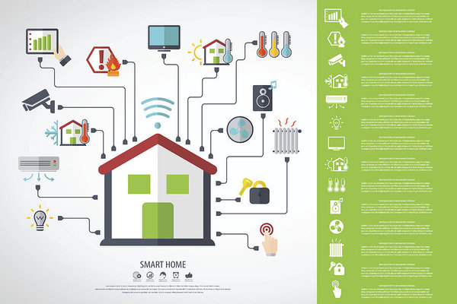
4. Conclusion
Smart Home security is of extends importance since it affects the privacy of the household members. Thus, a variety of important security issues in Smart Home environments were discussed. Especially, the security objectives of a Smart Home as well as the main factors that increase the level of difficulty to provide security in a Smart Home environment were described. Furthermore, the threats that intend to compromise the security requirements were examined. Finally, existing security mechanisms that provide security features in a Smart Home environment were presented.
In a lot of cases, most of the home users are not security-aware enough to realize the implication of the Smart Home environments system.
5. References
- Sanchez, iL.; iMuñoz, iL.; iGalache, iJ.A.; iSotres, iP., iSantana, iJ.R.; iGutierrez, iV.; iRamdhany, iR.; Gluhak, iA.; iKrco, iS.; iTheodoridis, iE. iSmartSantander: iIoT iexperimentation iover ia ismart icity testbed. iComput. iNetw. i2014, i61, i217–238.
- Gopinath, iashwin i(August i2013).” iAll iabout itransferring ipower i i iwirelessly” i(PDF). iElectronic for iyou iE-zine iretrieved ijan i16,2015
- Magana-Espinoza, iP.; iAquino-Santos, iR.; iCárdenas-Benítez, iN.; iAguilar-Velasco, iJ.; iBuenrostro-Segura, iC.; iEdwards-Block, iA.; iMedina-Cass, iA. iWiSPH: iA iWireless iSensor iNetwork-Based Home iCare iMonitoring iSystem. iSensors i2014, i14, i7096–7119.
- Hwang, iK.-I.; iChoi, iB.-J.; iKang, iS.-H. iEnhanced irobust iZigBee-based ihome iautomation. iIEEE Trans. iConsum. iElectron. i2010, i56, i583–590.
- Desai, iA.S.; iKonstam, iM.A. iHome iMonitoring iHeart iFailure iCare iDoes iNot iImprove iPatient Outcomes iLooking iBeyond iTelephone-Based iDisease iManagement.
- Suryadevara, iN.K.; iMukhopadhyay, iS.C. iSensor iActivity iPattern i(SAP) iMatching iProcess iand Outlier iDetection. iIn iSmart iHomes; iSpringer: iBerlin, iGermany, i2015.
- Valtchev, iD.&Frankov, iI., i&ProSystem iSoftware iAG. i(2002). iServices iGateway iArchitecture ifor ia Smart iHome. iIEEE icommunication iMagazine,126-132.
- Suryadevara, iN.; iGaddam, iA.; iRayudu, iR.; iMukhopadhyay, iS. iWireless isensors inetwork ibased safe ihome ito icare ielderly ipeople: iBehavior idetection. iSens. iActuators iA iPhys. i2012, i186, i277–283
- Teger, S., & Waks, D. (2002). System Dynamic Inc(pp.114-119). End-User Perspective on Home Networking.IEEE Communications Magazine.
- Casole, M. (2002). WLAN security – Status, Problems and Perspective. In Proceedings of European Wireless 2002. Florence Italy.
Managing Modern Businesses using Artificial Intelligence
Shriyans Jain¹ and Priti Palkar²
Student¹ and Head², Department of Information Technology, N. G. Acharya & D.K. Marathe College, University of Mumbai, Mumbai
Abstract
Artificial Intelligence seems to be everywhere. We experience it at home and on our phones. Before we Know it if entrepreneurs and business innovators are to be believed AI will be in just about every product and service we buy and use. But it is more than a service it is application which can help solve various business problems as business problem are becoming more big and complex it is hard for a human being to solve these problem by their own. This kind of application help them in taking the decision by themselves. AI is so powerful that once it is trained it can handle a complete business by themselves without any human interference. Some example of AI application which we face in day to day life are Alexa, Siri and Google Assistant are the common example of AI which we almost all have interacted in our life some or the other point of life. These application are not directly related to our topic but have many similarity through which we can understand our point more easily. These application help us in many of our day to day activity they keep a track of where we go at what time what is our time to reach office ect. and notify us accordingly to make thing’s go in the right direction. In Business AI help us to take complex decision to maximise profit. AI Work on Studying or taking reference from the past instances and scenario to take action on the current problem this is the very basic way through which AI works. Developers and various other individuals like scientists and engineers are working day and night to make AI more powerful. As the world is growing very fast the and limitation for AI are also increasing day by day many new problem occur everyday which do not have any past reference which causes AI many Problems to take decision. It is also disappointing when AI efforts run into real-world barriers, which can lessen the appetite for further investment or encourage a wait and see attitude while others charge ahead. We also need to understand that where we can implement AI and were it is not fissible.
Introduction
In todays world we can find AI everywhere in our surrounding. This also makes us understand that AI is becoming a huge part of our life when it comes to using any technology/products. The main of objective of AI is to reduce load over human and help make the work done more perfectly to maximise profit. AI in business can be very useful as it can help take decision over various business problems very easily. As AI getting more powerful day by day it is also harming the job of personal because it can almost do all that stuf which a human being can do. The name AI says it all in AI we make over machine work in such a way that it can think like a human being and can take decision in such a way like human does by using various mathematical algorithm and by using past similar experience and instances. Some times AI can take better decision then a human being because it take’s reference from the past experience as it has lots of memory it does not forget any instance whereas in human being their are chances that one can forget that. While taking any decision a human can become partial because he has feeling which can effect the decision he is going to take whereas in AI It does not have any feeling so it can take any decision without being partial to anyone. But in some cases AI losses against human being such as if an event or problem occurs which is completely new i.e. it does not have any previous instance in such case decision making becomes tougher and sometimes impossible for AI. In such case it increases the chance of failure and loss. Whereas in human being one can take decision based on the experience with the work and their own knowledge of how the product or the public react to the decision he takes. The power to take risk is more in human being than that of AI. As AI is becoming stronger day by day there are chances that one day they can replace human being completely in a workplace. The AI system are designed in such a way that they learn new things each and every day. There are some product which shows this quality of AI very nicely.
A AI based product give us the felling that we are interacting to human being. Some product which are available in the market which purely works on AI is cozmo. It is a pure example of how AI learns and interact with human being. If we give total control of our business to AI there are chances that it will take the business to very great extent because it can keep an eye on each and every activity happening around itself without missing any which is impossible for a human being. The most used AI service in the field of voice assistant is google assistant and Siri
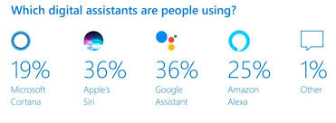
Their are various reason because of which we should use AI in our business such it can help us reduce down time utilize the resources more efficiently and reduce cost which is one of the most important factor in any business. Whenever we give any responsibility to AI the chance of failure becomes less.
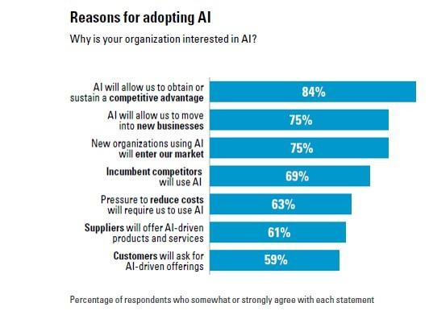
If we give the power of running a business to AI there are high chances that the company will grow over time. There are various examples of the company who have used AI for their management have score great results then by running the company depending on an manager/ human being. In the below image we can see a company who works with funds. Previously the use to do their trading depending on human being and on their experience but recently they are allowing a AI application to trade on behalf of a human being. They have allowed their human team and AI application to trade simultaneously to compare the profit between them. In the initial face the AI application was not able to compete against the human team due to lack of previous experience but as time passed it started learning the market trends and monitoring them after some time the AI application trading graph started to increase and started coming closer to human team. After some time the AI application graph surpassed the human team and the end result was the human team has made 23.87% profit whereas the AI application has made 26.56% profit i.e. approximately 3% more this shows thee capability of AI application.
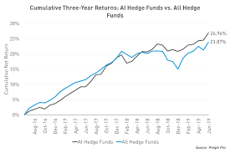
Like the above company there is one more company who has incorporated AI in their working environment in that companies profit graph we can see that the company was making a profit x with their human team which was not increasing above that. But when thy incorporated AI with their working their profit started to shoot up in the initial moths the profit made by AI was very little but as tie passed the AI application learned more about the organization and their working which lead to the profit increase every year after some year they were able to make 50% more profit than the normal profit based on the human team
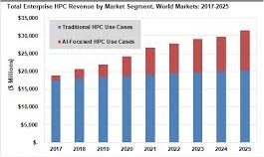
Despite of so many plus point not many company use AI. Only 14% of the company around the world use AI or have developed the AI application based on their need. 9% of the company are not thinking about AI they think it is waste. Whereas 23% company are about to develop their application within 12 months and 25% company are going to complete their development in 12 to 24 months. Rest 29% are going to develop in 2 to 3 years
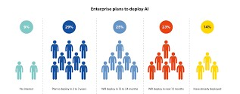
Challenges and risk of AI
One of the most important and the first problem which we face is developing a thinking AI systems are currently too difficult to achieve in practice and also one cannot give its requirement properly to the developer which can cause a problem. As AI has many plus point there are negatives as well. As AI is very new to the market and its working is very different from the normal working of the other application there are various number ethical and legal issues that are yet to be addressed. Developing of a AI Application is very costly for now it can be only done for a person who has wealthy owners to invest in his company. As the working of AI is different from the traditional way of working it creates negative impact and increases inequality in results. The people who are going to work with AI don’t understand this technology and how it works and the people who can are not much available and also they are expensive. There is high chance that the AI application developed can be immature i.e. it not trained enough to concur the day to day business problem. These AI Technology is oversold in the market i.e. due to lack of expert people and not much company using this technology the company who are using it overcharge for their service.
Area of AI implementation
As it is very flexible and able to adapt new things very easily AI can be implemented in almost every place just we have to modify the operation and function as per its work and train it accordingly. AI is mostly used in the field of IT were every thing is on system the application to manage them should also be their on the system so that work can be made easily done. After IT the AI is most used in Supply and Logistics were AI can better understand the route of destination and how much time it will be required to do that job and also AI can also arrange the job in such a way that all the resources are completely utilized to maximize the profit. Beside supply chain AI can also be used in Production Innovation and R&D hear AI can help us determine new techniques of production. It can evaluate the current market demand and give us the approximation of how much product we have to prepare/produce to avoid wastage. In R&D AI can show us which is the trending topic in market on which we can perform our research. AI can also be used for Customer Support
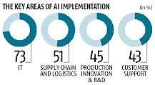
Solution for the problem related to AI
As we all have come across in the above phrase about the problem related to AI we can use some simple way to rectify these problems. One of the main and the biggest problem with AI because of which many organization do not use AI is cost. Cost of AI related product are always touch the skies to resolve this problem we can train individuals from our organization to make or work with AI related product this will reduce the cost of labour on the organization if the organization is outsourcing the product we should ensure that the other organization who is making the product should not over charge for the product. We should ensure the organization about the capabilities of AI so that they can trust it and use it in their organization without taking any stress. For ensuring them we can show them the profit graph of various other companies who are using AI in the current time and making profit we should show them companies which have similar working like them before AI implementation after AI implementation the working has become so good for them this will also help us to gather their trust. Making people aware about AI is on of the most important prospect to popularize AI.
Conclusion
As we know in todays world AI is catching its phase to reach the top. AI is been started to become one of most important aspect for many of the organization. But still there are various people who do not know about AI. AI has many plus point when used in business management it can help us grow our business by helping us in increasing the profit by using the resources efficiently and by helping us take complex decision on time. AI also helps us to know when and were to take which action that can help us increase the profit. As there are various plus point there are many negative also about AI some of them are the cost. If we go in a market to buy a AI application it will come with a huge price tag which cannot be affordable to every organization. The second most biggest problem of AI is he lack of specialist individual who can work with AI which make AI less preferable for any organization. If we overcome these problem we can use AI for business management it can help us achieve great results.
References
[1] Reshaping Business with Artificial Intelligence by By Sam Ransbotham, Philipp Gerbert, David Kiron and Martin Reeves.
[2] Impact of Artificial Intelligence on Business by Neha Soni, Enakshi Khular Sharma, Narotam Singh and Amita Kapoor.
[3] Artificial Intelligence and Human Thinking by Robert Kowalski
[4] Artificial Intelligence and its Application in Different Areas by Avneet Pannu
[5] Application of Artificial Intelligence & Associated Technologies by Jatin Borana
[6] Artificial Intelligence, Income, Employment, and Meaning by Betsey Stevenson
[7] Public Policy in an AI Economy by Austan Goolsbee
[8] What AI can do what Can’t for business by Michael chui james manyika and mehdi miremadi
[9] Using AI to enhance business operation by MITSloan

A COMPARITIVE STUDY ON DRONES WITH SIGNIFICANCE OF HYDROGEN FUELED CELLS
Megha Kandpal¹ and Pournima Bhangale²
Student¹ and Head², Department of Information Technology, V. G. Vaze College of Arts, Science and Commerce, University of Mumbai, Mumbai
ABSTRACT
Controller as well as autonomously running vehicles sent to the skies to capture high definition videos and photographs. It is considered to be the most emerging technology today. This paper focuses on SKAI(Hydrogen Powered drone technology) which has been recently launched for the betterment of future transportation. SKAI is a smart technology which typically uses hydrogen as its fuel to create electricity which does not affect the sensitivity of nature and also helps reducing the pollution as it leaves nothing behind but just water or water vapour. This drone is been designed to make it easier to travel from one place to another as it does not require launch pad etc. It uses simple constructs as it will be easier to detect the failure. It also has the advantages of hydrogen fueled cells in comparison to others. In this research paper there has been a discussion related to characterization of SKAI drones and hydrogen fueled cells and also its benefits and limitations in compared to other drones. As this drone is been designed to reduce the human efforts for transportation and travelling it also helps to recognize how it can be the future of transportation in upcoming years.
Keywords: SKAI, Hydrogen fueled cells, DJI Phantom 3, Quadcopter, FAA certification.
1.0 INTRODUCTION
According to Axel Smits (Chairperson and Senior partner, PWC Belgium). Drones are the most emerging technologies used. He raised a question on how drones can be used to make client’s operations more impactful? Drones can also be defined as an unmanned vehicle that acquire assistance to fly without any human pilot onboard. It uses different0systems of communication. Drones were initially operated in two different ways:-
1.Human operator with a remote control. These human operators operates drones from the particular place continuously giving signals to the flyingdrones. 2.On-board computers that are already attached to the drones that manages the drones according to air pressure. The first drone was 1918 Kettering Bug which was developed during the world war 1 phase for defense purposes and could move only to a certain amount of area. But today as the technology evolved the drones have the capability to move anywhere around the world. Here we can get an idea of how fast the technology is developing. According to some surveys it has been proven that these evolving technologies have helped changing the world. At present there are 1 million people registered as drone owners around the world. Using SKAI drones frameworks that are designed by (Designworks- A BMW company). They made each component so light it does not have any impact onto its airframe. The major task that they accomplished was designing hydrogen fuel tanks. FAA certified SKAI to be the most safest vehicle to run on air without affecting tropospheric conditions as it uses fibre-optic cables instead of metallic wires. Finally, this ended up creating a vehicle much powerful land less destructive for nature.
2.0 REVIEW OF LITERATURE
JACOBSON stated
“Hydrogen fuel cells vehicles are more effective in order to preserve nature. There are many ways to produce hydrogen but then too it in every possible way it emits less pollution as compared to other vehicles exhaust. And also hydrogen is the only energy that can be available as soon as possible with less amount of efforts.”
Goldin stated
“ Developing different techniques to make low cost and pocket-friendly manufactures can make each ssand every lives more interesting. There is a need to have safe planes and to conquer this there is a requirement of simple constructs as it can easily detect failure without any damage as complex constructs makes it hard to detect failures. If things are going to be affordable and cheaper it can affect the livelihood of many individuals.”
Tollefson stated-
“The first car that a child born today could drive, can be powered by hydrogen” this was said a long back by George Bush in 2003 as the usage of hydrogen is more good than biofuels and batteries as hydrogen fueled cells are more cheaper than them. As these cells can be used for a longer period of time as compared to other fuels and batteries.

3.0 RESEARCH IN USAGE OF HYDROGEN FUELED CELLS:
3.1 USAGE RATE OF HYDROGEN FUELED CELLS IN DRONES:
As compared to different drones such as DJI Phantom 3, Spark, Mavic, Owl drones and many more work only on batteries and these batteries are reusable but the only limitation to them are they can carry only a limited amount of weight and can fly upto certain possible area only. But hydrogen fueled drone(SKAI) can move from A to Anywhere without any problem as it does not work on batteries and can carry about 5 passengers onboard. More usage of hydrogen fueled cells can create a great difference in the pollution graph as it does not emit harmful exhausts.
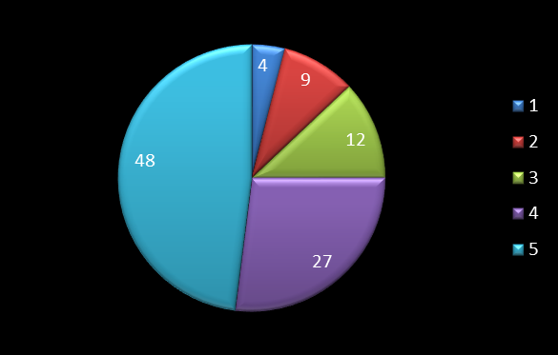
Fig-1: Hydrogen fuel cells usage rate
As shown in the diagram early 1800s hydrogen fuel cells usage was 4% and now have increased up to 48%. It has taken a very long time to adapt the usage of hydrogen fueled cells. Some of the researchers have predicted till the year 2030 there will be immense growth of hydrogen fueled cells in the vehicles as well as drones. There will be more air vehicles used which are normally known as air taxi run on hydrogen fueled cells rather than road vehicles to improve traffic conditions and pollution statistics can also be decreased.
4.0 RESULTS AND DISCUSSIONS
A comparative study is carried out using DJI Phantom 3, Quadcopter and (SKAI) showing their capabilities:
DRONES | DJI PHANTOM 3 | SKAI DRONES | Quadcop-Ter
Carriage Capacity | 1.124 kgs | 453.592 kgs | 10 kgs
Battery | 4480 mah | Runs on fuel having 200 or 400 liter tank | Runs on solar energy with the help of solar panels
Flight Duration | Approximately 23 minutes | Approximately 4 hours and more | Approxi-  Mately 3 hours 20 mins
Speed | 35 mph | 118 mph | Works as per the presence and amount of sunlight consumeD
Control System | Cannot have onboard pilot | Can be controlled by both onboard pilot and remote controller | Can run autono-  mously
This clearly shows that hydrogen fueled cells are more effective and useful than the rechargeable batteries as well as solar panels.
5.0 Limitations
As it is easily available and useful it also have few limitations that stops people to use it:
- Hydrogen is highly dangerous as it can create fire when mixed up with the air.
- Hydrogen is readily available without huge money loss but to create the hydrogen fueled tanks it requires a lot of stainless steel and big investment.
- As hydrogen is gravity resistant it can make a machine imbalance at any difficult point.
These limitations should be overcome so as to increase the production and usage of hydrogen fueled cells in vehicles and drones.
6.0 Conclusions
The enhancement of hydrogen fueled cells is supported by very few population as it has advantages along with dangerous disadvantages. This technique must be used but by overcoming all the disadvantages as it is time consuming but also a dangerous mixture to deal with. The limitations provided in this research paper must be read wisely and research is required for the safe use of hydrogen fueled cells in drones as well as vehicles to increase its productivity and usage.
7.0 APPENDIX
The above mentioned graph is been desined as per the survey of many automobiles organizations as well as Designworks(a BMW company) showing the usage rate from 1800 to 2017. When we analyze the graph we can clearly identify that the rate has increased but the process is very slow as compared to other developments. The highest rate shown is just 48% after a decade has been passed. The limitations must be decreased and usage should be increased.
REFERENCES
- Tollefson, Jeff. "Hydrogen vehicles: fuel of the future?." Nature News 464.7293 (2010): 1262-1264.
- Jacobson, Mark Z., W. G. Colella, and D. M. Golden. "Cleaning the air and improving health with hydrogen fuel-cell vehicles." Science 308.5730 (2005): 1901-1905.
- Trujano, Fernando, et al. "Security analysis of dji phantom 3 standard." Massachusetts Institute of Technology (2016).
- Kumar, Gaurav, Shubham Sepat, and Shubham Bansal. "Review paper of solar-powered UAV." International Journal of Scientific & Engineering Research 6.2 (2015): 41-44.
- Santhi, S., et al. "HIGH RANGE SOLAR AERIAL VEHICLE." International Journal of Computer Science and Information Security 14.11 (2016): 43.
- Appleby, A. J. "Fuel cells and hydrogen fuel." International Journal of Hydrogen Energy 19.2 (1994): 175-180.

SECURING THE VULNERABILITIES IN CLOUD COMPUTING
Payal Debnath¹ and Sunita Joshi²
Student¹ and Head², Department of Information Technology, JVM’s Mehta Degree College, University of Mumbai, Mumbai
Abstract
Cloud provides the most powerful platform for organizations and individuals to carry out their business. It provides services like online servers, storage space, customized software and hardware, creation of a virtual network that would seamlessly work as an actual physical network, etc. A recent study has found that usage of the cloud environment has dramatically enhanced over the years and most of the data is now being stored in the cloud network. This has grabbed the focus of hackers, which has led to the exploitation of data securities, data leakage, data breaches, etc. in the network. This paper contains comparison of the 3 cloud models, threats in clouds and its security measures in detail. Real-world attacks are included later, to illustrate the various ways that hackers try to infiltrate the network. Countermeasures that would help avoid such breaches are also presented.
NOMENCLATURE
DoS: Denial of Service
Amazon EC2: Amazon Elastic Compute Cloud
Amazon S3: Amazon Simple-Storage-Service
IaaS: Infrastructure-as-a-service
PaaS: Platform-as-a-service
SaaS: Software-as-a-service
1.0 INTRODUCTION
Cloud computing has been around for a very long time and most of the businesses are migrating their data slowly over the cloud. It provides a vast range of services like online storage, servers, network, software/hardware, building & deploying product platform, etc. with a low-cost structure. Cloud believes in Pay-as-you-go (i.e. only pay for services until you are using them); this has made cloud services trending, as small business sectors can also avail them.
The commonly used cloud services are Google Docs, which allows users to store, edit and share documents, emailing systems like Gmail, Yahoo and Hotmail, that allows users to send/receive emails which are stored on provider’s servers, Flickr and Picasa provide servers to store online photo albums, Dropbox, Strongspace, Xdrive, Google Drive, Zumo Drive, etc. provide online storage for various digital media, Hotstar, Sony App and Amazon Prime allows users to watch TV shows, Carbonite, Mozy and Jungle Disk provides users automatic backup of data on cloud servers. Some of these services are free while others need registration and payment.
MNCs are switching to Cloud services for storing data, Scaling up of resources, Software building tools, Servers, Customized software, etc. This helps them to reduce setup, operational and implementation costs as Cloud believes in pay only for what you are using, only till when you are using it. For example, a photo-sharing site, SmugMug uses Amazon’s S3(Simple-Storage-Service) for photo hosting. Mazda USA, an automobile company, rents RackSpace for its marketing and advertisement. Infosys uses EC2 provided by Amazon, to generate reports.
Cloud computing is undoubtedly convenient and low cost service that has change business conduct over the past few years. This has led to increasing risks like Cybercrimes, security threats, data breaches, unauthorized access, eavesdropping, etc. due to vulnerabilities in cloud computing. Hackers use a variety of methods to gain access to private & confidential data, illegally and disrupt the cloud system. If hackers get access to the exact location of the data they can steal private and confidential data for criminal activities. For Example, in 2016, the ‘National Electoral Institute of Mexico’, suffered a huge data breach, where 93 million voter registration records were compromised due to a poor configuration of server & confidential information became publicly available. Investigation showed that the server was an insecure & illegal Amazon server hosted outside Mexico. This shows the level of loss one can suffer if the cloud network is not secured. Countermeasures & remedy for such breaches are discussed later in this paper.
2.0 CLOUD SERVICE MODELS
Before buying cloud service, business needs to determine the level of control and flexibility they need.
2.1 IaaS: The most bottom layer is the system layer, it includes resources that consists network devices, storage disks and servers. It is commonly known as Infrastructure-as-a-service. These resources are available for usage as per requirement. Virtualization has helps to deliver a complex network infrastructure. This approach reduces operational cost of clients to build and maintain physical network. It also reduces the requirement of network admins to constantly monitor and support to the actual network. Amazon EC2 is an example of IaaS infrastructures. It provides a virtual computing environment with web service interfaces, using these users can perform deployment on Linux/Windows/Solaris based virtual systems.
2.2 PaaS: The next layer is the platform layer, also known as platform-as-a-service. It provides a platform to perform build, compile and deployment user’s specific applications. The service provided by this model consists of libraries and tools for building user’s applications. It allows users to control application development and configuration settings. Using PaaS users do not have to worry about setting up different environments for building their software, thereafter reducing the operational cost. Gmail, Google Groups, Google Calendar, Google Docs and Google Drive are suites of PaaS infrastructure. They allow customization of tools as per customer’s demand. Windows Azure is an example of PaaS provider. It supports various languages, tools and frameworks for building and deploying applications. Integration of applications into already existing IT environments can be achieved easily with the help of PaaS.
2.3 SaaS: The final layer is application layer, commonly known as Software-as-a-service. This allows users to rent application instead of purchasing licensed software, which requires monthly/yearly payments to continue using it. Cloud computing is undoubtedly convenient and low cost service that is now easily available. Example of SaaS services are DocuSign BigCommerce, ZenDesk, etc.
3.0 TYPES OF ATTACKS ON CLOUD
Since cloud has the ability to provide individuals with huge computing power; hackers avail such resources, analyze its configurations and settings to find out their vulnerabilities that helps them to understand the entire system. This gives them an insight about other networks on the same cloud. The most important security risk faced by cloud models is data loss. Data Breach can be done by internal(employees) as well as external(hackers) sources. Internal employees can have access to restricted data intentionally or accidentally. External hackers gain access to the data in cloud network using a range of hacking techniques, e.g. session hijacking and network eavesdropping. It is extremely important to recognize the possible attacks in the cloud in order to implement various security mechanisms to protect the cloud environments. Following are the possible types of attacks on the cloud environment that hackers perform to exploit the systems:
3.1 Denial of service attacks: Denial of Service attack attempts to distress a server/network that makes legitimate users unable to reach the service. Flooding, a common way used to crumble the targeted system by the hacker, where they send a large number of overwhelming bogus requests to the server and actual users cannot reach the service because of this false traffic in the network. For example, Bryan and Anderson, two security consultants, launched DoS attacks in a cloud network to one of their customers in order to test its connectivity using the Amazon’s EC2 cloud framework. By renting virtual servers on EC2, at the cost of $6, they used a homemade “Thunder Clap” program to successfully flood their customer’s server and made the company unreachable on the Internet. The following figure illustrates the DoS attack.
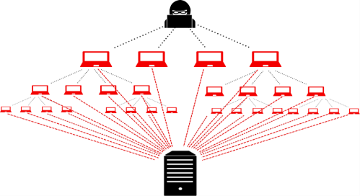
Figure-2: Denial of service
3.2 Abuse of cloud services: Earlier, attackers used multiple devices or botnets to generate a large amount of computing power, to conduct cyber-attacks on the network. However, this was a complicated process back then. Nowadays, cloud services have made it easy to get powerful cloud infrastructure, with both hardware and software components, after a simple and easy registration process
A brute force attack is a method, which violate and break passwords. This attack require large computing and processing capability as thousands of passwords are needed to be processed to a targeted user until it finds the correct password. Cloud computing provides a perfect platform for hackers to launch this type of attacks across the internet. A German researcher, Thomas Roth, demonstrated brute force attack in the ‘Black Hat’ Technical Security Conference. He was able to crack a WPA-PSK protected network by using a server from Amazon’s EC2. In approximately 20 minutes, Roth launched 4,00,000 passwords per second into the system & the cost of using EC2 service was only 28 cents per minute.
3.3 Malware injection attacks: This lets attacker gain access into user private data on the network. To perform this, they add infected module into the cloud systems. If the module implementation is successful then the legitimate user’s request will be directed to the infected module that will then take control of the execution flow thereafter. A common way to such attack is by injecting infiltrated JavaScript code inside web sites. Sony’s PlayStation become a victim of SQL injection attack in 2008, which is another example of such attacks.
3.4 Insider attacks: An insider, who purposely initiates any violation to the security policies of the company, causes an insider attack. The attacker could be an employee (of Client Company) or a service provider administration. To protect cloud from such attacks, a secured architecture should be implemented that would give employees/admins only necessary privileges & any offence to such privileges should be punishable.
3.5 Account or service hijacking: This attack requires user’s credentials. Phishing, spyware & cookie poisoning techniques are used for obtaining user’s ID & password. Once done user’s personal information or corporate data, which are kept confidential, will be compromised. For example, in 2007, Salesforce suffered a data loss of its client’s accounts because of a phishing fraud.
3.6 Spectre and Meltdown: These are another 2 types of attacks on cloud, where JavaScript embedded with malicious code can read encrypted data from the memory by exploiting a design’s loopholes of the modern processors. Both Spectre and Meltdown break the isolation between applications and the operating system; it lets attackers get information from the kernel. Users who are not updated with the latest security patches can face this.
4.0 COUNTERMEASURES
The cloud-computing framework consists of a cloud service provider, who provides computing resources to the end-users. To assure & provide the best quality of service, the service providers are responsible for ensuring the cloud environment has the capability to detect and stop any kind of attack. This can be achieved by applying advanced security technologies & making stringent security policies.
4.1 Security Policy Enhancement: Nowadays anyone can avail cloud services offered by the various Cloud Service Providers available in the market after a simple registration & online payments. This gives hackers a platform to take advantage to misuse such high computational power on the cloud system. Using this they practice malicious activities, like attacking other computing systems & spamming. As soon as an account on cloud is observed to be involved in any kind of suspicious activities then the account should be blacklisted immediately. Implementation & execution of security policies/SLAs can minimize the risk of abuse use of cloud computational power. Structured rules and regulations can help admins manage & control the clouds more efficiently & effectively. For example, AWS has defined a clear user’s policy, which states that whenever a complaint is received against an offending instance that is causing spam or malware, that particular account is terminated and further investigated.
4.2 Access Management: Cloud stores the customer’s data that are sensitive & confidential in nature. An access control mechanism is needed to ensure that only people with authorized access can have access to that data. Not only the storage systems need to be continuously monitored & secured, but also the access flow of the data (i.e. who can access the data & how much) also needs to be controlled. Malicious activities and suspicious instances are restricted using Firewalls and various Intrusion detection systems.
4.3 Data Protection: Data breaches can be either an insider employee or an external source (hackers/attackers). Insider employee can access illegal date either accidentally or intentionally with a hidden motive. Insider attacks are difficult to monitor, hence proper monitoring tools are necessary to be installed in the system. The tools like abnormal behavior pattern detection tools, data loss prevention systems, encryption and decryption tools, format prevention, user behavior profiling, and authentication/authorization technologies should be installed. With the help of these tools, admins can track real-time traffic monitoring, support the cloud system & trap suspicious activities as soon as they are encountered.

5.0 REAL-WORLD ATTACKS
5.1 Case 1: In 2011, Sony’s PlayStation Network was hacked, which caused them to shut down the PlayStation network from April to May. The attackers stole data of 100 million users. Investigation revealed that it was carried-out through Amazon EC2. The hackers pretended as a legitimate company and registered for EC2 service provided by Amazon. All they had to do was go through online registration and Credit card details, which apparently were fake. This is the reason a thorough KYC process by service providers is necessary before registering a new customer.
5.2 Case 2: In 2019, the Indian government’s Aadhaar card database suffered multiple data breaches, compromising up to 1.1 million citizen’s personal data, including name, address, retina scan, thumb impression, etc. Criminals were selling access to the database at the cost of 500 INR/10 minutes. Such leakage of citizen’s information can be dangerous as it can cause criminal activity in the nation & it will be difficult to get hold of the culprit, as they will be disguised as other innocent citizens.
5.3 Case 3: In 2019, in London, at 11 am EST, most of the Facebook users suffered ‘Denial of service’, while others were able to access only limited functionality. This was due to hackers were successful in flooding the Facebook server for several hours. A Facebook spokesperson said that this was due to configuration changes scheduled in a production environment. But this seems very unlikely as firstly, production changes are carried out on a 24/7 service only when fewer users are expected to use the service not during peak hours like 11 am and secondly if the changes would cascade an outage for several hours, customers are notified beforehand. Point to be noted here is Facebook has experienced various such attacks over the years but has always shown a shady & nontransparent behavior when it comes to facing such controversial questions.
6.0 OBSERVATION
All the cases discussed above are examples of outside attacks that were carefully planned and executed. Like we know with power comes responsibility, cloud providers provide a huge amount of computing power if misused can cause damage beyond expectation. Hence, service providers should verify their users before registering them i.e. a through KYC process is necessary.
Since scaling up of resources is easy with cloud, various fake instances are used to cause Denial of services by attackers. A monitoring device or Admin who should monitor sudden scaling up of resources is necessary. This will verify if the instances are flooding any particular website or participating in a brute-force attack. When any such account is detected, they should be immediately reported and blocked.
7.0 CONCLUSION
In order to make the latest technologies service available, cloud computing needs to make continuous development, with these vulnerabilities appears. Security is the key challenge when it comes to keeping the customer’s data safe and secure from attackers. Even though several security measures & techniques have already been developed for the cloud system, loopholes are still present and hackers try to crack the network wherever they see an opportunity. In order to provide a better and more secure cloud network such flaws and loopholes should be identified and rectified. In this paper, we studied the types of security threats, security measures, real-world attacks and countermeasures to those security attacks.
ACKNOWLEDGEMENT
Hearty thanks to Mrs. Sunita Joshi, Professor at JVM College, Airoli, for proof reading the content & all other Professors for providing their guidance & encouragement throughout my research.
REFERENCES
- Himanshu Agarwal, Anju Sharma, “A Comprehensive Survey of Fault Tolerance Techniques in Cloud Computing”, International Conference on Computing and Network Communications(CoCoNet),IEEE,2016
- E. M. Mohamed, H. S. Abdelkader, and S. ElEtriby, “Enhanced data security model for cloud computing,” in Informatics and Systems (INFOS), 2012 8th International Conference on. IEEE, 2012, pp. CC–12.
- X. Wang, B. Wang, and J. Huang, “Cloud computing and its key techniques,” in Computer Science and Automation Engineering (CSAE), 2011 IEEE International Conference on, vol. 2. IEEE, 2011, pp. 404–41
- F. Sabahi, “Cloud computing security threats and responses,” in Communication Software and Networks (ICCSN), 2011 IEEE 3rd International Conference on. IEEE, 2011, pp. 245–249.
- Feng, Q., Han, J., Gao, Y., Meng, D. “Magi‐cube: High Reliability and Low Redundancy Storage Architecture for Cloud Computing” 2012 IEEE Seventh International Conference on Networking, Architecture, and Storage. 2012, PP. 89 - 93.
- Wenbing Zhao, P.M. Melliar and L.E. Mose” Fault Tolerance Middleware for Cloud computing” 2010 IEEE 3rd International Conference on Cloud Computing.
- I. Gul, M. Islam et al., “Cloud computing security auditing,” in Next Generation Information Technology (ICNIT), 2011 The 2nd International Conference on. IEEE, 2011, pp. 143–148

PDF Invoice Data Extraction
Labhesh Mehta¹ and Dr. Hiren Dand²
Student¹, Department of Information Technology, K. J Somaiya College of Arts, Scence and Commerce, University of Mumbai, Mumbai
Head², Department of Information Techonology, Mulund College of Commerce, University of Mumbai, Mumbai

Abstract
Nowadays there is used of soft invoices everywhere with the help of an online system. However, Manually entering invoices is tedious and time consuming work there are no such systems that can accurately fetch useful data out of the invoice and process it. All the invoices have basic data like the name of shopkeeper and customer, billing date, due date, billing amount, etc. We can extract the same data and use it in other systems like Tally or we can add them in an excel sheet which will reduce the human effort in manually entering the data thus reduce typo, also will be fast, accurate and reliable.

Introduction
Nowadays there is used of soft invoices everywhere with the help of an online system. However, Manually entering invoices is tedious and time consuming work there are no such systems that can accurately fetch useful data out of the invoice and process it. All the invoices have basic data like the name of shopkeeper and customer, billing date, due date, billing amount, etc. We can extract the same data and use it in other systems like Tally or we can add them in an excel sheet which will reduce the human effort in manually entering the data thus reduce typo, also will be fast, accurate and reliable.

Problem Statement
Extracting data from soft invoices which can be used for a better way of book-keeping and reducing human efforts. Let's understand the base of the system and the use of data generated by the system.

1. Ease of Use

Daily Use of System
The use of PDF invoices is increasing day by day and has become an integral part of corporate business with the help of the internet and ease of technology. But for book-keeping, we are still manually entering data into the system. There is almost no such system or processing engine which can extract data from PDF and that data can be used further in a various system like automatic payment or tally software etc.

Maintaining the integrity of data
Data is something that can be found in any form and can be used in multiple ways which may or may not be safe. Giving away any form of information related to corporate business and its expenses can increase the risk. So to avoid the data theft approach system made in such a way that it won't save any of the output data.

Abbreviations and acronyms
We are going to look at some of the basic words that we have heard but don’t exactly know about it.
NLP - Natural Language Processing: Technique by which computer understands the human-readable language.
OCR - Optical Character Recognition: Technique by which the computer understands characters present in the image and gives it as output.
Regex/RE - Regular Expression: Technology using which we will search for patterns from the string.

Forms of data
Quantitative Data: This kind of data that can be measured in terms of quantity is called quantitative data, basically this kind of data is in number format. In this system, quantitative data is usually amount, quantity, etc.
Descriptive Data: This kind of data that can define/ describe any entity is called descriptive data, basically this kind of data is in string format. In this system, descriptive data is usually name, address, particulars, etc.

Methodology
To extract data from PDF invoices, we will allow the user to upload the PDF, then that PDF will be saved to server in the original format as well as Image and HTML format using python package pdf2image and pdf2tree respectively once the files are saved we will display user HTML file where he has to do one time activity of selecting and saving the tag of that template with its respective RE/Regex. We will save the HTML DIV styling .i.e. Location from top and Location from left.
Now, whenever the user uploads another PDF (maybe next month invoice) first will convert the PDF into an image to compare it with the original template (For example: If the Template is MTNL Bill, then our system should accept only MTNL Bill for that template). Then if it matches our template we will convert the PDF into HTML and we will find the div with respective to location saved into our database. Once the div is located we will check it, if it matches our RE/Regex once the match is found we will highlight that section and display it to the user or we can use the data of the highlighted region as per our needs.
In the way, we can extract useful data from PDF invoices. Also for same API can be constructed where other program can request this system to give the data.
For the new PDF we will run Spacy NLP package from python to show user/Suggest user the entities. If the PDF isn’t convertible to HTML will we display Image to the user where now he/she has to select the region now we will store the coordinates of the selected region and the text of that region will we extracted using OCR tool. now the same process will be carried out as of HTML file.

Process flow
- First user will have select the text which he wants to capture for the upcoming invoices then the user has to label it. On the backend, we will capture the HTML div location then save the location with respect to the label given and the RE/ Regex given by the user. The step can be called as Learning Stage where we will teach the machine about a location that we want to capture. The capturing process is done on the frontend using javascript and jquery. Onclick listener.
- Now on new PDF upload, we will convert it to image and compare it with our original image using the OpenCV python package if it matches around 85-90% we are good to go. As few invoices have an advertisement on it which changes from time to time also details changes so the changes are count as an error which is around 10-15% of our file. If it is matching now we will convert it into HTML and find the div with location which is saved into our database if div found then will we check it with the regular expression save into our database. If regular expression pattern matches we will highlight the div with its tag name which is the data we wanted to extract from a database.

Inputs and Outcomes
Input to this system will be a PDF of invoices. Where the user will have to upload the invoices monthly. whereas the expected output is useful data like due-date, amount whatever use have tagged during the one time process in form of high light or if using API particular data with respective data type.

Application
Anybody can use this system who wants to get important data from PDF invoices that are extracted and processed by the computer itself and further the data can use by any system.

Conclusion
A System or processing engine is possible which can accurately extract the data from the PDF Invoices. With almost no or little human interaction.

Acknowledgement
I sincerely thank my guide, Hiren Dand for the guidance and encouragement in carrying out this research and rectify the mistakes in the same for the betterment of this work

References
- UPPSALA , “Uppsala Portal : Automatic reading and interpretation of paper invoices” May 2016, accessed November 2019 . [Online]. Available: https://uu.diva-portal.org/smash/get/diva2:967971/FULLTEXT01. pdf
- "OpenCV" accessed November 2019 . [Online]. Available: https://opencv.org/
- "Tesseract for Open Source" accessed November 2019 . [Online]. Available: https://code.google.com/p/ tesseract-ocr
- Python invoice2data accessed November 2019 . [Online]. Available: https://pypi.org/project/invoice2data/
- Python pdf2tree accessed November 2019 . [Online]. Available: https://pypi.org/project/pdftotree/
- Python pdf2image accessed November 2019 . [Online]. Available: https://pypi.org/project/pdf2image/
- Image Processing with Scilab accessed November 2019 . [Online]. Available: https://atoms.scilab.org/toolboxes/IPD/8.3.3/files/Tutorial.pdf
Electronic Payments – Comparing Google Pay with Paytm
Vatsal Shah
Department of M.Sc.I.T., Kishinchand Chelaram College, University of Mumbai, Mumbai
Abstract
Presently electronic payments have become routine, everybody buys items over the web and pays the bill, which is turning into a simple and regular need. Secure strategies for the transaction portal for such online purchases have been extremely significant. Along these lines, security for such exchange is vital on the grounds that this data is private, for example, Mastercard / credit card numbers. This paper surveys security in electronic exchange utilizing debit cards and other payment applications over mobile applications.
Keywords: Credit Card, Debit Card, Electronic Transaction, Password, Paytm, Security.
I. INTRODUCTION
The rise of electronic exchange utilizing mobiles that began in the year 2000 has increased exponentially and is popular among individuals. It is helpful and the individuals can utilize electronic exchange while making payments whenever the timing is ideal.
Essentially banking has moved to web-based banking and Commerce has turned into an E-Commerce and it is imperative to verify the online information from being hacked by any unapproved or unauthorized clients. The advent of electronic exchange has decreased the opportunity of cash transactions. Payment of bills electronically saves time and can be overseen from home, office or from any place by the user with a smartphone.
Electronic payment framework alludes to an electronic gadget that enables a person to make electronic trade exchanges, and furthermore to buy online items. It likewise encourages e-wallet where it is connected to a person's bank a/c. Clients utilize computerized wallets to store payment information, have no need to repetitively feed data every time they make a purchase. To add security to these applications and transactions is a significant errand.
I.I OBJECTIVE
1) To consider the procedure of electronic exchange is done utilizing a mobile application.
2) To examine the advantages of electronic exchange.
3) To underline the motivation behind Security in an electronic exchange.
II. LITERATURE REVIEW
There are various research papers that were created for security in electronic exchanges. Writing study [1] which gives the data about the various conventions which defeat the issue of security and [2] various issues, dangers which happen during the exchange and furthermore gives the answers for that issue.
These are the accompanying security dangers that are looked into in this study. Security issues in electronic exchange application are as follows:
1) Malicious code:
• Viruses: The infection has the capacity to reproduce and spread itself to different documents in the system.
• Worms: They are like infection however it is intended to spread from one system to another.
• Trojan horse: They give malicious users control over legitimate users.
2) Hacking: It is an endeavor to get into other systems without knowing to that individual.
3) Credit card fraud: In this client utilizes the other Credit card pins for personal use.
4) Spoofing: In this programmer endeavors to increase unapproved access to the system by professing to be the approved client.
5) DOS: It happens when authentic clients are kept from getting to assets by the programmer.
There are certain RBI Guidelines for an online transaction which are as follows which have to be followed:
1) Confidentiality: The private data of the user should be confidential and not accessible to unauthorized users or third-party vendors.
2) Non-repudiation: A person to communicate with one another must accept the authenticity of the message.
3) Authentication: During a transaction, it should ensure that it is the authenticated account holder who is making the transaction.
4) Data Integrity: The transactions and wallet amounts are shown to the customer within the application.
5) Access and availability: Some apps and USSD systems work through SMS or voice calls from the mobile phone, thus being available to customers who do not have internet or data connections on their mobile devices
6) Privacy: The payment app or service should not ask for customer data that violates the privacy or increases the risk of identity theft.
III. METHODOLOGY
Various papers have been surveyed, various reports have been investigated to comprehend the electronic payments security threat and the requirement for a secure method.
IV. PROCESS OF ELECTRONIC TRANSACTIONS
IV.I PAYTM
The online-payment mobile application Paytm is the biggest applications used in India. Paytm is a payment and web-based business organization in India. The application was launched in August 2010.
The Paytm Wallet application gives highlights to you like booking of air tickets and cabs, paying the power and DTH bills among others, money transfer using mobile phones. Users can likewise give the option of web-based shopping and purchase movie tickets through the wallet.
Following charts indicates how the Paytm application works when we buy an item:
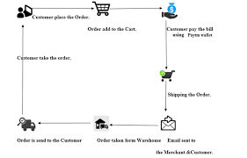
FIG-1: PAYTM SHOPPING STEPS [5]
Steps are followed in online shopping.
1) Customer place the order.
2) The order is added to the cart.
3) Pay the bill using the Paytm wallet.
4) Shipping the order.
5) Email is sent to customers and merchants.
6) The order is received by the customer.
These are the steps that need to be followed while doing the electronic exchange. The security procedure is coming in stage 3 when you purchasing an item.
IV.II GOOGLE PAY
Google Pay is a digital wallet and online payment system developed by Google. This wallet was launched in September 2015 globally. Initially, Google Pay was known as Tez in India which was launched in August 2017.
Through Google Pay we can pay for online booking of tickets, ordering online food and much more.
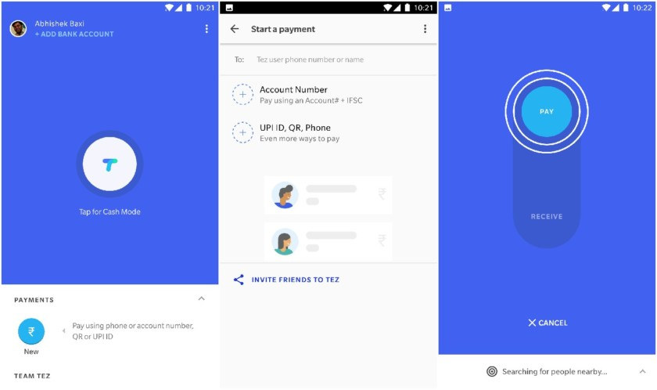
FIG-2: LOOK OF GOOGLE PAY(TEZ) [8]
V. SECURITY DETAILS OF PAYTM
During the research we found that there are various security violations which are as follows:
1) SMS and emails sent from the bank for verification are visible to anyone who has access to the user's phone.
2) Third-party applications like Uber, Bigbasket directly deduct the amount without a confirmation of the bank of the user.
3) The user is always logged in and never automatically logged out. Session timeout is not available on PAYTM.
4) Details of the transaction are difficult to find on the application.
5) During the installation of the application, they ask for access to media, camera, files that are not required for a small transaction that is to be fulfilled by a user.
There are various advantages besides the violations mentioned
1) Each transaction has a unique ID which makes it easy to track.
2) Money transfer is available easily with a secure Paytm pin.
3) Easy to read the monthly statement, which is shared over the mail.
4) Transaction confirmation Email and SMS is immediately sent over by the bank as well as Paytm.
VI. SECURITY DETAILS OF GOOGLE PAY
During the research we found that there are various security violations which are as follows:
1) SMS and emails sent from the bank for verification are visible to anyone who has access to the user's phone.
2) Error messages are not very clear.
3) Deducts SMS cost for adding bank details on Google pay.
There are various advantages besides the violations mentioned:
1) A UPI Pin is required to check the bank balance. Anyone with access to the phone cannot check or transfer the amount without the pin.
2) A statement is available to check the monthly transactions for a user.
3) During registration, it confirms the user's bank account details before adding it to the application.
4) It does not ask for access to media, images, and camera which is not required for the application.
VII. ADVANTAGES OF ELECTRONIC TRANSACTIONS
• You can send and get payments anywhere anytime.
• It is easy to use and understand.
• It saves time.
• Your account can be managed from a mobile phone.
• It gives the option of email or SMS notifications.
• Complete control of transactions.
• You can send or receive funds into your e-wallet application directly.
• Unlimited amount of transaction you are able to do.
VIII. PURPOSE OF SECURITY
These days everybody goes online shopping since it saves your time and you can get the items at home. While purchasing an item on the web, security is one of the significant parts to be taken into consideration. The motivation behind security is to conceal the data of clients and information to be moved online safely without and third-party interference.
For security reasons, you have to follow rules so that your information won't get hacked by any third-party individual who must not get your private and confidential data.
IX. TIPS FOR SECURITY
These are the following tips which you need to be followed for secure transaction [6].
• Install security software: For security purposes, you should install the security software on the mobile phone so that the data can protect.
• Use encryption signs for the password: When you do a login, make sure that the password gets encrypted. When it is transmitted over the network it will not be used by anyone.
• Used different password: Always used a different password, so it can’t be used by anyone if the password is known to the other person then change the current password.
• Avoid public computers: For financial transactions always use a personal computer. Never use any public computers.
• Avoid public WI-FI: Do not connect to an open Wi-Fi, always connect to a private and known network.
• Buy the product from the reputed site: Always buy a product from the reputed site make sure that your security is not compromised. Also, check the confirmation email once you complete the transaction.
X. CONCLUSION
A brief about an electronic exchange is clarified over this research paper. The benefits of electronic transactions on mobile phones have been talked about and furthermore gives a few hints for security.
After analyzing data from both Paytm and Google Pay we found that Google Pay is much secure than Paytm.
REFERENCES
- SECURITY OF ONLINE ELECTRONIC TRANSACTIONS by Nikhil Khandare, Volume 1, Issue
- E-Commerce Security Issues and Solutions. Niranjanamurthy vol. 2, Issue 7, July 2013.
- Online References. https://scroll.in/article/809228/three-chartsshow-how-mobile-wallets-are-exploding-inindia-but-plastic-cards-are-still-ahead.
- Online Payment and Security of E-Commerce. International symposium on web Information system and application.
- https://www.irjet.net/archives/V4/i4/IRJET-V4I4708.pdf
- Online Reference http://profit.ndtv.com/news/yourmoney/article-top-10-tips-for-safe-onlinecard-transactions-381728
- https://www.iimb.ac.in/sites/default/files/inline-files/iimb-csitm-security-issues-in-mobile-payment.pdf
- https://www.androidauthority.com/google-launches-tez-new-digital-payment-app-india-heres-everything-need-know-801059/
Cyber Threats in Online Digital Platform (SNS) Review & Solution
Aditya S Kadam¹ and Priti Palkar²
Student¹ and Head², Department of Information Technology, N. G. Acharya & D. K. Marathe College, University of Mumbai, Mumbai
Abstract
In today’s world, the internet has out pouring data. The use of social or digital networking sites is very high compared to another usage of internet. While focusing on the internet, social or digital networking is very popular and major thing that gains attention of millions of people. The main objective of the people is desire to exchange idea and communication across the globe. With updated and advancement in technology social or digital networking emerged as the crucial part of human life. It is not just use for communication purpose, but also used to promote business promotion all over the globe. As millions of peoples are nowadays connected to social or digital networking platform it has also promoted the cyber criminals or hackers for cyber crimes. A threat on the digital platforms can be intentional and unintentional, targeting an organizational or individual. Facebook, Instagram, Twitter and LinkedIn, WhatsApp etc are famous social networking sites used. People are unware of the security issues while sharing and exchanging their day to day activity on these platform. Cyber attackers or hackers or criminals exploit personal as well as business information and other confidential information of the user for hacking their accounts. Thus privacy and security is an utmost concern in social or digital networking platform. Even though we have updated antivirus system or other software it is not as effective against these security threats. These papers aim to review and identify various security threats in social or digital networking platform. Also, it review on some of the examples of cyber threats occurred and propose some solution to help people how to overcome and what are the precautions to be taken against cyber threats associated with the social or digital networking platform.
Keywords: Social Networking Website, Social Networking Sites, Digital Platform, Security, Privacy and Cyber threats.
Introduction
Social Networking sites or digital platforms focus on connecting and building social relations among people who share same interest and activities. Also, they are online applications that allow people to communicate with each other by sharing or exchanging text, profile, images, files etc. These social platforms can also be defined as a structure made up of nodes that are tied by more or specific type of relations [1]. Social networking or digital platform allows user to share views, images, videos, innovative ideas, and personal ideas with the other people whom they are connected using various social applications generally known as digital platform. With advance updation in this the overall popularity in social network website or digital platform has increased remarkably globally.
Some of the key takeaways from their Global Digital Report 2019 include [2]:
➢ The number of internet users worldwide in 2019 is 4.388 billion, up 9.1% year-on-year.
➢ The number of social media users worldwide in 2019 is 3.484 billion, up 9% year-on-year.
➢ The number of mobile phone users in 2019 is 5.112 billion, up 2% year-on-year.
Due to the advancement in the automation or use of internet, almost all the people have started using social network sites or digital platform to communicate with their nearest one such as friends, partners and any other member. These digital platform allows one to interact with other at remote location very quickly from any part of the globe at very nominal cost. The registration is free for all user as these digital or social network website enable user to register before use. Some of the popular social networking sites especially in India are [3]
1. Facebook. 2. WhatsApp 3.Instagram 4. YouTube 5. Snapchat 6. Twitter 7. LinkedIn 8. Gmail etc…
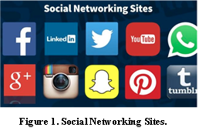
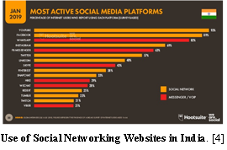
The above image is showcasing the presence of users using each digital platform in India. Since the spurting access of the internet in the late '90s, India has also become a part of the digital world with over 460 million users online in 2018 alone..
The social networking website or digital platforms have had their share of positive and negative impact.
Many people spend most of time using these digital platform which results in losing their jobs or personal lives. Most digital platform have members create and manage their personal profiles, post different types of files, provide facilities for member to automatically discover connections candidates with existing members and providing more interesting and convenient features so user can spend long time on these sites. As result of this many digital platform companies are developing new advance applications for such social networking site.
Due to the number of users towards these (social or digital platform) is increasing day by day. In India, in the past few decade the popularity and users connectivity is increased huge. As a result users make many risks and mistakes while using unauthorized sites, downloads, and network access, misuse of corporate computers, misuse of password and transfer sensitive data between work and personal computers while working at home. However, the more the trust the users have on the social networks the more vulnerable they are to a variety of attacks and data leakage which leads to cyber threat.
Cyber Threats in Social Network Website or Digital Platform
The risks can be divided into two kinds of threats that are Traditional network related threats and Privacy related threats.
(i) Traditional network related threats: Its deal with the security of people or with safety of data that is saved in the systems. Since the social networks have enormous numbers of user and amount of data, they are natural targets spammers, phishing and malicious attacks. Moreover, online social attacks include stalking, cyber bulling and defamation. Attackers or hackers create fake profiles to damage induvial within a network.
(ii) Privacy related threats: These threats can be faced due to the publishing of information on the social networking site. A lot of information on personal home pages may contain very sensitive data such as birth place, personal mobile number, and address so on. The hackers used this information by using social technique to steal money.
Cyber Security Issues
(i) Cyber Crime – This crime is conducted by induvials either alone or groups. The main function of such crime is to getting money, causing damage or obtaining private or valuable data. These crimes are used to generate credit / debit card information, disturbing the website operation and intellectual property.[5]
(ii) Cyber War - Cyber warfare involves the actions by a nation-state or international organization to attack and attempt to damage another nation's computers or information networks through, for example, computer viruses or denial-of-service attacks. [5]
(iii) Cyber Terror – Such kind of terror is caused by an organization that works independently for performing terrorist activities through cyberspace. [5]
Documented Cases
(i) ‘KBC officer and Indian government’ con woman of Rs 83k.. In this the attacker first gather the information through social network and steel the money which leads to privacy related threats.
(ii) Actor Ruchita Jadhav - victim of cybercrime and harassment. The actor’s Instagram account was hacked by an unknown user with a Turkish mobile number, who sent her threatening messages to destroy her career if she doesn’t oblige to pay $500 USD to get her account back.
(iii) A content moderation scheme for Facebook and other social media. Cyber content moderation is another solution to serious types of crimes - like objectionable videos.
(iv) Mumbai man held for posting nude pics of friend . The attacker without victims’ knowledge access her phone and shared privacy over social network site.
The way these crimes happen it’s very tough to trace the culprit even if the source is traced —more the technology progresses more the complications just like we have in case of modern medicine so our focus should be empowering and giving more knowledge to the users to overcome such kind of social network threats.
There are many more such type of cyber threats and found the most threats happen due some factors which are listed below.
(i) People are less concern with the importance of the personal information disclosure thus they are at the risk of disclosure and privacy invasion.
(ii) Many user have knowledge of threats but unfortunately not have right direction towards privacy setting.
(iii) The policy and regulatory board are not enough to handle these type of social networks threats which is day by day increasing with more challenges and modern technologies.
(iv) Lack of involvement of Government Authorities.
(v) Lack of tools and appropriate mechanisms to handle and deal with different security and privacy issues.
(Vi) Social network need more improvement and updation so user can manage their accounts more securely.
Frequency of successful attacks by year in social networking sites
Years | Cyber Threat Report (%)
2015 | 70.5%
2016 | 75.6%
2017 | 79.2%
2018 | 77.2 %
2019 | 78.0%
Solution and Recommendation
For accessing and securing information on digital platform or social networking site, following are few solutions and recommendation can be followed.
      - Try to reduce the amount disclosure of information about your personal or organizational on social networking site.
      - Always keep a track of your private account. Make sure you have set a strong password for the various account which you are using.
      - Changing of password monthly or weekly so information can’t be hacked by hackers or any unauthorized person.
- Don’t get attracted towards any promotional activity posted on social network as it can be malware or misleading information.
- Customize your security as per your need.
- Never visited the links which you feel suspicious and be aware of unknown links send by unknown person.
- Use of good antivirus to deal with a virus that may come from internet due to use of unauthorized site which may lead to damage or stolen your data from the computer.
- If you are victim of any such threats, informed it to cyber security cell or IT cell so any further damaged will be prevented or restricted.
- For Mobile Phone - Do not buy second hand mobile handsets without having any knowledge about the pre downloaded applications. Do not give your mobile phone numbers while chatting over the internet to avoid stalking.
Literature Review
Cyber threats and related privacy concerns are amongst the high rated topic nowadays as linking of multiple user to such sites increasing dramatically. Various articles and blogs come up with these issues that how the increase use of such sites and software lead to various online crimes and involvement of attackers to lead such activities are increasing day by day.
EC-Council a blog in website mentioned that “What are the primary threats visible on social networking or digital platform”. It talks about various threats associated with social networking sites and their precautions to be taken.
Roman Tobe examined “how cybercriminal execute social media threats?” and the scheme and scams associated in this. Also reviewed the basics steps required to protect against social media threats. [6]
Medha Raj, Sharmistha Bhattacherjee, and Abhijit Mukherjee reviewed the usage of social networking websites among school students. They overall research was based on the impact of use of social network sites by students and influence on their academic result. [7]
Sergiu Gatlan discuss & reveals that most social networks also come with an "over the counter" marketplace where various crimeware services and tools are being offered for sale, from a wide range of hacking tools and services, to botnets for hire and facilitated digital currency scams.
Conclusion
Social networking websites or digital platform offers advance way to communicate and get attached to people from any part of the globe by use of advance technology. Although it also raise new challenges towards security and privacy issues. In this paper, I reviewed the impact and risk of breach of privacy on digital platforms in today’s world. Also the increase in usage of social networking site. Also brief about security threats and issues in this. Also, highlighted the few documented cases associated with cyber security threats. Also suggested various recommendation and solutions to the users for improving the security while using social network sites.
I feel we should concentrate on prevention than cure, spread awareness about safety of social network and steps one must follow. Here also we can draw an analogy from medicine - we treat diseases, infections as we need to save the patients but our work does not end there. We spread awareness on prophylactic measures so that no one contracts the infection. So our focus should also be on reduction of rate of these crimes so that people do not fall prey to these things. Reduction in cyber Crimes by proper usage of digital platform makes a big difference to society. We must give examples of people who got into trouble - that’s why we need to bring out maximum cases. We tell them the dos and don’ts involved in the different social media sites like twitter, Facebook, what’s app etc. as they may have different applications - these will be more specific. No one should get troubled or get fooled. For eg , we tell people to keep changing passwords frequently , not keep same password across sites , not open web pages which are not secure , always see that Laptop or PC has active antivirus and anti-spyware , not storing credit cards in e-commerce sites like amazon etc. - such simple things also people don’t follow.
My study is to emphasis on creating awareness and to alert the users with application guide to avoid the security threats and crime taking place online in digital platform
References (Research Papers)
- Michael Fire ; Roy Goldschmidt ; Yuval Elovici : Online Social Networks: Threats and Solutions.
- Global Socail Media Research: By Dave Chaffey.
- Abdulla Al Hasib – Threats of Online SNS.
- Michael Fire, Roy Goldschmidt, and Yuval Elovici :Online S Networks: Threats and Key Solution.
- M. Prasanthi "Cyber Crime: Prevention and detection. The International Journal of Advanced Research in Computer and Communication Engineering, Vol. 4, Issue 3[10], pp. 45-48, 2015
- Arpita Banarjee, C Banarjee & Dr Ajeet Ponia - Security Threats of Social Networking Sites: An Analytical Approach .
- Medha Raj, Sharmistha Bhattacherjee, and Abhijit Mukherjee - "Usage of Online Social Networking Sites among School Students of Siliguri,WestBengal,India"
- Sergiu Gatlan - "Social Media Attacks Generate $3.25 Billion for Crooks Each Year"
- Balachander Krishnamurthy : Privacy leakage in mobile online social networks

How can AI used in Smartphones?
Akshay Hanumant Thite¹ and Dr. Hiren Dand²
Student¹, Department of Information Technology, Vikas College of Arts, Science and Commerce, University of Mumbai, Mumbai
Head², Department of Information Technology, Mulund College of Commerce, University of Mumbai, Mumbai

Abstract
Nowadays Smartphone becoming necessary thing for human being and there are number of smart phones which offers number of features which makes human life easy. Currently, there are two new technology coming to the mobile market which may be change the mobile era, the first one is 5G (5th generation of mobile network technology) and the second is AI (Artificial Intelligence).
In this research we are going to see in which area of smart phones AI is used efficiently and what are the areas where AI need to be improved in smart phones.

Introduction
In most advanced economies, artificial intelligence entering the workplace in a big way. In fact, not only is AI becoming common in workplace, but also indoors and outdoors. But one question arrives what is AI? And the simple answer is “AI which collects data from user, computing it and allow a system to think like human or to make a decision like human which makes human life easier”.
When we heard the term “Artificial Intelligence” (AI), we imagine robots doing our job. Since AI based computers are programmed to make decision with little human efforts and there will be no wonder if machines will soon make the difficult decision which are difficult for human to take.

Review of Literature
In most advanced economies, artificial intelligence entering the workplace in a big way. In fact, not only is AI becoming common in workplace, but also in the home outdoors places. But one question arrives what is AI? And the simple answer is “AI which collects data from user, computing it and allow a system to think like human or to make a decision like human which makes human life easier”. Artificial intelligence is one of the most advance and important development in mobile phones and following are the areas where AI is used in current generation of mobile phones:
Smart phones camera
Where AI can transform the picture like real human being sees those picture just like how you got the pictures and it’s going to suggest you settings automatically for a low light or a greenery or a portrait.
Mobile phones battery capacity
In this AI constantly learning how you’re using it or how your charging your device and its tweaking how the phone is being charged.
Navigation Maps
Company like Google and apple maps navigation services use by artificial intelligence to interpret thousands of data points that they can receive to provide you with real-time traffic data.
Music and Media Streaming Service
Whether you are using Netflix, Spotify, YouTube or any other music streaming application, AI us making the decision for you. You feel that you are in total control but you are not and this is a very bad because if you are using YouTube app where you are wasting your countless hours just watching the recommended videos which is suggested on YouTube.
Online Ads Network
One of the niggest users of AI is the online ads industry which currently uses Artificial Intelligence to not only track user data but also serve us ads based on those data.
Methodology
As we know there is always a room for improvement.
So, what will smartphones of the future look like after 10 years?
Following are the areas where AI can improve in future:

Mind Controlling
Earlier we are interacting with smartphones with using physical keypad but this was eventually replaced by the touch screen display that we use today. With services like Apple Siri and Google Assistant, we can now interact with our devices just by using our voices as command.
The next step huge in the evolution of smartphones is mind control where mobile phones can understand what human is thinking without saying and typing anything or mobile can control with using human thinking power. The technology would allow you to perform each and every task you can do with using touch or voice command with your mind. Where you can open an app of choice, play a specific video on YouTube, and even you can edit images with your thoughts. Even you can also send a text without touching your phone and can control the screen brightness.
Controlling the smartphones will be more faster. You can open any app without touching the screen and without stretching your fingers. Facebook is currently working on developing a technology where people can type using their minds without interacting with keypad. The typing speed about five times faster when compared to typing on our smartphones.
Over the air charging
The battery life of the smartphone is average. Even if you have a high-end phone with its massive 4,000+ mAh battery, you’re still only looking at around two days of average use. Once the device charging is totally drain, you either have to plug it in for a few hours or place it on a wireless charging pad, if that mobile phones support the wireless charging.
Things might be a going to change in the future. ‘Energous’ is company which is currently developing technology to charge your devices over the air. Wih using this technology you can place your phone three feet away from the ‘WattUp Mid Field’ transmitter and it will start charging your smartphone.
In future, this transmitters can charge your devices from long distances. This transmitters can used like a phone tower and would continuously charge your smartphone, making sure that your smartphones battery never die. These charging transmitters are so much powerful that, they keep your smartphone’s battery at 100 percent all the time and you never have to worry about battery life again.
Replacement for Smartphones in future
In future smartphones may be replace by other device. These devices form a new factor, which allow user to perform the tasks that smartphones can do.
In future may be the smartphones get replaced by regular glasses, which are based on AR technology. With using this glasses would let you make and receive calls. When someone is calling you, you’d see their name/image in front of your eyes. When you answer a call, you’d immediately hear the caller voice without to using an earphone. You also be able to play the music, navigate the song, and read the emails and texts you’ve received with using glasses. All the things that you want to see it will be display on your eyes with using AR technology. Even if you want to take pictures on camera, a frame would show up in front of your eyes, showing exactly what the camera will capture. By saying the word "Snap" in your head and the image will be taken.
Thanks to a new AR (Augmented Reality) and VR (Virtual Reality) technology, where screen/image will be projected in front of your screen glasses and you can play the music, watch the videos and see the images that you captured from your camera phone.

Conclusion
Consider a smart phones like a human being. As human has eyes and sensitivity to observe the surrounded things like wise smart phones has camera and mobile sensors to take the input for processing. A normal human brain can take thousands of decision every day but respondent could only recollect few of them. Lots of things are happening at the background and that helps you to run your life but working of human brains is different from one person to other person. Likewise every mobile phones is different and processor is the thing which make difference between every other phone. Several new upcoming smartphones are coming with integrated AI chips and AI required hardware. These chips are mostly called a neural engine or neural processing unit. They are designed for the fast processing of rapidly changing image data, which would consume more processor bandwidth and network connection bandwidth.

To take the decisions mobile phones required intelligence software and high capacity chipset which can act as a human brain and that can process more amount of data in less amount of time to take actions according to inputs and Huwai is the first mobile brand which include dedicated AI hardware in Kirin 980 chipset which is used in Huwai Mate Pro 20.

Acknowledgement

My sincere thanks to all teaching professors of the information technology of the Msc.IT Part 1 for their encouragement and whole hearted support for this project.

Also thanks for valuable feedback and knowledge from the reference book and journal.

References
- Gaurav Jindal, Mridul Anand, Android application with artificial intelligence in mobile phones, Vol:03, Dec 2012, pp 46 – 49.
- Kaustubh Kale, Artificial Intelligence in Mobiles, Vol:05, June 2018, pp 1592-1594.
- Anand Rao, Sandeep Ladda, The smarter phone: How AI-enabled devices will reshape the technology, media and telecoms industry, pp 4 – 7.
- Qiang Yang, Feng Zhao, Artificial Intelligence on Mobile Devices, Vol: 02, ISSN 0738-4602, 2016, Pp 9 -10.
- Francisco Jeronimo, Mobile AI and the Future of Intelligence Devices, Nov 2017, Vol: 01, pp 5- 8.
- Aithority, AI: Increasing the intelligence on Smartphones, Vol:04, May 2019.
- Andrew Williams, What does AI in a phone really Mean?, Vol: 01, Oct 2018.

Blockchain in Internet of Things: Conquering security and privacy concerns
Kulsum Izhar Siddiqui¹ and Prakash Patil²
Student¹ and Head², Department of Information Technology, K. J. Somaiya College of Science and Commerce, University of Mumbai, Mumbai
Abstract
In this high era of advancing technology, Internet of thing is prevailing as revolutionizing area that is evolving in every possible field. Apart from the exponential flourishment in exploration and production, it sustains vulnerability in terms of privacy and security. The standard security and privacy measures are inapplicable in IoT due to its fragmented topology and resource limitations. On the same ambience Blockchain is emerging technology that has revolutionized digital currency. Blockchain can be interpreted as a rigid time-stamped series collection of data. This data is distributed well and managed appropriately. The Blockchain can be considered as a missing link to map the gaps prevailing in IoT. This paper throws light upon various aspects needed to overcome IoT issues using Blockchain Technology. As IoT is omnipresent it is essential to curb the privacy and security problems to make it safe and trusted to wide range of consumers.
Keywords: Internet of Things, Blockchain, privacy, security, decentralization, data security, network security.
Introduction
IoT gained a wide reorganization at moment as it has impacts on everything right from the way we travel across to modernising education, personal healthcare to the way we shop; extending the ways for manufacturers in production. Each department big or small, every application simple or complex, IoT finds its deployment in every case.
Concisely, IoT is an idea of dealing with connecting any device as long as it is powered on/off to the Internet or any other devices present within the network. IoT is a massive web consisting of connected objects (where objects are smart devices/machines entitled as things) and individuals (who use/operate those things)- all of these ‘things’ collect and transfer data from the surrounding.
OVERVIEW IOT WORKING
IoT devices and objects consists of sensors and actuators which are connected to Internet of Thing platform or a dedicated software, which collect and merge data from the different devices and applies certain operations to generate and share valuable information with applications built to satisfy specific needs.
These powerful IoT platforms completely reason what data is helpful and what will safely be unheeded.
This data may be accustomed sight patterns, build recommendations, and sight attainable issues before they occur.
Existing System
IoT Architecture
Layers: | Functions:
Business | Operates the business models and entire IoT.
Application | This part of architecture functions for providing application specific services.
Processing | Stores and process data on cloud or other databases
Transport | Transfers data via networks
Physical | The sensors and actuators that percept the environment and gather information.
Problem Definition
Challenges faced by Internet of things
Generally, IoT devices are limited in computation feasibilities, storage capacity and network operability, hence they are prone to attacks.
Security Risks
The following are the prominent concerns associated to security in IoT devices:
- IoT’s tends to connected to smartphones, laptops, pcs, etc wherein compromise level of security leads to increase risks of confidential information leaking during collection and transmission of data.
- IoT objects are connected over a consumer network, if any device consists of any threat it will cause to entire network and harm them.
- Occasionally unauthorize access can exploit security features and create risks for physical security.
Privacy Risks
The following are the prominent concerns associated to Privacy in IoT devices:
- IoT machines/smart objects are interconnected with various hardware and software, there are high chances of information exposure to unauthorize users.
- All devices transmit user’s personal information through internet sometimes without any encryption leading to distorting privacy.
Few of the attacks IoT devices are prone to:
Software attacks | Including malware such different kinds of viruses.
Physical device attacks | It involves unauthorized device control.
Network attacks- | Consists of wireless vulnerability exploits and DoS attacks
Encryption attacks- | Password cracking, data theft.
Purposed Technology
Blockchain Technology:
Blockchain is emerging technology gained momentum in last few years owing its application in cryptocurrencies.
Blockchains are collection of records stated as blocks which are linked with each other. The link is preserved from attacks using cryptography. These chains are invulnerable to changes in data.
Blockchain is associate degree wide spread, distributed ledger which is capable to record transactions between couple of machines. These transactions are verifiable, economical and permanent means.
Three pillars of Blockchain
1. Transperancy.
2. Immutability
3. Decentralization.
Applications of Blockchain
Blockchain, in the beginning was used in Bitcoin along with some other cryptocurrencies.
Over the period of time it has gained huge momentum in several industries including health, real estate, etc.
Also, it has prominent and wide application in finance sector.
Structure
Blockchain structurally decentralised, distributed, and frequently public, digital ledger whose work is to take a note on transactions among several computers, hence any concerned record cannot be altered retroactively, while note the changes occurring in all succeeding blocks.
This henceforth enable the users to cross check and audit transactions severally and comparatively inexpensively.
A blockchain info is managed autonomously employing a P2P network and a distributed timestamping server.
This genuine approach can be implemented by mass collaboration among users of similar interests. This
facilitates sturdy progress wherever participants' uncertainty relating to information security is marginal. The use of a blockchain removes the feature of infinite dependability from a digital plus.
Decentralization Architecture and security benefits
The data is stored across a p2p network, this architecture eliminated a wide range of threats caused due to centralized storage of data.
Decentralized architecture of Blockchain tends to utilized ad-hoc message transferring and distributed networking.

P2P blockchain networks limits central points of threats that computer/device crackers can exploit; On the same context there is no central point of failure.
Blockchain security prevention techniques consists of public-key cryptography.
A public key (a long, random-looking string of numbers) is an address on the blockchain.
Value tokens sent over the network, further recorded as belonging to that address. A private key is similar as a password which enables its creator to access to their digital assets or the means to otherwise interact with the various capabilities that blockchains now support.
The information stored by blockchain is observed to be imperishable without alterations.
Every unit node/block present in decentralized system consist of a replica blockchain. Th quality of data is preserved by huge database replication and computational trust.
There exists no “formal” transcript and none of the end user is “reliable” more than some random user.
The activities are newscast to the network with the help of software applications. The conversation is carried on the basis best-effort given. The nodes dedicated to mining are once that will validate the transactions/conversations.
Advantages of Decentralized Consensus in IoT
- Decentralized security
The decentralized architecture backed by blockchain will initiate a huge attributed utilization of consensus mechanism, this empowers P2P trading in a fragmented format eliminating the presence of any third party.
Hence preventing the privacy and security of personal data, also restricts invades to confidential information.
- Smart Contract
Trending blockchain technology provide the feature of smart contract. Using these contact users can assure that they won’t suffer any loss. It enables users generate certain agreements which could be fulfilled if any loss occurs in future.
- Data Encryption
Data is a valuable asset, using blockchain the data is kept safe, only trusted parties across the supply chain are authorized for data access reducing chances of privacy invading.
- Prevention of physical theft
These technologies coming together can reduce the risk of physical theft of smart devices. Blockchain will assist to recognize ad block unauthorize or alien devices within networks. Also, if any smart ‘thing, (i.e. Device) is lost or reported as stolen it can be tracked from the network.
IOT and Blockchain integration
Incorporating the blockchain in Internet of Thing’s smart gadgets will minimize the costs of installing and managing servers for an IoT network.
Advantage of IoT encompassing Blockchain is prevention from network attacks such as the man-in-middle attack, by reason that it doesn’t contain only single thread of communication.
P2P conversation introduces their own collection of hurdles, major among them is the concern of security. Security in IoT is not just about preserving and assuring sensitive data and personal records.
The offered results will have to maintain privacy and security in huge IoT networks, along with it provide some form of validation and consensus for agreements to avoid attacks like spoofing and theft.
To ensure that the functionalities of an IoT system is equipped without a centralized system, the proposed decentralized point should support three important features including:
- Peer-to-peer messaging
- Distributed file sharing
- Autonomous device coordination
Active Future project
The integration of blockchain and the IoT has emerged as top most sensational use cases for this high-tech stage of development. In recent trends two business giants, Volkswagen and Bosch firmly invest on the idea comprising thought of decentralizing data and IoT’s must co-exist.
Conclusion
It can be concluded that Internet of things, is prevailing as a gigantic technology wherein there lies concerns of trust and ethics due to its inability to provide security and privacy of data. Blockchain emerges as the connecting link which directly assures data privacy and security for IoT devices.
The decentralization of data along with cryptography attempts to conquer over all types attacks and assuring against all loss. Blockchain along with Internet of Things will drastically revolutionize the technical era.
There is need of future thought and rework on the idea, wherein it can produce more reliable solutions.
References
Website Links
- https://www.netburner.com/learn/architectural-frameworks-in-the-iot-civilization/
- https://en.m.wikipedia.org/wiki/Blockchain
- https://www.datasciencecentral.com/profiles/blogs/using-blockchain-technology-to-secure-the-internet-of-things-iot
- https://medium.com/@arindey/internet-of-things-iot-security-privacy-applications-trends-3708953c6200
- https://www.computerworld.com/article/3027522/beyond-bitcoin-can-the-blockchain-power-industrial-iot.html
Reference Papers
- Applications of Blockchains in the Internet of Things: A Comprehensive Survey

( Volume: 21 , Issue: 2 , Second quarter 2019 )

ISSN: 1553-877X
- “Blockchain Based Data Integrity Verification for large scale IoT Data”
Published in: IEEE Access ( Volume: 7 )
Date: 11 Nov,2019.
ISSN:2169-3536
- Blockchain in IoT security: A survey.
Published in: 2018 28th International Telecommunication Networks and Applications Conference (ITNAC)
ISSN: 2474-1531
- “Privacy Preserving Solutions for Blockchain: Review and Challenges”
Published in: IEEE Access ( Volume: 7 )
Date: 31 Oct,2019.
ISSN: 2169-3536
- When Internet of Things Meets Blockchain:
Challenges in Distributed Consensus (Article in IEEE Network, March 2019)
DOI:10.1109
- “Blockchain technology innovation”
Published in: 2017 IEEE Technology & Engineering Management Conference
ISBN: 978-1-5090-1114-8
- Blockchain Challenges and Application.
Published in: 2018 International Conference on Information Networking (ICOIN) ISBN: 978-1-5386-2290-2
DOI: 10.1109/ICOIN.2018.8343163
- “Blockchain Meets IoT: An Architecture for Scalable Access Management in IoT”
Published in: JOURNAL OF INTERNET OF THINGS CLASS FILES, VOL. 14, NO. 8, MARCH 2018
- “Blockchain As A service for IoT”
Conference: 2016 IEEE International Conference on Internet of Things (things) and IEEE Green Computing and Communications (GreenCom) and IEEE Cyber, Physical and Social Computing (CPSCom) and IEEE Smart Data (SmartData)
DOI: 10.1109/iThings-GreenCom-CPSCom-SmartData.2016.102
A Mechanism for Prevention of Flooding based DDoS Attack
Shivani Jayavant Chavan¹ and Dr. Hiren Dand²
Student¹ and Head², Department of Information Technology, Mulund College of Commerce, University of Mumbai, Mumbai

ABSTRACT
The flood attack threatens all tastes of DDoS (denied service distribution) causing the most serious impact on a network / Internet. As a DDoS feature, there is no need for much computational effort to target the target servers and networks. The development of a mechanism against attacks not identified in the application and in the transport layer is a desired target for intrusion detection and / or investigation of the intrusion prevention system. This document presents various vulnerabilities that explicitly attempt to stop legitimate users from accessing services at the TCP / IP application level and at the transport layer. The aim of this work is to propose a technique of existing taxonomies for the detection and analysis of the flow of synchronous and non-synchronous traffic with the observation of the network in the time interval. In addition, this approach uses authentication of the traffic source of legitimate and harmful traffic using CAPTCHA in several ways.

INTRODUCTION
Today Internet services acquire crucial importance, therefore the degradation of the quality of the service or the total negation of the service can be fundamental. Denial of Service (DoS) attacks targets to prevent legitimate users from accessing network or system resources. Attacks driven by more than one node / origins in an internet traffic are recognized as Distributed Denial of service (DDoS).
There are two main methods of taking off a DDoS attack. The first method is to take advantage of network design flaws. Attackers send some camouflage packets to the target server to confuse an application running on the target. The second method adopts flood traffic that runs out of bandwidth or server resources. The main targets of the attack launcher are routers, connections, firewalls, the victim's computer and network infrastructure, the victim's operating system, current communications and the victim's application.
There are two main challenging features of DDoS. One is that the DDoS package manages to appear as original packages that cannot be clarified without any influence is staggering. Secondly, it is almost impossible to find the origin path of an intruder due to the forged IP address. Because of these two main weaknesses, network systems have often become the target of numerous attacks that have been illegally transmitted to obtain useful resources. DDoS can arise due to the extreme need for reliable users of specific resources such as flash crowds and making the server overloaded. DDoS are a major concern for companies that have integrated their technology into the public network, allowing multiple parties or users to access data. As indicated by the educational and research communities, there is a significant increase in the frequency and size of the target network by 2015: 20 percent of the service provider repeatedly reports attacks on over 50 Gpbs.
The percentage of suspects seen in application-level attacks increases, to 93 percent this year, from 90 percent last year and to 86 percent in 2013. The observed DDoS attacks are still relatively small with 84 percent of observed events smaller than 1 Gbps. There is an attack rate of 760 Mbps this year. In the world of the Internet, it is not considered a large amount, but it will surely seriously degrade the business and other related companies in their functions. In the statistics of the ATLAS data on the duration of the attack, there has been an increase of about 1% in the previous two years which lasted less than an hour. The average duration of the attack in 2015 was 58 minutes, which is relatively consistent with previous results.
The DDoS attack criteria vary considerably and the attackers are constantly increasing the procedures they use to escape defense and make the attack successful. Attacks are broadly classified into three categories:
- Volumetric Attacks: These attacks are based on creating bottlenecks on a target network or server. It severely affects the bandwidth of a network causing delays in responding to authentic user requests. These attacks simply serve to unleash the crowd.
- TCP State Drain Attacks: In TCP State Drain Attacks, attempts are made to exhaust the connection state tables found in many infrastructure components, such as load balancing, firewalls, IPS, and the servers themselves. applications. They can even register high-capacity devices that can maintain the state in millions of connections.
- Application level attacks: the deadliest and most difficult to prevent are located in the application level or are also called level 7 attacks. They are the most elegant and sophisticated because their machine generates robots and injects their worms at low speed. Therefore, this renders the traditional prevention schemes for monitoring based on the flow of incoming traffic inactive. An approach to detecting real traffic requires the installation of an online component or another package-based component for its DDoS defense.
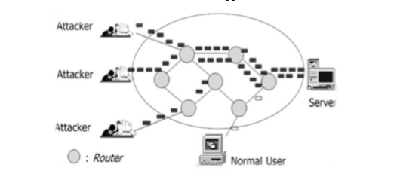

Fig-1: Structure of typical DDoS attack

2.0 RELATED WORKS
Numerous defense and prevention mechanisms have already been established to combat DDoS attacks. The goal of the prevention system is to eliminate the maximum possibility of attack or to make the victim aware of the possibility of an attack in order to resist an attack without obstructing real traffic. As indicated for the integral modules classified in modules as detection, characterization, tracing, mitigation is necessary. In general, when a DDoS attack is detected and to get information about the target server or network congestion, all you can do is disconnect the victim or manually resolve the problem.
The goal of the DDoS detection methodology is to monitor traffic on the originating node and in the network and for the same purpose requires a refined behavior analysis. Low-rate denial of service (LDoS) detection mechanisms are lacking. The proposed multiple sampling average based on lost sampling takes network traffic as a signal based on a small signal model for 10 ms in 30 seconds. The results generated against the threshold to identify the LDoS attack. Another approach to maintaining the QoS of the actual traffic flow has proposed a defense based on tracking against the DDoS flood attack which detects the attack at the end of the source. TF, DFM, IP tracking algorithm in the victim's final modules are established in a competent network.
Discarding attack packets at the end of the origin. To overcome the lack of early diagnosis and high precision, a mechanism based on the victim's extremity with a low percentage of false positives is built in a short interval. Better results than KullbackLeibler divergence when the order of information divergence measures has increased in the detection of low and high speed DDoS attacks.
The signature-based approach, the anomaly-based approach and the entropy-based approach are three methodologies for detecting DDoS attacks. These methods are used in a network based on their various conditions, such as normal traffic or in a situation with high network traffic or low incoming traffic. In the signature-based approach, the threshold is limited, so when a DDoS attack occurs, millions of packets will be counted. To overcome this, install a threshold for the number of detected signatures that will be adopted. Whenever the entropy value of the router increases unexpectedly, it is difficult to distinguish between flash events and the multitude of DDoS attacks. To this end, the concept of mean entropy is calculated at the edge of the ISP domain. Sends an alert to the downstream router to estimate the entropy value. This approach by combining entropy, mean entropy and standard deviation of the flow system can identify suspected DDoS flow. In real Internet traffic, packets can be in long synchronous flow or low level non-synchronous flow. Normal traffic flows are assumed to be short-lived and not synchronized. The suggested algorithm records the address pair of the source and destination address in time intervals and performs several intersection operations in consecutive time intervals and records it for sufficient times. If it exceeds the threshold, it is labelled as an alarm and is also detected using HCF (hop count filter) to map the number of jumps from a source to the destination.
Another approach is the rapid entropy-based method of maintaining the accuracy of detecting DDoS attacks by flow-based analysis. Attack packets are generally generated by tools installed in a bot to flood the link or a network. This shows that the flow link between DDoS flood attacks is much greater than that between random flash crowds. To identify suspicious flows, target superpoints are used to measure flood behavior and observation of flow similarity using a sliding window mechanism that allows for differentiation of random flash events and very efficient flood traffic. To defend against DDoS attacks At the application level, the technique here proposed a traffic authentication method for the origin of the traffic. The mitigation approach uses a random tree automatic learning algorithm in the training, cross validation and testing phase. The bait and bait servers are used to regulate the legality of habitual and unpleasant traffic. To determine the malicious IP address that the Command & Control (C&C) server should be, blacklist malicious IPs based on several intelligence sources simultaneously. Flow counting is a distinctive way in which the severity of the flood attack cabin is known. It is calculated at each entry point in a network at fixed time intervals. DDoS attack is characterized when the difference between rapid flow entropy counts at all times and the average value of entropy in that time interval is greater than threshold value Shows the effectiveness in terms of calculation time compared to conventional entropy.
For DDoS flood attacks, bandwidth or resource consumption are the primary methods of making the service unavailable. The greater the number of synchronous flow over a time interval, the greater the synchronized traffic. Such traffic behaviour can treat a host or network with DDoS attacks from direct attacks or reflective attacks by bots. There are several metrics based on information theory in the detection of distributed DoS attacks. The supervised learning model technique takes into account network traffic, http header filtering and the normalization process used by Support Vector Machines (SVM).

DDoS PREVENTION: SCOPE AND CLASSIFICATION
All attacks try to influence the victim. But the DDoS attack differs from where the victim demonstrated his weakness. The figure shows our extensive study and categorization of some familiar DDoS attacks at the network and transport level. Degree of automation: to train the attacking agent of the army, it is necessary to find a way to install errors in machines or zombies. Exploited vulnerabilities: attackers exploit the problems of protocol design problems such as TCP, UDP, ICMP, HTTP, FTP TELNET etc
. These errors can cause floods, amplifications or attacks of malformed packets to overwhelm a victim's service. Attack network: In general, some attackers use proxy servers and other ways to hide their existence by tracing after identifying attack agents. Some of the types of malicious network, such as bots or the IRC network where the centralized mechanism fails. Attack Speed: A dynamic network layer or a transport layer attack is also important for detecting ongoing attacks in the early stages. It can be at a constant or variable rate. With an increasing attack rate, the attack traffic gradually increases at the end of the victim. Victim type: Depending on the host type of the server, such as a single host or a connection or an application server, the attacker uses several methods to launch a DDoS attack. Impact: The severity of the attack on the network or transport layer depends on the amount of incoming traffic infected by the bot controller. It can be destructive to fail completely without leaving any recovery option. Secondly, it can be harmful and recover later. Scan strategy: in the scan strategy, the number of possible sensitive machines will follow while creating a reduced volume of traffic. Among them, the compromised random scan hosts random addresses in the IP address space, using a different seed. Scan Hitlist scans the externally listed IP address. In permutation scanning, pseudorandom permutation of the IP address space with indexing, semi-coordinated and complete scanning with the advantages of random polling. The backward chain propagation attack code is downloaded from the machine that exploited the system. Package content: part of the incoming package may be filtering through dynamically distributed firewalls, while other types of non-filterable packets that change continuously, making machine detection difficult.

4.0 CONCLUSION
It is precisely a necessity to eliminate the burden of illegal packets due to DDoS attacks on a network / Internet. This document comments on several vulnerabilities that explicitly attempt to terminate legitimate user access to services at the TCP / IP application level and at the transport layer. Therefore, it is necessary to reduce the DDoS attack of the synchronous and non-synchronous traffic flow. The proposed work is able to observe some suspicious or fake IP addresses using the information recorded for the flow of synchronous and non-synchronous traffic during the time interval. In addition, it marked address pairs authenticated by a challenge response mechanism, namely CAPTCHA while other packets are discarded. In addition to this document, the proposed work will simulate results with datasets and tools in the future.
REFERENCES
1. “D.K. Bhattacharyya, J. K. Kalita (2016) DDoS Attacks: Evolution, Detection, Prevention, Reaction, and Tolerance.”
2. “Sven Dietrich , David Dittrich , Peter Reiher, (2013) Internet Denial of Service: Attack and Defense Mechanisms.”
3. “David Dittrich, ‎Peter Reiher, ‎Sven Dietrich,(2004) Internet Denial of Service: Attack and Defense Mechanisms.”
4. “Shui Yu, (2013) Distributed Denial of Service Attack and Defense.”
5. “Mark Rhodes-Ousley, (2013)Information Security: The Complete Reference, Second Edition.”
6. “David C. Wyld, ‎Michal Wozniak, ‎Nabendu Chaki (2011) Advances in Network Security.”
7. “Daphne Tuncer, ‎Robert Koch, ‎Rémi Badonnel ,(2017) Seven Deadliest Social Network Attacks.”

IoT: FUTURE AND CHALLENGES
Manisha Talreja
Student, Information Technology Department, Kishinchand Chellaram College, Mumbai
Abstract
Every single object can be transformed to a smart device with the help of IOT. It has four important components: Sensors, Cloud connectivity, data processors and User Interface. IOT has a large impact on our society due to its possibility of connectivity at anytime, anywhere and to anything. If devices get connected to each other through internet, they can easily communicate with each other also. But the story doesn’t end here, a man and a device also needs to communicate with each other which ought to be a biggest challenge. In future we should consider IOT as the core part of internet as well as of our lives. This paper highlights the IOT’s Future and what challenges we will face to accomplish our future goals. How IOT will help in various aspects like :Business, technical , Societal and legal challenges is being discussed in this paper.
1. INTRODUCTION
IOT is simply adding internet to things which originally haven’t been using it. Because of IOT, systems or objects are able to communicate, create and exchange data with each other. IOT is reaching new heights with the numerous factors in this era and also creating a wider scope for future enhancements. IOT will set a great impact in our lives, when the data gathered by it, is analyzed correctly. The security standards are always a threat and challenges to the scope of IOT, which will have a negative impact on IOT. We definitely need to extend IOT in a dynamic way to connect Objects, devices, services and persons in a secure way. IOT generates, collects the data through sensors, actuators, control panels, human interfaces, etc and that data is first analyzed to produce more information or to perform further actions. For objects to exchange information with each other, it is necessary that each object should be connected with internet with their unique IP address. But due to limited number of IP addresses, researchers are finding another naming system for objects to communicate.
2. Problem Definition
Now because of IOT, objects can share information with each other via communicating and what if in Future IOT connects Human brain and allows us Brain to Brain communication. There are no restrictions of what can come tomorrow and How IOT will help us to achieve. Future IOT will soon be able to gather parameters from our body by a smart system like smart toilet and will help us examine fluids.
However there are only 0.6 objects that are currently connected to IOT. There should be more than 40 billion devices as a part of IOT by 2020.
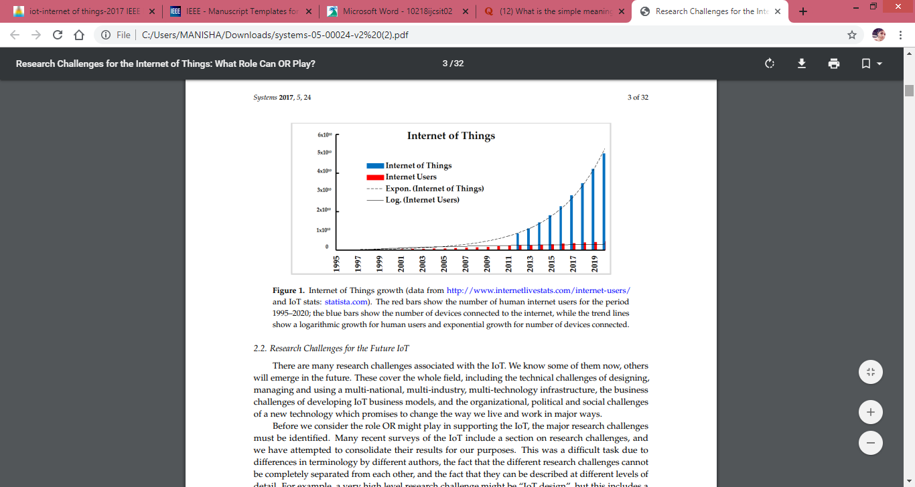
Fig-1: Usage of IoT
The bars in red show the number of human internet users for the period 1995– 2019; the blue bars show the number of devices connected to the internet, while the trend lines show how it has increased by time.
Many challenges are associated with IOT especially in research..Some challenges will also emerge in future while some are already known. The known include Technical, Social, Business and Political changes of a better technology which will positively change the way we vital and work.
3. Proposed Methodology
For any application requirements, communication protocols, identification of objects, security, applications, data, information processing, and the service platforms, standards are required. Yet IoT doesn’t have a standard definition.
The following are few standards available: DDS( Data Distribution Services) which is an IoT standard for real-time, scalable and high-performance machine-to-machine communication. AMQP (Advanced Message Queuing Protocol) is an International standard for message-oriented middleware environments. MQTT (Message Queue Telemetry Transport) is a lightweight protocol that allows sending simple data flows from sensors to applications and middleware.
Standard specifies “HOW TO DO” the activities. It provides guidelines of doing all the work with standards which should be at all the levels, starting from designing, managing and using the IoT.
For IoT to succeed, many international standards development organizations(SDOs) including IEEE, ISO, IETF are analysing the IOT’s Standards. They are main focusing on the technical level such as RFID, Bluetooth, NFC, Address protocols, Network protocols, IPv6, Routing Protocols and HTTP protocols.
4. CHALLENGES TO IoT
When we think about connecting more than 20 billion devices to IoT in the future, there ought to be many challenges coming in the way. Some of the important challenges are discussed in this Session:
- Security Concerns: Attackers always find a way to breach into anyone’s privacy. As all the IoT enabled devices are associated to the internet, it will provide a gateway for malware. Other devices in the network can also be harmed if the IoT devices are weakly secured. It will give entry points to the attackers to harm the devices. It will be easy for attackers to collect the data, analyse and use the data for wrong purposes. So it is very crucial to ensure the safety and sureness of the IoT devices.
- Privacy Issues: The people using IoT devices trust them a lot with the collection of their personal data, without realising the future implications to their data. As the devices are continuously attached to the internet, the private companies and government are taking an opportunity to track and survey people’s private data.
- Standard issues: Ideally all the interconnected IoT devices should be able to exchange the information but actually there is more complexity as it depends on variety of communication protocols. So there is need to apply for same standards in creating market for new technologies. If the same standards are not used by manufacturers, interoperability will be more difficult between the devices.
- Development issues and emerging economy: In the various sections of developing countries, low cost of micro processors and sensors will make IoT devices accessible low income households. But there comes a lot of problems when it comes to High speed internet, basic infrastructure, technology architecture utilization in developing countries. IoT devices would be useless, if basic infrastructure is not in the place. IoT brings new opportunities as well as many layers of complications.
- Business: Any investor definitely needs to invest a huge amount of money in any IoT project, but he certainly wants a full proof plan of action for IoT. There is a lack of inspiration for beginning, putting resources and managing any IoT venture. All kind of consumer markets, ecommerce should be fulfilled by IoT and also with a promise of higher returns.
- Societal: Understanding point of view of customers is not simple. The customer’s requirements tend to change very fast. The market has to be in a rush to meet these changes. The market needs to invent new features and capabilities to satisfy the changing needs. There also needs to be strong and reliable technology to secure the IoT data so that the sensitive data collected by IoT shouldn’t get leaked.
5. Future of IoT
IoT has not grown fully, it is in developing stage. While Developed countries are already availing the benefits , However, we have to overcome the challenges for the better future of IoT. We need to think in a way where IoT becomes reality. Smart Grids, Smart cities, Smart homes, Healthcare, Earthquake detection, Radiation detection/hazardous, gas detection
Smartphone detection, Water flow monitoring, etc are all the IoT examples. But the IoT’s Future should have many more things in it.

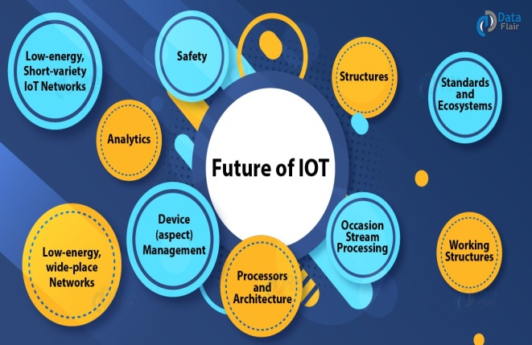
Fig-2: Dimensions of future of IoT
- 21 Billion estimated IoT devices: It is estimated that by 2025 more than 21 billion devices will be connected to the internet. According to the IoT analytics more than 5 billion things were connected to internet in 2016.
- More Cities will become smart: Not only individuals will use IoT but Cities also will become smart by connecting to IoT. They will be totally automated, will collect data, control traffic, remotely manage through sensors, video camera systems and visitors kiosk.
- Artificial intelligence will continue to become a bigger thing: From lightning systems to even coffee makers, every device is collecting data which analyses your daily habits and pattern of usage. That data is used to felicitate the storage in cloud and for further processing. Artificial intelligence helps computers to learn without something having to program them. So the devices can make their own decisions with the help of data collected. The collected data will help machine learn on what your choices are and accordingly adjust.
- Routers will become secure: Mostly all the IoT devices you use are inside your home and connected to the internet. The devices are not made secure by the manufacturers as they will be used inside the home but as Internet is connected to them, the routers are the entry points for the hackers. Today’s routers are not totally secure but in future router will provide more security, such as password protection, firewalls. It will also provide the ability to configure only certain devices in your network.
- 5G network will continue to promote growth of IoT: 5G is already on the launching stage of 2019. It assures to give faster speed and to connect more and more smart devices. Smart devices will gather, analyse and market the data at a higher speed. This will motivate companies to make more IoT devices and satisfy customer requirements for new products.
- Security and Privacy concerns: As more devices will connect to the IoT, there is a more threat of privacy concern. Especially in household because they will not be monitoring all the IoT devices. It will give new targets to attackers to break into the system.
- Personalised marketing platforms: There definitely will be a rise in internet users. Rise will eventually mean more demands and requirements. Everyone would have their unique concept of how they would want to use the IoT technology which will create a big market platform for personalization.
- Safety: The recent IoT has a lot of danger and demanding situations in their programme and working systems. A secure technology is required to defend the IoT models to match with new ultimating situations.
6. Result
Our research believes that to tackle major challenges of IoT, OR (Operations Research) should be applied. OR is a study method of decision making and problem solving which is useful in management organizations. In OR, complex problems are simplified into simple parts and then solved in fixed steps. There are very few case studies which have tried to examine the efficiency of the IoT, because of its complexity and lack of real world data.
The important section of any IoT project is choosing appropriate type of connectivity. The concept of virtual world of Internet Technology connected to the real world get real because of IoT
7. Conclusion
This paper gives a brief review of the IoT, its research challenges, its future use and its wide spread adoption. It also tells about the world wide efforts to develop interoperability standards. The goal of this research is to tackle the coming challenges in the future as well as in the current IoT technology, which mainly addresses technical, business, societal challenges to the IoT. The technologies such as Sensors and RFID would make our lives better and comfortable.
The IoT is improving the way we work and entertain ourselves plus it has become the basis of digital transformation and automation, developing new business offerings. The IoT ecosystem guarantees the accessibility of the services by providing the main objective privacy, confidentiality, ensure the security of the users, infrastructures, data, and devices of the IoT
8. References
- JORDAN SCHUETZ, Developer Advocate, MuleSoft, “The Future of IoT”, Apr 11, 2018.
- Daiwat A. Vyas , Dvijesh Bhatt, Dhaval Jha , “IoT: Trends, Challenges and Future Scope”, Volume 7, Number 1, pp.186-197 Sept 2015 – March 2016.
- Nikhila C, “Operation Research: Definition, Scope and Techniques”,
- Falguni Jindal, Rishabh Jamar , Prathamesh Churi, “FUTURE AND CHALLENGES OF INTERNET OF THINGS”, Vol 10, No 2, April 2018
- Scott Jenson,” The Future IoT: Building Better Legos”, 50(2):68-71 · February 2017
- Regenesys Institute of Management, “Present and Future of the Internet of Things (IoT)”
- Kayla Matthews, “5 big challenges still facing the Internet of Things (IoT)”, Apr 20, 2018
- Peerbits, Contributors' Post, “10 biggest security challenges for IOT”

Trends, Challenges and opportunities in big data analytics
Shruti S. Wani¹ and Mokshita shetty²
Student¹ and Lecturer², Department of Information Technology, Patkar Varde College, Mumbai
Abstract
Now-a-days the data generated and communicated is increasing tremendously. This data emerging in such a huge amount is called as big data. Thus big data is a large, diverse set of information that grows at ever increasing rates. This paper contains the trends, the upcoming opportunities in this field of data analytics. The paper also contains the challenges that arise due to such a huge data being generated. This data can be the data in various forms such as text, audio, video, pictures etc.
Keywords: Big data, Hadoop, spark, Knowledge, cost, challenges, storage, analysis, etc.

I. INTRODUCTION
Big data is the data that emerges from searches; this can be data from social networking sites, bank data, school and organizations’ data etc. Data can be any confidential information or any general information. Now-a-days people search data using google, this data is uploaded by someone and accessed by someone else. The major providers of Big data services are the big companies such as IBM, SAP, Oracle, AWS etc. This big data coming from various sources can help analyse a person’s choice of interest in say shopping, travel areas, social sites’ responses etc.
Now-a-days even researchers use data to make analysis. Shopkeepers use customers’ data to judge the trend in the market. Also this data can be used to find the product that is of most interest to the people. Big Data is most often used in the areas of marketing, sales, IT, Healthcare and finance and many more.Also data analysis is useful in WoT (Web of Things) to analyse the data and use it for further processing.

A. Collecting data [1]
Sensors, smartphones, social media are used for producing and collecting physical world data that can be integrated, communicated and accessed on the web. This data can be represented in numerical, symbolical form.
B. Sending the data [1]
The data gathered is sent across or communicated using various devices such as mobile phones, laptops etc.
C. Combining data
Once the data is coming in; it needs to be integrated so that it can be helpful in forming meaningful data called as the information.
D. Aggregation and abstraction [1]
Creating abstraction form data or pattern of data can provide and aggregated view that can be considered useful. This requires domain specific background knowledge to extract information from web of things. The quality and form of data obtained must be maintained in order to have pure data.
E. Big data market analysis[2]:
Data is useful for market analysis as it provides a view of market trend. Shopkeepers can collect data related to shopping trends in order to increase their sale for a particular product. Also companies conduct surveys where data gathering becomes easier to analyse the market condition. Also these surveys help the companies to bring up their products more efficiently in the market make the highest sale of their product. This is also helpful in bringing up the business. Also now-a-days companies have come up with various models which require only to feed the survey data and the models come out with the best plans to increase the market condition for a product of a specific company.
F. Big data analytics [2]
Big data analytics checks for analysing different pattern within the data to generate conclusions or make decisions based on the data. Big data can help organizations better understand the data and also help identify the data that is important to business and in taking future business decisions.

II. CHALLENGES
Following are some of the challenges that arise in big data analytics:
A. Data Challenges
This is concerned with the characteristics of data. Some of them are as mentioned below:
1)Volume [4]
Deals with size of data say petabytes, exabytes, zettabytes and much more.
2)Variety [4]
Deals with different forms of data say structured and unstructured forms of data such as data in the form of images, videos, audio, text, multimedia, sensor data etc.
3)Veracity [4]
Deals with complex data structures, anonymities, inconsistencies as well as quality of data obtained.
4)Velocity [4]
Deals with the management of inflow of data; meaning that the amount of data coming in at a particular time period.
5)Variability [4]
This is the issue where the stored data when utilized at different instances gives different meaning each time.
6)Visualization [4]
This is the method of representing the data in a format that is easily understood. This can be of the form such as pictorial form, graphical form etc.
7)Value [4]
This is a way of extraction useful data from a large set of data without affecting the rest of the data in any form.
B. Process challenges [2,4]
These are related to how the data is captured, integrated and transformed as well as how the proper analysis model is selected and results are provided. Some of them are as below:
1)Data acquisition and warehousing [4]:
Deals with acquiring data from various sources and storing them in proper places(warehouses) for further use.
2)Data mining and cleansing [4]:
Deals with cleaning and extracting useful data from a huge data generated.
3)Data aggregation and integration [4]:
Deals with integration of data that is extracted from large pools of data which is later on cleaned and combined for actual use.
4)Data analysis and modelling [4]:
This is a stage where analysing the selected data and choosing a perfect model for the representation of data is done.
5)Data interpretation [4]:
Interpretation means representing the data in a form which is understandable. Models for data representation should be selected such that they help in the proper representation of the available data.
C. Management challenges
Concerned with the managing data such as:
1)Privacy [4]
Privacy must be maintained as the data may be confidential. In today’s era of digital world, this is an issue of concern.
2)Security [4]
This is another issue of big data in digital era. Data that is being generated is in massive amount and can be harmed by intruders. Thus securing data is a challenge.
3)Data [4]
Data governance is perceived by organisations to maintain quality of data, improving the information and maintaining its value as an asset of governance.
4)Data and information sharing [4]
Sharing data and information should be balanced as this may help organizations to maintain close connections with their business partners.

5)Cost/operational expenditure [4]
Since the size of data has increased, so has the number of data centres that have spread over a wide geographical range. As a result cost of acquiring, storing, cleaning modelling and interpreting of data is tremendously increasing.
D. Data Storage and Analysis [ 3,5]
- This is a major challenge in big data. As the size of data is increasing, there is a shortage of storage to store data. Previously analysts used Hard Disk Drives as a storage medium but this lowered the input/output process speed as a result of which they came up with SSD(Solid State Drive) and PCM(Phrase Change Memory) to store data. Thus it is necessary to pay attention to the designing a proper storage system that can store large amount of data.
- DAS(Direct-Attached Storage), NAS(Network-Attached Storage), SAN(Storage Area Network) are the storage architectures that are used by the enterprises now-a-days.
E. Discovering knowledge and other issues [3,6]
It contains some sub fields such as authentication, archiving, management, preservation, information retrieval, and representation. Analysing large data set needs more complexities. Also, handling inconsistency and uncertainty in the data set is a major issue.
F. Scalability and Visualization of Data [ 3,6]
- As the size of data is increasing day-by-day, there is change in number of processors being used and also number of cores used by these processors is increasing. This is due to increase in amount of data which needs faster processing speed. Thus processors with multiple cores to speed up the data processing is required.
- Parallel processing is the term used when multiple processors are processing the data simultaneously. Visualization of data helps the analyst to represent the data in a better way .
G. Information Security[3,6]
- Information security is a major issue in today’s world. There are different policies set by different organizations to keep their sensitive information safe. Techniques such as authentication, md5 etc. can be used to maintain the security of data in big data.
- Lack of intrusion system, scalability of network, real time security monitoring etc. are some of the issues in security of big data.
H. Data transmission[5]
This is another problem faced in big data. As the size of data is large, Transmission of such large data becomes difficult. Security issues arise when the transmission of data is done though network. At times transmission of huge data is not possible because of the size limit of transmission.
I. Data curation[5]
This deals with the discovery, retrieval and assurance of quality of data. Currently working with data set with the size of petabytes, teraabytes is possible. Also data warehouses and data marts are used to manage structured data sets. Both these are SQL based database systems. For unstructured data, NoSQL database is used.

III. TRENDS/OPPORTUNITIES [8]
Following are some of the trends of big data analytics:
A. Rapidly Growing IoT Networks
- The trend of IoT is currently increasing. Now-a-days everyone uses smartphones which are used to control home appliances. Google assistance, cortona etc. are used to automate a task. Thus due to increased interest in the field of IoT, more and more of companies have started investing in this technological field.
- As a result many organizations are providing better solutions for IoT. This is leading to the collection of more and more of data, analysing and processing this data.
B. Accessible Artificial Intelligence
- This is another technology associated with big data that is trending currently. This is a technology where robots/machines are made to behave similar to humans. This technology helps in executing the tasks faster. As a result, humans can focus more on critical tasks. This is reducing the workload of humans.
- Organizations also use these AI based machines to speed up their work and make their work much error free and efficient.
C. The Rise of Predictive Analytics
- This is the type of analysis that is mostly used by the organizations to predict the future and take decisions based on the predictions. Also this technology is used by researchers of the organizations to do research in order to increase their market by predicting human behaviour towards certain product.
- This is helping the organizations to predict the trend among their customers.
D. Transferring untransformed data on Cloud
Information that is not transformed into digital form is known as the dark data. This is a huge source of data. These databases are to be digitized and sent to the cloud so that they can be used for prediction in business.
E. Chief Data Officers
Since the amount of data is increasing, Chief data officers are being given more critical jobs in the organizations. It is these officers that are responsible for taking their companies in the right direction. As a result there are many jobs available for data marketers that has helped in the growth of career of many individuals.
F. Quantum Computing
- Since there is much data being generated, it is becoming difficult to analyse and interpret this data currently with these current technologies. If this time of analysis and interpretation is reduced, it will help companies to take better decisions in proper amount of time.
- This is only possible with the use of quantum computing. Companies are currently experimenting on this quantum computing in order to include it in their business in near future.
G. Smarter and Tighter Cybersecurity
Security is a major issue currently. This is due to massive amount of data being generated that is leading to hacking of data. Big data is helping to overcome this problem as it can be integrated into a cybersecurity strategy through security log data where it is used to provide information about past threats [8].
H. Open Source Solutions
There are many such open source softwares that are helping to speed up the data processing. They are also allowing to access the data in real-time. Thus they are currently in demand; also they are cheaper in cost which is a big advantage.
I. Edge Computing
Due to increasing trend in IoT, many companies are using connected devices to gather data about customers. This is helping to reduce the time required to gather, analyse and process the data. This gives a better performance as there is less amount of input and output of data. Also, if amountof data is less, storage cost incurred on companies is reduced, as companies delete unwanted data collected by IoT devices.These methods help reduce the cost .
J. Smarter Chatbots
This is a way where systems interact with the customers in case of queries. No human intervention is required. As a result, the load on the employees in organizations is reduced. Also, chatbots help in processing data by providing relevant answers to the customers. Also, this is an easy method to analyse customer data from the conversations with the customers.

IV. METHODS/TECHNIQUES USED
A. Predictive Analytics [2,4]
Concerned with forecasting and statistical modelling to determine the future possibilities. Discovery, evaluation, Optimization and deployment of predictive models is done by analysing big data sources in order to mitigate risks.
B. Data Acquisition [2]
This is of two types i.e. identifying and collecting the data. Acquisition as the name suggests is acquiring or collecting of data. Identification can be done by two methods:
1.Born digital: This is the type of data that is gathered with the help of digital medium such as computers. This data is traceable. Also this data has ever increasing range
2.Born analogue: This is the data is in pictures, videos and other forms of analogue data. This data has to be converted to digital data using sensors, cameras, digital assistants etc.
C. Prescriptive Analytics [ 2,4]
These analytics is about optimization and randomization testing to see how different business organizations enhance their business keeping their expenses low. This is all about determining the cause-effect relationship between analytic results and business process. These analytics help in determining business analysts in their decision making process.
D. Descriptive Analytics [2,4]
As the name suggests, this analytics method makes use of figures and diagrams to describe the data. The analysts need to have the skill of reading facts from available figures or describe the figure in detail.
E. In-Memory Data Fabric [2]
This is a way where the processing of data is done by distributing the data DRAM, Flash, SSD memories of distributed computers. This leads to faster processing of data and information as well as the load on the servers is reduced as data gets distributed over computers.
F. Text Analytics [2]
A method where data is extracted from textual information. This can be the data coming from news feed, emails, blogs, social sites, messages etc. Large data coming in this way is processed to generate meaningful data and to make decisions out of these data. Natural Language Processing(NLP) is also used to analyse text data
G. Audio Analytics [2]
This technique extracts data from unstructured audio data. Now-a-days this technique is used in health care industry. It is used to judge the health condition of a baby from its cries’. It is also known as speech analytics.
H. Non-Relational Databases[2]
Now-a-days non-relational databases are used to store massive amount of data being generated. One of them is JSON (JavaScript Object Notion). Also, companies have started using these non-relational databases instead of normal databases as they store a huge data in today’s world.
I. Data Virtualization [2]
No technical restrictions may arise while accessing data that is virtualized. Physical data is virtualized i.e. stored on cloud storage and other storage methods. This is done now-a-days to safeguard the data and also to reduce the storage space.
J. Data Integration [2]
This is all about collecting data from various sources and combining them to form a meaningful information. This can be any audio, video, text data. This combined data is then used for further processing.
K. Optimization [5]
Used to solve problems in fields such as physics, engineering etc. Real-time optimization is at times required in big data. Data reduction and parallelization are some of the other methods used for optimization.
L. Statistics [ 5]
This is a way of collecting, organizing and interpreting data. Statistics is basically the numerical representation of data. This can be done through the use of graphs, pie diagrams etc.; where numerical values are used to represent data.
M. Data mining [5]
It is a technique where valuable information is extracted from the available data. Use of different techniques such as clustering, classification, regression etc. is done to mine the available data. Big data mining is more challenging as compared to traditional data mining. Some types of clustering algorithms are CLARA(Clustering LARge Applications),BIRCH(Balanced Iterative Reducing using Cluster Hierarchies) [5].
N. Machine learning[ 5]
A technique where computers learn based on the empirical data provided to them. Computers on their own, make decisions as per the data provided to them. This is a branch of artificial intelligence. Deep Learning/ Deep machine learning is a part of machine learning which is a topic of recent interest. These computer systems that learn using supervised/ unsupervised learning methods, are also used to make neural networks which works similar to a human brain.

O. Visualization approach [ 5]
Visualization is a technique where the data is represented in the form of tables, charts, diagrams, graphs etc. This helps the analysts to understand what the data actually says. Feature extraction is a technique that is used by researchers to reduce the size of data before actual rendering of data.
V. TOOLS
Following are some of the tools that are used for data analysis:
Table-I: Big Data tools based on batch processing.[5]
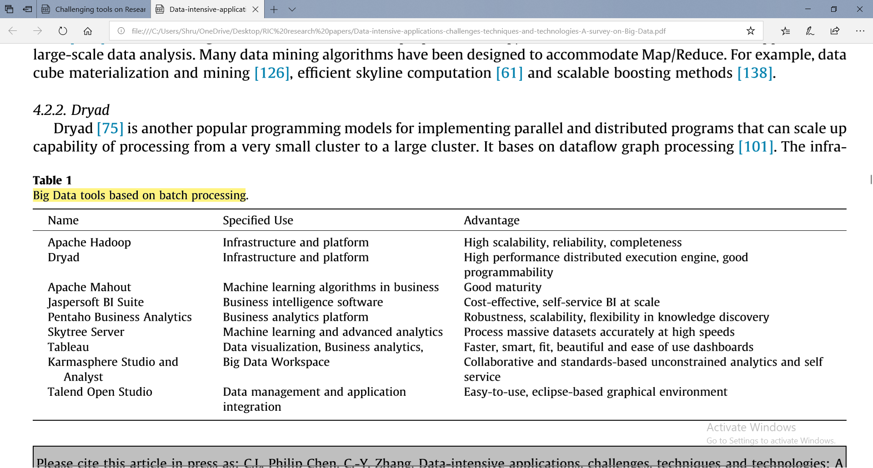
A. Apache Hadoop and map reduce [ 2,3,5,6]:
It is a framework written in java that stores and process Big Data. It uses an algorithm known as map reduce. Map reduce divides the work in smaller parts and processes it in parallel fashion. Hadoop has four core component namely Hadoop common, HDFS(Hadoop Distributed File System), Hadoop Yarn, Hadoop Map Reduce.
B. Dryad [3,5,6]
Users need not know anything about programming which is a big advantage of this tool. This tool runs directed graph. Thus this tool supports generating job graphs, making machines available for processes, failure handling, collection performance metrics etc.
C. Apache mahout [ 3,5,6]
Aim is to provide scalable and commercial machine learning techniques for large scale data. Core algorithms include the techniques such as clustering, Classification, pattern recognition, regression, collaborative filtering etc.
D. Jasper soft BI suite [ 5,6]
Open source software used to produce reports from database. This is used in many companies for their business. It is a fast operating software that does no need to perform ETL process which makes it faster to process. It can work with this fast speed on storage platforms such as Cassandra, CouchDB, MongoDB etc.
E. Panteho business analytics [5]
A software used for business purpose that generates reports from structured and unstructured databases. Helps in decision making in a positive way. It has a good security, scalability and accessibility and is associated with storage platforms such as NoSQL, MongoDB, Cassandra etc.
F. Skytree server [ 5]
First Machine learning and analytical system to accurately process data at a high speed. This server has five use cases such as recommendation system, anomaly/outlier identification, predictive analytics, clustering and market segmentation and similarity search.
G. Tableau [ 2,5]
This software is used to visualize data from the database and represent it in an effective way. This tool is used for business purpose by organizations having huge set of data. It also embeds Hadoop infrastructure. Hive is used to structure queries.
H. Apache drill [ 3,5,6]
It is flexible enough for various query language. Specially designed for exploiting nested data. It uses HDFS(Hadoop Distributed File System)for storing data and Map Reduce for processing this data. Can process petabytes of data and records in a second.
I. Storm [ 2,5,6]
Distributed and fault tolerant system to process limitless streaming data. It is an open source software. Specially designed for real-time streaming of data whereas Hadoop is used for batch processing. Users can run different topologies for different storm tasks. There are two daemons namely Nimbus and supervisor. Another one is zookeeper that records all states of the previous two daemons on the local disk.
J. Apache spark [ 2,6]
It is an open source framework developed at the AMP lab of California, Berkeley. Spark provides interface to program distributed clusters for data parallelism and fault-tolerance. It uses RDD(Resilient Distributed Database).
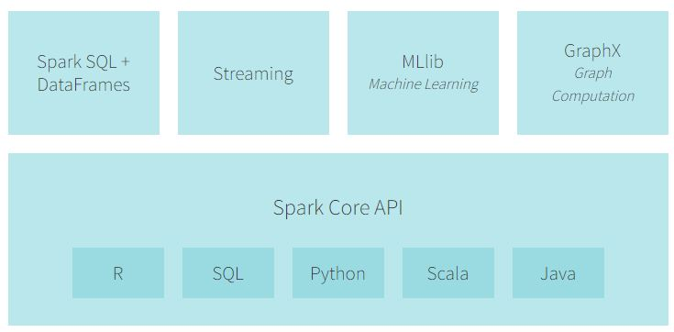
Fig-1: Components of Apache Spark[9]
K. Splunk [5,6]
Combines cloud technologies to help users to search, monitor and analyse their machine-generated data. Splunk differs from other tools as it includes indexing structured, unstructured data, real-time searching, reporting analytical results.
L. Apache Cassandra [2]
Open source, distributed, decentralized storage system that tolerates high volume of structured data across commodity servers. It was first developed by Facebook. It is a NoSQL database. Applications of Cassandra are- Messaging, IoT applications, Product catalogue and retail apps etc.
M. Apache kafka [5]
- It is used for streaming real-time data.It streams data from one system to other using pipelines. The streaming application uses the data that is streamed online.
- It has four core APIs i.e. Producers(publish streams of records), Consumers(subscribes the topics of interest), Streams, Connectors.
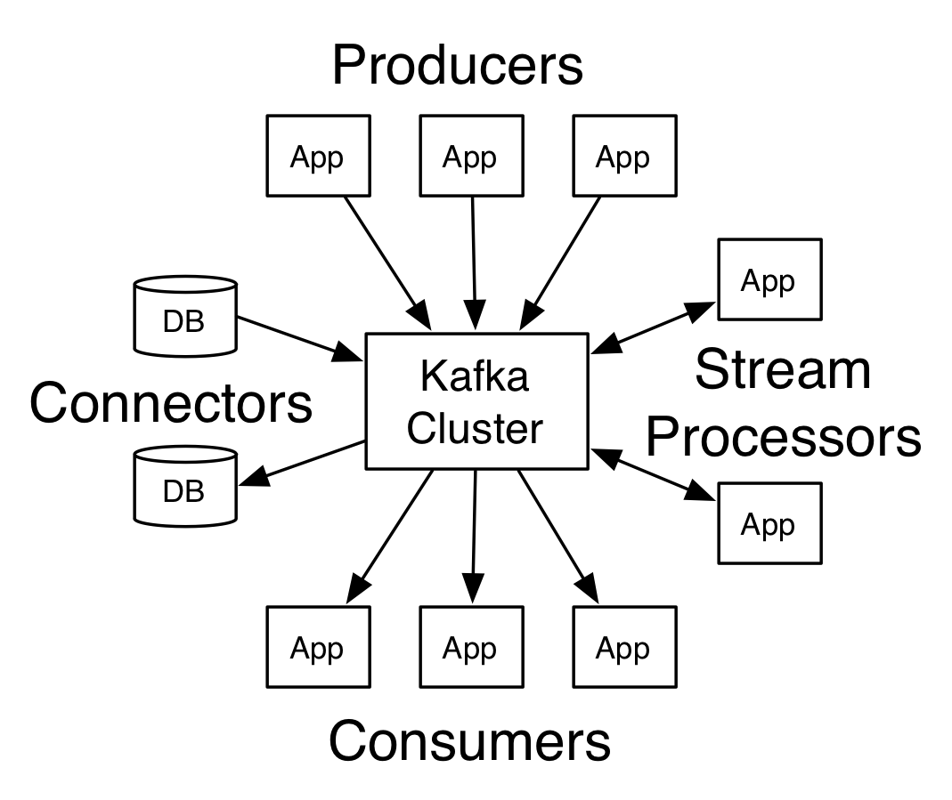
Fig-2: Components of Apache Kafka[10]

VI. CONCLUSION
As the size of data is increasing constantly, so are the complexities with the data. As the technologies will increase in near future, the data that will be generate by its users will increase. This will lead to an increase in the challenges faced with the various processes carried out on the data available. Also security issues are a major concern with the challenges of data. Thus systems need to be made scalable to overcome the issues and challenges that are being faced as well as the ones that may arise in near future.
VII. REFERENCES
- Payam Barnaghi, Amit Sheth and Cory Henson, “From Data to Actionable Knowledge: Big Data Challenges in the Web of Things”, pp 7-9, November/December 2013
- Dr. Venkatesh Naganathan, “Comparative Analysis of Big Data, Big Data Analytics: Challenges and Trends”, International Research Journal of Engineering and Technology (IRJET),Vol. 5, pp 1948-1951, 1953-1955, 1958, May 2018
- Althaf Rahaman.Sk, Sai Rajesh.K, Girija Rani K, “Challenging tools on Research Issues in Big Data Analytics”, vol.6, International Journal of Engineering Development and Research, pp 638-639, 642-643, 2016
- Uthayansankar Sivarajah, Muhammad Mustafa Kamal, Zahir Irani, Vishanth Weerakkody, “Critical Analysis of Big Data Challenges and Anakytical Methods”, pp 269,273-275, 2017
- C.L.Philip Chen, Chun-Yang Zhang, “Data Intensive Applications, Challenges, Techniques, Technologies:A Survey On Big Data”, pp 6-14 January 2014
- Kauser Ahmed P, D.P. Acharjya, “A Survey on Big Data Analytics: Challenges, Open Research Issues and Tools”, Vol.7, No.2, 2016, International Journal of Advanced Computer Science and Applications, pp 511-513
- Xiaolong Jin, Benjamin W. Wah , Xueqi Cheng, Yuanzhuo Wang, “Signiﬁcance and Challenges of Big Data Research”, February 2015, pp 4-5
- Big Data Trends Available at: https://www.kdnuggets.com/2018/09/10-big-data-trends.html
- Components of apache spark-diagram Available at: https://www.kdnuggets.com/2016/03/top-spark-ecosystem-projects.html
- Components of apache kafka-diagram Available at: https://kafka.apache.org/documentation/# gettingStarted

Data Visualization techniques concept and issues
Pratima Keni¹ and Namarata Kawale²
Student¹ and Lecturer², S.S &L.S, Patkar Varde College, Goregaon (West), Mumbai
Abstract
In today’s world Data is a main asset in life. The information is acquired from different sources. There are million or trillions of data where it is difficult to animalising on that. In recent few years there is new technology which comes into the market; this technology is nothing but data visualization technique. This technology is used in different areas like marketing, medical, networking. Due to invention of computer human is get closer to the modern digital era through the Data visualization technique. Data visualization is very important concept user analysed the data according to that it helps to user for taking decision on specific problem. There are many tools freely available in market so that Data is easily analysed. There are so many factors consider while annualized the data size of the data, complexity, scope of the data. Section I tell about what is data visualization, where it is to be used, basic steps for data visualization technique. This all points are covered in that. In Section II Data visualization Basic steps with its explanation. In Section III which techniques are used while performing data visualizing and which one is better for understanding. The purpose of this Research paper what are methods which are used for data visualization. While using DVT (Data Visualization Technique) what are issues may be occurred this is written in Section IV. Section IV is dealing with issues while using any data visualization technique in different areas. Especially issues occurred while working with big data.
Keywords: Data Visualization, techniques, Acquisition, Filtering, Mapping, Rendering, multidimensional, heterogeneous data
I. INTRODUCTION
The information is essential part of human life. Data stored it any format like email, chat, word document, excel format. Because of the different format of the data there is a big challenge how to represent that data.
Visualization in that there is lots of data which is comes from different sources and that data represent in bar graph, tree diagram and more than other format. In that data is textual or numerical format which is converted into meaningful image format, because human brain is very effective catch up large amount of data easily.
II. DATA VISUALIZATION BASIC STEPS
For visualization of the data which is converted into specific model so there are some important steps are listed below [1]:
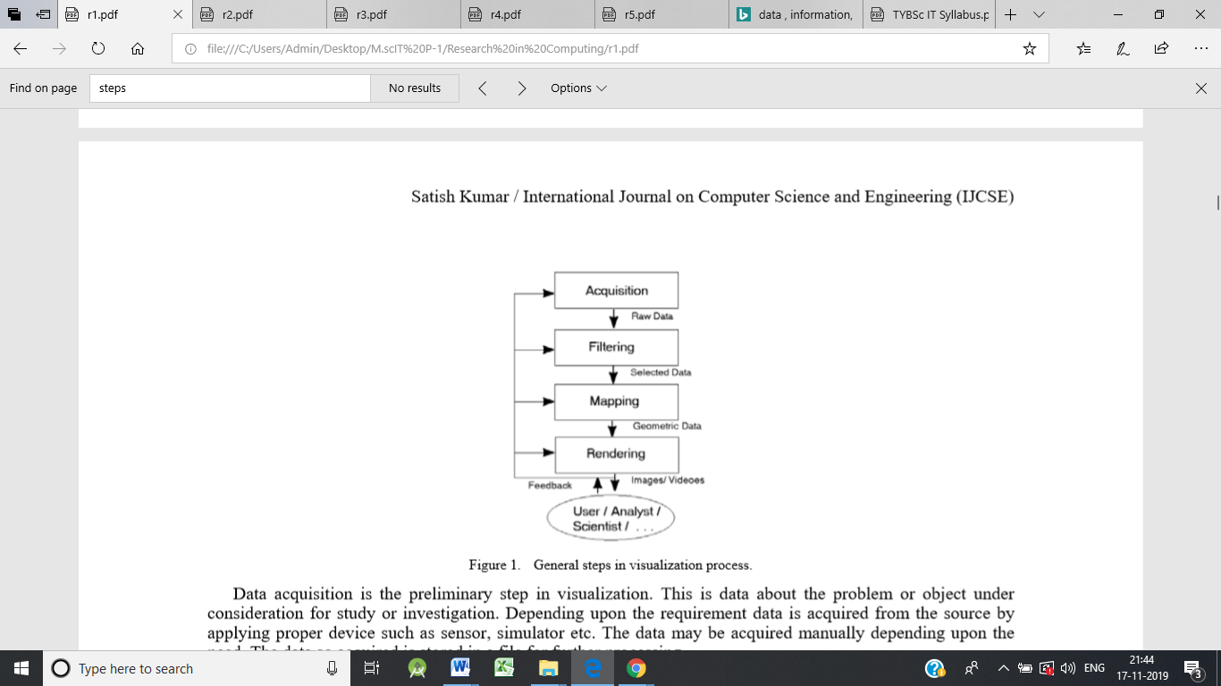
Fig-1: Data Visualization Basic Steps
The explanation of the Figure 1 is given below
- Acquisition
In that we are declare aim or objective of that data. Depending on the requirement data acquired. According to the requirement we are gathering that data from different sources. Gather that data through sensor or simulation. After gathering that data stored that data somewhere place so we can used that data for further process. This is nothing but raw data.
- Filtering
After gathering that data then filters that data. The important data which is useful select first that data and stored it somewhere so we can use it for further process. The commonly used filter technique is clustering.
- Mapping
Mapping process in that data is converted into lines, triangle or polygon, and have an attribute of colour, texture and size.
- Rendering
Rendering in that data is stored in videos or image format. Rendering is complex step. According to the images and videos user gives feedback on that.
III. DATA VISUALIZATION TECHNIQUES
Techniques are used for representation of the data in any format. There are some Techniques are listed below:
- Line graph
In line graph points are determined by variable. If points are changed then variable is also change. It is used for representation of the temperature at specific time period. [6]
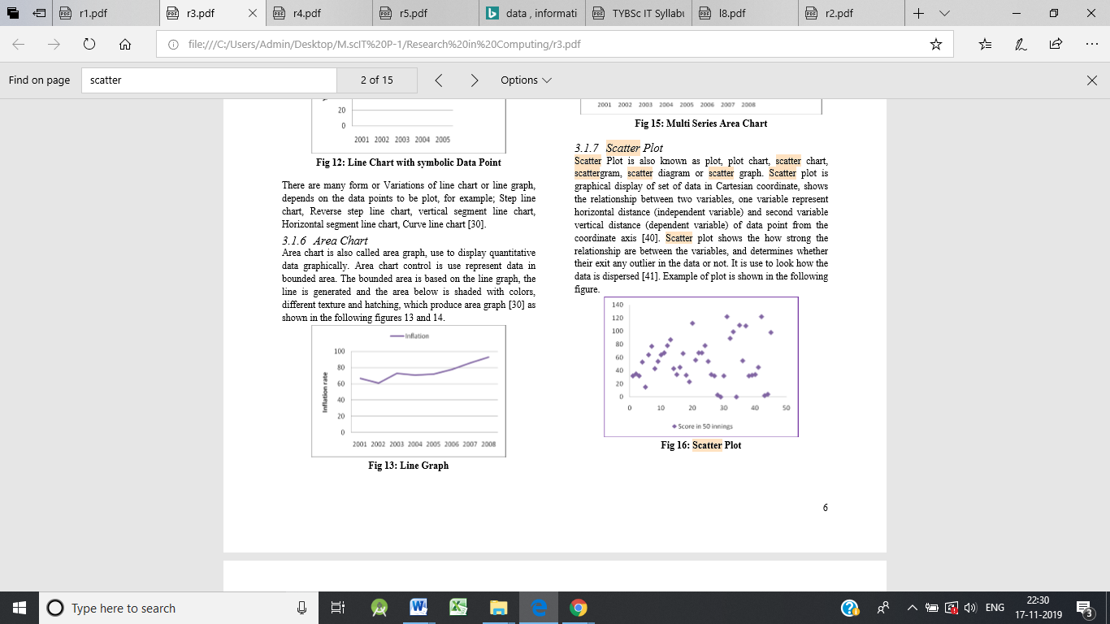
Fig-2: Line Graph
- Scatter plot
It is also called as scatter graph. The points represent relationship between two variables. One variable represent horizontal distance and Second variable represent vertical distance. Scatter plot represent how strong the relationship between scatter plots. [3]
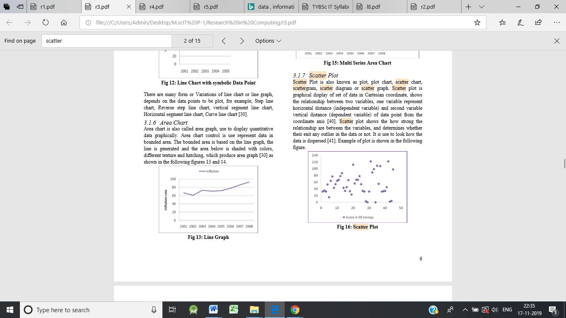
Fig-3: Scatter plot
- Tree Map
Tree map is also known as tree mapping. The data which is represent in the hierarchical format. In that nodes and sub nodes compare with each other and recognize the pattern. Each data or object is represented by the rectangle. Attribute depends on intensity of the colour. [3]
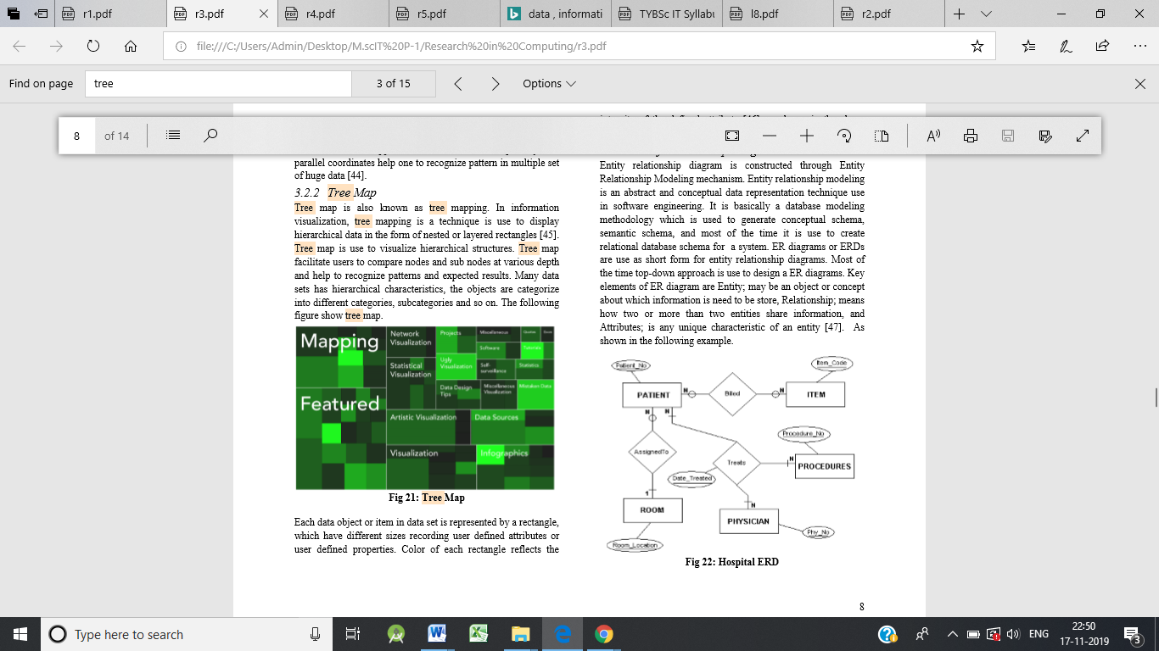
Fig-4: Tree Map
- Parallel Co-ordinates
It is used for plot individual different co-ordinate across many dimensions. Each element are plotted into the vertical line format and then connected with each other. It is used for multiple sets of huge data.
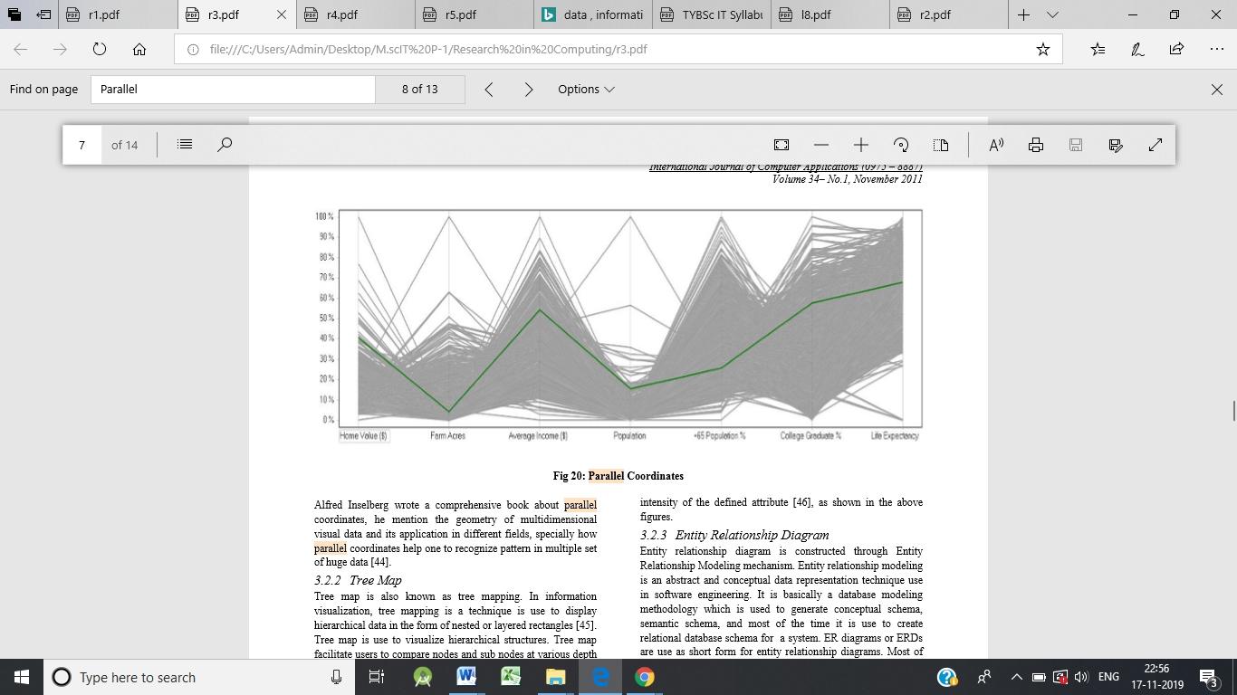
Fig-5: Parallel Co-ordinates
- Scatter Plot Matrices
Scatter plot matrices represented by small dot. So that it is fitted into the single page. It is used for multiple regression analysis.

Fig-6: Scatter Plot Matrices
- Spatial visualization
Spatial visualization actually dealing with local base data such as map, 3D maps, graphs, timelines. It is also dealing with relationship between different events.
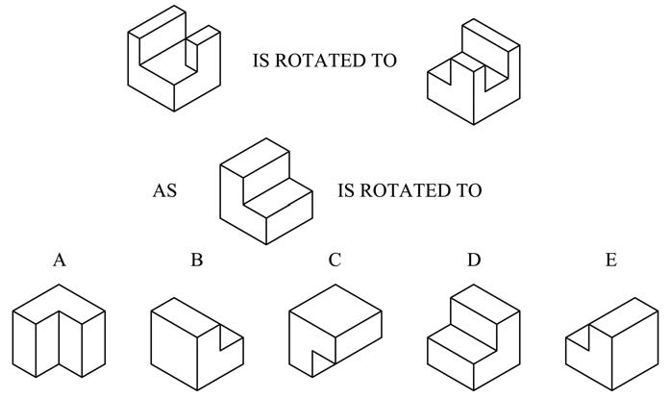
Fig-7: Spatial Visualization
- 2D isosurfaces
In 2D surface, there is certain boundary in that and we have to consider each point as a value. Interpolation is required in that for where the boundary is crossed. We are using contour lines for representing 2D isosurface.
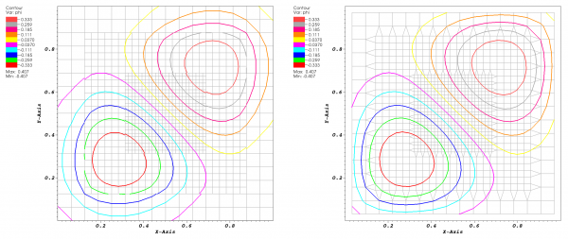
Fig-8: 2D isosurfaces
- 3D isosurfaces
3D surface is a same as 2D isosurface manner. In 2D isosurface it is shown by contour manner but in 3D isosurface it is shown in triangular manner.
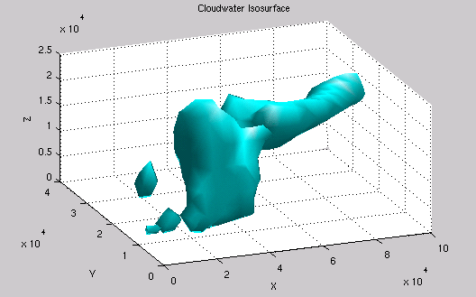
Fig-9: 3D isosurfaces
- Rubber sheet
In Rubber sheet there is 3D surface mapping the values into 2D surface. Points are connected in triangular format.
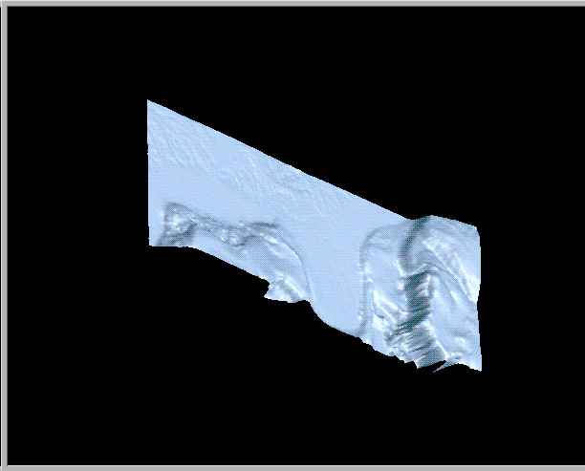
Fig-10: Rubber Sheet
- Volume visualization
A 3D scalar data grid by casting through projection plan into scalar field. There are three volume visualization methods isosurfacing, maximum-intensity projection and direct volume rendering.
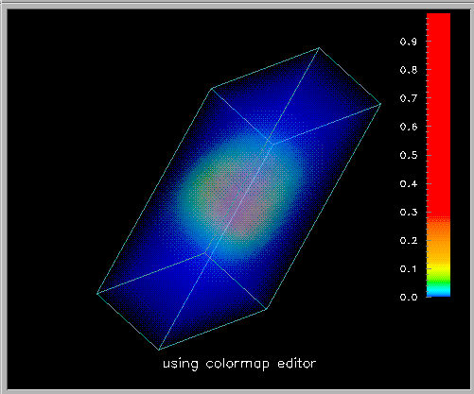
Fig-11: Volume Visualization
- Scalar glyphs
Glyphs data visualization in that collection of different objects which is converted into glyphs. Glyphs have attribute size, shape and colour. Glyphs have single value.

Fig-12: Scalar glyphs
IV. DATA VISUALIZATION TECHNIQUES ISSUES
In today’s world visualization is most important technology. In that analyser collecting the data from different sources and give the proper output so that it helps to us make any decision. In market there are many business tools are available so that which gives us report of that data. But, there is some problem may occur while when we are dealing with big data we can take it as a challenge and opportunity also.
Some times when we are working with real world data that time problem may arise. Because there is enormous volume data. Time constraint, speed, size and diversity of the data that attributes need to be considered when study with big data.
One of the most issues occurs while doing visualization is knowledge gap. Most of the researchers are unaware about how to use tools of data visualization. They have lack of knowledge about current technology.
There are some areas where data visualization technique can be issue or challenge:
Area | Uses | Issues or challenges
Visualization in Digital Forensics | In that data which is collected from many sources. They are preserving that data. Analyse it. They are stored that data for investigation purpose. | Investigation on email so that they need one or more computers. Volume of the data is large so that there can be limitation problem occur.
Visualization in Network Security | In that analysing the data from active computers assist with network traffic audit, monitoring and instruction detection | multidimensional data  Lots of data, lots of sources  scalability and time usage visualization
Visualization in Data Mining | Exploring and analysing large amount of data for creating a pattern | multidimensional, heterogeneous data  Scalability, quality of the data  Dynamically data changing
Visualizing Knowledge | After gathering the data analyse that data. Expectation, perception and giving opinion on that data. | making mechanism for creating structure, retrieve and visualize the data  Quality of the data.
Visualization in Risk Management | To identified, analyse and giving priority according to that risk. | We can decrease the level of the risk using Qualitative assessment techniques: quantitative data need to be completed.
Uncertainty Visualization | Working with uncertain data simulations. Mathematical process on that data and visualize it. | Multidimensional, multilevel, multisource data.  Uncertainty in visualization and calculation of the data.
Qualitative Data Visualization | Developed a Qualitative data which is useful. | Qualitative Data visualization gives little bit information so we need to more space for storing that data. Need creative, discipline and structure.
V. CONCLUSION
This research paper work on data visualization techniques concept and issues. Basically data visualization means collecting a data from different sources, analyse that data, structure that data in specific manner according to that take a proper decision. In that first we are dealing with basic steps of that like acquisition, filtering, mapping and Rendering.
Different techniques of data visualization are listed in that paper according to requirement and pattern of that data we can use this techniques. While dealing with big data there can be issues occurred that issues are mentioned in this paper.
VI. REFERNECES
- Jiaying liu , tao tang ,wei wang , bo xu , xiangjie kong , (SENIOR MEMBER, IEEE), AND feng xia , (SENIOR MEMBER, IEEE) “A Survey of Scholarly Data Visualization”
- Zhao Kaidi School of Computing, National University of Singapore” Data visualization”
- Winnie Wing-Yi Chan Department of Computer Science and Engineering Hong Kong University of Science and Technology Clear Water Bay, Kowloon, Hong Kong “A Survey on Multivariate Data Visualization”
- Ismail Demir, Johannes Kehrer and Rudiger Westermann Computer Graphics and Visualization Group, Technische Universitat M ¨ unchen, Germany ” Screen-space Silhouettes for Visualizing Ensembles of 3D Isosurfaces”
- A. S. Syed Fiaz Assistant Professor, Department of Computer Science and Engineering, Dhirajlal Gandhi College of Technology, Salem, Tamil Nadu, India. VIT University, Vellore, Tamil Nadu, India. D. Sumathi Assistant Professor, SITE, VIT University, Vellore, Tamil Nadu, India A.S. Syed Navaz Assistant Professor, Department of Computer Science, Muthayammal College of Arts & Science, Namakkal, Tamil Nadu, India. “Data Visualization: Enhancing Big Data More Adaptable and Valuable”
- Matthew N. O. Sadiku , Adebowale E. Shadare , Sarhan M. Musa and Cajetan M. Akujuobi “data visualization”
- Thomas NOCKE, Till STERZEL, Michael BÖTTINGER and Markus WROBEL “Visualization of Climate and Climate Change Data: An Overview”
- Malu A. C. Gatto “Making Research Useful: Current Challenges and Good Practices in Data Visualisation”
- Viktorija STASYTYTĖ Vilnius Gediminas Technical University “RISK IDENTIFICATION AND VISUALIZATION TECHNIQUES FOR REASONABLE ENTERPRISE RISK MANAGEMENT”
- Kigongo UC Berkeley – School of Information akigongo Vanessa McAfee UC Berkeley – School of Information Vanessa” Visualizing and Exploring Qualitative Research: Interview Transcripts”
- Aileen R. Buckley Department of Geography University of Oregon Mark ,Gahegan Department of Geography The Pennsylvania State University State College, PA 16802, Keith Clarke Geography Department University of California, Santa Barbara Ellison Hall 3611 Santa Barbara, CA 93106-4060 “GEOGRAPHIC VISUALIZATION”
- Satish Kumar Panjab University SSG Regional Centre Hoshiarpur, Punjab(India) “A Review of Recent Trends and Issues in Visualization”
- David H. S. Chung Submitted to Swansea University in fulfilment of the requirements for the Degree of Doctor of Philosophy” High-dimensional Glyph-based Visualization and Interactive Techniques”
- Steven Parker, Michael Parker, Yarden Livnat, Peter-Pike Sloan, Charles Hansen, Peter Shirley ”Interactive Ray Tracing for Volume Visualization”
- Book Author: Usama M. Fayyad, Andreas Wierse, Georges G. Grinstein Book Name: Information visualization in data mining and knowledge discovery

The Impact of Viruses Attacks on personal computer users and its mechanisms
Ankita Suryakant Sutar¹ and Abhijeet Kale²
Student¹ and Head², Department of Information Technology, B. N. Bandodkar College of Science, University of Mumbai, Thane
ABSTRACT
The main important reason to do this research is to survey the impact of viruses attack and provides some suggestions on how single person can protect their personal computer against virus attacks. It is good to know the address the virus attacks and its protective mechanisms among the personal computer users in this global world. The data integrity and information must be maintained. There are thousand and thousand of different viruses these days which improve every day. From these virus performance of computer goes slowly, entire disk will be crashed, programs are modified and more.
Keywords: Personal computer, mechanisms, Virus attacks.
INTRODUCTION
The main thought of research paper is to find out the factors which leads the virus attacks some of users. A virus of computer is a very small code and this code replicates itself to another code and attacks other software by making copies of itself. Today's world has seen a dramatically increases in the use ofPC. Virus attacks on computer are more dangerous that shows up more damage to the computer. To study the actions that a virus performs in one's system and also the activities that are possible to occur over time, which is very important. This helps in protecting our PC secured with security mechanisms to the protective information. The intension of this research paper is to organize to the reader the threats that the computer viruses can create and provide Requirement on how individuals can protect them against viruses.
Computer Virus Attacks
There are different kinds of viruses but they form definite groups. They all operate differently and affect our computers and the information contained on them in different ways.
Email Virus: If the person opens the e-mail attachment, the word macro is activated then spread only with the opening of the attachment the email.
Eg. I LOVE YOU.
File Virus: This virus also known as FTP virus.
Eg. Sunday and Cascade.
Boot Virus: this virus is known as boot sector virus. Destroy programs and data.
Eg. Disk Killer, Stone virus.
Macro Virus is computer virus occur mostly in Microsoft world and damages a sequence of actions this virus  Written in micro languages for programs.
LITERATURE REVIEW
When a virus code replicate itself to other programs then virus infection occurs. a proper host program and copying its code to the host program such that the infected programme find out another program to infect further(n.d.).etc
The 'computer virus' was firstly named by Fred Cohen in 1983. viruses never occur naturally. They are always occured by people.
Definition of virus is that a computer program code that extends by copying itself. Computer virus attacks have become very critical issue and can fastly spreads using the Internet, causing even more damages, which is not good. Mostly viruses are very active in memory until we turn off our system in general. But when we off the pc we just temporarily remove the virus from memory, but not permanently .
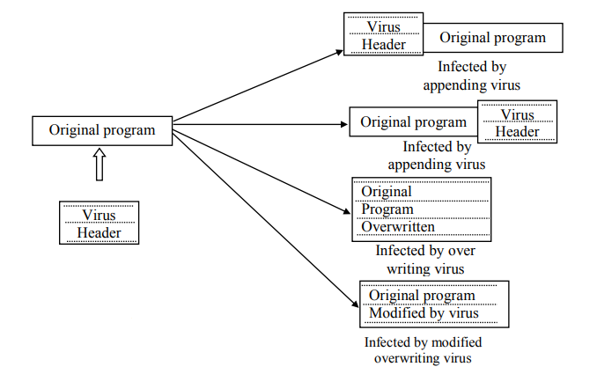
Computer viruses have become an worldwide issue and can travel fastly through the Internet and causing even more dangerous.
Today every single person who uses computers need to have a complete virus protection scheme to face the growing threat of these old and new viruses.
Objectives of this research are
•Analysing the reasons which cause virus attacks among the personal computer users.
•Recommend the possible softwares and mechanisms to protect their computer resources from virus attacks.
Results
The No of the peoples replied that viruses have high affect on personal computer usage. From the collected data 68 peoples revealed that their PC infected by virus attack more than 5 times within in just last three months.
File infection has been recognized as a critical problem by the PC users and it affected the PC harshly.
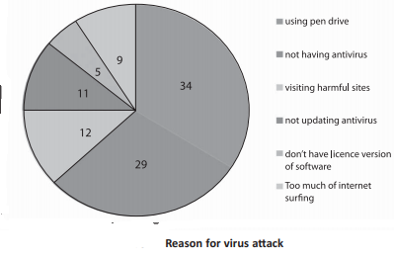.
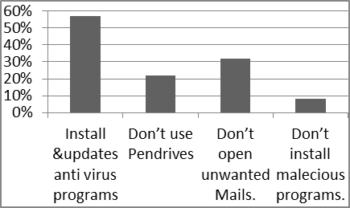
Mechanisms for virus attacks
Following are the some ways for personal computer users to protect their own computer system.
Keep your the system updated and anti-virus software installed on your system and update it regularly.
This mechanism protect our system by checking for viruses each time when computer accesses an executable file. Install any software firewall and keep it enable specially when the computer is connected with the internet.
CONCLUSION AND FUTURE SCOPE
All peoples replied that virus attack has high effect on their personal computer usage. This research release number of lucrative mechanisms which would help to the personal computer users to protect their computers from the virus attacks. The modest recommendation for this research is the virus prevention and detection mechanisms. It is the simple and least expensive ways for the virus attack by practicing such as keep the antivirus program up to date for the latest threats, patching OS loophole, application software loophole and browser loophole frequently, avoid unsafe internet surfing such as visiting doubtful websites, surfing on the cracked websites and downloading from unsafe websites. By following these safety measures the personal computer users can save important resources and their computer system. When any type of virus is found, it should be displyed immediately to take appropriate action.
The PC users revealed the symptoms they felt when their PC infected like the system slows down in performance (48%) places the first place, failure in application functionality and unnecessary messages & error messages (20%) lays second place and system continuously restarted (12%) placed in third place. From this research the peoples revealed the reasons for PC’s virus infections are just because of o using pen drives(43%), not having antivirus(29%). Further this research highlighted installing and updating antivirus (57%), not using pen drive / using USB devices (22), do not open unwanted mails / unsecured sites (13%) and do not install malicious programs (8%) are the best preventive mechanisms to reduce the virus attacks.
Appendix
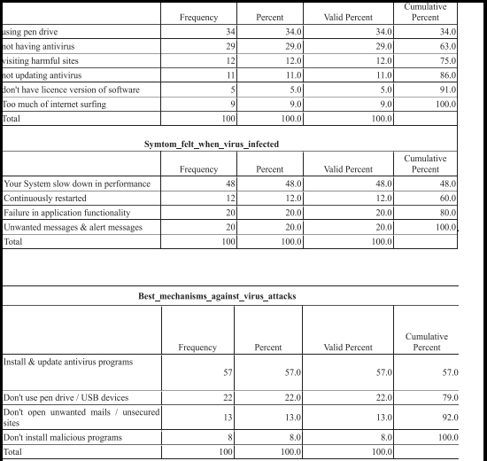
References
- An Overview of Computer Viruses in a Research Environment Matt Bishop Department of Mathematics and Computer Science Dartmouth College Hanover, NH 03755.
- The Working and Problems of Computer Virus in Enterprise Areas Bhaskar V. Patil1 .
- Yusuf, M.S. et al, International Journal of Computer Science and Mobile Computing, Vol.6 Issue.2

The Art of Computer Virus Research and Defense (Symantec Press) Paperback – 3 Feb 2005 by peter szor
- Prabhat K. Singh, Arun Lakhotia. “Analysis and Detection of Computer Viruses and Worms: An Annotated Bibliography“. Center for Advanced Computer Studies University of Louisiana,
- Awosusi, A.I., and Oriye, O. (2015).Functional basis of Anyigba, Nigeria as a fastgrowing university town. Mediterranean Journal of Social Sciences,
- A study of Past, Present Computer Virus & Performance of Selected Security Tools Mr. Bhaskar V. Patil, Bharati Vidyapeeth University
- Analysis and Detection of Computer Viruses and Worms' An Annotated Bibliography Prabhat K. Singh, Arun Lakhotia Center for Advanced Computer Studies University of Louisiana, Lafayette, LA 70504

Virtual Farm Monitoring And Security Techniques
Chinmai Shivaji Dandekar¹ and Dr. Rajendra B. Patil²
Student¹ and Head², Department of Information Technology, S. K. Somaiya College of Arts, Science and Commerce, University of Mumbai, Mumbai
ABSTRACT
Several techniques are being introduced regarding the faming and the agriculture. As a result there is a need for advancement and updating the methods in agriculture. By Implementing such techniques we can reduce the rate of crop loss and increase the rate of profit to the farmers. Which will enhance and improve crop productivity and quality. It is mandatory to determine and compare the environmental conditions as well as the crop production condition in the selected field of farm. Monitoring and Security can be achieved using different sensors and electronic components. Virtual farming will help farmers to stay connected to farm from any were.
Keywords: Agriculture, Security, spider cam, Virtual Monitoring.
INTRODUCTION
Farmers are our main resource of agriculture. In our country traditional way of farming is utilized. We can prevent this by modern farming techniques and by inventing new. Agriculture is important for our countries economy as India is known as the agricultural country worldwide. By using monitoring and security techniques we can automate and change the view of farming. Using this techniques by embedding with sensors, actuators, software’s and internet based electronic components. Better irrigation techniques can enhance the productivity and quality of crop production. We can change the way of farming by deploying automation techniques. When this techniques were first introduced they only contain static pages. The content describes the efficiency of the system used for monitoring and security of the farms. What if we combine different techniques regarding farm monitoring and security. The research paper defines the efficiency in farming. This research states the steps and techniques we can adapt to overcome the problem with maximum number of positive outcome. Introducing new technique for monitoring fields using modern components will be discussed in this research ahead.
LITERATURE SURVEY
This research paper was developed with help of different research papers and some innovative ideas. The research string includes different types of strings like “Comparison between different Monitoring and Security Systems” and “Performance of the systems”. Research papers regarding this topic are very few. While many of them are about the evolution of systems and adapting new techniques. The research papers the literature survey yielded are the following:
1. The system for dry soil detection is used to detect the moisture and water contingency of the soil and maintain the water need for the crops from as per required. The sensors detects and passes the output to the system so as to perform actions accordingly.
2. The system used for security is the fungal detection system using thermal imaging. This system provides us the defected crop image accordingly and gives alert to the system. By which the farmer can perform action accordingly to avoid great loss.
3. The system used for security from Birds by using motion sensors for detecting the motion of the passing by object and avoiding them by switching the sprinklers.
4. Thermal imaging can provide similar reading as thermometer. For temperature in close range, thermal imaging leads to in accurate results and informative data differentiable.
Comparing these system of Virtual farming and security to get a better results is essential for future farming methodologies to overcome farming techniques.
RELATED WORK
The comparison of the systems are done by the percentage of accuracy of solving the problems accordingly and percentage of results. This is shown by the graphical format of readings given by the system and readings given by making changes in the system. The changes are made by combining two different methodologies or adapting new updates to enhance the performance of the system.
The components in the system may vary accordingly for more stable and quick outcome of the data using updated technologies. The graphical representation of performance of components is also compared. This will make easy selection of system to propose accordingly.
HARDWARE COMPONENTS
NodeMCU VS Arduino
1. Expense- Slight cost difference in both Components.
2. Flash - 32KB for Arduino , 4MB for NodeMCU.
3. SRAM - 2KB for Arduino, upto 50KB for NodeMCU.
4. Clock Speed -16MHz(ATMEGA328 can handle up to 20MHz) for Arduino, 24–52MHZ(CPU can handle 80MHz) for NodeMCU.
5. GPIO pins - 14(6 PWM) for Arduino, 17(All PWM) for NodeMCU
6. ADC - 6 for Arduino , 1 for NodeMCU
7. Operating Voltage - 5V for Arduino(board is powered from jack then 7–12V) , 3.3V for NodeMCU
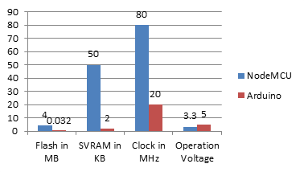
Graph-1.1: NodeMCU VS Arduino
Cameras for thermal imaging
Thermal imaging cameras draw images by detecting the heat in the object. This camera can also be used to detect the fungal on the plant by comparing the thermal images captured at the point previously and after infection of the plant.
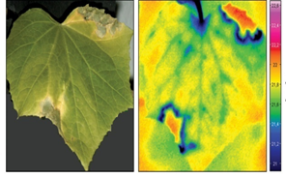
Figure-1.2: Plant Thermal Image
A the image justifies the heat of the plant comes from the infected area as red and the green and blue color defines the healthy tissues of the leafs. By using this technique we can secure the crops by applying right fertilizers at right time.
The model of camera used with this components is OV7670 640×480 VGA CMOS Camera Image Sensor Module. The image of the component is given below.

Figure-2.2: OV7670 640×480 VGA CMOS Camera Image Sensor Module
Structuring the Cameras
By analyzing the problem of whole field we cannot set up cameras for each crop to monitor regarding the crop damage and security. This problem can be resolved by adapting moving cameras using gear system and wheels that will move as per directed in the system. Placing the camera in such way will help the system to monitor the whole field and get accurate data. Viewing the camera from the top location will lead to better image capturing. This technique of using the cameras is also known as spider cams. The below images illustrates the use of spider cams. This technique will be a great asset for monitoring crops virtually and acquiring accurate results of the crop condition. The distance of the camera from crop must be less than 1 meter to get more accurate results. Spider cams can be organized so as to follow a pattern as given in the system so to capture and monitor entire field area.
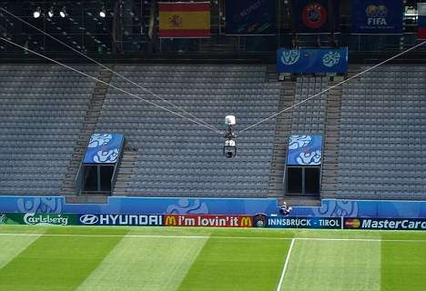
Figure-3.1: Spider cams
Motion Sensors
Motion Sensors can be used for detecting the activities of animals and birds near to the farm area. Placing the motion sensors on the spider cams can provide better results. The sensor module is shown in the figure below.
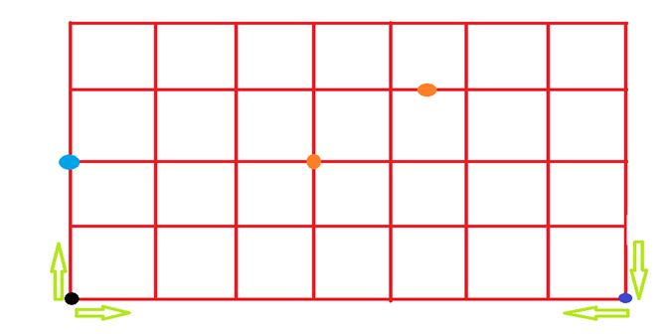
Figure-3.1: Pattern of moment of the camera
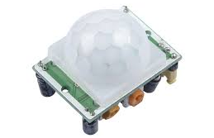
Figure-4.1: Motion Sensors
MOMENT OF CAMERA BY GRAPHICAL PATTERN FOLLOWING TECHNIQUE
Moment of the camera is essential for monitoring the entire field. There should be a fixed pattern to be followed by the rotating machine pre install and also there should be a system for custom graph pattern design. So the service man can analyze the field size and shape to design pattern accordingly. For illustrating the graphical pattern of the system is given below in graph plotting system. This can be customized per meter of half a meter.
PATTERN EXPLANATION
This is can be the default pattern than can be pre implemented in the system.
1. The black dot represents the initial position of the spider cam. From this position the camera will follow Up-Right-Down sequence for the line to be monitored as shown in the graph the distance inputs if each block should be filled in the system.
2. After reaching the Dark Blue dot the Camera will fallow Left-Up-Left-Down sequence so the camera can travel the whole field and get better results.
3. Light blue dot represents the spider camera.
4. The orange dots represents the defected area located by the camera. Which will provide coordinates to the system, by which the farmer can easily rectify the area of problem occurred.
SYSTEM COMPARISON
In this research the comparison phase which are to be discussed. Here we compare the existing system with the updated systems. The brief of comparison is as follows:
COMPARING THE SYSTEMS WITH UPDATED SYSTEM
Now the system used are compared with the updated pattern system which is explained above. As analysis both the techniques are dependent on each other. Hence the updated system has both system techniques gives more security and accurate results as compared to the distinct systems. The comparison is done on the basis of percentage of accuracy, performance and reliability for computing the results. The comparison is essential to show the difference of product usage and one can easily rectify the better technique to be used for Virtual farming and security needs. The table below shows the percentage of Features of Distinct and Updated system.
Features | Virtual monitoring and Security Distinct | Virtual monitoring and Security Updated
Performance | 84 | 98
Accuracy in results | 89 | 95
Reliability | 79 | 89
Table-4.1: Comparing The Systems With Updated System
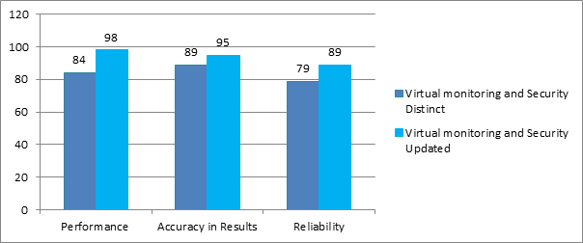
Graph-4.2: Comparing The Systems With Updated System
CONCLUSION
Based on the research work it could be concluded that the updated pattern techniques used is more effective and performs better as compared to the distinct system. As the combination of two techniques will make the system expensive but cost can be handled by using alloys of plastic with metal which makes the products more durable. By using such practice can predict the crop infection and apply remedies to take actions accordingly. Using this techniques farmers can easily monitor farm and produce good quality of goods as the crops have been taken good care. This will reduce human effort and cost of farming to a certain extent.
REFRENCES
1. Design and Implementation of Farm Monitoring and Security System in International Journal of Computer Applications 181(9):10-15 • August 2018
2. IoT Based Intelligent Agriculture Field Monitoring System. January 2018
3. Farm security solution modeling: Information and communication technology (ITC) Perspective. 11 October 2015.
4. Isaac BO : Information and communication technologies as driver of growth experience from selected small scale business in rural southwest.
5. Abhinav, V. D. Design and Implementation of an Intelligent Security System for Farm Protection from Wild Animals. International Journal of Science and Research.
6. Willig, A. and Karl, H. Protocols and the Architectures for Wireless Sensor Networks. John Wiley and Sons Ltd. 2005
7. Maheswari R. Development of Embedded Based System to Monitor Elephant Intrusion in Forest Border Areas Using Internet Of Things. International Journal of Engineering Research.

Impact of Smartphone Usage: A Review
Ahinsa Arun Gaikwad and Manali Satyawan Jadhav
Department of M. Sc. IT, S.S. & L.S. Patkar Varde College, University of Mumbai, Mumbai
Abstract
Mobile is familiar word to everyone. Mobile market now a days is very huge industry and it is growing day by day. Mobile makes our day to day work easy. Availability of variance in feature, look and feel, price have a vast range. Every technology has some pros and cons. It is totally depend upon how we use it. Wireless communication is provided rather than wired communication which support many advantages like portability, compactness, lightweight. Mobile usage is in very field. Like in education, E-Learning is taking place which support and enhance the education system and increase student interest in learning. But now some adverse effect of mobile usage is coming out. This may causes many diseases and some times death too. Therefore using the mobile we have to follow some precautions or have to take care of something.
Keywords: Mobile, Virtualization, Digitization, Human Health, Diseases, Education, Smartphone
I. INTRODUCTION
The wireless innovation was concocted in the year 1880 by Alexander Graham Bell and Summer Tainted when first time the photo phone was created [1]. Initially phone was globally used for communication. Later few features are added which is useful for day to day life such as FM radio, massage service, etc. Almost a decade ago, smartphone jumped in market which change the whole world. Now the smartphone market is growing and become the unstoppable. Everyday there is number of smartphone launching. Provide better feature than other. Product can’t be stable in market because every day it get new competition of new and better once.
Mobile phones became the basic need of human being. Digital world become more easy and less time consuming, to handle this handy gadget is smartphone. More better features and pocket friendly cost are the attraction of the smartphones. Smartphones are available in approximately Rs. 2000 to lacs and more. Digitizing the banking system, educational system is less time consuming and more popular in generation.
Every technology comes with it’s advantages and disadvantages. Smartphones are making are work easy and portable but it also have some adverse effect on living being and environment.
II. GROWTH DUE TO SMARTHONE
Wireless communication make the world connected. Best medium for it is mobile. Mobile means portable communication or can say wireless communication. We can carry mobile everywhere because of its compact design, lightweight, and portability. More last few decade mobile become more smart that it can simplifies many works and help the human in more accurate way. This smart device we now know as ‘Smartphone.’ Smartphone is beneficial in may fields such as education, banking and finance, agriculture, communication, social, marketing, etc.
Traditional education is limited to classrooms, books, library. Attending the lectures in classroom, carrying heavy books , visiting the library for supplementary stuff is the traditional way. But now due to the digitization, virtualization and smartphones world of knowledge is open to everyone. Books are now available online as we can download it for free or very less amount. The vast library of book is available irrespective to language, field, author, type, etc. Carrying the heavy book is not good option. Some times books are not available physically to particular geographic location. But now with online book books are available on internet and we can use it without any geographical constraint. digital book are easy and very much portable to carry with the support of smart devices. Online class room is where lectures are recorded as audio or video and available to student who are not able to travel or present in particular geographical location. Many other stuffs of education such as calculator, compass, dictionary are also provided by smartphones.
Communication was the main goal initially behind launching the mobile. Internet make the world smaller. Low prices for communication and data subscription are attracting the customer. Communication is not limited to audio or massages but now we can video call a person and only one but can call multi[le person called as video conferencing. Similarly we can conference the audio call and multiple participants can add who are at different geographical location. Now we can not only pass the massages but also multimedia like audio, video, documents, etc.
Social media is most attracting platform for every generation but specially for young generation. People can socially connected via internet. Social media and OTT platform are became the new language for entertainment. OTT platforms are growing rapidly such Netflix, Amazon, iTunes, etc. Songs, movies, and other entertainment stuff is available in smartphone so we anytime, anywhere can start our entertainment with our smartphone.
Era of digitization also make banking and finance sector digitized. Now we can use banking facilities online with online banking using smart devices more preferably smartphones. Transferring the money, balance checking is digitized with save the time to go to bank and perform the task as well as reduce the usage of paper with is very good for the environment. We can carry many financial documents very easily in smartphone with the help of the smart wallet.
Marketing is growing with smartphones as we can buy anything from online marketing websites or application. Buying and selling become portable easy and convenient with the help of the smartphone.
In agriculture field, may mobile application is available for farmers for betterment of land and their knowledge. Weather forecasting is easily available. Farmer can sell their product directly in market without any middle parties. Many videos or information is available about product, farming techniques. All these features are available in smartphone which is easy to understand with different local language support and better understanding user interface. Also smartphone are portable and low cost solution.
III. ADVERSE EFFECT OF MOBILE
Every technology has more or less drawbacks. Mobile became the basic need, but this need is becoming our addiction which is not at al good. Addiction of mobile degrading the human physically, psychologically, economically and socially.
Wireless device contain some radiation which has frequency range of 3 KHz to 300 GHz. Wireless device such as smartphones, computers, wireless router (WiFi), etc. This gadgets contain radiation which may causes many diseases. These devices generate harmful radiations which can cause too many harmful diseases such as Brain Tumour, Male Infertility, and effect on the foetus, Alzheimer’s disease, Ear Hearing Impairment, asthma, insomnia, high blood pressure, rheumatoid arthritis leukaemia, birth defects, Immune system, and Heart trouble,.[8] Radiations are also show up of some symptoms which are: headache, sleep disruption, tiredness. In serious cases DNA damage can also happen because of radiation produced by wireless devices like which given off by the mobile phone devices during the receiving and sending process of the data.[8]
Psychological affect is difficult to detected in early stage. This happened due to excess use of smart phones. User become addicted to smartphone to the extend that he/she forget the real world and start living imaginary world. Sometime customer may go to depression mostly because social media. Social media show the world very fascinating. Depression may causes mental illness, and some times suicide. Smartphone also change or manipulate the mind-set, this some time lead to criminal mind-set. Games are also affecting the human psychology. There are many cases of depression and suicide just because of excess gaming.
Smartphone is now the easy and convenient way for banking but with banking a major issue is raise that is ‘security’. Is mobile devices are secure enough? The data that is store in your mobile device is must be protected with legal antitheft or antivirus. Data can be steal from devices. There are many ways such as virus that may break the firewall or corrupt the data, malicious inside that leak or altered the data that is shared or stored. Many cases are registered of fraud. This fraud can be done via stealing your data or by fake calls that asked for your personal information. Banking or other password that store some sensitive information. Many of customer faces the fraud messages or scams. When mobile is steal or lost the major concerned is the data that us present in the mobile. This all factors of smartphone security may lead to major economical fraud.
Human is social animal. But smartphone is breaking that social connectivity in humans. Every public place most of the public is on smartphone. Conversations become less, emotional connectivity is missing. Mobile main aimed was communication but social media and other platform decreases that communication. Call prices and data subscription prices are decreased and become pocket friendly but social connectivity and awareness is also decreasing.
IV. FINDINGS
- Smartphone is better device to carry and access documents easily.
- Smartphone proved many features of communications like video call, conference call from anywhere anytime irrespective to the geographical location.
- Smartphone is an alternative to many devices such as calculator, scientific calculator, compass, weather forecast, laptop, storage device, radio, mp3/mp4 player, etc.
- Costumers are more interested in features rather than price.
- Smartphone and internet allow to work from smartphone.
- As per the requirement, internet speed is increasing. From 3G to now 4G and WiFi is new medium of internet. Usage of smartphone during driving and walking is increased lead to the more number of accident.
- Increasing the frequency of internet causes many diseases.
- Smartphone usage caused many psychological diseases.
- Antivirus and antitheft software make customer assured about security while using the smartphone.
- Antivirus and antitheft gives confidence to use net banking and other third party services.
V. CONCLUSTION
Digitization and compact, portable design of smartphone it is very simple and convenient way to carry many documents and books. Many work can be done using smartphone without being physically present to the location such as billing banking, etc. Communication and transfer of data became very easy.
Smartphone has many advantages but excess gaming, social media decrease the concentration and memorizing power in humans. Students are distracting due to other application of smartphone than the educational and social purpose. Many diseases are accruing due to radiation of smartphone. Many financial frauds are done.
Smartphone is a gat invention of the generation but we have to know the limits of this. Use the smartphone a needed and legal usage.
REFERENCE
[1] Ellis H Marconi, masculinity and the heroic age of the science: wireless telegraphy , British Association conference at Dover in 1899. Hist Technol 32: 120-136.
[2] Rakhi Thakur, Customer usage intention of mobile commerce in India: an empirical study, Journal of Indian Business Research Vol. 5 No. 1, 2013
[3] Ms. S. Kundhavai , Dr. K. Sumathi and , Mrs. N. Selva Lakshmi, Reviewing the Impact of the Smartphone Usage On Academic Performance Among Students, International Journal of Applied and Pure Mathematics Volume 118 No. 8 2018
[4] ThaeMin Lee, The impact of the perceptions of interactivity on transaction intentions and consumer’s trust in mobile commerce , Journal of Electronic Commerce Research, VOL. 6, NO.3, 2005
[5] Jonathan Lee, Janghyuk Lee, Lawrence Feick, The impact on customer satisfaction-loyalty due to switching costs on the link: mobile phone service in France, Journal of services marketing, vol. 15 no. 1 2001
[6] Parul Maurya, Yogita Penuli, Ashutosh Kunwar, Hemlata Lalia4, Versha Negi, Anjana Williams, Vandana Thakur, Impact of the Mobile Phone Usage on Psychosocial Wellbeing of Student, IOSR Journal of Health Science and Nursing, Volume 3, Issue 6 Ver. I
[7] Dr. Alpana Vaidya, Vinayak Pathak , Ajay Vaidya, Mobile Phone Usage among Youth, International Journal of Studies and Applied Research, April 2016, Volume V, Issue 3
[8] Abbasi SK, Suhag AK, Larik RS, Khan M, Mangi GZ, Impact of Excessive Mobile Usage on Human, J Comput Sci Syst Biol 9: 173-177. doi:10.4172/jcsb.1000235
[9] Akshat Dewan, Dr. Varsha Khattri, Implication of mobile usage on its user, Global journal of mobile application and development (volume-4, issue-3, September-December 2019).

A STUDY OF USAGE OF ONLINE PORTALS AND E-WALLETS AFTER DEMONETIZATION
Snehal Mahadik¹ and Dr. Hiren Dand²
Student¹, Department of Information Technology, Vikas College of Arts, Science and Commerce, University of Mumbai, Mumbai
Head², Department of Information Technology, Mulund College of Commerce, University of Mumbai, Mumbai
Abstract
The unexpected move by the government to deal with corruption and black money by ceasing Rs.500 and Rs.1000 notes as legal tender was a very big decision which hit the economy and business at large. Whatever the move was, the intention of the move was a step towards digitization. Digitization is a reflection of technology. Digital payments through mobile Apps and mobile wallets helps in having hassle free transactions. The various apps have now become one-stop shop for payment of bills at one click using Smartphone. Digitization has made man’s life easy. One can perform both financial and non-financial transactions using the wallets. Using apps like BHIM, UPI, Paytm one can do transaction anytime and from anywhere. Products such as *99#, IMPS, UPI and Bharat QR have made banking transactions accessible 24*7, not only for the urbanites but also for the semi-urban and rural areas
The Research aims to find out whether demonetization has lead towards digitization? Did the usage ofA pps increase after demonetization? Are people using digital apps more after demonetisation? What is the impact of demonetization on the online payments and how these online payment portals have responded to this decision? It also seeks to find out whether the decision payment structure. The Study aims to study some online payment portal like Paytm, Freecharge, *99# and BHIM which have opened up as payment portal and have created easy and safe payment methods for customers. The major aspects of study are:
● Impact of demonetization on customers using such Apps.
● Increase in customer using digital payment Apps after demonetization.
● Consumer behavior of using digital payment Apps regarding issues like security, satisfaction etc.
Keywords: Digital Payment, Demonetization, Online transactions.
Introduction
Demonetization is an act of ceasing a currency unit of its status as a legal tender. It is pulling out from the circulation of money and replaces it with some other notes or coin. India has done Demonetization thrice in its history- 1946, 1978 and recently in 2016.
Talking about India’s recent Demonetization, on 8th November, 2016 Prime Minister Narendra Modi announced that notes of Rs.500 and Rs.1000 will not be used as a legal tender. One month period was given to replace the notes with new Rs.500 and Rs.2000 notes. The old notes were accounted for 86% of the total circulating cash in the country. The decision was taken to curb corruption, terrorism funding, black money and to promote cashless economy which will open the doors for digitalization.
Digitalization is computerization. When you dematerialized something from its original physical form into digital form it is known as digitalization. Digital money is therefore a form of money which has no physical appearance. It has the same value as cash has. It is used through some digital technology. The digital money transactions are usually made through telephones, cards,
ATM, Internet etc. Though money is in online form it is legally accepted widely, which also can be cashed. The various online portals are used for making digital transactions. PayTm, Freecharge, Airtel Money, Ideapay, BHIM etc. are some of the well-known apps available for digital transactions. The current research studies ‘the responses of consumers towards the use of online portals’.
Research Problems
For this paper, the following problems were raised-
● Is there a universal acceptance for digital money?
● Which digital payments Apps are commonly used?
● How far are digital payments Apps convenient?
● What is the satisfaction level of consumer using such Apps?
● Are digital payments App secured?
Objectives of the Study
To study an impact of Demonetization on online portals following objectives have been set:
1. To know the most common online portals used by customers.
2. To study the frequency and satisfaction level of usage of different portal.
3. To study the satisfaction level towards the functioning of the Portal.
Literature Review
Demonetization Gains- an article in The Financial Express by Madan Sabnavis (Chief Economist) dated 28th December 2016-According to the author, demonetization could be right move but its efficacy would depend on how we follow up on the basic objectives of having cashless economy. Demonetization was probably the largest move taken by government. While on the one hand it was aimed at attacking black money, on the other hand it has changed the way we transact business. He says that cash based economy in India has definitely got affected. However he is not sure whether black money will revive
“कॅशलेस चेआव्हान”- An article by Niraj Pandit in Loksatta dated 18th December 2016.This article has covered challenges before demonetization. Problems such as Transaction charges, Cyber security, Networking, Internet rates are the biggest challenges. He urges Social media to be positive towards digitization and promote cashless transactions. According to him using UPI is more safe and convenient than that of E-Wallets.
Impact of Demonetization: Cash Takes Digital Leap- an article by Pratik Bhakta in Economic times dated 14th February 2017- Author focused the impact of demonetization as an initiative towards digitization. He says that demonetization has proved to be a biggest leap towards cashless economy. And the future remains to be bright if taken in a righter perspective.
2017 and beyond. Let’s get digital-an article in Business line dated 27th December 2016 by senior director at Centre for the Future Work, Cognizant. According to the author the future of business is cashless economy. He is a strong believer that future is bold enough to face challenges, he further says that, Digitization is an enabler towards more efficient, productive and profitable economy.
The Game of Wallets- an article in The Financial Express dated 14th march 2017 by Dheeraj Aneja and Shinmin Bali. He says digitization has hit India and the landmark for this hit is demonetization. He believes that this will change the payment structure of India. Players such as PayTm, Mobikwik, and Free Charge wasted no time in capitalizing this opportunity by giving solution to the cashless woes. Cash crunch as a result of demonetization and payments.
Research Methodology
For conducting Research study, Researcher has used Primary Data as well as Secondary Data.

Primary data
Primary Data was collected through Questionnaire
Secondary data
Secondary data was referred through Newspaper articles and other internet sources

Data Analysis
Demonetization leading to Digitalization
It has been observed that 90% people believe that Demonetization will lead towards Digitalization. However, 10% people think that Demonetization will not lead to Digitalization.
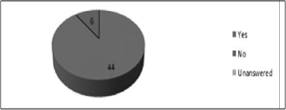
Online Portals for payment
88% of the sample used online portals for making payment or receiving money. While, remaining 12% do not use online portals for transaction.
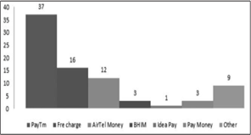
Preference of online portal for payment
74% people preferred PayTm App for making their Payments followed by Freecharge at 32%, Airtel money at 24 % respectively.
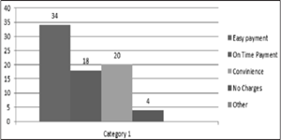

Usage of portal
68% of sample uses the online portals because of easy payment. However 40% feel that the online portals they use is convenient. 36% of the sample believes that online portals are trustworthy in making payment on time.
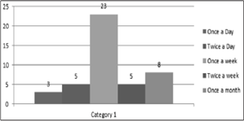
● Frequency of usage
Frequency of using online portals varies, however the frequency reveals that students use online portal at least once a week for making payments.
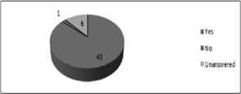
● User friendly portal
Portals are user friendly and 43 out of 50 respondents find them easy and convenient to use.
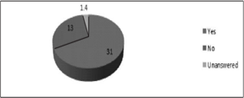
● Usage of Portal after Demonetization
The usage of using the portal has increased after demonetization and 62% believe with this fact.
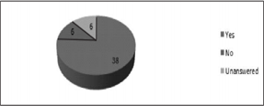
Satisfaction towards functioning of Portal
76% of Respondents are satisfied with the functioning of online portals.
Purpose of using portal
30% people use online portals for Recharge followed by Shopping at 23% and Online transfers at 20% respectively.
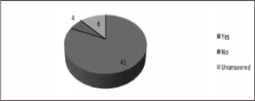
Satisfaction derived from services of the Portal
82 % of respondents are satisfied with the services provided by online portals. However, 8% of users are not satisfied with the services provided by the online portal.
Findings of the Study
1. Everyone is aware of the demonetization and also believes that it is a step towards digitization and the biggest event witnessed in Indian history.
2. Majority of the people agree that demonetization will minimize cash transaction and further result in increased usage of cashless mode for transaction.
3. The number of people using online portals for making payments is more than those who do not use online portals.
4. People who use online portals commonly prefer PayTm and Freecharge because they found these portals easy for making payment and convenient to use.
5. People using online portals or E-wallet find the apps user friendly, easy and convenient to make and receive payments.
6. The frequency and usage of online portal have increased after demonetisation. Recharge, Shopping and online transfer are the most common purpose behind usage of online portals.
7. However there are certain problems faced while using the portals like- Unavailability of portal in regional language, poor network and server down, lengthy process, payment failure, security issues and slow response.
8. The features that make online portals more attractive are Offers,
Promo code, Discounts, Cash backs, Catchy web design, Variety of options, Passbook option, Global reach, Time saving and 24*7 availability.
From the above findings, the hypothesis of the study
H0: After Demonetization, there has been increase in usage of online portals and E-wallets among student.
H1: After Demonetization there has been no any increase in usage of online portals and E-wallets among student.
H0 gets accepted and H1 gets rejected.
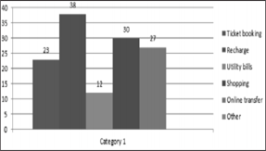
Conclusions
After conducting the survey, Researcher has come to the conclusion that Demonetization has been an historic step in India. Though it has been done thrice in Indian history, it has substantially influenced Indian economy this time. Thus, recently done Demonetization is important for Indian economy because it has triggered digital payment industry. Definitely, Demonetization has led towards Digitalization. But still few problem needs to be overcome by digital payment industry.
In present scenario, the use of Cards and E- wallets has increased, although there is limit to the usage of these cards. Because of the limits, people have difficulty in payments. Though, Demonetization has given way to Digitalization; it has a long way to go in Indian society.
Suggestions
Charges and Penalties to be removed
As Digitalization seems to be the future of Indian Economy, it has to be free from hassles of payment and acceptance. The limit for payment and acceptance has to be removed and proper incentives to be given for those who
use it.
Security system
As, Digitalization is playing an important role in IT world; it has to be more secure. So that the number of people accessing the portal should not face security issues. In order to help them, the IT security system should be more efficient.
User friendly Portals
Portals need to be made user friendly. So that anybody can access it. Further, Illiterate people should also be benefited from it. Thus, these portals should be Made available in regional language.
References Newspaper clippings
- “Demonetization Gains”- An article by an economist Mr.Madan Sabnavis in The Financial Express dated 28th December 2016.
- “Cash takes Digital Leap”– An article by Pratik Bhakta in The Economic Times dated 14th February 2017.
- The Economic Times- Wealth page dated 9th January 2017.
- “Demonetization led to spike in transaction, not in value” An article in The Financial Express by Anup Roy.
- Muthulakshmi, E.K. (2017). Impacts of Demonetisation on Indian Economy- Issues & Challenges. Journal of Humanities and Social Science. 34-38.
- Shah, A. Y. (2017). Impact of Demonetization on Rural India. International Journal of Scientific and Research Publications. 7(3). 220-223
- Shanbhogue, G. Kumar, A. P., Bhat, S. & Shettigar, C. (2016). A Study On Demonetization of 500 And 1000 Rupee Notes & Its Impact On the Various Sectors and Economy. International Journal of Research in Economics and Social Sciences.6(12). 274-284.
- Veerakumar, K. (2017). A Study on People Impact on Demonetization. International Journal of Interdisciplinary Research in Arts and Humanities.2(1). 9-12

Mapping human understanding to robot perception
Sonali Pabitramohan Sahu¹ and Dr. Rajendra B. Patil²
Student¹ and Head², Department of Information Technology, S.K Somaiya College of Arts Science and Commerce, University of Mumbai, Mumbai
Abstract
Human get knowledge from observation and experience .humans are excellent at gaining knowledge by the experience .human can act accordingly to condition and interaction .so the question can robot do the same or in reverse or, in others words can robots act according to situation with a limited amount of knowledge receives from sensors to a more complicated knowledge of surrounding that its doesn’t sense. In simple terms what kind of mapping is can be adapted from sensory knowledge to a more expressive knowledge. when Darwin n see a object moving on a floor ,does it really a ball ?the fact that a object is moving in a certain speed can be capable to understand that is a ball. When a robot and agent should be able to access a specific knowledge ,how to relate the knowledge to more actual situation .how much percent of knowledge should be transferred and what can be deleted? This paper will review about the perception of robot to a human understanding .
Keyterm: omissions, ontology,robot perception ,human robot interaction
Introduction
The interaction of human and robot can be complicated because a human act according to the condition .this topic taking you to a communication of human and robot at a point that is more similar to human and human communication and less robot human interaction .the communication does not need to be very proper miscommunication can be happened .but we are more interested to know how a robot can act to a specific condition with having a specific domain knowledge .how it will related his knowledge to human perception or human point of view. A robot need to understand and perceive knowledge by sensors and need to know what it don’t know .It is easier to program an agent which can calculate fast and can find missing data then human .lets take an example of scenario .a human have a flight for Banglore and he received a message from airline that the flight has been delayed for the 5 hours .the human calls the airline manager to know the reason for delayed of flight and it is because of mechanical problem and airline will pay for your lunch .the airline send the email of confirmation for the traveler to select restaurant and will be reimbursed. Airline didn’t inform about the limitation of reimbursed. after the completion of trip the traveler call the airline agent and asked about the reimbursed so the airline asked to send the receipt of bill .the traveler emailed the receipt .but the limitation of reimbursed is not disclosed to traveler .they sent the reimbursed to a partial amount because there is limitation .so the question is why the limitation is not exchanged to a traveler ?precise knowledge omitted knowledge is shown in fig 1.
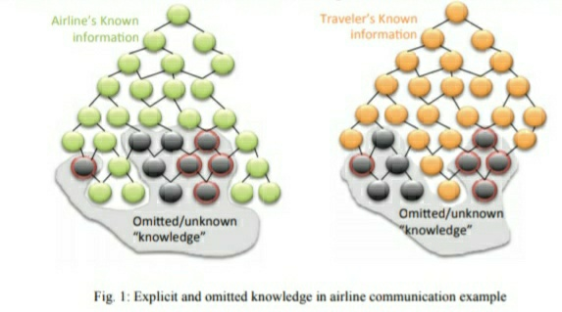
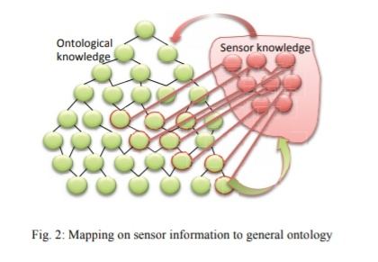
So we can simply say that human was not having the knowledge that there can be limit in his knowledge base. On the other side the airline agents consider that having limit is obvious. so what is the solution? can it be prevented by the robots if the robot was a machine not a human?
Literature Review
- According to Hanson, the robot he is created can be able to communicate with verbally and nonverbally and to create a trustful and postive relationship without any doubt .it will help to communicate more.
- According to him,our robot can help in medical care issue also ,it can save nurse time by doing indentifying the patient,checking the blood pressure, temperature,filling the forms etc .
Robotics and Ontologies
Ontology is an set of categories in a domain that’s shows their attributes and correlation between them .ontology is used in robotics to interrelate the knowledge and act upon the situation .the ontology can be domain specific large small can be at any extent.ontolgy are used in robotics for creating a standard knowledge representation for communication of robot and human.one of the basic requirement for the interaction of human and robot there need a common vocubalary.The standard provides an simplest way of representing knowledge and provide a common set of term and definition which have precise meaning for both human and robot .It allows to transfer unambiguous knowledge among any group of human and robot .robot are expected to perform in complicated situation so the standard knowledge representation (skr) will help for human robot collaboration.lets us take an example :There are words which sounds same but have the different meanings like "allowed" and "aloud".both the words sounds same but have the different meanings .so this concepualization of word should be cleared for robots neither it will cause misunderstanding.
Specific knowledge and omission
The question is how much knowledge should a robot need to act upon a critical situation.if a robot concieving information is it important to know everything or something can be omitted or some of them can be assumed ?lets us consider a example:if we want to walk from bedroom to kitchen but the door is not opened it is closed.socan u open the door will be enough? Or does it have to elaborate and say that door is not open .could u open the door .such decisions are taken by the intelligence of human.the problem is how other party will understood which is not being explicit?
There are different type of cases such as interaction of two robots.on one side you can transfer information to any level without omitting the robot will not get tired of it .on other hand it will be great to test that other agent based on the ontological representation as mapped to specific and common ontology . the next case is interaction of human and robot .in this it will be diificult what to omit or to give full detail .from the above example the object is ball or the object color is red what to omit it get complicated here .
The answer might be concurrence of human and robot and making a profile of human inteeligence ,human knowledge and human choice or preference .it wiil help robot to access that profile and make out a relevant decision for particular situation .computational machine should follow the same. morever,in future robot can operate a human operator to give information would be useful form user
Methodology
The information is gained from the internet from various sites and articles.
➢ Some content of this research paper is also done by the help of some published papers.
➢ After reading the various articles about the current and future of robots.
➢ After reading the various articles about the current and future of robots.
Conclusion
1. Robotic Perception is critical for a agent/ robot to make correct decision ,plans and to handle real world environments,by means of numerous operation and critical functionalities from mapping to recognise object.
2. Robot perception also includes automatic driver less vehicles, tracking object, voice and speech recognition,route detection,human detection, traffic detection,fake identity detection.
3. Robot perception will help in human robot interaction Even in complicated situation .it can also useful in localisation and navigation.
References
[1] Lorenzo and Nori,"The prototype of icub humanoid robot simulation",2008
[2] Yogeshwarn Mohan ,"An extensive review research in swarn robotics",IEEE 2009
[3] W.J Zhang ,"Soft robotics",2017
[4] John Atkinsocy and Mauricio solor,"Artificial intelligence and intelligent research in chille ",2009
[5] Kamlesh .v,"Surveillance robot for military application using Ram ",volume issue 2-April 2015,ISSN : 20349-9303

Analysing attacks and defence on an Android system
Mahek Gala¹ and Dr. Rajendra B. Patil²
Student¹ and Head², Department of Information Technology, S.K Somaiya College of Arts Science and Commerce, University of Mumbai, Mumbai
Abstract
In this Era of digitalisation computers and internet are making third revolution and making things possible which were impossible before. One of the major contributors to this the android which we use as operating systems in our smartphones. Every popular growing thing has a problem that is, it gets targeted in the similar way the android is also targeted by hackers and cyber-attacks. In this paper, various attacks reported with respect to android and also the various defence available to protect user from these attacks have been investigated.
- Introduction
Mobilephones have been an integral part of our regular life. We use them for many purposes such as communicating, checking emails, taking photos, surfing the internet. If we consider the recent market share 76.24% of the devices are android powered by android operating system [1]. This popularity for android has attracted a number of cyber criminals. There are various types of attacks that are targeted towards android such as data stealing, hacking, etc. and malware acts as a platform for these cyber-attacks. The malware infections have been increasing rapidly these decade. In future which will effect individuals and their organisations which will in turn affect banking, email, and transmitting sensitive information. Critically, a lot of Malware, Viruses and vulnerabilities have been found which are based on smartphones APIs and most of them look like safe software; some trusted applications collect user’s data such as geo location without user’s knowledge with GPS service in smartphone.
Although the android is most targeted OS but its architecture has layers for security which includes certification, permissions, etc. Also the google provides security to the platform which helps the platform to be safe and secure from cyber-attacks. Some of the services are mentioned below.
- Security Services by Google
Google provides cloud-based services for protection so that a user need not a physical security. Some of the primary google security services are [2]–
- Google Play: A collection of services allows user to install, purchase, and discover applications for their android devices from web. It also provides reviews, application verification, and other security services.
- Android Updates: This features delivers new capabilities and security updates to the android devices the updates are mostly over the air (OTA).
- Application Services: It is the framework that gives android application to use the cloud capabilities
- Verify Apps: Warns and verifies apps which are dangerous or not safe for the device.
- Android Device Manager: An app to locate the device if the device is lost or stolen.
- Security Attacks in Android
In spite of these security services we face many security issues which can cause severe harm to our device.
1. Permission Escalation Attack: It is an attack in which malicious application can interact with other application to access their critical resources without requesting for any authorisation.
2. Collision Attack: Android supports sharing of ID. It is a technique in which two or more than two apps share same id so that, they can get access for permissions which are given to other apps. Making it simpler to understand let us consider two applications A and B, A has permission to read_contacts and read_phone_status while B has permissions to read_messages and location_access and both A and B share same user ID then it is possible for application A to use permissions granted to itself as well as granted to B, In the same manner also B can use permissions granted to itself as well as granted to A.
3. Spyware: It as type of malware, It is apk file which gets downloaded automatically whenever a user visits harmful website and apps installed from sources which are unknown. Other than google play store, in android it is possible to install the applications from unknown sources. Spyware can be considered one of the main reasons for security threats to android OS.
- Defence services by Google
Google provides a service named play protect. It is built-in malware defence system for android. This play protect is supported by Google’s machine learning algorithms which are always improving in real-time. It works continuously on our device to protect the device, app and data safe. The user can rest easily as it automatically scan the device and makes sure whether the user is having the latest latest mobile security. One of the Google's popular service named Find My Device helps whenever you have lost or forgot your device. You can find device and locate it by signing in Google and you get the feature of directly calling device directly for the browser. Locking the device and displaying message on screen, which may help if someone found the device, can contact. The major benefit is that if u have lost the device you can delete your complete data [4].
- Proposed Methodology
The main aim of the research is to provide holistic account of smartphones and their problems with privacy and protection. Hence, from a collection of various researches a methodology has been proposed. One of the major reason for misuse of app permission is shared user ID. As due to shared ID, permission granted for one app can access permission for another app but not everytime only if the shared ID value set name and signed is by same certificate. Most of the users are not aware of the applications which are misusing the permissions. Hence, a methodology is proposed so that an security tool can be created which can increase and help to manage permissions. The permission includes the following steps:
- Listing of applications based on their package name or app ID.
- Find out the application for which shared user ID is set or can be set and segregate them.
- List these shared user ID.
- Compare each application with the sared user ID set.
- After comparing the generated output list is of the finalised app.
- The user should get the notification when the shared user ID app tries to access the permissions with other apps.
- The resources which are used by the shared user ID apps must be displayed by the security tool app.
- Conclusion
In this work, at first, we discussed the types of attacks and defence which are possible for an android system. we saw various google security services and defences. Also we saw various attacks which can cause harm to person data and also its confidential data might be breached. Finally we proposed a small proposition which can help more providing more better security.
Android being the popular and most used operating system its security is also should be considered. As it is important to make sure that user's privacy and confidential information is protected. At the end the user also should be careful about the apps the use they should also take care about the shared ID. Unknown sources apps should not be installed at all as they can cause equal harm use of shared ID can do. Atmost care must be taken as it can cause a serious harm to users data.
References
[1].https://gs.statcounter.com/os-market-share/mobile/worldwide/2018
[2].https://source.android.com/security#google-security-services
[3].https://source.android.com/security/enhancements/enhancements43
[4].https://www.android.com/play-protect/
[5]. L. Wu, X. Du, and J. Wu, “Effective Defense Schemes for Phishing Attacks on Mobile Computing Platforms,” IEEE Trans. Veh. Technol., vol. 65, no. 8,pp. 6678–6691, Aug. 2016.
[6]. S. Liang and X. Du, “Permission-combination-based scheme for Android mobile malware detection,” in 2014 IEEE International Conference on Communications (ICC), 2014, pp. 2301–2306.
[7]. H. Saini, Y.S. Rao, T.C. Panda, Cyber crime and TheirImpacts: A Review, International Journal of EngineeringResearch and Application, vol.2, Issue2, pp.202-209, 2012
[8]. C.-C. Lin, C.-C. Chang, D. Liang, and C.-H. Yang, “A New NonIntrusive Authentication Method Based on the Orientation Sensor for Smartphone Users,” in 2012 IEEE Sixth International Conference on Software Security and Reliability, 2012, pp. 245–252
[9]. T. Feng, X. Zhao, B. Carbunar, and W. Shi, “Continuous Mobile Validation Using Virtual Key Typing Biometrics,” in 2013 12th IEEE International Conference, Privacy in Computing and Communications, 2013, pp. 1547–1552.
[10]. F. Al-Qershi, “Android vs. iOS: The security battle,” in Computer Applications and Information Systems (WCCAIS), 2014 World Congress on. IEEE, 2013, pp. 1–8.
[11]. A. Maji and K. Hao, “Characterizing failures in mobile oses: A case study with android”, 2010 IEEE 21st International Symposium on. IEEE, 2010, pp.249–258.

Big Data Technologies and the Opportunities on the Market
Priyanka Sonawale¹ and Dr. Hiren Dand²
Student¹ and Head², Department of Information Technology, Mulund College of Commerce, University of Mumbai, Mumbai
ABSTRACT
Big Data is a field that treats approaches to analyze extract data, or generally manage informational collections that are excessively huge or complex to be managed by traditional information handling application software. Data with numerous cases (lines) offer more statistical power, while information with higher multifaceted nature (sections) may prompt a higher bogus revelation rate. Big Data has gained much attention over the years because of the IT industry and academics. In the digital computing world the data, information are collected at rapid rate to process those data. Currently billions of people are using the internet, and over millions of people are using smartphones. Over the year in the future those rates are predicted to increase and the predicted data production will be increased. The information is shared and transferred at a greater speed on the wireless network the volumn of the data is increased and in turn the speed of growth of the market will be increased. Though due to the fastest growth of the data production and analysing the data it increases the risk and numerous challenges such as quick development of data, move speed, various information, and security. Today the big data and it’s technologies are still in the inception stage. Consequently, this investigation widely reviews and orders the different qualities of Big Data, including its inclination, definitions, fast development rate, volume, the board, examination, and security. This research proposes the oppurtunity the Big Data techonologies povides to improve the market.
Index Terms: Big Data, Big Data Technologies, Market Opportunities, Apache Hadoop, Big Data Challenges.
Nomenclature
UFDs-User Defined Functions
NoSQ-Not only SQL
RDBMS-Relational Database Management System
HDFC-Hadoop Distributed File System
1.0 Introduction
The present universal public exceeds 7.2 billion, and more than 2 billion of these individuals are using Internet in day to day life. Moreover, 5 billion people are using diverse cell phones, as indicated by McKinsey. Because of this innovative transformation, many individuals are producing huge measures of information or data through the extended utilization of such devices. Specifically, those devices produce a lot of diverse or mixed data that are either structured or unstructured. This is known as Big Data. Huge Data is described by three angles:
- The data are innumerable,
- The information can't be sorted into ordinary social databases, and
- Information are produced, fixed, and prepared rapidly.
Large Data is promising for business application and is quickly expanding as a section of the IT business. It has produced significant interest for different fields, including the production of medicinal services machines, banking exchanges, online networking, and education. Generally, information is put away in a profoundly organized configuration to boost its educational substance. In any case, current information volumes are driven by both unstructured and semistructured information. Subsequently, start to finish handling can be obstructed by the interpretation between organized information in social frameworks of database the board and unstructured information for examination.This study offers:
- A complete survey of massive information technologies;
- A discussion of the technologies for analysis and management of the large Data;
- An list of the problems and challenges connected with the massive information.
This paper explains basic ideas and describes the information volume, it describes the opportunities, and challenges; and concludes the paper.
2.0 Background
Big data can be described by the following characteristics:
Volume
Volume in big data means the dimensions of the data. Volume refers to the amount of data generated through websites, portals, and online application. Volume encompasses the available data that are out there which need to be assessed for relevance.
Velocity
Velocity in big data is the speed in which the big data are generated and the speed at which the data needs to be processed. If the data is not processed at the required speed, it loses its significance. Due to data streaming in form of social media sites, sensors, and monitoring it is important for organization to speedily process data both when it is on move and when it is static.
Variety
The information created from different gadgets and sources pursues no fixed organization or structure. Contrasted with content CSV or RDBMS information shifts from content documents, log records, gushing recordings, photos,and different other unstructured organization.variety is about the capacity to characterize the approaching information into different classifications.
Veracity
It is the all-encompassing definition for huge information, which alludes to the information quality and the information esteem. The information nature of caught information can change extraordinarily, influencing the precise investigation.
Source | Production
Youtube | Users transfer 100 hours of new recordings every moment. Each month, more than 1 billion novel clients get to YouTube. Over 6 billion hours of video are observed every month, which compares to nearly 60 minutes for each individual on Earth.
Facebook | Every moment, 34,722 Likes are enrolled  100 terabytes (TB) of information are transferred day by day.  Currently, the site has 1.4 billion clients  The site has been converted into 70 dialects.
Twitter | The site has more than 645 million clients The site produces 175 million tweets for each day
Google | The site gets more than 2 million hunt inquiries for every moment  Consistently, 25 petabytes (PB) are handled
Tumblr | Blog owners publish 27,000 new posts per minute
Instagram | Users share 40 million photos per day
WordPress | Users upload 3,125 new photos per minute Bloggers publish near 350 new blogs per minute
LinkedIn | 2.1 million groups have been created

3.0 Big Data Technologies
The main components and network of big data as follows:
• Techniques for investigating information, for example, A/B testing, AI and characteristic language handling
• Big information advancements, similar to business insight, distributed computing and databases
• Visualization, for example, outlines, charts and different showcases of the information.
To extricate information from Big Data, different models, programs, virtual products, durable goods and advancements have been structured and proposed. They attempt to guarantee progressively exact and dependable outcomes for Big Data applications. Be that as it may, in such condition, it might be tedious and testing to pick among various developments. Truth be told, numerous parameters ought to be considered: innovative similarity, sending unpredictability, cost, effectiveness, execution, unwavering quality, backing and security dangers.The Multidimensional data can be represented as OLAP Data Cubes. Array Database system provide the memory storage and high level query support on mathematical data type.Apache Hadoop, NoSQL, MongoDB are the data integration tool which allows big data analysis.
Apache Hadoop
Apache Hadoop is an outstanding Big Data innovation that has a significant supporting network. It has been intended to maintain a strategic distance from the low execution and the unpredictability experienced when preparing and breaking down Big Data utilizing customary advancements. One primary preferred position of Hadoop is its ability to quickly process huge informational collections, because of its parallel groups and disseminated document framework. Truth be told, not normal for conventional advances, Hadoop don't duplicate in memory the entire far off information to execute calculations. Rather, Hadoop executes undertakings where information are put away. In this way, Hadoop calms system and servers from an impressive correspondence. Another bit of scope of Hadoop is its capacity to run programs while guaranteeing adaptation to internal failure, ordinarily experienced in appropriated condition. To ensure that, it avoid information misfortune by reproducing information on servers. The power of Hadoop platform is based on two main sub-components : the Hadoop Distributed File System (HDFS) and the MapReduce framework.
HBase
HBase is a conveyed non social database based on the highest point of HDFS. It empowers quick record queries (and updates) for enormous tables. HBase inside places the information in listed "StoreFiles" that exist on HDFS for fast queries. HBase is worked for Low Latency tasks. HBase gives access to single lines from billions of records.
HDFC
HDFS is a dispersed document framework fitting to store huge records. HDFS is certifiably not a broadly useful document framework. It doesn't give quick record query in documents. HDFS stores enormous documents (gigabytes to terabytes in size) crosswise over Hadoop servers. HDFS is appropriate for High Latency tasks cluster handling. Information is principally gotten to through MapRe-duce.
NoSQL:
While the customary SQL can be adequately used to deal with enormous measure of organized information, we need NoSQL (Not Only SQL) to deal with unstructured information. NoSQL databases store unstructured information with no specific mapping. Each line can have its very own arrangement of segment esteems. NoSQL gives better execution in putting away enormous measure of information. There are many open-source NoSQL DBs accessible to study enormous Data.

4.0 Opportunity on the Market
As indicated by McKinsey, the viable utilization of Big Data benefits economies and introduces another flood of gainful development. Benefiting from important information past Big Data is the essential focused system of current ventures. New contenders must have the option to pull in representatives who have basic aptitudes in taking care of Big Data. By outfitting Big Data, organizations increase numerous favorable circumstances, including operational efficiency, informed strategic direction, improved customer service, new products, and new customers and markets.

4.1 Marketing opportunity
Marketing Decisions Process is very complex. Different choice are available to decision maker which result in multiple objectives and countless alternative actions. The marketing strategy aim to initiate, strengthen, intensify, and preserve overtime their relationship between a company and its stakeholders, represented primarily by its customers and involves the analysis, planning, execution, and evaluation of the activities carried out to pursue these objectives. Relational marketing become popular in late 1990 increasing customer satisfaction to get competitive advantage. The increased flow of information and the introduction of e-commerce have enabled global comparison customers can use Internet to compare features, prices and opinion on products and services offered by various competitors. The number of competitors using advanced techniques for analysis of marketing data has increased. The systematic gathering of sales transaction provide a large amount of data that can be transformed into knowledge and then into effective and targated marketing actions.

4.2 Challenges
It is easy to get caught up in the hype and opportunity of big data. However one of the reason big data is so underutilized is because it may also present challenges. One survey found that 55% of big data projects are never completed. As more and more data is gathered, digitized, and moved around the globe the policy and compliance issue become more and more important. Accessing data for consumption is a challenge for big data projects. Some of the data may be available to the third party and gaining access can be a legal contractual challenges. New tools and techniques built specifically to address the need of big data must be leve lagered, rather than trying to address the aforementioned issues through legacy system. The inadequacy of legacy system on one hand and lack of experienced resources in new technologies is a challenge.

5.0 Conclusion
This paper concludes the fundamental concept of Big Data and it’s technologies. This concept include the importance or role of big data in today’s technologies. Big Data is everywhere and it can help organization any industry in many way. he massive knowledge has become too complicated and too dynamic to be ready to analyze and manage with traditional data tool. Regardless of the significant advancements in Big Data field, we can see through our examination of different innovations, that many weaknesses exist. More often than not, they are identified with embraced designs and methods. In this way, further work should be done in a few zones, for example, information organization, domain explicit devices and platform tools so as to make cutting edge Big Data infrastructure. Consequently, mechanical issues in numerous Big Data zones can be additionally contemplated and establish a significant research topic.
APPENDIX
In the previously mentioned reference the Nawsher Khan is about improvement to upgrade the productivity of information the executives, they have concocted an information life cycle that uses the innovations and phrasings of Big Data. The phases in this life cycle incorporate collection, filtering, analysis, storage, publication, retrieval, and discovery. Every one of these stages (on the whole) convert crude information to distributed information as a critical angle in the administration of logical information.
REFERENCES
- future of robots .Nawsher Khan, Ibrar Yaqoob, Ibrahim Abaker Targio Hashem, et al., “Big Data: Survey, Technologies, Opportunities, and Challenges,” The Scientific World Journal, vol. 2014, Article ID 712826, 18 pages, 2014.
- "Siddharth Singh, Survey on Big Data Using Data Mining". International Journal of Engineering Development and Research. 2015.
- D. Che, M. Safran, and Z. Peng, “From Big Data to Big Data Mining: challenges, issues, and opportunities,” in Database Systems for Advanced Applications, pp. 1–15, Springer, Berlin, Germany, 2013.
- K. Douglas, “Infographic: big data brings marketing big numbers,” 2012,
- O'Driscoll, J. Daugelaite, and R. D. Sleator, “'Big data', Hadoop and cloud computing in genomics,” Journal of Biomedical Informatics, vol. 46, no. 5, pp. 774–781, 2013.
- M. Loukides, “What is data science? The future belongs to the companies and people that turn data into products,” An OReilly Radar Report, 2010.
- D. Acharjya, K.P. Ahmed, A survey on big data analytics: challenges, open research issues and tools Int. J. Adv. Comput. Sci. App., 7 (2016), pp. 511-518

Brain Manipulation Techniques
Shivani Nilakhe¹ and Dr. Rajendra B. Patil²
Student¹ and Head², Department of Information Technology, S.K Somaiya College of Arts Science and Commerce, University of Mumbai, Mumbai
Abstract
Our mind is actually very effective, yet it's far feasible to govern it the use of mind manipulation techniques. It is feasible to simply introduce a certain notion in our mind, and sense the feelings related with that thought and to educate your mind to respond in a manner that we assume to choice.[1] Every thinking individual objectives at happiness and pursues his or her own path in the direction of this goal. As individuals, our concepts of what constitutes happiness range. Our unconscious mind is aware about the resources of our happiness however our aware thoughts is frequently unable to comprehend the same. To harness our complete capability, it is vital that our aware and unconscious minds paintings on the equal time.[2] The unconscious thoughts is the seat of our attitudes, emotions and outlook on life. Psychopaths, sociopaths and narcissists are masters of manipulation and exploitation.
- INTRODUCTION
Brain Manipulation strategies could have very powerful results. They can appreciably affect an character’s movements, behaviour’s, thoughts, beliefs, tastes, relationships, or even their personal identity. Brain Manipulation may be very subtle and complex. Brain Manipulation is an idea that has fascinated human beings for decades. Stories had been told by means of the media and in movies approximately companies of human beings who've been brainwashed or hypnotized into doing matters that they would have in no way done in any other case.[4] There are humans on each aspects of the issue; some consider that there's no such element as mind control and that it is all just made up at the same time as others trust that they could be manipulated via mind control at any moment. Brain Manipulation refers to all coercive psychological structures, including brainwashing, thought reform, and coercive persuasion. It is the shaping of someone’s attitudes, ideals, and character without the character’s know-how or consent. It employs deceptive and surreptitious manipulation, typically in a collection placing, for the monetary or political income of the manipulator.[3] It works by way of step by step exerting increasing manipulate over people through a ramification of techniques, such as excessive repetition of routine activities, intense humiliation, or sleep deprivation.
Some of the brain manipulation techniques are banned due to some respective reasons.[13] They are as follows:
- Brainwashing: Brainwashing is the technique where someone will be connived to abandon beliefs that that they had inside the beyond if you want to take new ideals and values. For example, in case you are from an African USA. After which pass to America, you may regularly be compelled to change your values and beliefs on the way to in shape in with the new lifestyle and environment which you are in.
- Hypnosis: Hypnosis is a cooperative interplay wherein the hypnotist will offer pointers that the participant will respond to. Hypnosis is a very safe and powerful tool; humans can once in a while be risky.
- Persuasion: Persuasion works in order to steer the behaviour’s, motivations, intentions, attitudes, and ideals of the difficulty.
- Deception: Deception is used with the intention to propagate in the subject ideals in occasions and things that simply are not genuine, whether they're entire lies or just partial lies.
- TECHNIQUES
Some of the brain manipulation techniques that can be used are as follows
- Visualization: We educate our thoughts to paintings towards achievement by visualizing ourselves accomplishing fulfilment. Sports psychiatrists use this technique significantly to supply peak performances in athletes.[8]
- Total or partial isolation from the family or social nucleus: Cutting the viable victim’s affective ties enables mind manage since there’s overall or partial dependence at the manipulator.[9]
- Writing down goals and continuous self-assessment: Writing down our dreams offers them concrete shape. Continuously reviewing goals and the progress made towards accomplishing them enables you to make essential the changes needed. Reviewing the development made also allows keep your purpose consistent and spirits upbeat.[8]
- Change of diet: An abrupt exchange in weight loss plan, mainly decreasing protein, additionally weakens a possible victim’s frame and mind.So consuming somethings that offers a right food regimen that is right share of proteins and minerals can to control the mind.[9]
- Mirror talk: Man is his personal satisfactory buddy and worst enemy. Negative self-speak will become a self-fulfilling prophecy. Always talking right down to oneself may be a sure fire way of being looked down upon by means of all. If, on the other hand, we give ourselves effective strokes and inspire ourselves, the thoughts feeds and focuses on what's manageable and works in the direction of that aim. [8]
- Thinking of the opposite: This is a simple one. It stands to motive that maximum distracting thoughts are poor, and consequently have opposites. Simply replicate on the other – not simply considering it, but feeling it as nicely.For Eg, If you are indignant, think of something glad. Your preferred nephew, or a happy region. Feel it along with your whole body. If you're experiencing forbidden lust, then focus on their terrible factors and ugly capabilities.[10]
- Meditation: Meditation is one of the oldest strategies of controlling the mind. By calming the mind and emptying it of all mind, we surely allow peace and calm to circulate our minds. Meditation quiets disparate thoughts continuously flitting via our thoughts and gives our unconscious its voice.It is scientifically established that the alpha waves produced by way of the mind, peak after meditation. Alpha waves improve innovative and high-quality thinking. Meditation empowers the thoughts to attention on the existing and only on what is crucial.[8]
- Criticism: Criticism may be used as an isolation tool. The manipulators will commonly talk in “us in opposition to them” phrases, criticize the outside international and declare their own superiority. According to them, you should experience lucky to be associated with them.[11]
- Distancing: This technique is really letting your mind slide by way of without attaching to them. Realize that thoughts are simply that: mind.They don't have any energy beyond what you give them. You don't ought to consider them, or act on them.Just renowned them, and allow them to go.[10]
- CONCLUSION
Mind manipulate strategies are successfully used to remedy many ailments, in relieving acute ache, and in reducing stress. It is a terrific way to stay nice and active in attempting situations. The techniques can be used by anyone who is desiring to think in a positive way. It will help the people to do so. Autosuggestion for instance is a mind manipulation technique this is excellent used to dispose of terrible conduct like smoking, drinking and drug abuse.[6] It is in no manner too past due to research and placed to use some thoughts manipulation techniques and take control of your existence and make it better.
The above techniques can be used to control our brain in a positive way rather than doing some negative things.[5] Some of the above techniques would help one to get rid of some bad habits as well.
- REFERENCES
- R. Sharma, V. I. Pavlovic, and T. S. Huang, BToward multimodal human-computer interface,[ Proc. IEEE, vol. 86, no. 5, pp. 853–869, May 1998.
- L.-D. Liao, C.-T. Lin, K. McDowell, A. E. Wickenden, and K. Gramann, T.-P. Jung, L. W. Ko, and J.-Y. Chang, BBiosensor technologies for augmented brain-computer interfaces in the next decades,[ Proc. IEEE, vol. 100, 2012, DOI: 10.1109/JPROC.2012.2184829.
- B. Blankertz, G. Dornhege, M. Krauledat, M. Schro¨der, J. Williamson, R. Murray-Smith, and K. R. Mu¨ller, BThe Berlin brain-computer interface presents the novel mental typewriter hex-o-spell,[ in Proc. 3rd Int. Brain-Comput. Interface Workshop Training Course, 2006, pp. 108–109.
- J. J. Vidal, BToward direct brain-computer communication,[ Annu. Rev. Biophys. Bioeng., vol. 2, no. 1, pp. 157–180, 1973.
- B. Hamadicharef, BBrain-computer interface (BCI) literatureVA bibliometric study,[ in Proc. 10th Int. Conf. Inf. Sci. Signal Process. Appl., 2010, pp. 626–629.
- A Nijholt and D. Tan, BPlaying with your brain: Brain-computer interfaces and games,[ in Proc. Int. Conf. Adv. Comput. Entertain. Technol., 2007, pp. 305–306.
- J. R. Wolpaw, BBrain-computer interfaces as new brain output pathways,[ J. Physiol., vol. 579, no. 3, pp. 613–619, 2007.
- https://www.wisdomtimes.com/blog/mind-control-techniques-for-a-good-life/
- https://exploringyourmind.com/is-there-such-a-thing-as-mind-control-techniques/
- https://www.positivityblog.com/5-time-tested-techniques-to-control-and-calm-your-mind/
- https://psychologia.co/mind-control-techniques/
- https://lifehacker.com/three-of-the-easiest-ways-to-manipulate-people-into-doi-5953183
- http://1.droppdf.com/files/UGo1M/banned-mind-control-techniques-unleashed-daniel-smith.pdf

CRITICAL DATA AND WAREHOUSING
Tejaswini Tukaram Kadam¹ and Abhijeet Kale²
Student¹ and Head², Department of Information Technology, B. N. Bandodkar College Science, University of Mumbai, Mumbai
Abstract
Clinical decisions are critical because they are linked to human entities. Managers and decision makers in the clinical environment search for new solutions that can carry their decisions.
Data warehousing techniques share a usual set of tasks, involving business requirements assessment,information design, developers design, execution and succession. Crucial information depositing are complicated and tedious to analysis a series of patent records. Information combination tasks of medicinal information support are complicated layout when designing crucial information depository framework.
The recent information depository framework are feasible results to tackle information combination uncertainty and could be affected by small to huge critical information depository applications.
Keywords: Combination, Information Depository, information design, Information Depository framework.
Introduction
Interest in medical systems should be examined a priority because all collaborators in the medical environment goal to give the finest services for patients and find the best stand for decision making. Recently, clinical data have been used for latest objectives apart from clinical basis, such as research, treatment enhancement and critical decision making. The outlay of medicines and treatments are continuously increasing; thus, to detect the tools and systems that lower these costs is a aim of all medical organizations. A critical information depository is considered as the finest approach to accomplish this aim.
A decision depend on wrong or an invalid information may guide to catastrophic outcome rather than support decisions. The CDW is a place where health maintenance providers can obtain access to clinical data collected in the patient care procedure. It is forced that such data warehouse may give information to users in areas vary from research to management.
In this connection, initiation of the data design such as data modelling, normalization and their attributes which accelerate measurements of the effectiveness of operation, relationships between causality and treatment protocols for structured diseases and conditions are captured. Creating malfunctions of cost and assess information or predicting demand to administrate resources from the management perspective are an essential requirement.
A crucial information store requires addressing various problems with CDMS. They are specifically information location, scientific platform and information formats. These factors are crucial and unless these blockade are destroyed. it is a accomplishable strategy considering the time factor for those problems when merging dissimilar data locations.
Storage of such sequences of information will uplift another sequence of queries as to how long such information is necessary to be stored in the CDW. The CDSs involve islands'' of information over different departments, laboratories and linked administrative processes, which are tedious and laborious tasks to individually access and combine reliably.
Integration of those kind of information stores are demanding tasks and an important problem to tackle and resolve in the CDW arena. As computer technology gets more powerful, it is being possible to gather data in volume, and to a quantity of detail that could not even be visualized just a few years ago.
At the same time, it provides a extending probability of detecting intelligence from data through database marketing, information retrieval and statistical techniques such as Exploratory Data Retrieval, Information evaluation and Information Mining.
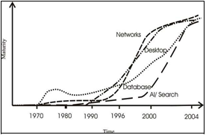
Technological Maturity [primary source: Dhar and Stein (1997)]
A DSS needs the establishment of information depository in order to absolute it's life cycle.
A DW merges the data separated through a coordation into a unique concentrate information design with a general format. A basic concept of a DW is the variation between information and data information is collection of noticable and documentable reality that are often establish in functional or transferable structure. A Data warehouse is a depository of combined information, accessible for querying and analysis. Therefore, information depository possibly examined a proactive proceed towards the data combination, as related to the more established "pasaive" proceed towards where oraganizing and combination begin when a query appears.
For case, healthcare institutions Refining conformation based medication attempt to combine their information virtue in order to attain a vast learning base for more experienced investigation as well as to give a developed resolution support service.
Building a Data Warehouse (DW)
The data warehouse is a information formation male optimal for allocation,mass accomadation and complicated query processing.
It gathers and stores combined sets of past data from many operational systems and provide there to or multiple information marts, which are information system system that make optimal for quick access. It may also give clients access to support enterprise views of data. A DW can potentially provide several advantages to an organization with quality development, and decision support by allow quick and systematic access to information from legacy systems and linkage to many workable data sources.
The DW is that part of an general Constructed data sorrounding that assist as the single combined reference of information for oraganizing.
The DW is Subject-Oriented, Integrated, Time- Variant, Non-Volatile information is encouragement of administration decisions.
- Subject-oriented: Subject-oriented means that all applicable data about a issue is collected and deposite as a unique set in a utility layout
- Integrated: Integrated refers to data being stored in a globally allowable fashion with compatible naming conventions, measurements, encoding structures, and physical attributes, even when the fundamental operational systems store the data separately
- Non-volatile: Non-volatile means constant information that does not change each time an operational activity is performed.
- Time-variant: Time-variant way that the information depository involves has history of the content, as well as present information.
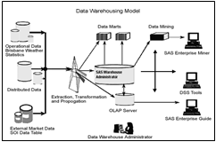
Example Information depository is a procedure requiring a deposit of software and hardware elements that can be used to better examine the huge quantityof data that organisations, companies and research disciplines are collecting to make better operational or essential resolution. The information warehousing procedure does not include of just including information to the data warehouse, as well needs the configuration and advice to gather, suapicion, examine and present data.
Data warehousing is a procedure, not a outcome, for collecting and controlling information form different sources for the aimof collecting a single, specific perspective of part or all of a business. The arrive. Even though there are various technical problems that challenge construct a information depository result and conspiring information depository framework.
The Apporach
Our attain was the investigation with the well known and accessibleBKR. This attain has been extract by the interactive perceptionof a Queensland base industry partner who gives Information Technology solutions to health care providers. Most of the data design and attributes in this experiment is an conceptual only.
We have taken vicious steps not to follow the regular, relational database paradigmand reduce data duplications. There are no longer problems and disadvantages with duplicating the data as storage is efficiently free or very low cost. The duplicated data must be accordant throughout the procedurewheneverrequired to preserve the data integrity.
During the design and planning stage of the application part, we used a employment analytical reach where a small group includes the information repository designer, bussiness competitor and predicted users of the corporate data warehouse to grasp the key procedures to the employment. In this association, it is as assimilated that the designer works with a bussiness examiner, work bussiness controllers and predicted users of the corporate data warehouse to grasp the key procedure of the employment and the questions business leaders and other users of the warehouse would ask of those procedures.
The data for those areas are complicated and there are hundreds of duplicated data attributes. In contrast, patient management scenarios in the Mental Health discipline are dissimilar. In these conditions, it is a crucial element to combine strategic use of information to plan service delivery for a non-integrated environment.
This environment involves paucity of applicable information to monitor health service activities and investigate patient results. The middle and senior management could not efficiently monitor levels of team actions, or determine which elements were predictive of the clinical results of mental health patients. The capacity to combine all of this data for aims of analysis and actionable knowledge explore the appearing technical arena of clinical intelligence.
Reference
1] Lau, E.C., et al., Use of computerised medicinal evidence (EMR) for oncology outcomes research.
[2] Ballantyne, D.J. and M. Mulhall, Procedures and equipment for electronically apporaching and administrating individual health care data and services.
[3] Cao, H., et al. Extracting a clinical information depository, to detect alliment finding alliance co-occurance statistics. in AMIA Annual Symposium Proceedings. 2005.
[4] Ewen, E.F., C.E. Medsker, and L.E. Dusterhoft. Data warehousing in an integrated health system: building the business case. in Proceedings of the 1st ACM international workshop on Data warehousing and OLAP. 1998.
[5] Chaudhuri, S. and U. Dayal, An overview of data warehousing and OLAP technology. ACM Sigmod record, 1997.
[6] Jaber, M.M., et al., Flexible data warehouse parameters: Toward building an integrated architecture. International Journal of Computer Theory and Engineering, 2015.
[7] Kimball, R. and M. Ross, The data warehouse toolkit: the complete guide to dimensional modeling. 2011: John Wiley & Sons.
[8] Sahama, T.R. and P.R. Croll. A data warehouse architecture for clinical data warehousing. in Proceedings of the fifth Australasian symposium on ACSW frontiers-Volume 68. Computer Society, Inc.
[9] Shin, S.-Y., W.S. Kim, and J.-H. Lee, Characteristics desired in clinical data warehouse for biomedical research. Healthcare informatics research, 2014.
[10] Mohammed, R.O. and S.A. Talab, Clinical data warehouse issues and challenges. International Journal of u-and e-Service, Science and Technology, 2014.

CYBER SECURITY: THE IMPACT OF CYBER ATTACK ON BANK
Jayshree Waghela¹ and Abhijeet Kale²
Student¹ and Head², Department of Information Technology, B. N. Bandodkar College Science, University of Mumbai, Mumbai
ABSTRACT
In Today's world, cyber security performs a very significant role, whenever we thought about cyber security the first thing which came to our mind is the cyber-crimes related to it, which are daily increasing immensely. The Challenges related to crime prevention have become more tough and requires new technology that can manages a tremendous number of confidential data generated through different resources. Cybercrime had adversely negative impact on many different division of banking field, defence field, social media, government and industry fields, private, military and scientific sectors. Etc. In last recent years, data breaches incidents have been immensely rising, one of main cyber attack incident happened on COSMOS bank, the second most cooperative bank in India. Research has been made on how the cosmos attack happened, all the details of timeline analysis are noted. This paper focuses on the cyber attack incident of cosmos banks and preventions which will reduce the risk of cyber threats/attack.
INTRODUCTION
Cyber security is the preventive methods which protect the integrity of networks, program, and data from attack, damage, or unauthorized permit. It involves protection of information and systems from cyber attack and cyber threats. Cyber threats takes many forms such as application attacks, phishing, exploit kits, malware, ransomware, data breaches etc. Recent advancements of technology, have opened up new chances for cyber security which can reduce the probability of cyber-crimes.
1.0 CYBER CRIME
Cyber crime/attack is a malicious attempt by a specific person or organization to breach the information of another person or organization. The attacker seeks some kind of benefit by disturbing the victim's network. Cyber-attacks nearly strike businesses every day. It's been growing every year as people try to benefit from unsecured business systems. Nearly, 53% of cyber-attack causes loss of about $ 500,000 or more. Cyber threats launched with ulterior agenda where the attackers hack the systems and data as a form of hacktivism.
2.0 COSMOS BANK CYBER ATTACK INCIDENT
In August 2018, COSMOS Bank became the major target of cyber-attack. Hackers breached the bank's ATM/switch server in Pune, robbing all the details and information of multiple Visa and Rupay debit card owners. The details were then used for performing about 12,000 fake transactions across 28 countries on August 11 with additional of 2,841 transactions happening in India. Following time analysis have been made on cosmos attack:
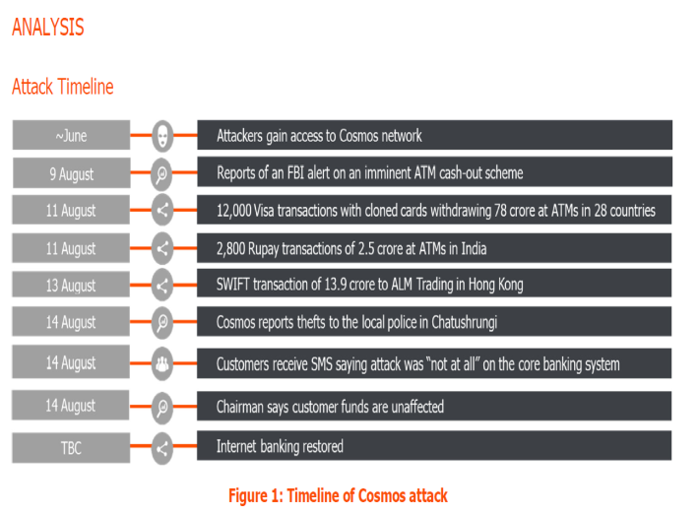
The attack did not stop here. Two days later, just after the ATM switch attack, attackers hack the bank's server, a SWIFT transaction was initiated for transferring funds in the account of ALM Trading Ltd. in Hanseng Bank, HongKong. The total loss from the attack were INR 94 crore or 13.5 million USD. Cosmos Bank was compelled to immediately close its ATM operations and suspend the online and mobile banking facilities.
2.1 How did the attack happen?
The CBS of the bank collected all the debit card payment demand by using a switching proxy system. Attackers made a proxy switch through which all the fake payments were passed. ATMs were at risk when the depositors withdraw money at ATMs, a request was being passed to the corresponding bank's CBS. From the CBS database end, if the account had enough balance, CBS allowed the transaction. In the case of Cosmos Bank, the malware infection developed a proxy system that was moved by CBS. While replicating the cards and using proxy switch system, the attackers were able to accept and sanction the demand requests that were withdrawing over INR 80.5 crore in nearly 15,000 transactions.
2.2Why is this attack more serious?
Just a few days before the attack, the American FBI alerted all the banks about a serious hacking attack to ATMs around the world. A confidential alert was made to all the global banks to aware about the theft against such a global malware attack on ATMs. Smaller banks with a little security systems were considered to be most unsecured with a process known as 'ATM cash-out'. Attackers aimed bank and used replicated cards at ATMs to falsely withdraw millions of money in just a little time.
3.0 TECHNICAL ANALYSIS ON COSMOS ATTACK
Here is the technical analysed details of the cosmos attack incident.
3.1 ATM Modality: US $11.5 million theft
• On August 11, 2018, the bank's internal and ATM's foundation was jeopardized. This attack involves multiple targeted malware infections and attackers destroyed the connection between the Central and the backend/Core Banking System (CBS).
• After doing all the modifications to the target account balances to allow withdrawals, MC was then used in fake 'on-us', foreign-to-EFT, standing-in, etc. activities that enabled the hackers to permit ATM withdrawals for about US $ 11.5 million by Rupay in 2850 domestic transactions and by Visa in 12,500 international transactions using 450 replicated debit cards in 28 different countries.
• Using ATM/switch, the hackers created false TRP (Transaction Reply messages) in result responded to TRM (Transaction Request messages) from cardholders and terminals. As the outcome, the actual messages (ISO 8583) were never transferred to the CBS from the ATM/switching solution that was put at risk, which allowed the vicious withdrawals and affected the fake detection on the CBS. Following is the diagrammatic representation of how a malicious ATM transaction works:
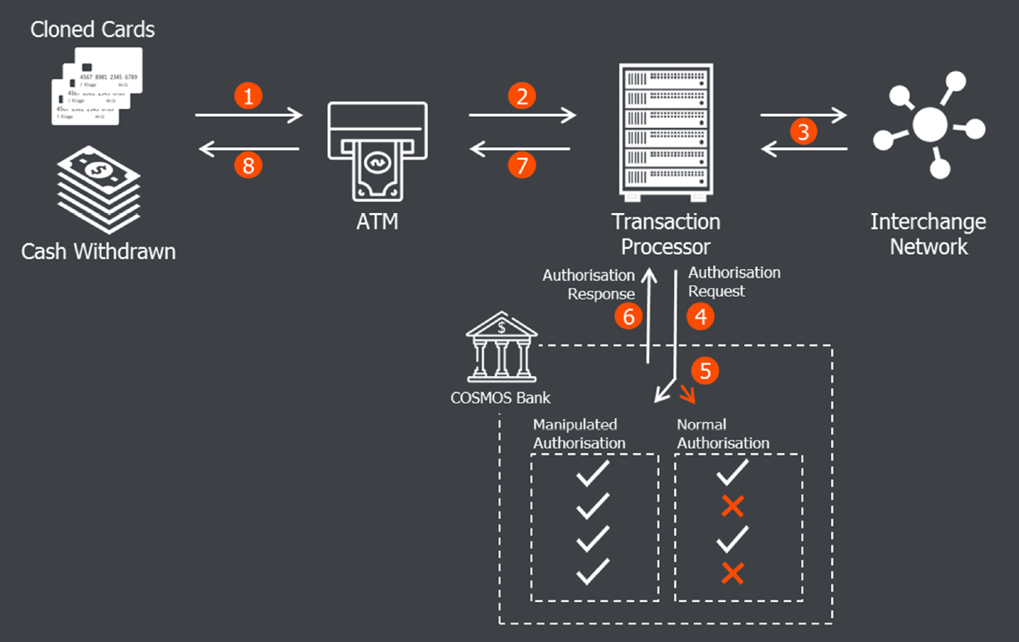
3.2 Switch Modality: US$2 milliontheft
- The attackers kept the attack continued by using the bank's SWIFT environment authentication to forward 3 malicious MT103 - ALM Trading Ltd in HongKong at Hang Sang Bank made loss of US $ 2 million.
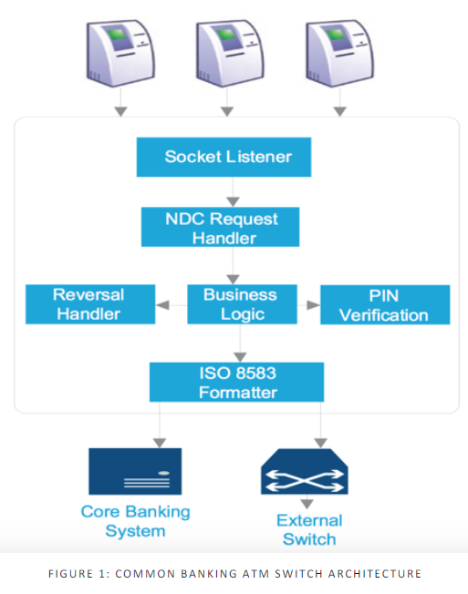
- The attackers really well-planned the operation and coordinated by focusing on the bank's infrastructure and made changes to the currently deployed ATM payment switch software to build a infected proxy switch. As a outcome, all details were sent from payment switch to approved the transactions that never really transmitted to CBS, so the checks are on the number of card, status of the card (Hot, Warm, Cold), PIN, and more that has not at all executed. Instead, the request was managed by the hackers by transmitting fake responses for permitting transactions.
- This ATM/SWIFT attack is assigned to the Lazaarus Group. The attackers used some attack techniques which includes Firewall changes in Windows, Admin Shares in windows, Timestamping, adding services, and many other methods were used.
4.0 POTENTIAL BUSINESS IMPACT
COSMOS Bank had faced monetary losses and non-monetary losses as any other financial organization. Here are the following analysis made on the business impact of this breach.
4.1 Monetary Impact
- Direct Monetary loss:- On August 10-11, nearly Rs 78 crore was withdrawn from transactions in 28 different countries. On August 13, the attackers transferred amount of Rs 13.94 crore into an account in the Hang Seng Bank in HongKong by beginning a SWIFT transaction. In just two days, a total monetary loss of 94 plus crore rupees was faced by COSMOS bank from this breach.
- Cost of No Service:- When COSMOS Bank came to know regarding the attack, as a preventive measure Bank immediately shut down all the servers and the net banking facilities. Clients were no more be able to use the ATM and the banking facilities. This caused loss of business because of no operations.
- Investigation Cost:- After the attack, COSMOS Bank had to suffer legislation cost for the cyber attack. A case had been filed under section 43, 65, 66(C) and 66 (D) by Information Technology Act (ITA), which results in a legal cost to Bank. Bank had also assigned a expert forensic agency to examine the fraud.
- Operational Overhead Cost:- Many operational costs for COSMOS Bank includes the following:
- Cost to replace the cloned card:- Bank had to exchange the cards of users whose cards were cloned for the attack.
- Marketing and PR Cost:- Bank had to face significant marketing and PR costs to interact with the clients, partners, media, board members, and stakeholders.
- Repairing and Rebuilding Cost:- The bank had to fix the systems that were compromised and need to take required security measures to avoid such incidents in the future.
- Employee Overhead Cost:- Bank had to payoff its employees even if they didn't work for days when the bank shut down all its servers and net banking facilities.
- Regulatory/Legal Cost:- Bank had to report RBI to take required actions after the breach.
4.2 Non-Monetary Impact
- Reputational value loss:-COSMOS Bank had irreparable harm to its reputation and had been tagged as breached Indian Bank globally. It will impact their future operations either with their clients or partners, or stakeholders. They will also face difficulty in getting new customers, as people fear keeping their savings in a breached bank who lost crores.
- Loss of customer Loyalty:-The attack changed the customer's perception regarding the bank's security, which in turns affects the present customers of Bank.
5.0 PREVENTION OF CYBER THREATS
It is important to find and defeat such threats in actual-time by following immediate best practices:
- Back up data regularly for verifying the integrity of data and testing the process for recovery.
- Secure your offline backups for ensuring backups are not connected permanently to the computers and networks they're backing upon.
- Firewalls, servers, and IPS configurations must be audited to block permit to the known malicious IP addresses & Server Message Block (SMB) ports.
- All emails (incoming/outgoing) should be scanned to identify threats and output the runnable files to the end-users.
- Apply filters to avoid phishing emails by validating inbound emails using technologies which includes Sender Policy, Domain Message Validation Report and Conformance, and Domain Keys Identity Mail.
6.0 CONCLUSION
The recent money heist at Cosmos Bank looks almost the work of the Lazarus threat group. There had been evidence of Lazarus planning and performing operations on ATM infrastructure in compromised bank networks. The Lazarus actors are working hard to increase their capability for conducting large scale fraud against the banking and the financial organisation. Such local criminals and money mules has been seen before, though pulling off ATM card-based cash-outs on a large scale brings a new avenue for exploiting compromised banks. Laundering funds stolen through fake SWIFT messages and making fraud money are the new approaches of Lazarus group. Nonetheless, this incident shows that they didn't completely turned away from targeting SWIFT systems yet. So more precautions need to be made to avoid such malicious cyber threats.
References
- R. Rajput, "UN Security Council panel finds Cosmos Bank cyber-attack motivated by N Korea", The Economic Times, 2019.
- Suparna Goswami and Geetha Nandikotkur, "Police Investigate Cosmos Bank Hack", Bankinfosecurity.com, 2018.
- Graeme Burton, “A. Warning - ATM hackers steal $13.5m in 28 countries from India's Cosmos Bank - just days after FBI warning”, 2018.
- Rajendra Jadhav, “Cosmos Bank loses $13.5 Million in Cyber attack”, 2018.
- "Cosmos Bank ATM hack: NPCI says cyber fraud due to malware attack on bank's IT system", Businesstoday.in, 2018.
- V. Dutt and A. Kaur, “Cyber security: testing the effects of attack strategy, similarity, and experience on cyberattack detection”. International Journal of Trust Management in Computing and Communications.Vol.1, Nos. 3/4, 2013.
- Rajarshi Purkayastha, “Stay secure. Stay safe. Lessons from the Cosmos Bank attack”, 2018.
- Pankaj Khelkar and Divyesh Singh “Hackers withdraw Rs 94 crore after stealing ATM card data from Pune bank”, indiatoday.in, 2018.
How GIS can boost Tourism Management System.
Prachi Bhanushali¹ and Dr. Rajendra B. Patil²
Student¹ and Head², Department of Information Technology, S.K Somaiya College of Arts Science and Commerce, University of Mumbai, Mumbai
Abstract
The 21st century is the Era of information economy. With economic development and social progress, people's cultural standards of living are improving and the leisure time (i.e. free time) continues to increase. So tourism has grown to be increasingly famous amongst people as a sort of way to spend their loose time. [1] An individual contacts the travel agencies, for planning a trip the travel agencies collects all the information of that place through GIS and plans the trip.
This research paper basically illustrates the concept of GIS-Geographic Information System and TGIS-Tourism Geographic Information System, and how this concept can help tourists to travel in a country or any place around the world they have never been before. Tourist journey to explore new locations and the subculture and unique sights of that location.
So, for finalizing the excursion you can use GIS Maps.
INTRODUCTION
In traditional method, an individual goes to visit a place where they may have never been before. So they would go and talk to the localities in-order to find the information about the tourist spots and the way to get there. While communicating to the localities an individual may face a basic, know problem of speaking in different languages i.e. it is possible that the localities may not know to speak and/or recognize the language you are trying to communicate in with them. [6]
So to overcome this problem a new business area is developed (i.e. tourism agencies) focusing on tourism and travelling for tourists. Here's an individual becomes a guide(agent) for tourists and the agent would do all the required arrangements (tourist spots, best route, place to stay and etc.) for the tourists and gets paid for it. Here the tourism agencies would itself have to find the tourists spots, best route, and etc. before making a package for the tourists and for this they would require all the information about the place and have to analyse everything, also by considering the weather. In addition, for collecting, analysing, storing, displaying, etc. the agent needs a good software, which would simplify this work largely. Therefore, here is the concept of using GIS geographic Information System for tourism. [10]
But at the very first point, what is GIS?
Geographic Information System is an “Information System” that stores all the information about the geography of all the places around the world and visualizes this geographic information on a map as a data to an individual.
Components of GIS: Hardware, Software, Data and People, and the types of GIS statistics are Raster Data and Vector Data. The geographic records are described explicitly in phrases of geographic coordinates (i.e. Latitude and Longitude or some coordinates) or implicitly in terms of postal code, avenue cope with, and so forth. GIS has the capacity to translate implicit geographic records into an express map location. [4]
How GIS works: Visualizing Data- The geographic information this is saved within the databases are displayed inside the GIS software program. Combining Data- Layers are combined to shape maps of choice. The Query- To search the price in the layer or creating a geographic query. [9]
Using GIS in tourism Management Company, the company can easily collect the information of the places to visit for tourists, can store this information as their data for future use, can analysis this data as required and can display this data gathered after analysing in a map format for better understanding for the tourists.
GIS maps is commonly used by visitors and vacationers to finalize their region to go to on the idea of the unique appeal of that vicinity and its culture and is used by the tour's and journey organizations for their clients (vacationers).
The concept of TGIS
The most basic reason of tourism is that tourists leave their residence in search of novelty. Most of the journey records and statistics have geographical attributes, which gives a foundation for the establishment of TGIS. The complete description of this concept is as follows: On the premise of geographic statistics database for tourism, TGIS makes use of strategies and idea of statistics technology and system engineering to collect, replace, manipulate, display, question, analyse the cartographic output tour records. It is the tour provider machine that places enter controls and applications into one machine. [3] The research objects of TGIS is those records and information which are associated with the tourism geographic information, including transportation’s, lodging’s, enjoyment, purchasing and subculture traits and functions.
The ultimate goal of TGIS: to offer correct, timely and handy services to meet the unique needs of various customers. The improvement and layout of TGIS need to be guided with the aid of the regulations of tourism enterprise and must be regular with the exploring idea of tourism planners that very well considers the tourism economics, advertising, awesome, psychology and other factors in order that it could meet the necessities of an extensive variety and forms of purchasers. [2]
Therefore, with the tremendous growth of the web, a broad spectrum of tourism information is already spread/distributed over various web sites. To fulfil the visitor request for an extensive records series it is far inevitable to make gathered information from exceptional resources available. Besides this problem, tourists are also confronted with differences regarding information of tourist places, etc. presented on different web sites. [5] The solution to this problem is using maps to represent information in an effective and creative way so that it would be easy for the tourist to understand about the place before planning to visit that place. Maps are the herbal means of indexing and presenting tourism related statistics. Travellers are using maps to navigate for the duration of their travels and for making ready their routes. Moreover, maps exploit the two dimensional abilities of human imaginative and prescient and gift the facts in a compact and “easy to study” way. One of the example of this solution is the maps installed in Malls at each floor representing the names of shops and the path to get there, customers at mall can go and read the map as it is easy to read and understand.
Benefits of GIS for Travels and Tourism
Following are some of the benefits offered by (GIS) Geographic Information System to travels and tourism region:
Visualization of Tourist Spots
Travels and Tourism is one of the extensive and important industry that unfolds over all nook of the world. When you are visiting to a brand new place’s it is the duty of the travels and tourism enterprise holder, to welcome their visitors by way of making them go to each travellers spot. However, for that we want to know the traveller spot of that vicinity.
Therefore, in such cases GIS maps are very beneficial. GIS maps facilitates in marking and finding out the visitor area and thru GIS customers can visualize the ones spots they are planning to visit.
Tourist Location
GIS helps in locating the traveller region to the travels and tourism enterprise holders and their clients. With the assist of GIS they are able to visualize the vicinity without problems at the same time as sitting at domestic and can even plan a tour to it, with the proper planning of your tour.
Route Planning
So, if you were planning a tour to a new state, then how would you be travelling there? How are you going to reach there? and etc. Therefore, for that we need not only navigation but also proper and efficient route. In such cases, GIS maps are very useful, as they permit you to in making the proper path for your excursion. With the assist of GIS, you may plan your route via making the quality efficient routes and may pick certainly one of them that is greater possible to you.
Accommodation
Travelling to a new venue, this is so exhilarating however, you get caught in terms of the food and live, which means approximately your accommodation. GIS maps allow you to out with this foremost problem. As we recognize, now we are able to look for the resorts and eating-places of any venue very effortlessly over Maps. Hence, you do now not want to worry about the lodging facility. All you want to do is just use GIS maps and get the high-quality lodging facility to live in step with your options, which is close by to the traveller spots you will visit.
Cultural Events and Special appeal
We tour to explore new locations and the way of life and special appeal of that place. So, for finalizing your excursion you can use GIS maps. GIS maps, typically used by the travellers and tourists to finalize their vicinity to go to on the premise of the unique attraction of that place and its culture. With GIS possible effortlessly look for the cultural activities and precise attraction furthermore; the enterprise holders also can replace such locations in the map. These are the some primary advantages, which GIS presents to Tour and travels enterprise. If you recognize any other such benefits of the GIS for excursions and travels industry, do allow us to know via commenting below within the remark box of GIS for travels and Tourism enterprise. [8]
CONCLUSION
The development of tourism no longer simplest needs its personal facts control and change, however also adapts to the monetary improvement and statistics wishes of the entire society. The GIS applied to the tourism management is the inevitable call for tourism control and tourism development. The development of modern information generation continuously gives new demanding situations to tourism control. In this case, it's far a completely crucial trouble that the way to make complete use of the GIS inside the tourism management to make tourism control better adapt to the desires of Information development. It needs an ongoing in-intensity discussion and research. [7]
References
[1].Pallavi U. Pandagale Dept. of CS and IT, Dr. B. A. M. University, Aurangabad“Geospatial Technology for Tourism Management in Aurangabad City “, 2014
[2].Mohan Lalit, Dhawan S. C., Krishna A. P. "Web Based Tourism Information System Using Geographical Information System (GIS) - A Case Study".
[3].Vladimir Bacik “Creating thematic maps online using PHP, KML and Google Earth, an example of visualizing selected indicators for the Slovak republic”.
[4]. Jovanović, V., “Ocena karakteristika razvoja turističke destinacije Zlatibori Zlatar - Master plan”, The Faculty of Tourism and Hospitality Management, Singidunum University, Belgrade, Serbia, 2007.
[5].Njegus, A., “Tourism destination management information systems”, Tourism Education Project, Ministry of Trade and Services & Faculty of Tourism and Hospitality Management, Singidunum University, Belgrade, Serbia, 2007.
[6].Thomas, C., and Ospina, M., Measuring up (the Bussines Case for GIS), ESRIpres, Redlends, California, 2004.
[7].De-hui Liu, “The application of GIS in tourism: discussion on tourism GIS and its research development and prospect,” Geomatics & Spatial Information Technology, vol. 31, no. 1, pp. 90-95, February 2008.
[8].https://www.igismap.com/gis-for-travels-and-tourism/#visualization
[9].https://grindgis.com/what-is-gis/what-is-gis-definition
[10].https://en.wikipedia.org/wiki/Geographic_information_system

Impact of AI in Ecommerce Industry
Palak Ramesh Pandya¹ and Dr. Hiren Dand²
Student¹ and Head², Department of Information Technology, Mulund College of Commerce, University of Mumbai, Mumbai
Abstract
As technology is increasing day by day, people get use to with new technology where there is use of less time and hard-work and more time to rest our minds and body. Now with respect to technology Artificial Intelligence is ruling all technologies. AI systems are used to create intelligent systems
to make work easier. Human thinking power and problem- solving techniques are used to develop one system that is AI systems. Nowadays we see AI applications being implemented worldwide. We can see the impact over Ecommerce industry also lot of investors are willing to invest in AI technology. Ecommerce websites make use of AI tools for customer’s satisfaction, decrease in marketing costs etc.
The main aim is to study impact of AI in ecommerce along with its applications. This study will analyse the causes and effect of AI over industry also will depicts its significance of AI over next few years.
Keywords: Artificial Intelligence, Ecommerce Industry, Applications and Impact of AI

Introduction
What is AI? Artificial Intelligence is the technology where computers are made to think and act like humans. John McCarthy is known as the father of Artificial Intelligence. It was mid 1950s that McCarthy coined the term “Artificial Intelligence” and he defined AI as ‘the science and engineering of making intelligent systems’. Artificial intelligence is based on various disciplines of a science and technology such as Biology Computer Science, Psychology, Linguistics etc. AI was thus differentiated into two types, Strong and Weak AI.
1. Strong AI: Strong AI think exactly like human brains. Uses clustering algorithms to process the data.
For example: In games it acts more independent.
2. Weak AI: Weak AI there are programmed keywords according to that they will react. For example: Alexa, Siri they will catch the keywords and give the answers accordingly they don’t derive anything as humans do.
Ronak stated that currently around 27% AI tools are implemented. By 2020 around 80% tools will be implemented and customer interactions will be handled by these AI tools.[06]
Google’s research that is start-up of DeepMind, AI company that specialises algorithms and machine learning algorithms. Many firms started to take interest making most use of AI in web applications such as Facebook, Instagram, Snapchat etc.
For example: If we consider , industry there will be many departments such as HR, Marketing etc. Now for each department we require employees to handle, what if these all will be handled by AI machines, work will become simpler and time will be saved.

Review of Literature
- Yashoda Kiran Lingam “The role of AI in making accurate stock decisions in E-Commerce Industry”, Volume 4, Issue 3, International Journal of Advance Research Ideas and Innovations in Technology. This paper signifies influence of AI over Ecommerce sector in managing and improving Inventory Management. Machine Learning tools and algorithms are used to make accurate decisions and how a normal retailer has been changed to online retailer.
- Ahmed Hanza Osman, Naomic Salim and Albarana Abubieda “Survey of Text Plagiarism Detection” , Computer Engineering and Applications, Vol 1, June 2012. This paper highlights issues which can be solved using Plagiarism such as Detection methods and current techniques.
- Vinit Mishra, Bhavika Adnani, Hema Hulla and Priya Vidhrani “AI based Bank Cheque Signature Verification”, International Journal for Research in Applied Science and Engineering Technology(IJRARSET),Vol 7,Issue-04,April-19.This paper states how signatures are used, Biometrics are used for security purpose. It also focuses on Feature Extraction, Training and Testing, Signature Recognition and Verification.
- Diksha Khurana, Aditya Koli, Kiran Khatter and Sukhder Singh “Natural Language Processing State of Art , Current Trends and Challenges”. This paper illustrates how NLP is used. It signifies all the phases of NLP and deep study.
- Sameer Abdul Kader and Dr John Woods “Survey on Chatbot Design Techniques in Speech Conversation Systems”, International Journal of Advanced Computer Science and Applications, Vol 6, 2015. This paper illustrates how speech is best mode of Communication in humans, so researchers have researched a lot and thought of implementing this feature into AI systems.
Objective of paper
- Study the applications of AI that is AI tools and machine learning algorithms in Ecommerce.
- To generalize impact of AI in Ecommerce sector.
Why AI in Ecommerce
As we know how things changes day by day. Business tycoons are always in a race of getting their business at higher levels. Many investors started to take deep interest and make use of this technology in Ecommerce sector.
- Cost Computing is low
Ecommerce benefit is lowering the cost. Customers are attracted by deals, discounts, free shipping and much more. It will be effective to use and can gain more profits with less investments.
- Internet based devices
Internet based devices flourishes entire schema of Ecommerce. Almost every device was connected to Internet so it becomes much easier to implement technology in Ecommerce.
- Growth in neural network and Human Technology
Artificial Intelligence deals with neural networks and deep learning due to this there is more scope in neural networks as result we implement this in Ecommerce.
AI In Ecommerce
AI based products improve business efficiency, more precise in Ecommerce stores. Current AI driven ecommerce strategies are NLP, Computer Vision and Reinforcement learning.
- Natural Language Processing (NLP)
NLP adds awareness and creates better understanding for search queries and typical Ecommerce sites. NLP deals with searching and sorting algorithms. Dynamic NLP guides us with trending products. Like if a person searches for product moisturizer so it will recommend face pack.
- Computer Vision
Computer Vision creates and helps retailers to deal with high quality images, makes customer deal with detailing of products.
According to figure 1 it deals with search and recommendations.
- Reinforcement Learning
Reinforcement Learning is used to predict customer’s behaviour.
Enables for scaling and ranking products basis on search criteria and boosts up Ecommerce sites.
Fig 1
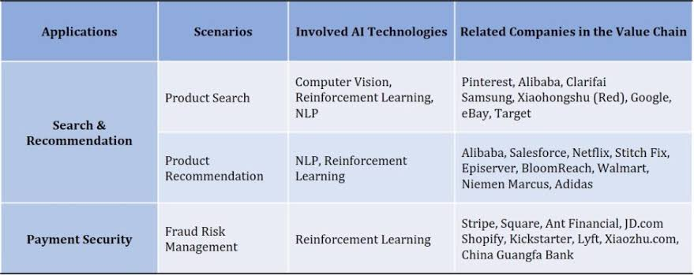
Applications in Ecommerce
AI applications have ability to change visualizations, identifies patterns and creates personalized experiences.
Few applications are as follows
- Artificial Intelligence Assistants and Chatbots
Chatbots have played major role in Ecommerce sector. Using AI and NLP chatbots have become more popular. Due to increase of smartphones, chatbots became easier to ease.
For example, Yana chatbot with 100% AI and no human interference. Yana helps users to book cabs, order groceries etc. It receives more than 50,000 messages at time.
- Smart Logistics
Smart Logistics include automated warehousing. AI automates warehouse operations and delivery processes. AI converts collecting the data and analysing inventory management. It uses computer vision. For example, Jd.com
- Recommendation Engines
Artificial Intelligence identifies customer’s behaviour. For example, LensKart.com uses Intelligent frames recommends customer to best suite on one’s person. Amazon and Netflix Artificial Intelligence to improvise one’s efficient behaviour.
- Image Search
AI services makes work easier. This makes better understanding of images. Buyers can make better visualization of products.
- Handling Customers data
It is more important to handle customer data for services. AI handles entire information and manages for future purpose.
AI Case Studies
- Amazon
Alexa is best example of AI implementation and becomes most popular product all over world. AI helps to predict customer’s attraction based on their searches and thus becomes best example all over world with best marketing strategies. Amazon scales up increase in sales.
- Stitch Fix
We need personal stylish reviews whether the outfit is looking good or not. Stitch Fix provides clothing recommendations applying stylish algorithms. It follows up with personal recommendation and can erase own history data.
- Alibaba
Alibaba is well known for its famous chatbots namely T- mall Genie assistant and Ali assistant. It is claimed that 95% of customer inquiries are solved by this chatbots. Alibaba implements AI algorithms which helps to create internal and customer service operations like product recommendations.
- eBay
eBay uses eBay Shop-bot as core and integral part of site. Shop-bot helps customer for finding the products which they are looking for. It is actual implementation of NLP. Customers can communicate via text, images and SMS.
Areas covered by Ecommerce
Almost every sector was covered by Ecommerce generally divided into four main sectors of Ecommerce.
- Digital Marketing/Marketing Automation
Marketing is core for any business to attract customers. Using Artificial Intelligence it will reduce repetitive tasks to attract customer and convince them for buying product. Automation helps to build personalized one to one connection and to attract more customers. We have many tools namely Marketo, etc.
- Salesforce Automation (CRM)
Sales related term we assume it is related to organize and managing data. It forecasts and generate reports for sales management. CRM tool is responsible to manage customers data, main aim is to keep all data related to customers that has detailed locations and can be shared for further processing.
- Data Analytics
Data Analytics is essential component of Ecommerce sector. It segregates data into different patterns , ratios, averages etc.

- Customer Support and Service
AI has changed entire system whenever customer need service they get that service on time. Due to chatbots it identifies customers issues etc.
Impact of AI in Ecommerce
Adopting AI in Ecommerce has its own impact and benefits. Impact of AI explained below.
- Personalized Recommenders
Many ecommerce sites store customers searches along with previous product recommendations. Gap between retailers and consumers using AI tools. Few tools are Personali.ai and Choice.ai helps to construct personal experiences by collecting and analysing data.
- Visual Search
Ecommerce enables AI functionality in their businesses. Visual Search means customer will search a particular product and then it enables adding product in cart. AI software will thus identify brand name etc,
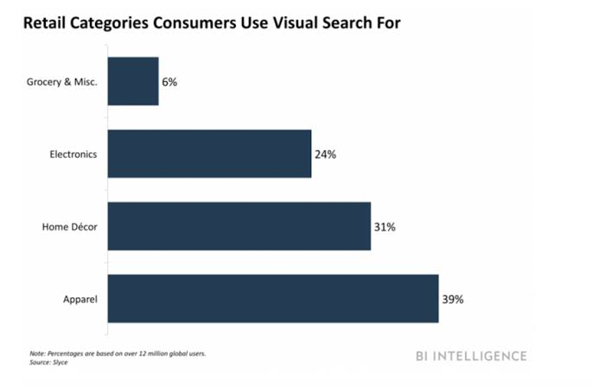
Fig-2
- Voice Commands APIs
By 2017, more than 50 percent people used voice commands as it is easier. Ecommerce sites implemented this feature such as Easy-Talk.
- Virtual Shopping Apps
In Ecommerce sector, virtual reality is different. Many ecommerce stores started their own virtual shopping. Alibaba was first to create first virtual experience Buy+ in 2016 it indicated virtual products from top stores. Now a days we have VR development.
- Autocomplete Search Plugins
Main goal for any ecommerce sites to create best experiences to their customers resulting in more sales. Through this feature one can find n number of products related to only one letter. Many tools are initialized with company developed mainly Nexotopia and Loop54.
AI in Ecommerce Benefits
AI in Ecommerce has great influenced all over globe. Few benefits are listed below.
- Creating Customer centric search
Customers are always disappointed because they don’t get accurate result for which they are looking for. AI uses NLP which keeps improvising data. It matches with keywords and give accurate result.
- Retargeting its potential customers
Customers have stopped buying because of its services. AI helps to retarget the customers by providing better service.
- Identification for exceptional targets prospects
Ecommerce websites keep a note of customers who has visited their site more, thus providing them with offers, discounts etc.
- Creating more efficient sales process
Ecommerce websites influences by sending posters , advertisements over social media .
Example: Snap-Chat, Instagram, Facebook advertisements are provided whenever we surf .
- Create a new level of personalisation across multiple devices
As traditional shopping, we have to visit particular store and then buy that product. But in Ecommerce we can access any shop online whether by mobile app or websites.
- Provide personal touch with chatbots
Chatbots makes easier as it is available by 24/7 services. They are designed to solve queries etc.
- Filter Fake reviews
This is the most important benefit is to filter fake review. Business rivals adds wrong reviews to make their sites fail.
- Intelligent Agents
New Intelligent agents have become most important tool in Ecommerce. It has 3 main terms: matching buyers and sellers, facilitates transactions and providing infrastructure.
Conclusion and Future scope
I want to conclude that AI has emerged on high scale but it is still far for being implemented. According to me Ecommerce industry should continue use of AI tools along with partner up with companies to create more precise solutions. Many experts concluded that future of AI and machine learning has potential to change usage. As our paper defines impact and benefits of Ecommerce. It has more concerned over reliability and cybersecurity will continue future. AI trends and machine learning hold business growth minimizing risks. I believe AI in ecommerce impacts transaction, customer retention, satisfaction etc. AI is a place where we buy and sell online. So are you ready to take business to next level AI.
Future AI in Ecommerce
- Connecting offline channels with online Ecommerce retailers:
This will benefit both online and offline retailer. Both will earn and make profits.
- Data-driven Customization:
Personalized recommendations based on customer data.
- Human in the loop:
AI tools require human expertise for functioning.
Appendix
In fig 1 it depicts basic AI methods along with AI technology. It involves generally along recommendation engines, searching algorithms whereas in fig 2 it depicts how visual search works in Ecommerce.
References
- Prof. Lakshmi Narayan. N | Naveena. N "A Study on the Applications and Impact of Artificial Intelligence in E-Commerce Industry" Published in International Journal of Trend in Scientific Research and Development (ijtsrd), ISSN: 2456-6470, Volume-3 | Issue-5, August 2019
- Yashoda Kiran Lingam. The role of Artificial Intelligence (AI) in making accurate stock decisions in E-commerce industry, International Journal of Advance Research, Ideas and Innovations in Technology
- Vinita Mishra , Bhavika Adnani , Hema Lulla , Priya Vidhrani “ Artificial Intelligence based Bank Cheque Signature Verification System “International Journal for Research in Applied Science & Engineering Technology (IJRASET) ISSN: 2321-9653; IC Value: 45.98; SJ Impact Factor: 6.887 Volume 7 Issue IV, Apr 2019
- J SRINIVASAN, R DEEPIKA, SREEDEVI AND ARTHI JONE “ARTIFICIAL INTELLIGENCE OF E-COMMERCE PLATFORM” Asia Pacific Journal of Marketing & Management Review ISSN 2319-2836 APJMMR, Vol.7 (8), AUGUST (2018), pp. 1-11
- Ahmed Hamza Osman, Naomie Salim and Albaraa Abuobieda “Survey of Text Plagiarism Detection” Computer Engineering and Applications Vol. 1, No. 1, June 2012
- Weber, F.; Schutte, R. A Domain-Oriented Analysis of the Impact of Machine Learning—The Case of Retailing. Big Data Cognitive. Computing. 2019, 3, 11.
- Madhurima Khosla, Harish Kumar "Growth of E-commerce in India: An Analytical Review of Literature" IOSR Journal of Business and Management (IOSR-JBM) e-ISSN: 2278-487X, p-ISSN: 2319-7668. Volume 19, Issue 6. Ver. I (June 2017), PP 91-95
IMPACT OF ONLINE SHOPPING
Abhishek .V.Tripathi¹ and Dr. Hiren Dand²
Student¹ and Head², Department of Information Technology, Mulund College of Commerce, University of Mumbai, Mumbai
Abstract
An online shopping is a system that allows customers to book products online for items or a service from a store that serves to both walk-in customers and online customers. Online shopping is becoming a new trend of shopping nowadays & is also becoming an important part of lifestyle. Due to wide spread of internet usage by people and e-commerce usage by traders, online shopping has seen a huge growth in recent years. Majority of online buyers are young people & hence this study finds out the aspects of customers towards the online shopping. The customers not only use internet to buy products online but also to compare prices, product features & after sale services facilities they will receive if they purchase the product from the particular stores.
- INTRODUCTION
Online shopping is a type of e-commerce which permits consumers to directly purchase products from a seller by using the Internet.Other names are: e-shop,e-store,Internet shop, web-store,virtual store and online store.An online shop shows the similarity of purchasing products as well as services from internet shop and this way/system of shopping is known as business-to-consumer online shopping.Online shopping is the process in which consumers decide to buy the product through internet.
Internet has developed into newly distributive channels for varieties of products. Using the internet for shopping online has become a primary reason to use the internet, along with searching of products and details about them. Therefore internet has developed a massive competitive market, where the competition against consumers is severe.
Nowadays, customers can make online shopping using different computers and mobile devices, including desktop , laptops, tablet computers and smart phones i.e. All Electronic Gadgets. Infact, we can even purchase the grocery products online for daily use. Earlier food, cloth & shelter were called as primary need but today one more need is added i.e.INTERNET. The popular online retailing companies in India are Amazon.in /Amazon.com, Flipkart, Snap deal, Myntra& E-Bay, etc. The five important factors which attract consumer perceptions for online shopping are information, easy to use, satisfaction, security, proper utilization of available information to compare the different products.
- Review of Literature
Online or Web Shopping is a type of electronic trade which permits customers to purchase merchandise or administrations from a seller over the Internet utilizing a web program.
2.1. Advantages
- Convenience-Nowadays, Internet is becoming one of our basic needs. Many customers have Internet access at home and work too.And, onlineshopping stores are available 24 hours a day. Any user can access and make purchase from anywhere.
- Data and Surveys-The presentation of Online stores for a particular products to be purchased by customers with content, photographs and sound documents, whereas in a physical world a customer can directly access the product before purchasing. The online shops give detailed information about the seller, makers, the honest reviews of customers, etc.
- Cost and Choice–Different varieties of products are available on online stores. Customers can easily compare number of products and make their best choice. Also, the discounts available are much better than compared to offline retail shops
- Some other Advantages-Saves time and efforts.,Good discounts,online tracking and many more.
2.2. Disadvantage
- Delay in delivery
- Lack of significant discounts in online shops.
- You cannot feel and touch the merchandise
- Less interaction.
- Less shopping experience.
- Objectives of Study
- To study what age group makes most use of online shopping.
- To study how often the consumers do online shopping.
- To study the preference of the consumers between Shopping and Offline shopping,
- To study why user prefer online shopping on offline shopping.
- To study what products do users go for in an online shopping?
- Source of data
The data for the study on Impact of Online Shopping has been collected by using Google Forms.
- Universe of the study
The universe of the study consists of all the users who use internet.
- Sample size and Sample study
Total 38 people submitted the survey form on which this study was conducted.
- Data Representation Tools
The collected data is classified into bars, Pie chart and chart diagram.
- Importance of Study-
The study is done to know the impact of online shopping. How is it useful or harmful for any individual?. Are the customers satisfiedby making online purchase?.What problems dooffline shop owners face due to online shopping system? What products do customers mainly buy from online stores?. Which age group makes more Online purchase?
Data Interpretation
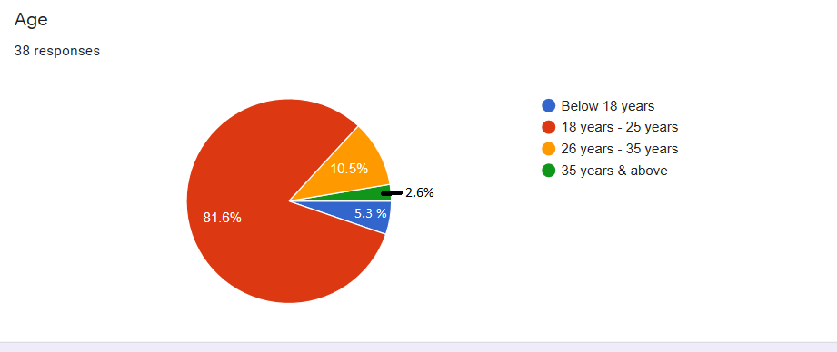
The above Pie diagram, shows that the participants of this study were mainly of 18-25 years with 81.6%. Also, the age ranging of 26-35 years consists second most participants for this study with 10.5%. And remaining 7.9% were from the age ranging of below 18 years and above 35 years.
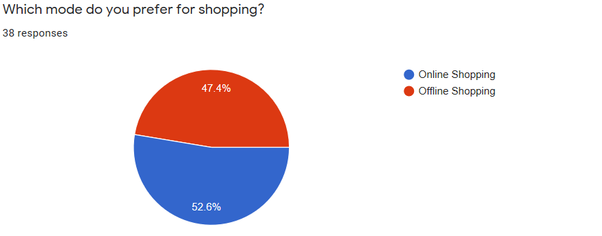
The above diagram shows that from 38 participants 52.6% prefer online shopping and remaining 47.4% prefer Offline shopping.
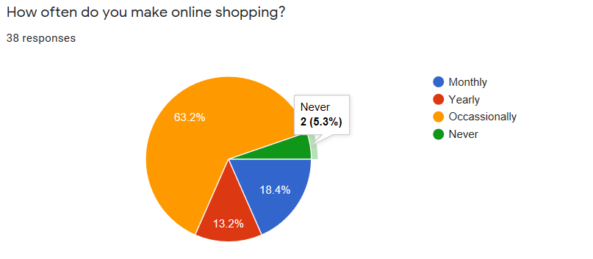
The above Pie diagram sows that te participants of this study mainly shop online occasionally with 63.2% followed by 18.4%, 13.2 and 5.3% who make purchase Monthly, Yearly and never respectively.
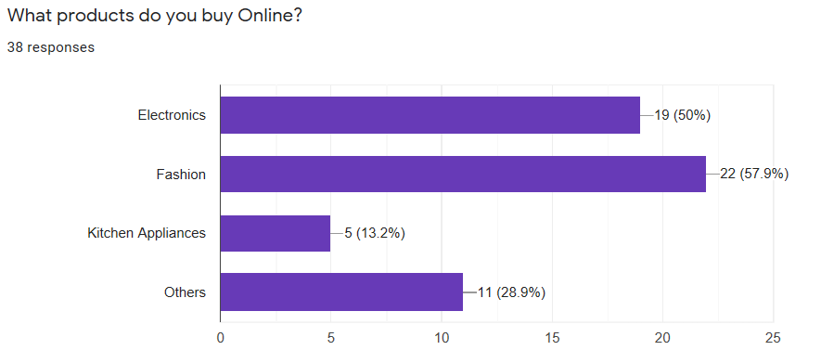
The above bar chart shows that 50% users prefer to buy electronic items,57% users love to buy Fashion accessories,13.2% users gofor buying Kitchen appliances and 28.9 % user buy other products rather the Electronics,Fashion and Kitchen Appliances.
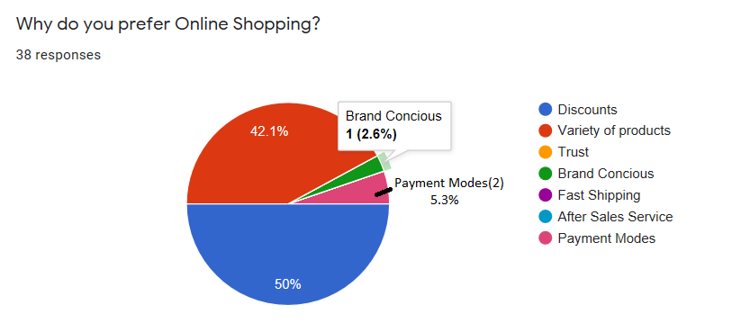
As per the above pie diagram, 50% of users prefer shop online because of discounts. 42.1% users shop online because of Varietyof products available. The remaining 7.9% prefer online shopping because of Payment modes and Brand Conscious.
- Conclusion
According to the study, majority of users prefer onlineshopping more useful and convenient rather than Online Shopping.The user make shopping whenever they have any requirements but majority users purchase occasionally some also make purchase monthly, yearly and some never shop online because they prefer offline shopping. They mainly prefer to buy Electronics, Fashion accessories and Kitchen Appliances.
- References
- Ps://en.wikipedia.org
- Srinivasan, R. Online social media and networks: Impact on marketing practice. The AMA Journal Reader, 2014.
- Oestreicher-singer G, Libai B, Sivan L, et al. The network value of products. Journal of marketing, 77(3), 1-14, 2013.
- Ho-DacNN, Carson SJ, Moore WL. The effects of positive and negative online customer reviews.
- Sridhar S, Srinivasan R. Social influence effects in online product ratings. Journal of Marketing, 76[5], 70-88,2012.
- Ludwig Stephan, Ko de Ruyter, Mike Friedman, Elisabeth C. Bruggen, Martin Wetzels, and Gerard Pfann, “More Than Words: The Influence of Affective Content and Linguistic Style Matches in Online Reviews on Conversion Rates,” Journal of Marketing, 77, 97-103, January 2013.
- Adams, D.A., Nelson, R. R., & Todd, P.A. (1992). Perceived usefulness, ease of use, and usage of information technology:A replication. MIS quarterly, 227-247.

Neural Scene Representation and Image Synthesis
Deepak Shah¹ and Dr. Hiren Dand²
Student¹, Department of Information Technology, S.K Somaiya College of Arts Science and Commerce, University of Mumbai, Mumbai
Head², Department of Information Technology, Mulund College of Commerce, University of Mumbai, Mumbai
ABSTRACT
Scene representation—The process of converting a visual sensory data into concise descriptions—is a requirement for intelligent behavior. Recent work has shown that neural networks exceed expectations at this assignment when given with huge, labeled datasets. Be that as it may, removing the dependence on human labeling remains a critical open issue. The GQN takes as input pictures of a scene taken from distinctive perspectives, builds an inner representation, and employments this representation to anticipate the appearance of the scene from already unobserved viewpoints. The idea of this research paper is an attempt is made to train the neural network to render images.
Keywords: Neural scene representation, Generative Query Network, prediction of an object using the image.
INTRODUCTION
People give more attention when it comes to how we get it a visual scene our brains draw on prior data to reason and to create inductions that go distant past the plans of light that hit our eye retinas. Example: you enter a room for the first time, you immediately perceive the things it contains and where they are situated. If you see three legs of a chair, you may think that there's probably the fourth leg with the same shape and colour covered up from see. Indeed, in case, you can’t see everything in the room, you’ll likely be able to outline its format, or envision what it looks like from another point of view. The visual and cognitive assignments are easy to people, but they speak to a noteworthy challenge to our counterfeit frameworks.
Nowadays., with the increase in technology the state-of-the-art and visual acknowledgment frameworks are prepared to utilize expansive datasets of commented on pictures delivered by people.
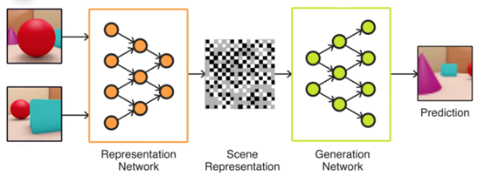
Fig. The overview process of Neural scene representation.
Procuring this information could be an expensive and time-consuming handle, requiring people to name each aspect of each protest in each scene within the dataset. As a result, regularly as it were a little subset of a scene in general substance is captured, which limits the fake vision frameworks prepared on that information.
RESEARCH METHODOLOGY
The Generative Query Network (GQN), a system inside which machines learn to speak to scenes by using as it were their claim sensors. The GQN takes as the input picture vector of a scene taken from a particular viewpoint, builds an internal representation, and deploys this representation to anticipate the visual of that scene from already unobserved perspectives. The GQN illustrates representation learning without human intervention or domain information, clearing the way toward machine learning.
The GQN show is composed of two parts: a representation organize and a generation arrange. The representation organize takes the agent's perceptions as its input and produces a representation (a vector) which portrays the essential scene. The generation network at that point forecast (‘imagines’) the scene from an already unobserved viewpoint.
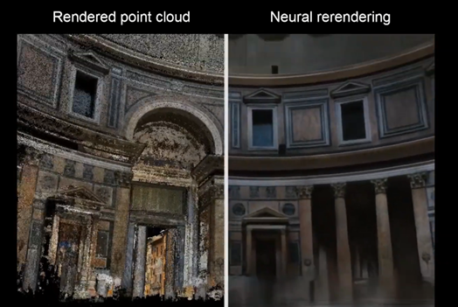
Fig. Represents the Original image and Neural rendering image.
• The representation network is unaware of the perspectives that the generation network will be questioned to anticipate. As an outcome, it will deliver scene representations that contain all data (e.g., object identities, positions, colours, counts, and room layout) essential for the generator to create precise picture predictions. In different words, the GQN self-learn what these variables are, as well as how to extract them from each and every pixel it forms. Besides, the generator understands any statistical regularities. e.g., typical colours of the object, as well as object shape and symmetries, patterns, and textures) that are common across different scenes.
• The GQN manifest several important properties
1. The GQN’s generation network can ‘imagine’ already unobserved scenes from new perspectives with remarkable precision. When given a neural scene representation and a new camera angle, it creates sharp images without any prior determination of the laws of perspective, occlusion, or lighting.
2. The GQN’s representation can learn to count, localize and classify objects without any object labelling. Even though its representation can be tiny, the GQN’s predictions at query viewpoints are profoundly exact and nearly indistinguishable.
3. This suggests that the representation network sees precisely, for occasion recognizing the exact arrangement of pieces that develop the scenes.
4. The GQN can represent, degree and diminish vulnerability. How the image forms, what its size will be and where it will be located? It is competent in accounting for vulnerability in its convictions almost a scene indeed when its substance is not completely obvious, and it can combine numerous halfway sees of a scene to create a coherent entirety.
5. The GQN’s representation permits for robust, data-efficient reinforcement learning. When given a GQN’s compact representations, the state-of-the-art deep reinforcement learning operators learn to allocate their tasks in a more data-efficient way compared to the model-free pattern operators.
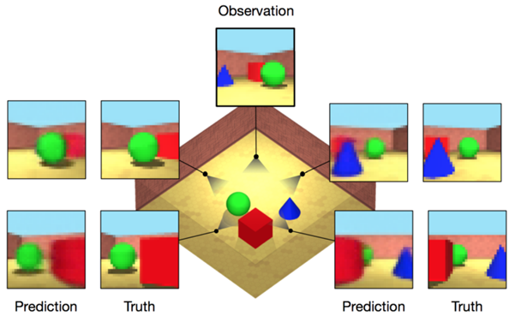
Fig. Neural scene representation and image synthesis with multiple objects.
RESULTS AND ANALYSIS
• To evaluate the possibility of the system, we tested with a collection of situations in a recreated a 3D environment.
• We consider a scene where square room contains different types of objects such as Walls, tables, windows, chairs textures - as well as the shapes, positions, and colours of the objects and lights - are randomized. In this case, we have used finite datasets to train and test the model.
• After training, the GQN computes its scene representation by watching one or more pictures of an already encountered, given out test scene. With this representation, which can be the as small dimension, the generator’s predictions at query viewpoints perspectives are highly accurate and for the most part identical from reality.
• Unlike in traditional supervised learning, GQNs learn to form these inferences from images without any human intervention on the scenes. Also, the GQN’s generator learns an inexact 3D renderer (in other words, a program that can produce a picture when we have a scene representation and camera perspective) without any prior specification of the laws of viewpoint, impediment or lighting.
• When the contents of the scene are not extraordinarily indicated by the perception (e.g., sense of overwhelming impediment), the model’s vulnerability is reflected within the changeability of the generator’s tests. These properties are best observed in real-time, intelligently questioning of the generator.
• Analysis of the prepared GQN highlights a few desirable properties of its scene representation network.
• To verify whether GQN learns a factorized representation, we made some changes to a single scene representation property (e.g., object colour) while keeping other settled (e.g., protest shape and position), leads to comparable changes in the scene representation. We found that object color, shape, and measure; light position; and, to a lesser degree, question positions are indeed factorized.
• We also detected that the GQN can carry out ‘scene algebra’. By including and excluding representations of related scenes, we found that question and scene properties can be controlled, indeed over question positions. At last, since it may be a probabilistic model, GQN moreover learns to coordinated data from diverse perspectives proficiently and reliably.
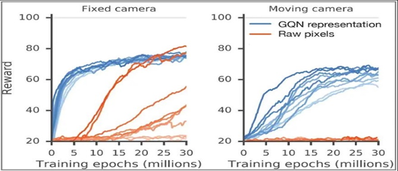
Fig. Represent the analysis of the neural scene with a fixed camera and moving camera.
CONCLUSION
Our work illustrates an effective and a powerful way to machine learning of grounded Neural Scene representation and rendering of an object, and of the related recognition frameworks that comprehensively extricate these representations from images, clearing the way towards completely unsupervised scene understanding, imagination, arranging and behaviour. Total scene understanding includes more than a fair representation of the scene’s 3D structure. In the future, it'll be imperative to consider broader angles of scene understanding – e.g., by questioning over both space and time for modelling of dynamic and instinctively scenes – as well as applications in virtual and extended reality, and examination of synchronous scene representation and localization of perceptions.
Our experiments have in this way distant been limited to manufactured situations for three reasons:
1. A need for controlled examination,
2. Cconstrained accessibility of reasonable real datasets, and
3. Limitations of generative modelling with current equipment.
FUTURE SCOPE
1. This AI technique is useful for finding ways to recover the details from a blurry pics and videos from historic monuments.
2. With this technique, one can unobserved scenes from new perspectives with an remarkable precision useful in medicinal practices, Sonography, Dermatology etc.
3. Tracking exact, end-to-end following and exact, real-time, and chronicled areas for devices, individuals, and things. Power-efficient, dependable positioning empowers following on a really worldwide scale.
4. It can be useful in self-driving vehicles and AI-based Live Sense.
5. Crime scene discovery and crime scene examination which can be valuable for examination purpose.
6. Engineering and pharmaceutical can also use this technology and obtain benefits from a different perspective.
7. It can be also useful in weather forecasting and agricultural practices.
REFERENCE
1. Biederman, I., Recognition-by-components: a theory of human image understanding (1987).
2. TIMOTHY B. LEE Google researchers created an amazing scene-rendering AI (2018).
3. S M Ali Eslami, Danilo Jimenez Rezende, Google deepmind Neural scene representation (Jun 2018).
4. Krizhevsky, I. Sutskever, G. E. Hinton, NIPS ImageNet classification with deep convolutional neural networks (2012).
5. MAX NIHLÉN RAMSTRÖM Sketch to 3D Model using Generative Query Networks (Apr 2019).
6. S. M. Ali Eslami, Danilo J. Rezende, Frederic Besse, Fabio Viola, Ari S. Morcos, Marta Garnelo, Avraham Ruderman, Andrei A. Rusu, Ivo Danihelka, Karol Gregor, David P. Reichert, Lars Buesing, Theophane Weber, Oriol Vinyals, Dan Rosenbaum, Neil Rabinowitz, Helen King, Chloe Hillier, Matt Botvinick, Daan Wierstra, Koray Kavukcuoglu, Demis Hassabis Neural scene representation and rendering (Jun 2018).
7. Alexander Keller Jaroslav Křivánek Jan Novák Anton Kaplanyan Marco Salvi, Machine Learning and Rendering 2018.
8. C. Ledig, L. Theis, F. Huszar, J. Caballero, A. Cunningham, A. Acosta, A. Aitken, A. Tejani, J. Totz, Z. Wang and W. Shi Photo-Realistic Single Image Super-Resolution Using a Generative Adversarial Network (2017).
9. Vincent Sitzmann, Michael Zollhöfer, Gordon Wetzstein, Scene Representation Networks: Continuous 3D-Structure-Aware Neural Scene Representations Jun 2019.

Challenges & Best Practices in Mobile Application Development: A Review
Prathamesh Kashinath Kadam and Shivraj Kashinath Kamble
Department of M.Sc. IT, S.S. & L.S. Patkar Varde College, University of Mumbai, Mumbai
Abstract
Now-a-days there is a rapid increase in mobile application development in industries. There are various challenges like acceptance of GUI, understand ability of the services delivered, compatibility with varying Smartphone architecture, ease of navigation, aesthetics and flow of controls and menu, portability, security, reliability, etc. that are to be considered with seriousness in order to avoid any kind of vulnerability or failure.Mobile applications are of great importance as they are providing various features which are of great use for us like-use of navigation for finding particular location, online shopping, online movie tickets booking, etc. There are various challenges that are to be faced during these applications development. In this paper, we will focus on covering up all those challenges and the best practices that can be performed in order to tackle those challenges.
Keywords: Mobile application, Mobile Application Development, development challenges, best practice.
I. INTRODUCTION
Nowadays users are expecting from their mobile phones to function almost similar to that of a desktop computer systems. But due to complex methodologies of mobile application development, it makes it more challenging than the desktop computer system. Mobile Application Development is a process of building up application software for mobile phones devices & for doing so development environment with specialized integration is used which are Android Studio or Eclipse is required. But while doing this, there are various parameters like OS, Processing Power, memory, compatibility, etc. are to be considered firstly. These apps should be interactive, easily downloadable through various platforms such as Google Play Store and iOS App Store.
There are various challenges like reliability, availability, security, robustness and usability which are of major concern while developing and deploying an application. There is a scarcity in the methodology adopted w.r.t the advancement in mobile application development due to lack in research methods and analysis about challenges that might occur during mobile application development process.
V. Rahimian and R. Ramsin[1] look through the challenges in mobile application development by considering the current state of mobile development techniques. Leigh Williamsons listed unique challenges for Mobile Application Development like- form factors, user input technology, usability and user interaction designs [2]. Similarly J. Dehlinger & J. Dixson found 4 major challenges for mobile application development engineerings.This challenges were found by them while creation of universal users interfaces, while trying to enable software reusability via various platforms, while context-aware designing mobile app and in agility balancing and requirement uncertainty[3].
This research paper focuses on the challenges faced during mobile application development & ultimate practices to overcome those challenges.
II. CHALLENGES WITH THEIR BEST PRACTICES IN MOBILE APPLICATION DEVELOPMENT
There should be more focus on “what not to do” rather than “what to do” while developing an application. Some of the challenges are discussed in this paper along with their best practices in order to overcome those challenges.
- Improper Resource Estimation
It occurs is the beginning phase of mobile application development. If the business is not aware of required requirements and resources, it will easily deviate. It is considerably challenging for few developers to analyse these requirements and resources.
BEST PRACTICES-There should be proper business plans and logics to be discussed in a and recorded according to customer’s requirements and feedbacks. This approach requires proper and better user communication, partial resource operations and repetition of assessments to be followed in each interval of time.
- Scheduling of Time and Cost
Due to low budget and funding there are many mobile apps projects which became unsuccessful. Many people think that developing a mobile application is not that costly, but it actually depends upon the application and its feathers. A developer working on a lower or limited budget tends to deliver a low quality product. This is similar w.r.t time too. If a developer isn’t given a proper time for developing an application, there is a high chance of getting an incomplete or poor quality product.
BEST PRACTICES-Proper plan should be made according to the appropriate time and cost over each activities to be executed. All the features or enhancements to be made are to be noted and accordingly necessary plans are to be made.
- Selection of Target User
Before developing mobile application, a group of target user is to be considered. Lack of analysis and foresight will make the application to be of lower value in the market. According to the target user interest the application is to be made. If there is lack in this selection, the development is already going in the wrong direction.
BEST PRACTICES-Users feedback is the best way to overcome this challenge. This will enable us to not all know the target user but also will tell us which feathers the target users are interested in. This will help us to know the features to be needed in our application.
- User Interface
User interface is one of the important things in mobile application development. The front end design should be compatible with all the devices screen resolution. Generally a developer forgets about user interface and focuses moreover the features to be needed. This makes the application hard for user to understand and handle, which indirectly reduces its value in the market.
BEST PRACTICES-Developers team should avoid using too many resources, rather analyse those resources and build up a simple and clear design for the mobile application.
- Performance vs Battery Life
Performance and Battery life is one of the main challenges for developers while developing mobile application. Developers generally focuses on better performances of an application, which generally ends up with mobile getting heated up due to lots of power consumptions because of application performances. This generally lets to user’s switching better and similar application which reduces the power consumption and heating of mobile phones.
BEST PRACTICES-Developers needs to consider the battery life applicable for most of the devices. According to that battery life, application performance should be decided, rather than just focusing over the performances and ignoring devices battery life.
- Memory Space
More the feathers, more the application size increases. Developers generally try to implement and integrate multiple features in one application, avoiding the main objective features. This lets to maximization of application size and application occupying lots of devices memory space.
BEST PRACTICES-The best way to overcome this challenge is to focus over the main objective features of an application, rather than adding too many features into it. While updating of an app, the old data should be completely replaced with the new data, rather than keeping unwanted old data attached to the new updated application which results in increase in application memory space.
- Security & Privacy
Importance of security and privacy is increasing day-by-day. There is a chance of device being used by an unauthorized user. This is the a bit challenging as there are many devices along with its operating system. Developers generally end up making the privacy terms and conditions complex to user understanding. Data transmission as well as servers of application should be preserved and protected for securing user data.
BEST PRACTICES- Privacy terms and conditions should be displayed to the user in proper and simple designs, using simple language, make it easy to access. Data transmission and servers of an application should be protected using appropriate security measures and guarantee user’s accountability.
- Data Synchronization and Access
Mobile devices are good enough to access data, either from the application or from the browser. Application built should be created which can keep track of data being accessed from application database and should understand the connection being built via database. If the connection is disconnected, it should be able to reconnect to its last existing data and update the application data accordingly.
BEST PRACTICES-Proper synchronization of data is necessary when we are dealing with application data being send via network. Encryption is the best possible way to overcome this challenge along with proper synchronization of data in order to update and access the application data.
- Methods for Providing Input
It is difficult to provide an input via a keypad to the user. Also not many users are good with using keypad keys efficiently. Hence providing a method for an input is not that easy challenge to deal with.
BEST PRACTICES-We can enable user to give proper input via using a touch gesture rather than keypad. This will make it easier and attractive for the users to use the application easily and efficiently.
- Problems in Testing
It is challenging for developers for testing mobile application because of various operating systems, platforms, it makes it very difficult to perform testing. Various factors like VPN dropping, wireless network connectivity, and application altering process are also to be considered while testing. It is necessary to find whether there is any problem with hardware of the device or with the network connectivity of that device by testing all of these above factors.
BEST PRACTICES-Testing is to be performed in every phase of development in order to avoid errors or problems in further phases. Testing should be performed on every platform and also in different locations for different browsers verifications. If all of these factors are accomplished we can say that the app is ready and effective for deployment process.
III. CONCLUSION
Mobile applications nowadays offer various functionalities that it has become a part of our life. There is a tremendous rise in mobile application which makes it more challenging to make a bug free, efficient, user-friendly and useful application. Developers should follow all the best practices discussed in this paper in order to overcome the challenges.
This paper has discussed real challenges and best practices generally occurred to mobile application developers. If this best practices are properly implemented for the given set of challenges, it will provide a best product from it.
REFERENCE
[1] V. Rahimian and R. Ramsin, “Designing an agile methodology for mobile software developments: A hybrid method engineering approach” in Proceeding of Second International Conference on Research Challenges in Information Science, RCIS (2008), Marrakech, 2008, pp. 337–342.
[2] Leigh Williamsons, “A mobile application development primer. A guide for enterprise teams working on mobile application projects”. IBM Whitepaper, 2012.
[3] J. Dehlinger and J. Dixson,”Mobile Application Software Engineering: Challenges and Researches Directions”, Workshops papers. Oct 2011.
[4] Prof. K.D. Tamhane, Mr. Wsim T. Khan, Mr. Sagar R. Tribhuvan, Mr. Akshay P. Burke, Mr. Sachin B. Take,” Mobile Learning Application”, International Journal of the Scientifics and Research Publication, Volume 5, Issue 3 March 2015
[5] Venkatas N Inukollu, DivyaD Keshamoni, Taeghyun Kang and Manikanta Inuskollu, “Factor Influencing Quality Of Mobile Apps: Role Of Mobile App Development Life Cycle”, International Journal of Software Engineerings & Application (IJSEA), Vol.5, No.5, September 2014
[6] A.M. Vainieo, T. Tuunannen, P. Abbrahamsons, “Developing Software Product for Mobile Market: Needs for Rethinking Developmental Models and Practices”, in Proc. of the 38th Hawaii International Conference on Systems Science (HICSS'05), Jan. 2005.
[7] M. Palmierii, I. Sing, and A. Ciccheti,“Comparisons of cross-platform mobile development tools,” in Intelligence in Next Generations Network (ICIN), 2012 16th International Conference on, 2012, pp. 179 –186.
[8] S.B. Kalel, "Applying Agile Methodology in Mobiles Software Engineering: Android Application Developments and its Challenge", 2013.

Calculate the Waiting time of patients in hospital by using¬ Random Forest (RF) algorithm and Creation of HQS system
Shubhangi Eknath Zaware¹ and Abhijeet Kale²
Student¹ and Head², Department of Information Technology, B. N. Bandodkar College Science, University of Mumbai, Mumbai
Abstract
Patients hold up postponement and patient congestion is one of the significant difficulties looked by medical clinic. A patient is conventionally required to undergo sundry examinations, inspection or tests according to his conditions. This waiting time increases the frustration on patients. Patient Queue Management and wait time presage form challenging and perplexed job because each patient might require different phases and operations such as check-up and sundry tests. Desultory Forest (RF) Algorithmis utilized for Data mining of immensely colossal data Furthermore, this implementation can withal be applied to Time Prognostication. Utilization of HBase will give historical data of patients. HQS and RFA are parallelized on Hadoop Platform. Android Platform is utilized for providing Graphical Utilizer Interface.
Keywords: Big data,Cloud computing,Hospital Queue Suggestion (HQS),Hadoop, Random Forest(RF) algorithm.
1. INTRODUCTION
At present, most medical clinics/Clinics are packed and they are not productive in giving apt line the executives. Providing Patient queue management and waiting time presage is challenging and tedious job as each patient vary in different operations such as check-up, Multiple tests like X-ray, CT-Scan, blood tests, sugar-levels. Some of the tasks are independent whereas some tasks are waiting to consummate other dependent tasks.
Most patients must need to hang tight in various lines for various medicines. So as to finish required treatment in a most brief length of time holding up time of each assignment is anticipated progressively. PTTP calculation is proposed as learning calculation for figuring the holding up time. [1] Patient Treatment Time Prediction(PTTP) uses RF calculation for its execution. In light of this Hospital Queue Suggestion (HQS) framework is analyzed. In the Computer System we have mostly three sorts of Resources, they are Software, Hardware and Data. Information is the most significant asset of PC framework, since whatever processing we are doing is a result of information.
The huge unstructured information is called Big Data. Essentially. [2] The term huge information implies huge volume of information as well as different highlights that separate it from the ideas of ''huge information or huge volume of information''. [3] Now in present days extremely less measure of information is created in organized structure as contrast with unstructured information for example Content records, sensor information, log information, web information, person to person communication information or various assortments of information. For Big Data the executives Hadoop is utilized. Hadoop is a system that gives appropriated preparing of huge informational collections crosswise over bunch utilizing a straightforward programming model. It is open source information the board which uses conveyed processing.
2. LITERATURE SURVEY
Tolerant line the board and hold up time expectation structure a difficult and complex activity in light of the fact that every patient may require various tasks, for example, a test, different tests, e.g., a sugar level or blood test, X-beams or a CT examine during treatment. So there are five significant philosophies utilized in this framework Big Data the board with Historical Dataset, Preprocessing of information, Use Learning Algorithm PTTP(patient Treatment Time prediction)with base of RF (Random Forest) Algorithm Calculate the Waiting Time in Hospital Queue Suggestion. An arbitrary timberland advancement calculation is performed for the PTTP model. The line holding up time of every treatment task is anticipated utilizing the prepared PTTP model. A parallel HQS framework is presented, and an effective and helpful treatment plan is suggested for every patient. The patient may experience different treatment activities, for example, CT check, MR filter and an installment task. These arrangement of treatment activities are submitted to chief and Suggestion module by means of portable interface. After this a treatment Suggestion with least holding up time is exhorted.
[1] A large portion of the cell phones have worked in sensors that can quantify movement, area, direction and different other natural conditions. These sensors can furnish crude information with high exactness and precision for deducing and perceiving lining conduct. Besides we saw that individuals oftentimes convey cell phones when they are not at home. We can utilize a cooperative methodology for lining acknowledgment dependent on cell phones by following lining rules(First Come First Server). We can utilize a model of QueueSense with customers on cell phones which utilizes Android stages and a server in cloud. Cell phones utilize generally accessible sensors, for example, accelerometer, Bluetooth and compass to detect singular exercises. Lining highlights are determined dependent on lining properties regarding singular exercises and bolster vector machine(SVM) is utilized to consequently identify whether the individuals are lining or not on cell phones. The cloud backend process multi-lines situations and give estimation of line length and holding up time. Agglomerative progressive bunching is utilized on server side to partition queuers into various lines dependent on changing pace of relative situation of queuers.
[2] Emergency clinic Information for the most part contains a data frameworks, for example, Electronic Medical Records(EMR) and Picture filing And Communication System(PACS).Hospital information is focus by and immensely colossal stores the Structured And Unstructured Data. Most information utilized in the EMR is Structured Data which incorporates data of a patient, data of a treatment, analytic data and the reports. This above information is put away in the hadoop group with the assistance of a JDBC/ODBC interface and afterward the information is put away in a HDFS with the assistance of a MAPREDUCE and the HIVE .The Structured information in the HDFS is composed utilizing a HIVE and its SQL like Query language HQL.
[3] Information is Processed in the framework we have to give a sodality with the database then we have to check a presence of a table at that point we have to include a Partition else we have to make a Table and afterward we have to include a Partition. at that point simply update the information generally compose the information. and afterward we have to detach with the database.
[4] Hadoop is a structure which gives disseminated handling of huge informational collections crosswise over bunch utilizing a basic programming model. Principally Apache Hadoop Framework comprises MapReduce and Hadoop circulated record framework. Hadoop disseminated record framework, as Map diminish give a straightforward programming model well as other related activities for example Apache Hive, Apache HBase and so forth. The fundamentally three significant parameters of hadoop group; they are CPU, MEMORY and DISK. Every one of the hubs are committed to work for the hadoop errands as it were. This can be helpful for productive administration of group to give limit, adaptability and execution of bunch with the end goal that provisioning of assets will be efficient.
[5] Enormous measure of information is made by clients in day by day life. which requires tremendous measure of capacity and different procedures to find information from information. Hadoop engineering is of two principle parts HDFS(Hadoop Distributed File Sysytem) and Mapreduce for Big Data Analytics. There are different advances has a place with Hadoop Hbase for putting away huge dataset, Apache pig is scripting language for handling of enormous informational collection, Hive is intended for OLAP is quick and Scalable, Scoop is utilized for import and fare information from RDBMS to Hadoop, Zookeeper is utilized for circulated application and flume is for moving huge measure of information to brought together data.
[6] Arbitrary woods is most famous information characterization and relapse calculation for AI. This framework presented a Scalable Random Forest Algorithm which depends on MapReduce Technique .The calculation is isolated into three phases: instating, creating and casting a ballot. SMRF calculation has primary goal of improving the conventional arbitrary woods calculation dependent on MapReduce model. SMRF calculation give versatile execution, and it can haggle with the circulated processing situations to choose its trees scale.
3. PROPOSED SYSTEM
In light of the overview we have comprehended that the framework will deal with organized information including tolerant data, treatment data, analytic data and reports. The framework stores information in Hadoop group by the utilization of JDBC/ODBC interface in Thrift and after that it stores information in HDFS by Mahout and Hive. For preparing reason we use RF calculation and we create HQS framework for patients. Patients can check their holding up time by utilizing cell phones and subsequently can diminish their disappointment.
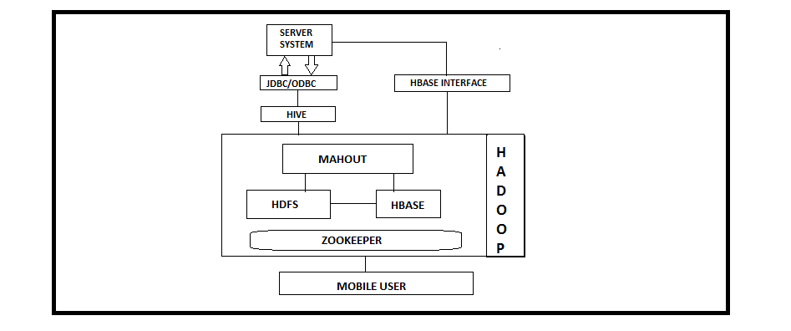
Fig -1: Diagrammatic representation of the proposed system.
4. CONCLUSION
In this paper we have looked into on the advances which are being utilized for emergency clinic lining conduct. further we have acquainted various systems utilized with execute them. Present strategies incorporate hadoop, sql, Hbase, RF calculation. Later on we have looked at the changed procedures utilized by specialists in their frameworks, for example, augmentation in RF calculation, putting away of structure information into the database and so forth. This correlation will help us in building our framework increasingly advantageous and valuable. From the examination we have proposed the framework which will anticipate time required for specific undertaking.
REFERENCES
- Kapil_Pandey, Anand_Gadwal, Prashant _Lakkadwala ,"Hadoop Multi Node Cluster Resource Analysis ",2016 Symposium on Colossal Data Analysis and Networking (CDAN)
- Qiang_Li, Qi_Han, Limin_Sun, "Collaborative Recognition of Queuing Behavior on Mobile Phones"2015 IEEE Transactions on Mobile Computing.
- JIANGUO_CHEN 1,2, (Member in IEEE), KENLI LI1,2, (Senior Member in IEEE), ZHUO_TANG1,2, (Member in IEEE), KASHIF_BILAL3,4, AND KEQIN LI1,2,5, (Fellow, IEEE)
- Aditya_Bhardwaj, Vanraj, Ankit_Kumar, Yogendra_Narayan, Pawan_Kumar, “Big_Data Emerging Technologies: Case Study with Analyzing Twitter Data using Apache Hive”, Proceedings of 2015 RAECS UIET Panjab University 21-22nd December 2015
- Hong_lei_Zhang, Peng_fei Li, Xin_hang Li, Sheng_qiang Chi, Jing_song Li*,"Design and Implementation of Clinical Data Center Based on Hadoop"; 7th International Conference on Information Technology in Medicins and Educations.
- Jiawei_Han, Yanheng_Liu, Xin_Sun," A Scalable Random Forest Algorithm Based on MapReduce",2013 IEEE.
- International Journal of Science and Research(IJSR).

Robotic Surgery- Overview of the Past, Present and Future
Siddhi Kondlekar¹ and Dr. Hiren Dand²
Student¹ and Head², Department of Information Technology, Mulund College of Commerce, University of Mumbai, Mumbai
ABSTRACT
Robotic surgical studies have been conducted for over 25 years. At that time a small number of companies were established and conducted clinical trials on patients. However, far more clinical applications have been performed than is expected from the study activity level.
This paper addresses several reasons for this, many of which are the result of clinical and business environments that are not related to technology. Suggestions are made that will increase the number of clinical systems that will be implemented and provides an outline of the progress and evolution of surgical robots and discusses future innovative possibilities.
Keywords: Robotic surgery, Healthcare, robotic technologies.
1. NTRODUCTION
Robotic surgery, today, doctors can operate successfully in the most complex, and precision cases. Case in point - the Da Vinci robot. Robotic surgery is also widely used in hair transplant procedures as it involves elaboration and layout. In today's robotics is in the lead in the field of operation. AI-powered robotics and ML algorithms improve the accuracy of surgical instruments by incorporating real-time surgical metrics, data from successful surgical experiences, and data from pre-op medical records within the surgical procedure.
The FDA approved robotic surgical treatment with da-Vinci Surgical Structure in 2000. Hospitals in US and Europe quickly adopted the technique for use in dealing with a wide series of conditions. The most often used clinical surgical system contains camera arm and machine-driven weapon with associated surgical instruments. The surgeon controls the army while sitting at a computer comfort near the operating table. The comfort gives an overview, magnified, 3-dimensional assessment for surgery on the surgical site. The surgeon takes charge of other staff who help during the operation.
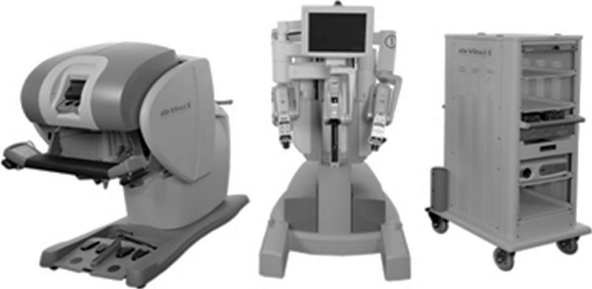
2. WHY ROBOTIC SURGERY?
- It is a less invasive procedure and it is easier to use robotic arms than the tools in endoscopic surgery.
- Accurate and precise disintegration and escape.
- 3D vision right on the front of the eye as it is the whole field is in front of surgeon’s face functional area. This makes it easy to focus on.
- Moreover, it reduces tremors and manual activities that may reduce the intensity of surgery.
- Each dangerous portion of the body is hard to find it can be easily accessed with the help of a robotic arms.
- Reduced trauma for the body.
- Blood loss is frequently less and the need for a blood transfusion.
- Less discomfort and postoperative pain.
- Less risk of infection.
- Remain shorter in hospital.
- Faster recovery and coming back to everyday life Activities.
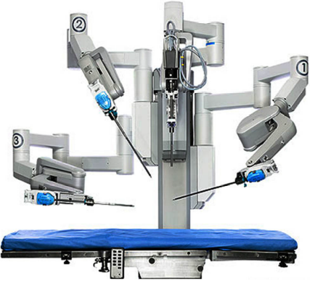
Control of camera and 3 arms
3. BENEFITS OF ROBOTIC SURGERY
- The most frequently mentioned benefits for robot surgical treatment are that it can produce exact invasive surgery that can be actively manipulated in a safe region.
- Complex routes can be undertaken particularly using flexible snakelike hands to reach areas that cannot be found.
- Numerous and repetitive offerings do not fatigue and compensate for organ motion due to heartbeat or breathing.
- Different purpose robots can allow surgery within a narrow stomach of an x-ray scanner or MR.
- Compared to traditional open, robotic surgery results in smaller crises, reducing pain and scarring, resulting in less time spent in hospital and faster recovery times.
- However, it only gives benefits to the patient. Your surgeon also benefits greatly from robotic surgery, getting greater accuracy, flexibility, control and vision.
- It also allows your surgeon to perform very complex or multipart surgical procedures which may be very hard or dreadful even without the aid of the robot.
4. CHALLENGES&FUTURE OFROBOTIC SURGERY
There are many challenges to these techniques.
- Robotic surgical systems are expensive. It requires desirable capital investment, in the range of $ 1.3 million.
- Large robotic prints and large robotic arms are too large for a robotic surgical system This is an important disadvantage today is the office room is crowded. It can be difficult to fit the surgical staff and robot to enter the workroom. The price of making a room for the people of the theater and the cost of robots is the costly technology.
- Current technology utilizes manual transformations that take significant amounts of time. When instruments are changed, the time for change is likely to be substantially reduced.
- One of the important disadvantages identified was the absence of unmatched instruments and equipment. Inadequate tools increase reliance on table assistants to perform some of the surgery. However, this is a temporary drawback because new technologies are and will be developed to address the deficiencies.
- Robotic surgery requires extra training until it is excellent. The FDA requires producers to carry out trainers earlier they can use robotic operating systems patients. One expert says that it usually takes 12-18 surgeons are uncomfortable and before the surgeons are able to perform the procedures as quickly as they are with standard techniques.
Robotic surgery is a long way to go to research is progressing to eliminate its disadvantages. A main issue is that the landlord is still in the locality of the patient. Robotic controls can be exact over long distances of fiber optic chains. However, the time interval in such a system among the robotic surgeon who commands by joystick and the robot's action can be important and relieve the patient. Power loss is an area of concern as in electrical failure. The progress of wireless order reservations will remove these blockages and make it clear that robotic surgeons can work over long distances.
Future progress in robotic surgery will consist of wireless time delay, voice commands, touch and integration with a magnetic resonance image. Magneto image imaging allows for open observation within a catchment area. In addition, it extends the range of provision for chemical processes within the body. Work is underway to merge robotics technology with this reduction so that malfunctions can be detected within the body and corrected on time in a much better way than at present. Robotic surgery with attendance voices will allow surgeons to do their effort with a few people. They will be able to switch and controller conditions directly at the same period they operate the levers.
Robots will not accept human knowledge, skills and experience in the foreseeable future. They will extend indefinitely human capacity and robotic surgery will continue to promote the boundaries of medical science.
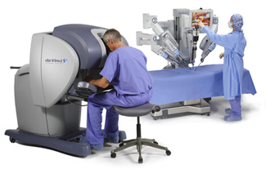
5. ETHICAL AND SAFETY CONSIDERATIONS
Robotic surgery can be done across the nations, deeply under the thesis and in external space. Such robotic surgery actual unnecessary controls will particularly require skilled personnel near the patient who can accept it in an emergency and can help the surgeon in the remote location. Reminders by robotics require authorized and ethical issues that need to be fixed before technology is implemented. Following part of the issue:
- When there is marginal benefit through the usage of robots, is it ethical to impose a financial burden on patient imperative systems?
- If surgery fails with the help of a robot due to technical difficulties, is the surgeon responsible for her?
- If units are placed in different countries, are not subject to ethical and regulatory considerations?
6. CONCLUSION
Super human movements, accuracy and precision are the promises that make robotic surgery us today. Robotic Surgical systems enable surgeons to perform microscopic tasks with more accurate and sharper impairments, which improves cosmetic, reduce the pain of the operation and reduce length of stay. Surgical progress on the invasiveness focused on minimalizing the surgical procedures, so that a number of procedures have changed significantly with no further contact with the structures they operate. Due to the progress made in vision-imaging, in laparoscope technology and in instrumentation, many procedures can be converted into several surgical specialisms from open operations to endoscopic ones.
Over the earlier, robotic technology has been greatly refined and smaller instruments have become smaller, that is, even newborn babies and children have greater dexterity, accuracy, stability and access. Such progress will enable continuous development in surgical tools and surgical care. But, to build on its success in the past and to fully control the possible of surgical robotics in the upcoming, it is necessary to maximize mutual communication and understanding among healthcare surgeons, engineers, industrialists and administrators.
Analytic and satisfying modalities can be focused by enhanced future research such that investigation can be on remote navigation and the surgery becomes a true reality. depend on the same factor.
REFERENCES
- Raj Kumar Pal, Sanjeev Kumar and Dr. Amod Kumar, “The Journey of Robotic Surgery,” Central Scientific Instruments Organization, Sec. 30 C Chandigarh, India.
- Arun Prasad, “Robotic Surgery in India”, Journal of Young Medical Researchers, Vol. 1, No. 1, Aug-Feb 2013, e4.
- Camarillo DB, Krummel TM, Salisbury JK. “Robotic technology in surgery: past, present, and future”. Am J Surg. 2004
- C. Avery, “Robotic surgery-the brave new world,” Physician-News for Medical staff, Residents, Fellows & Alumni October 2006 vol. 12, no. 9.
- D.B. Camarillo, T.M. Krummel, J. K. Salisbury, “Robotic technology in surgery: past, present, and future, The American Journal of Surgery188 (Suppl to October 2004) 2S – 15S.
- J. Ma, P. Berkelman, “Task Evaluations of A Compact Laparoscopic Surgical Robot System,” Proceedings of the 2007 IEEE/RSJ International Conference on Intelligent Robots and Systems San Diego, CA, USA, Oct 29 - Nov 2, 2007.
- Dachs GW, Peine WJ. A novel surgical robot design: minimizing the operating envelope within the sterile field. Proceedings of the 28th IEEE. 2006; New York City, USA: 1505-08.

Role of social media in digital marketing and impact on customer
Tanuja Deshmukh¹ and Dr. Hiren Dand²
Student¹, Department of Information Technology, Vikas college of Arts Science and Commerce, University of Mumbai, Mumbai
Head², Department of Information Technology, Mulund College of Commerce, University of Mumbai, Mumbai
Abstract
Digital advertisement or marketing is the avenue of digital verbal exchange that's utilized by the marketers to advise the products and the offerings toward the market. The ultimate cause of the virtual marketing is concerned with clients and allows the customers to intermingle with the product via virtue of virtual media. This research concentrates at the importance of digital promotion for both clients and marketers. The patron are searching and looking greater on net to find the high-quality deal form the sellers round India as compared to standard or conventional strategies specially through social media. The main purpose of this paper is to Shifting from the technology of conventional or mass media, by using using social media in virtual advertising.
Index Terms: - Internet, Digital Marketing, Marketing strategies
I. Introduction
Digital advertising is regularly referred to as 'on line advertising and marketing', 'net advertising and marketing' or 'net advertising'. The time period virtual advertising has grown in reputation through the years, mainly in sure nations. In America on line marketing is still standard, in Italy is referred as web advertising however inside the UK and global, digital advertisment and market has emerge as the maximum commonplace time period, in particular after the yr 2013.Digital advertising and marketing is an umbrella time period for the advertising and marketing of services or products using digital technology, especially at the Internet, however additionally consisting of cell phone, display advertisement, or any other medium. The way wherein digital advertising has developed considering the1990 and 2000 has made a way for the manufacturers and corporations utilize era and virtual marketing for their advertising. Digital advertising campaigns have become extra established in addition to green, as digital structures are increasingly incorporated into marketing plans and ordinary existence, and as humans use digital devices instead of going to bodily stores[1].A few corporations have revolutionized the way; internet is used in advertising, along with Google, Alibaba, Amazon and the Youtube. Marketing is a stressed, converting, and dynamic business activity. The position of advertising itself has changed dramatically because of numerous crises - cloth and energy shortages, inflation, monetary recessions, high unemployment, demise industries, death companies and effects because of rapid technological adjustments in sure industries [2].
Engagement with the social net manner that clients and stakeholders are active contributors in preference to passive visitors. Social media usage in an enterprise or political way gives all citizens to specific and share an idea approximately a company's merchandise, offerings, enterprise practices and government movement. Each taking part purchaser, non-client, or consumers who is collaborating on the internet via social media turns into part of the advertising branch (or an assignment to the advertising effort). Whereas as other customers examine their fine or poor comments or opinions. Getting clients, capability purchasers or citizens to be engaged on line is essential to a success social marketing. With the invention of social marketing, it has become important to advantage client interest in products related services. It can ultimately be translated into shopping for conduct, or vote casting and donating conduct in a political context. New on-line marketing ideas of engagement and loyalty have emerged which intention to construct patron participation and emblem recognition. Social media advertising is using social media systems and websites to sell a services or products. Most social media places has integrated facts analytic equipment, which enable groups to song the development, success, and engagement of advert campaigns. Companies cope with a range of stakeholders through social media advertising, consisting of contemporary and ability customers, current and ability personnel, newshounds, bloggers, and the overall public. On a strategic degree, social medium advertising and marketing consists of the management of a advertising and marketing advertising campaign, governance, setting a scope (e.G. More lively or passive usage) and the hooked up order of a organization's preferred social media "subculture" and "tone."
Social media and virtual advertising and marketing sports are very vital, it is no longer handiest for gaining sales, however additionally to lessen the price of traditional advertising and marketing activities. The big marketing budget that originally for traditional marketing activities can be shifted to activate the digital marketing strategies, because by going digital we can check how much the frequency of the customer that get our advertisement, how their buying and lifestyle behavior, etc[3]. The facts emerging from a survey show how social media facilitate the social interaction of clients, main to accelerated consider and aim to shop for. The consequences also display that trust has a enormous direct impact on purpose to shop for. The perceived usefulness (PU) of a internet site is likewise diagnosed as a contributory thing .The widespread availability of the internet has given humans the possibility to use social media, from electronic mail to Twitter and Facebook, Instagram and to engage without the want for bodily conferences [4].
II. Review of Literature
A quantity of research papers and articles provide an in depth insight on Internet Marketing. The findings from the literature are offered under:-
Researchers along with Castro nova and Huang (2012)keep that advertising and marketing strategies involving advertising intelligence, promotions, public members of the family, product and consumer control, and advertisement and market communication ought to start exploring and leveraging social media, no longer most effective because there may be a growing hobby among clients in Internet utilization, but additionally because of the truth that consumers take into account information sharing on the social media accounts as extra dependable than statistics issued without delay by ﬁrm.
With the advances within the net and the emergence of Web 2.Zero, the inter connectivity among people has elevated on the net. This improvement permits customers and corporations to collaborate at the internet. This has emerged through social media, which permit purchasers to generate content material and have social interactions on line thru social systems. There are ample amount of social systems which have allowed information transfer. For example, Wikipedia, a loose online encyclopedia, is a famous platform and also has the ability for customers to collaborate on records sharing. Other systems with the potential to generate evaluations and ratings, which include Amazon,com, permit customers to review.
III. Objective
- The main purpose of this paper is to contribute more to technology, research on Digital Marketing using social media for Customer satisfaction and growth of business
- To understand the usefulness of digital advertising inside the aggressive market and impact of digital marketing on purchasers.
IV. Methodology
This methodology is divided into description, steps and results.
- Description
Social media is the most vital part in today's marketing world. No matter the age group, to achieve an effective marketing strategy one will have to include the prospect of social media in their business. With the ease of accessing internet the count of social media users in India stand at 327.1 million in the year 2018 and it is expected to rise up to 448 million by 2023. Increased availability of net connections and get admission to in latest years, propelled by way of the valuable government's Digital India initiative became at once proportional within the increase of social media users. As of 2017-18 statistics, Facebook remains the most sought out platform for digital marketers but Instagram, WhatsApp and many more platforms are adapting to the change and making themselves readily available to the users in marketing business.
- Steps
There are many ways to go with the process of digitizing your businesses. First and foremost people have been using till now was creating a page on Facebook and promoting their business. Adding your website links or mentioning the address to your company helped a lot in promoting and attracting customers. Similarly one can use Instagram for making pages and post pictures of your business to build a good digital marketing strategy. Instagram has a tag feature which has basically revolutionized the way to connect to different people with same interest. You can follow tags or use them in your posts which collectively joins range of posts together of same topic. This helps in contacting people as well connecting with them. Marketing strategists has been using this technique in evolving their business to a whole new level. Following Instagram, many other social media giants like Whatsapp, Telegram, etc. has started adding the concept of marketing strategies for their users. Whatsapp has recently started the usage of business accounts where the user can declare their contacts as official business details and communicate with clients professionally. One can even create groups with large number of recipients to post pictures and other essential details of their business. In this race of digitizing the world, none want to be left behind and everyone is struggling to come at the top.
- Result
Social media has been growing throughout the last three years and businesses have noticed it. Here are some facts that have resulted from social media marketing:
1. The number of total mobile social apps users is 3.4 billion worldwide equaling 42% penetration.
2. Nearly 1 million humans used cell social media for the primary time each day in 2018 and has promoted their enterprise on it.
3. Users use an average 69% in their active time on smartphones which leads them to upcoming the web enterprise extra than the ones they are able to find close to their homes.
4. There at the moment are greater than 50 million small organizations using Facebook Pages to hook up with their customers
5. 78% of those who complain through their Twitter count on a reaction inside an hour. This means that humans accept as true with on line agencies have credibility and they are able to expect appropriate and timely services from them.
6. Top manufacturers on Instagram are looking an in step with-follower engagement price of 4.21% which is 58 times higher than on Facebook and one hundred twenty instances higher than on Twitter
7. Products had been the top content kinds for the pinnacle two hundred worldwide brands in terms of engagement, at 60% in 2015 beating life-style class with the aid of over 20%.
V. Conclusion
Social media is increasingly getting used as a customer service platform where clients and ability clients need solutions fast and in real-time.
It is quickly turning into the most vital component of digital advertising and marketing, which provides top notch blessings that help attain tens of millions of customers worldwide and if you aren't making use of this profitable source, you're missing out a superb marketing opportunity, as it makes it easy to unfold the word about your product and mission.
There isn't any doubt that Social media marketing has many blessings for new companies and known manufacturers By normal update in the right social apps advertisement approach, it will lead to multiplied visitors, better search engine optimization, advanced logo loyalty, more healthy patron pride and plenty greater. Your competition is growing on social media each day, so don’t let your opponents take the customers. The earlier you begin, the quicker you spot the growth for your enterprise.
VI. References
[1] Sathya "A Study on Digital Marketing and its Impact” DOI: 2, February 2017; Volume 6
[2] Dr. Madhu Bala,Mr. Deepak Verma " A Important Review of Digital Marketing" DOI:10, October 2018; Vol. 8
[3] Sarah Silvia "The Value of Social Apps and Digital Advertisement to get Millennial’ Behavior as a Consumer" DOI: 2, 2019; Volume 4
[4] M. Nicks Haji "A study of effects on the social media clients
[5] Chas, Jiyounig. 2009. “Shopping on the Social Networking Websites:Attitudes towards actual versus virtual items.”Books of the Interactive Advertising, 10: 77-93.
[6] Chi, Hsu-Hsien. 2011. “Interactive VS. Brand Community: Explanation of the User Guide and the Social Apps Market Response of Taiwan.” Journal of Advertising 12: forty four-sixty one.
[7] Heinonen, Kristina. 2011. “Consumer interests in social media: Manager approach in the customers’ social media and its behavior.” Journal of the Consumer Behavior 10: 356-364.

Security Risks Over Smart Home Automation
Deepkumar Patel¹ and Dr. Rajendra B. Patil²
Student¹ and Head², Department of Information Technology, S.K Somaiya College of Arts Science and Commerce, University of Mumbai, Mumbai
Abstract
This paper introduces an extensive depiction about various home automation frameworks and advances from a security and hazard angle. The work features different security defects and hazard in existing home automation frameworks. In our work, we address how the idea of security and in this way the significance of "gatecrasher" have advanced after some time. We inspect the difficulties in home computerization dangers and their security. The work proceeds to clarify why home automation systems are obvious objectives for an assailant. We bring up the job of client hazard in home automation framework. Rundown of home computerization advancements considered in our work incorporate setting mindful home automation frameworks. The work finishes up by clarifying future headings Security and Risk over home automation framework Research could take.
Index Terms: Home automation, Data Security, Risk Detection, User Interfaces.
1.0 INTRODUCTION
The logic of Smart home automation has been around since the late 1980s. In any case, with the headway of innovation, individuals desires for what a home ought to do or how the administrations ought to be given and got to at home has changed a ton over the span of your time, at that point has the idea of home automation frameworks. On the off chance that we take a gander at various Smart home automation frameworks after some time, they have constantly attempted to give proficient, advantageous, and safe ways for home occupants to get to their homes. Independent of the adjustment in client desires, progression of innovation, or change of time, the job of a brilliant home automation framework has continued as before.
The "Keen House." For some, it is the perfect of what a home could be. Regardless of whether it is vacuuming, doing the dishes, or killing every one of the lights naturally when you aren't at home, a house that deals with its own tasks has been a fantasy for quite a long time.
From Rosie in The Jetsons, to Pat in the apropos named Smart House, a progressively astute home has consistently appeared to be simply distant. While home automation innovation has come in gradual advances, it had quite often been incredibly costly for any important gadgets. In any case, in the course of the most recent quite a while costs have dropped, and request has detonated, prompting a market immersed with gadgets promising to robotize everything without exception that has a power rope.
The way that many decide to purchase savvy home automation gadgets, as cutting edge security frameworks, to make their family increasingly secure is commendable. Be that as it may, this paper tries to investigate how purchasing certain shrewd home computerization gadgets, for example, different Wi-Fi empowered center points and controllers, can really make one's home and life less secure.
2.0 SMART HOME AUTOMATION SYSYTEM
A smart home system is an automation and technical solution that enables automating the number of electronic, electrical and technology-based action within a home. By using a combination of hardware and software technologies it controls and manages over appliances and electronic devices in the home. Home automation is otherwise called demotics, and a home with automation framework is otherwise called a brilliant home. A portion of the procedures inside home automation framework structure, usage and upkeep include:
- Establishment of PC control for warming, ventilation and cooling frameworks.
- Web/remote/arrange access to all introduced segments and hardware
- Establishment and upkeep of system empowered observation cameras and physical security frameworks.
- Focal control and the board capacities over electrical installations and electronic machines.
Gadgets inside the home automation framework interface and speak with each over a neighborhood wired or remote system. The whole home computerization framework for the most part requires framework the board programming, establishment of gadget/apparatus controllers, movement and temperature sensors and different segments.
In home auto mation system there are many types which are:
■ Context-aware Home Automation Systems
■ Controller-based Home Automation System
■ Bluetooth-based Home Automation System
■ GSM or Mobile-based Home Automation System
■ SMS-based Home Automation System
■ GPRS-based Home Automation System
■ Internet-based Home Automation System
3.0 INTERNET SECURITY
Prior to PCs, a person's close to home data was put away on paper. On the off chance that a lawbreaker needed to take somebody's close to home data, they needed to go to that individual's home, and Take the documents and papers that had the ideal data. With the coming of the web, current society has moved the putting away of significant data onto PCs. Regardless of whether it is Standardized savings numbers or Visa data, a large number of individuals presently store their data either promptly on the web, or in a gadget that is associated with the Internet.
Digitizing our data has been without a doubt the most noteworthy advance so far of the Web, yet with this progression has come noteworthy dangers and perils. To this end, ongoing investigations
Show that like clockwork, an American has their personality taken.[2]
For the normal client of the Internet, the guarantee of accommodation and the charm of new innovation was more significant and more discussed than any potential security dangers. While he requirement for encryption in web and other web traffic has been known for quite a long time, across the board organization of what is really a fundamental security necessity didn't happen until 2013 in light of the NSA spying disclosures, and still stays inadequate.[10]
4.0 RISKS OVER HOME AUTOMATION
we are now going into another period, in which we are taking the gadgets of our lives and tying them into the Internet as quick as makers can dispatch items. Once more, the appeal of comfort eclipses the topic of whether these gadgets are secure. Similarly as clients of the web ought to have been educated regarding the natural dangers before they became clients, home automation clients presently ought to ask exactly who they are confiding in their home system with before they join some organization's "shrewd" gadget.
Prior to proceeding, it is imperative to initially explain that the security of a gadget is unique in relation to a security gadget. A security gadget may be a home alert framework, that identifies if a window is broken or an entryway opened However, that gadget's security alludes to what protections exist to keep a pernicious client from hacking into the gadget itself. For example, if that security framework has an application for a client's telephone, and the application imparts to the framework over decoded stations, at that point a malignant client may have the option to catch the correspondence, or even profess to be the client and shut off the framework remotely or accomplish something different totally. The potential outcomes are startlingly inestimable.
The significant takeaway here is that there is a certain threat in interfacing anything to the Internet. On the off chance that a gadget can be come to by its planned client from anyplace on the planet, that implies that some other client can conceivably get to it also. Take for example Insecam.org. This site keeps up a rundown of thousandsof webcams that clients have associated with the Internet without including any kind of secret word assurance. [8] The proprietors of these cameras ordinarily have no clue that anyonecan get to their camera and view it continuously. Is it their flaw for not seeing how this innovation functions? Is it the flaw of the organizations who make these cameras for not making it compulsory to set another secret key to utilize the camera? These are questions that are being approached past the point of no return for those clients.
A shaky webcam is surely disrupting, however somebody with a computerized home may inquire as to whether any programmer would even need to get to their WiFi empowered lights, or check the temperature of their fridge. In all honesty, the appropriate response is yes. There is consistently somebody who might be listening who needs to break into another person's framework, regardless of whether it is to carry out a wrongdoing, demonstrate that an issue exists, or simply flaunt their own abilities. Tragically, this isn't simply theory. Security vulnerabilities in many home automation items have just been found, and could be misused to genuine impairment.
In 2014, security specialists at IOActive, Inc. revealed different vulnerabilities in Belkin WeMo Home Automation gadgets, one of the most well known items in the home automation field. [7] WeMo offers different various items, including electrical plugs and light switches that clients can remotely turn on and off with a cell phone application. The vulnerabilities found were at first anticipated to influence upwards of 500,000 clients, [9] and enable assailants to:
● Remotely control WeMo Home Automation appended gadgets over the Internet [7]
● Perform noxious firmware refreshes [7]
● Remotely screen the gadgets (now and again) [7]
● Access an inner home system [7]
The effect of these vulnerabilities was possibly gigantic. Belkin rushed to guarantee clients that they had fixed the defects, [4] however the truth of the matter is that the blemishes were at one point there. On the off chance that they had been found sooner, these vulnerabilities enabled any WeMo gadget to be controlled from an aggressor anyplace on the planet. Not exclusively did the issues with security enable an assailant to control anything that was connected to a WeMo gadget: assaulting the WeMo gadget likewise gave an aggressor a decent footing in the WiFi arrange the gadget was running on, possibly taking into consideration spread of extra infections, worms, or other malware.
This was not a disconnected occurrence. Security scientists at Trustwave discovered vulnerabilities in numerous other keen home gadgets, including the mainstream Insteon HUB, which enables clients to remotely control lights, carport entryways, and different gadgets. ^{[1]} The framework was left crawlable via web indexes, and Insteon didn't require usernames and passwords of course. The impact of this being by basically looking through the correct example on Google and clicking a connection, anybody on the planet could remotely control these gadgets, no hacking information required by any means. [5]
5.0 CHALLENGES IN HOME AUTOMATION
Information, data, video or sound feeds accessible from home are quite often close to home. Almost all shrewd homes are associated with the Internet every minute of every day. This enables an assailant to be anyplace on the planet can in any case be focusing on the home. In addition, an assailant would cherry be able to pick the snapshot of assault. Home computerization frameworks don't have a devoted framework overseer, in contrast to a conventional system, which implies that aggressors can do their "foot printing" effectively with similarly less checking. At the point when the system is undermined, there is likewise almost no possibility of identification. A mortgage holder who is additionally the framework chairman might be hesitant to do the overhauls or fixes important, similar to a property holder's hesitance to do the pipes. Also, home automation frameworks could look confused to a common non educated property holder. Home automation frameworks for the most part comprise of gadgets having a place with various makers. Every accompany its own vulnerabilities. Also, home occupants who are not specialists on systems administration or security do the redesign or reconfiguration of their own home systems, not at all like scientists do in the labs, which gets its own arrangement of vulnerabilities. An aggressor consistently has the decision to filter the Internet for a particular weakness having a place with a particular home computerization gadget from a specific maker. An assailant can keep up the filtering procedure until finding the particular defenselessness they are hoping to misuse.
By and large, money is the main concern or inspiration for the basic mortgage holder while picking diverse home computerization items. They are either ignorant, misguided, or couldn't care less enough about different security dangers. Homes are utilized by individuals everything being equal; individuals with and without specialized foundations, individuals of various age bunches both youthful and old. In addition, a house is required to have visitors. Property holders can't anticipate that these individuals should be cautious about security. Devices associated with home systems are versatile like cell phones, PDAs, and so forth. These gadgets remain with the client any place they go and are associated with different systems. An assailant attempting to bargain a home automation framework could utilize these compact gadgets as a door to the home when they are associated back to the home. Clients are increasingly thoughtless about their telephones, more so than they are about their physical home. Most mortgage holders execute a type of access control systems to shield individual information from visitors and other people who approach the home. Their entrance control parameters are regularly convoluted and hard to actualize from a building viewpoint. A portion of the entrance control parameters incorporate what all's identity is available while getting to the information, why and where the information is being gotten to, and which gadgets are utilized to get to the information. While actualizing access control, the property holder likewise needs to consider the social ramifications of denying information access to a visitor. A visitor may feel offended, so the proprietor may need to think about the visitor's sentiments. The proprietor may need to change get to control polices regularly, which, if not appropriately settled, proposes a major security danger. So as to stay away from such confounded social circumstances T.H Kim et al. [19] thought of Clairvoyant Access Right Assignment (CARA), which lessens the weight of designating every asset to singular visitors on the property holder. CARA awards access to home assets dependent on the proprietor's social remaining with their visitors. The social standing is gotten from long range informal communication destinations, Instant Messaging Services, proprietor call logs, and Short Messaging Service (SMS) logs. This is a hazardous point of reference, as we realize that person to person communication locales are powerless against hacking, and individuals can control the proprietor or profess to be a companion. Also, dear companions on informal organizations could drop out with one another rapidly, however CARA isn't prepared to effectively deal with the circumstance. Social standing acquired from the long range interpersonal communication locales and visit logs are not constantly exact, either. Individuals can talk a great deal as an aspect of their responsibilities or as a feature of a contention and still not be companions. Besides, smart aggressors can start and keep the proprietor talking or make him start correspondence. The equivalent applies for telephone discussions too. Individuals don't utilize SMS messages any longer, they use administrations like WhatsApp. Presumptions dependent on emojis and shortened words could not be right, also. Individuals have their own style of composing; a few people use emojis and shortened words more than others. The exploration done by M.L Mazurek et al. [20] demonstrated that there is a major distinction between a client's psychological model (what client believes is actualized) of access control and the entrance control and safety efforts that are really executed.
6.0 CONCLUSION
On the off chance that security in the Smart Home Automation field is to improve, buyers need to get instructed, and vote with their wallets. Purchase just those items that assurance 100% start to finish encryption. Search for items that are open source. As a matter of fact find out about the organization, and the morals and practices that they cling to. Find out about the item update cycle. Will the item's firmware be redesigned if a weakness is found? On the off chance that the appropriate response is no, you ought to presumably consider purchasing something different.
In any case, maybe the most significant thing shoppers need to do is to just be mindful of the way that connecting your home to the web opens up a universe of new perils. Indeed, even the best organizations commit errors, and there is no assurance that even the most profoundly taught buyer can counteract purchasing an item that effectively gets hacked. Know about the exchange offs you are
Making among security and comfort for each new gadget you add on to your system. Each WiFi center point or Bluetooth empowered light is a potential helplessness to your system, and the entirety of the gadgets on it.
REFERENCES
[1] "Home Automation Systems Rife with Holes, Security Experts Say." Constantin, Lucian, 30 July 2013.
[2] Ellis, Blake. "Identity Fraud Hits New Victim Every Two Seconds." CNNMoney. Cable News Network, 6 Feb. 2014.
[3] "Global Home Automation Market to Reach US$21 Billion in 2020." Global Sources. N.p., 13 Mar. 2015.
[4] Goodin, Dan. "Password Leak in WeMo Devices Makes Home Appliances Susceptible to Hijacks (updated)." Ars Technica. N.p., 18 Feb. 2014
[5] "When 'Smart Homes' Get Hacked: I Haunted A Complete Stranger's House Via The Internet." Hill, Kashmir. Forbes, 26 July 2013.
[6] "Home Automation and Control Market worth $12.81 Billion by 2020." Markets.
[7] "IOActive Lights Up Vulnerabilities for Over Half a Million Belkin WeMo Users." IOActive, 18 Feb. 2014.
[8] "Network Live IP Video Cameras Directory Insecam.com." Insecam. N.p., n.d.
[9] Smith. "500,000 Belkin WeMo Users Could Be Hacked; CERT Issues Advisory." Network World. N.p., 18 Feb. 2014
[10] Timberg, Craig. "Net of Insecurity." Washington Post. The Washington Post, 30 May 2015.
[11] "2015 State Of The Smart Home Report." Icontrol Networks. N.p., 24 June 2015.
[12] Greichen, J.J., “Value based home automation or today's market,” IEEE Transactions on Consumer Electronics, Aug. 1992
[13] A. Alheraish, “Design and Implementation of Home Automation System,” IEEE Transactions on Consumer Electronics, Nov. 2004.
[14] Y. Hu, A. Perrig, D. Johnson, “Wormhole attacks in wireless networks”, IEEE Journal , Feb. 2006.
[15] Z. Feng, J. Ning, I. Broustis, K. Pelechrinis, S.V. Krishnamurthy, M. Faloutsos, “Coping with Packet Replay Attacks in Wireless Networks,” 8th Annual IEEE Communications Society Conference on Sensor, Mesh and Ad Hoc Communications and Networks,
[16] Stephen S. Intille, “Designing a Home of the Future,” IEEE Pervasive Computing, Apr. 2002.
[17] S.-M. Tsai, P.-C. Yang , S.-S. Wu , S.-S. Sun, “A Service of Home Security System on Intelligent Network,” IEEE Transactions on Consumer Electronics, Nov. 1998.
[18] S.R. Das, S. Chita, N. Peterson, B. Shirazi, “home automation and Security for Mobile Devices,” IEEE International Conference on Pervasive Computing and Communications Workshops , 2011.
[19] T. Hyun-Jin Kim, L. Bauer, J. Newsome, A. Perrig, J. Walker, “Access Right Assignment Mechanisms for Secure Home Networks,” Journal of Communications and Networks, 2011.
[20] Michelle L. Mazurek, “Access Control for Home Data Sharing: Attitudes, Needs and Practices,” in CHI’10 Proceedings of the SIGCHI Conference on Human Factors in Computing Systems, 2010.

THE NEED OF RESPONSIBLE AND ETHICAL FRAMEWORK IN ORDER TO USE SOCIALMEDIA INTELLIGENCE FOR BETTERMENT OF MANKIND
Suman Yadav¹ and Dr. Hiren Dand²
Student¹ and Head², Department of Information Technology, Mulund College of Commerce, University of Mumbai, Mumbai
ABSTRACT
Social media has become one of needs of daily life today. We are in the age of social media it has given us an opportunity to express our feelings , can communicate with people throughout the world. Social media is fairly easy to operate and cheap.
In today’s modern times, the data in form of personal, social is available on the internet through various social networking websites which has a great potential to impact the lives of millions of people. Unaware of its adverse impact, many a times, disaster like situation arises where taking control of situation becomes a herculean task as masses, media, sometimes private organizations or governments are involved directly or indirectly. In this paper, various possible guidelines or techniques are discussed which could be used while analyzing social media data or while using certain tools. I sincerely hope that these methods prove to be effective and the power of social media intelligence be used in good manner for a larger base of human population.
Index term: social media, E commerce, human intelligence, Social media intelligence
NOMENCLATURE
- SMI:- Social Media Intelligence
- E-commerce:- Electronic commerce
- OSINT:-Open Source Intelligence
- HINT:-Human Intelligence
- IMINT:-Imagery Intelligence
- SIGINT:-Signal Intelligence
1.0 INTRODUCTION
Since May 2018, there have been 29 cases of persons being lynched to death in India where no political angle was involved, neither religious dispute nor even cast, neither jihad nor naxalism. These misfortunate killings were because of a rumor about a child lifting gang which was spread like a wildfire throughout India and which alleged that many kidnappers have entered the state and safety of children is under potential threat. In the state of Tripura, government appointed announcer to dispel the rumor himself was lynched to death. In such case, who shall be held responsible for such killings? It is clear that mere announcements urging people not to believe in such rumors by the government will not help. Our authorities need to tackle such ‘never faced before’ situations and emergencies arriving out of Social media using intelligence derived from same Social media with methodological and ethical framework within which it will be used.
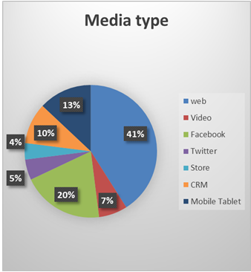
Fig-1.1: Media types
In the above figure we see that their are various media types web,video,facebook,twitter ,store,CRM,mobile tablet are used in daily life.
Why is it necessary?
If we look at the necessity of SMI through economical angle or in respect of a organization say E-commerce company, it is absolutely necessary for them to have data fetched from various websites like Google, Face Book, Twitter etc giving them valuable information about trends and mindset of people (rather customers). The tools used thereby give such information to the owners of the company which is further applied to make change in the product or services and thus enhancing the profit of the company. Success of the SMI does not depend on the accuracy of the data or information it has provided but its usefulness in the process of Decision making. Otherwise, it may result in doing harm or collateral damage to the suspects who are actually innocents.
2.0 REVIEW OF LITERATURE
U klinger
Online communication is becomes an important part in the communication of political actors in democracies.In the many country the all political parties run their own website and they are active on social media.
In this paper Ulrike Klinger stated that how political parties are use social media and how political parties implement it.They use the official Facebook sites,Twitter feeds.Those Social media sites are analyse for their vibrancy,and cluster focsing on various data, their participation, and mobilization. Political parties use social media as additional channel to spread information and as an elections purposes.
Alice E Marwick, Danah boyd
In this paper he state that young people’s online privacy practices on sits like Facebook. Traditional models of privacy is individualist,but the realities of privacy meditate the location of each person individuals in networks. The various social Technologies ,which enable people to share information of others , further preclude individual control over privacy.
The dynamical sites like facebook have forced to alter their concept of privacy to account for the networked nature of privacy to explain how privacy is achieved on the public networks.
Alice is explain the various facebook insights by their languages.
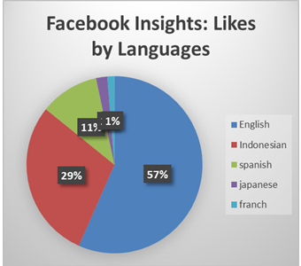
Fig-2.1: Facebook insights: likes by language.
3.0 ACCESS OF DATA
After any incident or major event in India, for eg. Mumbai attacks, Elections or natural calamity, the social media is flooded with various responses in form of opinions, images, videos, hash tags etc. This flood of information in the form of large data sets cannot be used directly. Various selection and filtering tools are used.
What is missing in this process is specific direction. The new methods suggested as below.
3.1 Collaboration of data from various actors
Using SMI cannot be a role of a single actor. Gathering it from various agencies which may include response from the public, data from government authorities, from private organizations and then applying it in such a manner which is of huge benefit to the masses.
Example can be cited of Facebook Disaster Map where in a situation of calamity, people affected can use the app and mark themselves ‘safe’, which is such a valuable information for agencies involved in rescue mission. Location of those who have marked themselves ‘safe’ and those who haven’t can guide the search operation provided that the data passes through filters of veracity and reliability.
3.2 Prediction and Forecasting
Many social media apps and websites have predicting capabilities based on the inputs of the users and live information available through satellites. Google maps has proved to be a useful application while navigating through crowded cities like Mumbai, Delhi etc. It gives the live update of the traffic and congestion to the driver enabling him to consider alternate route and thus saving on fuel, time, fatigue.
3.3 Public Service Design and Delivery
Indian population largely relies on railways for commuting from place to other. Indian railways has spread its wings in the social media platforms such as Twitter in order to provide best of the services to the passengers. In case of emergency or issues like maintaining cleanliness in the train coaches, the tweets by passengers are viewed seriously by the authorities and corrective measures are taken. Same should be followed in respect of issues in the cities to bring it in the notice of the civic authorities. Ideal administration would never afford to ignore the hashtags such as #potholes, #accident, #roadblock etc.
4.0 PROCESSING AND ANALYSIS
Usually social media data sets are huge, even after collecting the information from various partners, analyzing it is the greatest challenge. Especially when it comes to ‘Human emotions’, the usual methods do not give satisfactory results. A situational, cultural perspective is needed to analyze such collected data. For example, during the elections, sentiments of the people regarding the election process or a certain political party have to be analyzed. In this case, considering the cultural and location aspect, the lexicon or community specific words need to be paid attention to. This helps to understand the ‘context’ of the public concern which further helps to find the exact sentiments of the people towards the given process. Context should not be misinterpreted failing
to which may give rise to a critical situation.
The authorities should balance between ‘protecting privacy and security of the concerned people’ and ‘being able to analyze people’s sentiment’ throughout the process.
5.0 ASSESSING THE IMPACT AND ITS EVALUATION
Analysis of Social media datasets always give insight to the authorities thus enabling them to find the outcomes of the policies and suggesting measures to improve the same. This is the most important feature which enables the process of constant improvement.
When a certain project is proposed by the government or any institute which is harmful to the environment, people have powerful tool of social media to express the discontent. This not only helps the government to identify the opinion of the masses but also gives them idea of how much of the concerned population is affected by the decision. The popular example is of opposing to the flyover construction in Bangalore, India through twitter by tweeting #steelbeda movement. It is to note that regional lexicon is considered here to understand sentiments of the masses.
Another popular movement which attracted attention of all is #metoo movement has originated in western countries few years ago. But it gave courage to Indian women to express their grievances and thus helping authorities to attend the issue accordingly.
If we have to analyze the outcome of such events, it should be noted that tweets have to be filtered based on the five important public concerns namely lack of information, partisanship, distrust of institutions, personal economic impact and other, unclassified concerns. Since other measures of expressing their views were unavailable or ineffective for eg. Interviews with press or Protest because such measures can be manipulated by fake and paid crowd or lack of attention by media, the potential for social media as a near real-time measure of public opinion of policy reforms is realized.
6.0 INNOVATIVE METHODS AND TECHNOLOGIES
The data sets obtained through social media need not always be analyzed using traditional tools and techniques. It has to be beyond the regular methods thus enabling flexibility and context-specific implementation. Data responsibility decision trees, framework of moral values can be used to translate principles into a series of questions. Further, a transparency report showing with whom data is being shared and toward what public benefit could help allay concerns about government misuse of private-sector data assets.
The techniques of analyzing the social media should also collaborate with other inputs as open source intelligence (OSINT), Human intelligence (HUMINT), Imagery intelligence (IMINT) and Signal intelligence (SIGINT).
CONCLUSION
It is ascertained that Social media intelligence has significant effect on the society and it offers remarkable opportunities. The potential must be tapped by the government by engaging law enforcement agencies and giving legal framework to the SMI.
The same may be added in the academics and also as a part of training in the industries. After all, all the major fields like social and behavioral sciences, political science, psychology, anthropology and social psychology are related to SMI directly or indirectly.
This will give the common masses chance to learn, understand and accept the challenges and limitations that come with SMI. Ultimately, peoples’ active and wise involvement in the process is crucial as any social (refer latin Socius) process originates from them and for them. Which shall ultimately bring betterment to whole mankind.

ACKNOWLEDGEMENT
I am expressing my deepest gratitude to my family, friends, and colleagues for the continuous support, especially Dr.Hiren Dand , my professor for providing valuable insights pertaining to this domain.
REFERANCES
- U Linger,”Mastering The Art of Social Media”,02 April 2013.
- Kashif Ali, Hai Dong, Athman Bouguettaya, Abdelkarim Erradi, Rachid Hadjidj, "Sentiment Analysis as a Service: A Social Media Based Sentiment Analysis Framework", Web Services (ICWS) 2017 IEEE International Conference on, pp. 660-667, 2017.
- Wingyan Chung, Elizabeth Mustaine, Daniel Zeng, "Criminal intelligence surveillance and monitoring on social media: Cases of cyber-trafficking", Intelligence and Security Informatics (ISI) 2017 IEEE International Conference on, pp. 191-193, 2017.
- Tahirah Binti Mt Tahir, Mohd Heikal bin Husin, Nurul Hashimah Ahamed Hassain Malim, "Children and social media usage: Malaysian initial perspective",3rd International Conference on, pp. 143-147, 2016.
- Krishna Madhavan, Mihaela Vorvoreanu, "A Web-Based Tool for Collaborative Social Media Data Analysis", pp. 383-388, 2013.
- Qingchao Kong, Wenji Mao, Daniel Zeng, "Predicting user participation in social networking sites", Intelligence and Security Informatics (ISI) 2013 IEEE International Conference on, pp. 154-156, 2013.
- E Bothos, D Apostolou, G Mentzas, ”Social Media to Predict Future Events with Agent-Based Markets”, IEEE Intelligence System, vol-25,2010

Virtual Reality of the Future, How do you imagine VR content of nearest years?
Kunal Prasad Gogate¹ and Pournima Bhangale²
Student¹ and Head², Department of Information Technology, V.G. Vaze College of Arts, Science & Commerce, University of Mumbai, Mumbai
1.1 What is Virtual Reality?
Virtual Reality which is abbreviated as VR is a modern-day technology through which you can see the available multimedia contents in Lifesize.
VR contents that are designed for VR are basically of two types vision wise-
1. 360 VR - In this content while wearing VR headset, you can see everything in view in all possible directions (in life-size) in 3D. The available contents on internet are videos, games.
2. VR 3D - Everything appears in 3D like 360 but you cannot see in all possible direction. Instead you see what is intended to be seen but it will be in 3D and life-size.
1.2 Introduction
Virtual Reality devices are becoming a lot popular these days. There are stats showing 65% of United States households are home to at least one person who owns a Virtual Reality device. There are majority of people willing to buy a Virtual Reality device. Virtual Reality devices are prominently used in gaming industry.
Virtual Reality headsets are used a lot in gaming industries. Steam is one of the major sources that creates VR games to encourage VR headsets. This leads to the higher number of new game releases is due to multiple virtual reality (VR) devices that have recently been released. Majority shares of Steam games were VR headset supported, this lead to increase of sales in VR industry.
1.3 Virtual Reality Gaming Research
In recent years a lot of VR headsets have released some of them were Oculus Rift, HTC Vive, and PlayStation VR. The Hi-Tec Virtual Reality Game is a driving force that could in the future define the evolutionary path of the human species. Gamers are very excited to see that Virtual Reality has made their way in gaming industry. VR headset companies have also promoted different tournaments for these games to enhance their scope of audiences. Huge amount is also given to the winner this leads to morale boost of the players and increase the growth of VR headset devices.
1.4 Growth of Virtual Reality (VR)
VR has defined it as the “simulation of reality”, based on the human senses. As such, he pointed out that since people have two eyes, VR must be stereoscopic. If they are not stereoscopic, the system is only surround video, not VR. Stereopsis is what gives VR the perception of immersion. However, since people do not have eyes in the back of their head, and are not continually spinning around, the field of view does not have to be 360 degrees.
Virtual Reality devices represents 96.4% of the combined market of AR and VR headset devices which includes devices like HTC Vive, Oculus. Key Players in the market are Cisco Meraki, VOXELUS, Koncept VR, SubVRsive, MATTERVR, Visionary VR, IAM-Media (IAM-360), WEMAKEVR and Panedia Pty Ltd.
IDC has estimated that the growth of VR headsets in year 2019 will be around 19.5 million. This number will go on increasing in next 5 years.
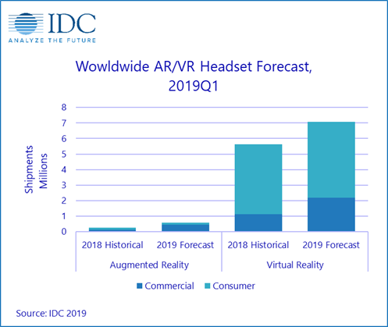
1.5 Future of Virtual Reality
• In the year 2020, The release of 5G network is expected to improve VR experiences for users with faster download speeds, shorter delays on video content and increased connectivity set to boost VR experience
• Data Visualization apps that help engage the brain beyond just numbers. There are so many cool things that are going to be done here.
• Navigation apps for indoor walking (malls, etc.). Think an AR overlay of the yellow brick road directing users to a store, tailgate spot, or dropped pin.
• Real Estate. You know that button on Zillow saying “Virtual Tour”? Make it actually virtual. Matterport has a $5,000 camera “doing” this, but I think an app on a Google Tango device might be the first big winner in this category.
• Virtual humans to drive the use of VR in social interactions. VR is set to become part of everyday lives as we create virtual humans to keep us company. Although expressions are expected to be hard to create in virtual environment so we might still want physical company too!
• Handheld devices will be main way users interact with VR, as controller give users a tactical feel and experience rather using motion sensing devices.
• Virtual Reality headsets will become sleeker to match the size of sunglasses.
• In year 2030, new interactive VR experience will allow people to experience life on Mars and be used for training purposes as well as sharing the work NASA is doing on developing sustainable human missions.
• When it comes to employment, selection tests will be done through neutral avatars, so hiring will be based solely on a worker’s capabilities.
• In medicine, VR will help resolve phobias or fears by virtually transporting the patient into conflict situations.
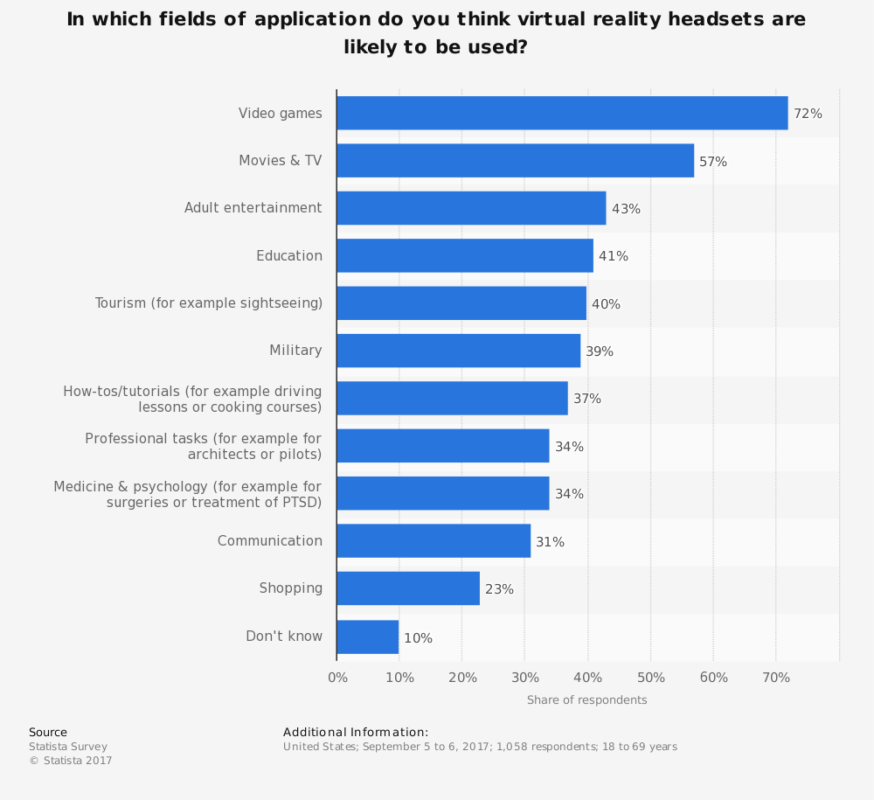
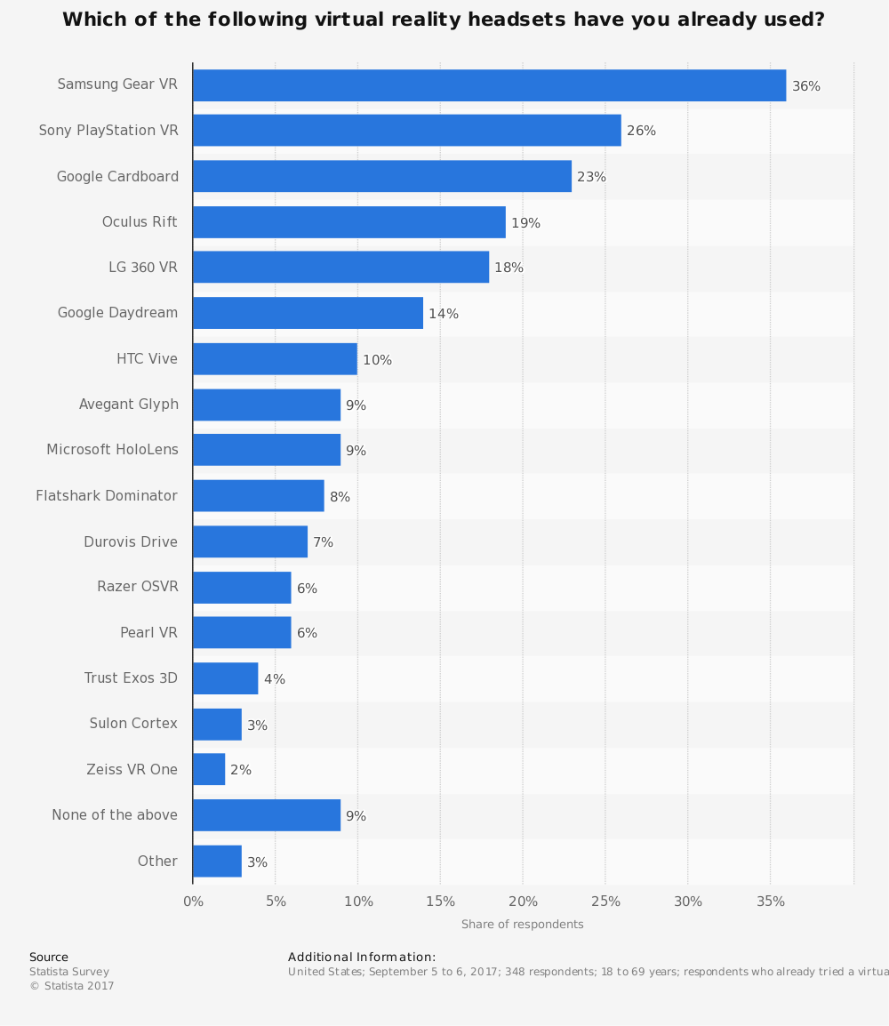
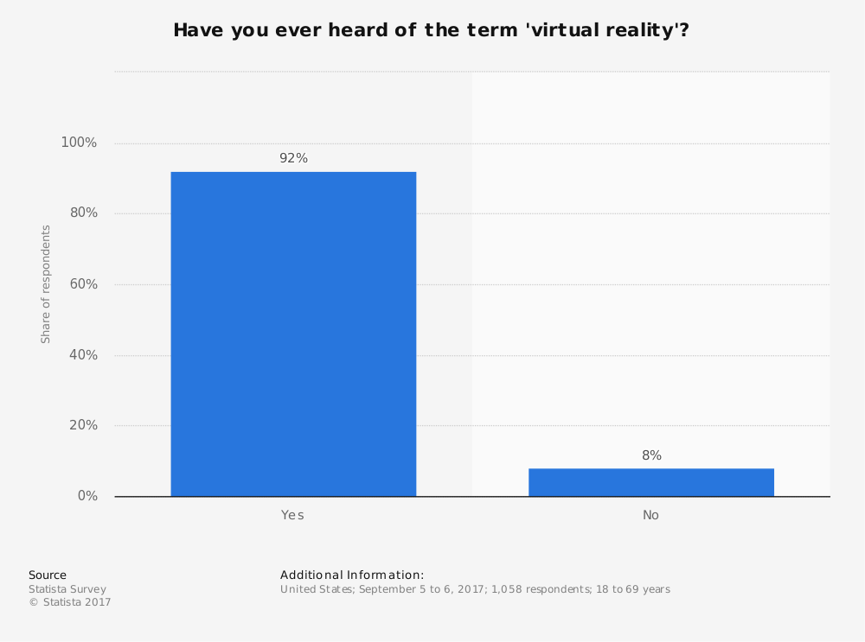
1.6 Conclusion
• Virtual Reality is going to grow at rapid rate and also in different fields
• VR is going to be an essential part of our life in nearest future
• The market will keep on growing
1.7 References
[1] Greenleaf WJ, Tovar MA: Augmenting reality in rehabilitation medicine. Artif Intell Med 1994, 6: 289-299. 10.1016/0933-3657(94)90034-5
[2] Carrozzo M, Lacquaniti F: Virtual reality: a tutorial. Electroencephalogr Clin Neurophysiol 1998, 109: 1-9. 10.1016/S0924-980X(97)00086-6
[3] Thompson, J., ed. 1993 Virtual Reality: An International Directory of Research Projects. Aldershot, U.K.: JBT Publishing.
[4] Thorpe, J. 1993 Synthetic environments strategic plan. Draft 3B. Alexandria, Va.: Defense Research Projects Agency.
[5] Cater, J.P., D.C. Varner, S.D. Huffman, K. Miller, Virtual Network Project 06-55697.
[6] Krantz, D., and S. Manuck 1984 Research on Virtual devices Feb 22-23 1993.
[7] The State of CyberSecurity by Darren Guccione, star Advisor, Contributor, CSO | 4 July 2019.
Wireless Power Transmission and Challenging Issues
Pooja Sultanram Saini¹ and Abhijeet Kale²
Student¹ and Head², Department of Information Technology, B. N. Bandodkar College Science, University of Mumbai, Mumbai
Abstract
Wireless Power Transmission is the transfer of electrical energy in the form of physical links without using wires. WPT reduces the use of wires and batteries. Wireless Transmission of Power is been used in many places where the wires are interconnected in hazardous or inconvenient way. In this research paper, we are going to discuss about the process, hardware requirements and different methods of WPT. This research also include the applications, challenges and limitations of wireless power transmission. The different advantages of WPT are also mentioned in these research paper.
Index Terms: Wireless Power Transmission(WPT), HF-Transformer, coil, voltage regulator, microwave power transmission, laser power transmission, inductive coupling power transmission, electric vehicles, field of electronics, led lighting, defence systems, solar power satellite.
- INTRODUCTION
Electrical devices such as mobiles, laptops, etc. mostly needs batteries which are to be charged regularly to continue their use. As the use of the electronic devices is increasing day-by-day, charging the devices becomes difficult while travelling. So there’s a need of powering the devices wirelessly. Using wireless charging is more eco-friendly as compared to conventional batteries. Wireless power transmission reduces the massive battery disposals as the batteries thrown are hazardous in environment. Wireless power transmission transfers energy from one point to another without using any wires. Wireless operations allows long range communication which is not possible using the wires. There are many WPT technology has been introduced to reduce the use of wires and batteries. These technologies mainly are of 2 types as radiative or far-field, which transfers the power over far distance and non-radiative or near-field, which transfers the power over short distance. In radiative technology the power is transferred by beams of electromagnetic radiation. And in non-radiative technology the power is been transferred by magnetic field using inductive coupling. These techniques can be used to transport energy at longer or shorter distances but should be focused at the receivers.
- PROCESS OF WIRELESS POWER TRANSMISSION-
WPT technology was first demonstrated by “Nikola Tesla” in 1980. In the process of power transmission there are three main systems which include microwaves, resonance and solar cells. Microwaves are used in electrical devices to transfer electromagnetic radiation. In the process of WPT the power is been transmitted from the source to the receiver without using wires.
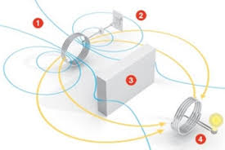
Fig: Process of WPT circuit and its working
In the process of transmission there are two coils included, named as a transmitter coil and a receiver coil. When the transmitter coil is powered by AC current to create a magnetic field it induces a voltage in the receivers coil. The transmission between the coil takes place through an oscillating magnetic field. Due to the transmitter the DC current induced is converted to high frequency AC current. In transmitter part, the current in AC increases the copper wire which helps in creating a magnetic field. Once the receiver coil is placed near magnetic field, then magnetic filed can induce AC current in receiving coil. Electrons present in the receiving device converts AC current back to the DC current, that will become the working power.
- HARDWARE REQUIREMENTS OF WPT-
The requirements of hardware in WPT includes HF-Transformer, HF-Diodes, coil, rectifier, basic transistors, voltage regulator two air-filled inductor coils and BLDC fan.
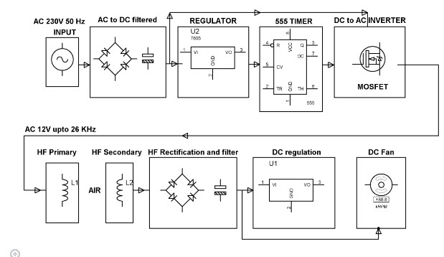
Fig: Wireless power transmission circuit working
3.1 HF-Transformer
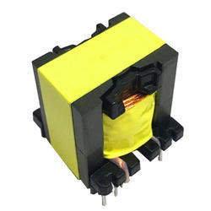
Fig: HF-Transformer
It transfers the electric power and physical size reliant on power to be transform and also the operated frequency. The emf equation shows that core flux density will be less for given voltage. This implies that the core can have the small cross-sectional area.
3.2 Coil

Fig: Coil
When the conductor is wounded around the core an electromagnetic coil is formed. By magnetic coupling, coil can transfer electrical energy from a circuit to another. Some common coils are barker, Tesla, choke, etc.
3.3 Voltage Regulator

Fig: Voltage Regulator
The Constant level voltage is been maintained by voltage regulator automatically. There exist three positive terminals voltage regulators with multiple output voltages which makes them useful for wide range.
- WIRELESS POWER TRANSMISSION METHODS
There are several methods or techniques of WPT. And the methods are microwave power transmission, laser power transmission and inductive-coupling power transmission.
  - Microwave power transmission-
In microwave power transmission electric power can be used to transfer at long distances. This method uses microwave voltage which emits microwaves. The transmitting antenna transfers to the receiving antenna at the end and convert it back into electrical energy. The microwaves used in the process are of high frequency range from 1GHz to 1000GHz. There are multiple types of microwaves having there own efficiency. Due to high frequency, microwaves are able to receive the waves from long distances and receiving unit receives the microwaves and convert it to the DC power and it is been called as rectenna. A rectenna has a dipole antenna with RF diode.
  - Laser power transmission-
Laser power transmission is the second technique of WPT which transmits using laser beam. These technique is been used for small distance applications. Light energy is been converted to electrical energy by receiving laser beam with the help of photo-voltaic cells.
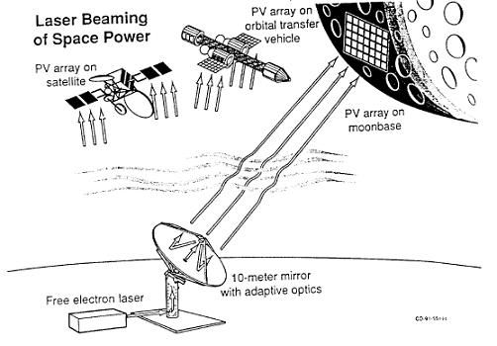
Fig: A Laser Power Transmission System
  - Inductive coupling power transmission-
It is one of the important method. This method is used for small distance transmission. With the help of mutual inductance the power transmission is been taken place between the conductive materials. Inductive coupling power transmission example is transformer.
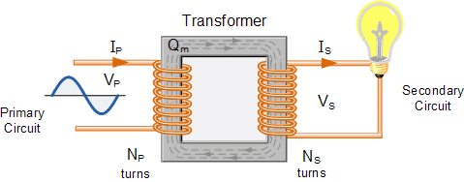
Fig: Inductive Coupling power transmission
- APPLICATIONS OF WPT-
In WPT the distance between the receiver and the transmitter, which is going to be large in focus of recent research, which is going to be large in the focus, can make the dream come true in human life different usage. Applications which depend on devices which has low power that can be wireless sensor or different electronics mobile devices power ranging less than 1W and industrial areas power ranging not more than 3KW. Direct wireless powering can be defined can be directly connected with load with led lights.
5.1 Electric Vehicles
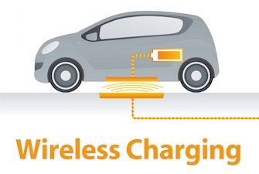
Fig: Electric Vehicle
Wireless Power Transmission helps to charge an electric vehicle. Multiple WPT technologies such as resonant coupling, inductive coupling, etc. for an electric vehicle charging. WPT is applied to charge an electric bus or rechargeable hybrid and battery electric vehicles. These delivers 3.3 KW at high frequency at a range of 20 cm. Consumers are more attracted towards the wireless charging vehicles.
  - Field of Electronics
Electronics is the largest application field for using wireless charging system such as laptops. This device delivers 20 W over a distance of 40 cm. The source resonators and the device resonators are perpendicular to each other. Mobiles or smart phones which are able to charge from wireless charger is also a great use of these technology.
  - LED lighting
LED lights can be directly charged using wireless electricity so it can eliminate the need for batteries. It can also help architectural lighting as it will float in mid-air with no power cord.
  - Defence Systems
To improve the safety, reliability, etc of electronic devices by wireless charging in defence systems are creating new design for future defence technology. The SAE has a committee developing recommendations and ultimately a standard for electric wireless charging and hybrid electric vehicles such as cars and buses.
  - Solar Power Satellites
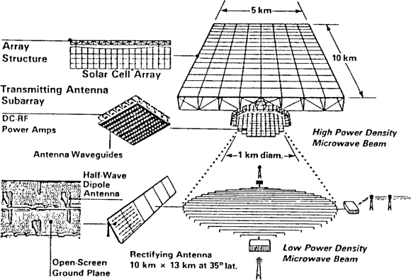
Fig: Solar power satellite
Wireless power Transmissions largest application is with solar arrays and placing them in Geosynchronous Earth Orbit. Another application of WPT is Ubiquitous power source or wireless power source.
- CHALLENGES AND LIMITATIONS OF WIRELESS POWER TRANSMISSION-
There are multiple challenges and limitations faced by wireless power transmission some of them are as follows:
  - Health and Security Challenges for WPT-
Security and safety concerns exits in WPT and their possible counter measures, such as jamming, monitoring, charging, spoofing and software. In these subsection security and health safety are been discussed. Wireless power transmission had become a solution to supply power wirelessly to wide range of low-power devices. However, security and safety re the important aspects by the community. The motivation to address security and safety problems are related to wireless power transmission and their importance in terms of efficiency and operation. The WPT could challenges in clinical uses when working at high frequencies. To obtain smaller reception coil size and a higher power transfer, the working frequency of WPT should be increased to GHz bands. Within, this band there should ne proper implies in transmitting and receiving circuits to perform the preferred transfer power delivery efficiency.
  - Metallic Components Challenge for WPT-
Qi is open interface which is an appropriate technique to cover planar wireless charging for an extensive of low power equipments such as mobiles, iPads, etc. Qi has limitation Transfer power of up to 5W but the future criteria is to cover the power transfer capability of up to 12W, so that other mobile devices such as notebook computers, ipads can also be covered. Extremely energy-efficient power transformation mechanism are necessary to reduce power consumption. The requirements of the slim designs devices might conflict with the dimensions of the electromagnetic shield. In addition to the losses of primary and secondary and coils and magnetic, etc. If the materials mentioned are placed in the middle of AC magnetic flux, induced eddy currents will be produced and circulated within the materials, this results in temperature rise and conduction losses. The subsequent growth of temperature in the materials could be a safety concern and a probable factor that leads to system damage or failure.
  - Transfer Distance and Efficiency Challenges for WPT-
Several studies have been directed in this area in recent years, but transferring efficiency of WPT methods continue to pose a challenge. There were many experiments performed by different researchers for near-field wireless power transmission, a number of different practical challenges can be identified such as orientation and interference. The first challenge is the orientation or the alignment of between the source and the destination coils. The maximum distance can only be achieved if the coaxial assignment is ensured between the coils. Second, when these technologies are expanded to charge several devices, mutual coupling between receiving coils and other entities may cause interference then we required watchful tuning.
- ADVANTAGES OF WIRELESS POWER TRANSMISSION-
- Wireless power transmission reduces the inefficient, costly cables, towers, etc.
- The electrical energy used by consumers also will get reduced in wireless power transmission.
- There is no restriction to transfer the data as WPT can be transferred to large distance also.
- In WPT there is no risk of the power failure or short circuit.
- Power theft in WPT would not be possible at all.
- CONCLUSION AND FUTURE SCOPE-
This research paper discussed about the processes, hardware requirements, methods, applications, challenges or limitations, advantages and disadvantages of WPT. It is assurance that the research on WPT had made great achievements but still there exist problems such as energy conversion rate, problems of biological safety, etc. which needs solution as soon as possible. This research paper gives an overview about wireless power transmission. There still exist some topics which will be studied in future research paper.
- REFERENCES-
- Nikola Tesla, ”The Transmission of Electrical Energy without wires as a means for Furthering Peace, “Electrical World and Engineer.Jan.7, 21, 1905.
- Che B 2014 on omni-direction WPT based on rotation magnetic field Harbin Institute of technology.
- Kurs A, Karalis A, et al 2007 WPT via strongly couled magnetic resonance science
- Farouk Balouchi and Bob Gohn, Published 2Q 2012 “wireless Power: Mobile Devices, Consumer Electronics, industrial devices, Wireless charging of electric vehicles,” Pike Research Report.
- Zhao Z, Zhang Y and Chen K 2013 new progress of magnetically-coupled resonant WPT technology proceedings of CSEE.
- Yang H 2016 principle and application of WPT wireless internet technology.
- Gopinath, ashwin(August 2013).”All about transferring power wirelessly”(PDF). Electronics for you E-zine retrieved jan 16,2015.
- Tomar,Anuradh;Gupta,Sunil(july2012). “Wireless power transmission: application and components ”International journal of engineering research and technology.
- Liu N 2014 research on th characteristics of WPT system via magnetically coupled resonance Shandong university.

Wireless Security and Communication Techniques
Shrutika Baburao Koli¹ and Abhijeet Kale²
Student¹ and Head², Department of Information Technology, B. N. Bandodkar College Science, University of Mumbai, Mumbai
ABSTRACT
The main aim beyond of this research is to survey of the various methods that are used to make more powerful reliability in WLANs. The first propagation of WLANs was initiated by small occupations and particular person at homes. The second generation of WLAN objects is safer than the first generation. Second generation broadband wireless access is examined to be corporate level networks giving more ability and treatment than first generation house and short occupation based WLANs. Although, security residue the most crucial area that deals with the pair of first generation as well as second generation WLANs. In this paper, we assign a analysis of second generation broadband wireless local area network machineries and aims on security techniques.
Keywords: Wireless reliability, knowledge assurance, knowledge security curriculum, curriculum evolution.
INTRODUCTION
Nearly wireless networks these days make use of IEEE 802.11 quality for conversation. IEEE 802.11b enhances the de-facto quality for wireless networking machineries around both small occupation and home end users. IEEE 802.11b identification permits for the conceptual communication of nearly 11 Mbps of raw information at within the ranges from various dozen to various hundred edge, and external ranges of various to tens of miles.
The network devices commonly are provided with the Wired Equivalent Privacy (WEP) data encryption, depend on the 64-bit RC4 encryption algorithm as described in IEEE 802.11b quality on wireless LANs. There are more costly devices that are allowed to use 128-bit encryption. All the junctions should be at the identical encryption extent to operate.
There are various faults in WEP making it useless for big security applications. To further increase wireless security, access points can rarely be configured to only respond to particular computers using the Media Access Control address of the network connector. Wired Equivalent Privacy secure wireless transmission from eavesdroppers. WEP also prevents illegal access to wireless networks. The WEP algorithm program service on the premise of a hidden key allocate between a mobile appliances and an access point. Packages are encrypted by making use the path before communication. An integrity check makes sure that packets are not altered throughout the communication. WEP does not claim to state how the key is shared between sender and receiver. Most systems share a single key around all mobile devices and wireless access points. More knowledgeable key management techniques that is being used to assist protection from the attacks.
The RC4 encryption algorithm is used by WEP, known as a stream cipher, which extends a small key into an infinitely extended random character stream. By the sender plain text is XOR’ed to produce cipher text, which is then transmitted. Although the cipher text can be acquired in transfer, hackers normally will not able understand the message because the hackers do not have access to the key that was used by the sender for encryption. A receiver can decrypt the contents of the message because it has a replication of the same key that was used by the sender to encrypt the message. However, if hackers alter the encrypted stream of data in transfer, the receiver will get wrong data. If hackers interrupt 2 such encrypted messages, then XOR of the cipher text will submit the XOR of the original messages. This information can support a determined and expert hacker to accelerate statistical attacks to acquire the original plain text message. Due to these susceptibilities, the encryption algorithmic program that is been used by WEP is not the powerful to secure among all attacks.
Even though WEP is specific in giving security, it carries out the protection among the pair of these attacks. To secure among alteration of a packet throughout the communication, WEP use an Rectitude Check field. WEP uses an Initialization Vector to expand the shared key between sender and receiver, and processes a dissimilar RC4 key for each packet. Since both these measures are performed inexactly in WEP. This is one of the bases why huge businesses have been uncertain to deploy wireless networks. In addition, organizations require broadband wireless; home WLAN objects do not provide the coverage or capability that enterprises need.
Second generation WLANs vary from earliest generation in the following esteem:
Relationship between coverage and capacity: While 1G WLANs highlights coverage, 2G WLANs advocate capability to support crucial enterprise applications. The corporate philosophy is that coverage will follow by furnishing the accurate number of access points (APs) if enough capacity can be designed in advance.
Focus on security: In 1G WLANs, security was a known weakness. In later 1G object, 128-bit static WEP made attempt at enhancing security. However, these WEP keys were effortlessly hacked. Security will stay one of the top factor why enterprises are unwilling to deploy WLANs; end user insertion of unmanaged access points has an 80% possibility of creating vulnerability of sensible information in more than 50% of enterprises. 2G WLANs lean to have an identity-based security management scheme.
Move toward combined network administration: For reliability and flexibility to co-exist in huge activities, 2G WLANs want to masterly combine the wired and wireless networks functioning in the enterprise. In planning and producing a WLAN for enterprise use, it is suitable to concentrate intelligence, mostly security management, in the basic, and distribute processing to the ends of the wired-wireless integrated network.
In order to deploy 2G WLANs efficiently, corporate network administrators need correct planning tools that is applicable to accurately design and execute a scalable, secure and integrated enterprise- wide network. In this paper, the main focus on the security tools and techniques that can be used by network managers to deploy secure and integrated system.
REVIEW OF LITERATURE
FIRST GENERATION WLANS
Security Issues
In order to make stronger the security of wireless devices, it is essential to notice the security concerns accomplished with 1G WLAN objects. There are three principals of reliability holes as follows:
1. Devices has reliability settings differently able by nonfeasance,
2. Minimal security is broken easily, and
3. Irregular access points are simple to deploy and tough to detect.
If users are to be productive, then WLANs have to be combined faultlessly with the wired network in the enterprise; such WLANs need to meet the twin necessity of security and mobility.
Other problems also alter security in first generation WLANs. Human factors such as lack of recognition and lack of conformity to utilize policies can create loopholes in systems that have been reliable in technical features. Technical factors such as lack of encryption can create loopholes in systems accordingly the personnel are security aware and bind strictly to security and utilize policies.
Security Features:
The minimal set of security attribute included in the 802.11b standard involves:
1. Service Set Identifier (SSID): Each access point has an SSID which determines it to devices on the WLAN. The network can be organized that buyers are necessary to perceive the SSID of the approach point previously connecting to it.
2. MAC address filters: The approach point can be designed to receive relations only from buyers with Media Access Control addresses take down with the approach point.
3. WEP Cipher Encode: 802.11 level comprised WEP as a procedure for assigning “privileged that is individually similar to the confidentiality of a wired LAN medium that does not hire cryptographic techniques to increase privacy”.
Security Vulnerabilities
Various security vulnerabilities abide in 1G WLANs. Some of them involve
1. By nonfeasance, the approach point broadcasts it’s Service Set Identifier in understandable message. Even if the Service Set Identifier broadcast is unseen, the buyer broadcasts the Service Set Identifier to the approach point while aim to connect to it.
2. The Media Access Control address of a analytic client can be “sniffed” off the network and then spoofed by the irregular client.
3. WEP encryption is easily broken. WEP only validates the client. This permits a uneven access point to take information forward by an valid client.
4. An uneven approach point can be inserted that will catch traffic from wireless buyers.
5. MITM attacks can be approached by cracking an approach point off its passage and then spoofing the Service Set Identifier of the approach point.
6. WLANs are easily cracked by denial of service attacks with procedures ranging from flooding the access point with spoofed MAC addresses to using devices like 2.4 GHz wireless phones to create immoderate radio interference.
Security Controls
Particular security procedures that can be executed to secure
802.11 wireless networks involve the following:
1. Leaving the broadcast Service Set Identifications.
2. Initiating automatic Media Access Control based approach control apparatus.
3. Permitting WEP encryption.
4. Lowering the power levels of the approach points to extent the capacity of hackers to connect from outside the defined boundary. This can also be achieved by restricted connections to transference rates of 11 Mbps and 5.5 Mbps.
SECOND GENERATION WLANS
Most violation in reliability of cordless devices is a outcome of a variation of surface two susceptibilities. Security against these vulnerabilities needs protection in perception, i.e. many controls. IEEE 802.1X function group inscription the problems of network reliability and approach control. IEEE 802.11i set bear directive the utilize of the 802.1X set of procedurels to upgrade and standardize wireless encryption. Such protocols involve the EAP, Secured EAP (PEAP) and TTLS, which restore the weak WEP keys available for 1G WLANs. The 802.11i standard gives for using TKIP and AES on the wireless network to encrypt data.
Encryption and Virtual Private Networks
Even though WEP is defect, it is still in demand as a first line of protection. WEP can preclude most abecedarian hacker attacks and illegal users possibly delay intrusions. The Wi-Fi Association declared in October 2002 the industry supported execution of Wi-Fi Protected Access (WPA) as an interval protocol before AES modifies to the standard. However, with WPA, enterprise managers divulge that the WLAN was safe but not truly mobile and reflective of user’s request. Due to user wander and the evolving changes in static IP addresses, WPA needs to be re-authentication, which posed issues with contemporary 2G WLAN execution. In addition, imperfectly selected, short, human readable identification used in WPA can be broken with a vigorous dictionary assault offline and without access to the network. However, integrity based schemes are being adopted, which produce security without offering mobility.
The order release of the IEEE 802.11i standard involves characteristics to address various susceptibilities intrinsic to WEP. TKIP is one of various such protocols being provided by several vendors. Even though TKIP still uses the RC4 encryption algorithm, it detach the weak key issue by forcing a new key to be produced every 10,000 packets or 10 kb. It also hashes the primary vector worths that WEP forwards as plaintext. TKIP involves a procedure for confirming the unity of the data called the Message Integrity Check, which wanders the vulnerability that permits a hacker to introduce data into a packet in order to deduce the encryption key. AES is the encryption standard and is under analysis for insertion in 802.11i. AES is the strong encryption substitution for Data Encryption Standard. According to the 802.11i standard, AES will restore WEP and RC4 encryption. This will need a hardware optimization to be allowed to handle the more vigorous algorithm.
Wireless networks are unsafe by default. An additional safeguard that is used to protect a wireless network is a Virtual Private Network. A VPN solution uses a integration of tunneling, encryption, authentication and access control. A VPN contrives a secure, encrypted network tunneled within a possible hostile network like a wireless network.
802.1x Family of Protocols
IEEE as a port 802.1x that is described by based access control procedure that produces a preferable way to handle access to network ports. 802.1x does not identify an authentication procedure, even though the most general approach for WLANs is EAP, that is architecture for a variation of substantiate procedures. The particular procedure is determined by the buyer and approach point during the authentication activity. The EAP client contacts the authenticator, which challenges the client for authentication knowledge. The authenticator gains this information from the client and then delivers it onto an substantiate server for confirmation. No other transmission from the buyer is permitted until the authentication server has validated the logon request. If the logon is received, the authentication server creates a WEP key individually for the client and forwards it throughout the approach point to the buyer. The buyer is now authorized to access the network beyond the access point.
There are various executions of EAP, involving
1. Transport Layer Security (EAP-TLS): Transport Layer Security was evolved by MS and used in 802.1X buyers for Windows XP, Extensible Authentication Protocol – Transport Layer Security produces strong security, but needs each WLAN user to run a client certificate.
2. Lightweight EAP (LEAP): Lightweight EAP was evolved by Computer Information System Company and used in their AirNet solution; LEAP supports robust Wired Equipment Privacy key generation and produces for fixed password user authentication.
3. Protected EAP (PEAP): Protected EAP was co-developed by CISCO, Microsoft and RSA Security; PEAP does not need certificates for authentication. It supports robust Wired Equipment Privacy key generation and produces alternatives for password, token or digital certificate based user authentication.
4. Allowing Transport Layer Security: Allowing Transport Layer Security was evolved by Funk System and Certicom as a evaluating level for Protected Extensible Authentication Protocol, EEAP-Tunneled Transport Layer Security handles password, symbol or guarantee side user authentication. Unlike EAP-TLS, EAP-TTLS needs only the server to be certified.
Wireless Gateways
Approach points and WLAN buyers are not designed to grasp the huge amount of overhead accessed by these additional surface of security. This alters mostly understood as WEP’s RC4 encryption is restore by the more vigorous AES encryption. One solution that is being executed is the wireless gateway.
Rather than to access points connecting instantly to the internal network, they are collectively connected to a device that carries the additional security levels where encryption and authentication are executed. This arrangement has the added benefits of clarifying roaming between access points without forcing additional authentication and the capacity to accomplishment of Quality of Service at a single point.
POLICIES, TRAINING AND AWARENESS
It doesn’t matter how abundant technology is hired at securing a wireless network, it will not be efficient unless there are sufficient policies in place along with security recognition training. Just as a venture has a security policy for a wired network, it must also have a powerful policy on saving its cordless network. Main part of like discretion would involve the:
1. Corporal location of approach points: Proposition range from hiding the approach points to escape defacing, to creating the radio signals by relevant locating of the antenna, to modifying the power levels to prevent the signal from “bleeding” outside.
2. Logical location of access points: Access points must commonly be placed in the DMZ screened from the corporate network by a suitably designed firewall.
3. Rogue access points: A ban must be carried out on rogue access points. Results for violators must be fussy and strictly enforced.
4. Peer-to-peer network: The peer-to-peer network on clients must be differently abled by default.
5. Layout: Suitably configuring all devices, i.e. encryption, substantiate and Service Set Identifier is necessary.
6. Interoperability: Requiring that standard tools be purchased from a single vendor wherever feasible will expand interoperability and compatibility.
7. Site surveys: Recurrent site surveys to locate any rogue approach points and buyers set up in ad-hoc mode.
8. Monitoring: Recurrent observing of the logs to make sure that interruptions have not occurred.
9. Updates and patches: Patch management policies are important to acquire timely updates.
10. Other: References to other security policies to ensure stability and integration with wired networks
DISCUSSION
Factors Affecting Deployment
Contemporary factors influencing the assigning people cordless networks in institution involve security problems, lack of coverage, lack of capability and control and usage problems. Factors influencing the deployment of 2G wireless involve capability and control problems. For example, many institutions deploy wireless technologies to extend the existing wired framework due to perceived lack of coverage problems. However, technologies such as those identified by the IEEE 802.11g and 802.11a elevated speed levels have emigrated rather the need of reporting and units of measuring computer information problems. But lack of capability still remains a concern. The other concern is security and usage problems. For occasion, control over airwaves, diffusion of awareness training and bearing of security and applicable use of policies and instructions are vital concerns in organizations explore to roll out wireless technologies.
ISSUED AFFECTING CURRICULISM DEVELOPMENT
An clear question is the fit of these factors into the information security subjects as taught in schools and universities. Questions such as the following naturally appear out of a discussion of wireless technologies and factors including their satisfied deployment. How can students be taught to be current when they enter the marketplace? How can Computer Science modules modify to reflect wireless recognition in the variety of career areas? Where do the problems discussed in this paper fit into the curriculum? What assignments and hands-on physical activity will the student profit from to preferable identifying the material and apply it in their approaching jobs?
First, students in all areas of Computer Science require becoming aware of security problems, not just neighboring wireless technologies, but also those implanted in wired networks, the existing framework and system programming. Although some students may plan to particularize in non-security connected areas, information security and assurance affects all features of computing. Second, trainers require to be trained in the current information guarantee technologies by accompanying training camps and keeping abreast of the current developments in the field. A strong dedication is required from the management to keep the information of the educators current in order to authorize top-down distribution of applicable awareness.
Third, computer and network security topics can be included into many traditional Computer Science route at the bachelor’s degree level, such as Operating Systems, Database Management Systems, Programming Principles, Software Engineering and Network Computing. Fourth, there requires being at least a pair of courses aiming solely on network and framework security, and information guarantee. Wireless security can be integrated into a pair these routes at the bachelor’s degree extent, and may be an developed route devoted absolutely to wireless networking and security problems can be part of the graduate subjects. We feel that this topic is latest and timely, and highly applicable to the teaching and practice of information security subjects.
The main challenge in curriculum evolution of wireless security courses is the building of applicable hands-on assignments. Because information security and wireless networking skills are recognized by students to be important for their approaching careers in business and industry, they want examples of “real” assignments, not insignificant or academic ones. In our courses, we tend to evolve both theoretical and hands-on assignments. While theoretical assignments can take the configuration of generating security plans and examine different plans in institutions, hands-on exercises expand this learning experience.
An example of a hands-on assignment including wireless security asks students to differentiate security plans of dissimilar institutions in appellation of their technical efficiency. Another example is to ask students to specify the modules needed to framework a simple wireless network. After this assignment is submitted, the common elements are allocated and students are then asked to arrange a wireless network based on their preceding research. Yet another example of a real-life assignment could include 2 teams of students – one team to secure a wireless network, and the other to try to attack and pierce the first team’s security.
New courses will need to be generated continually to meet new evolution in security and information guarantee. Some new courses that have been generated at our university involve information guarantee, computer forensics and risk estimation. Various new and appearing topics are multifaceted in nature; for example, computer forensics requires knowledge of computers and legal issues, and risk assessment demand a mixture of business and technical skills. Educating trainers in multiple authorities who will then circulate the information to students is the key to guarantee currency in the information security curriculum.
WLAN Vs. LAN SECURITY
A cordless Local Area Network can be as safe as a cordless Local Area Network if security guidelines are executed and apply strictly. Several categories of factors influence information security, nonetheless of whether the information is transferred through wired or wireless channels. For occurrence, human factors such as user recognition and operator irresponsibility are as important as scientific factors such as encryption and firewalling wireless gateways. Before execution of security policies, the organization must plan for several contingencies and vulnerabilities. After a plan has been designed, managers and users should be trained in the methods and made alert of the sanctions for violations of the policy. Then the plan can be executed throughout the organization. If the existing wired framework is fairly secure, then the wireless security methods need to be combined with the existing security instructions for the wired network. In order to preserve currency of information security curricula, wireless security topics need to be involved in a separate course or as major parts in an existing course.
CONCLUSIONS
The use of cordless local area networks is increasing rapidly. As cordless local area networks become essential parts of enterprise- level networks, it becomes critical that the wireless components of the network be as reliable as the wired network. Although the early versions of WLANs were not created for security, standards and procedures are appearing for securing 2G broadband, enterprise-capable WLANs. With 802.1X and 802.11i protocols, there are now good alternatives for encryption and authentication. These appearing security features must be executed in order to satisfy the security of information on the wireless networks. With careful planning and due application, a cordless network can be as reliable as a connected network. Human factors are as important as scientific factors in securing wireless security. As trainers in information security programs, we need to integrate wireless security into our curricula to preserve the applicability of our students’ knowledge in today’s world.
REFERENCES
1. 802.1x - Port Based Network Access Control.
2. Borisov, N., Goldberg, I. and Wagner, D. (In)Security of the WEP algorithm.
3. Dulaney, K. and Margevicius, M., Wireless LANs for Notebooks Begin to Make Sense, Gartner’s End-User..
4. Interlink Networks, Wireless LAN Security using Interlink Networks Secure.XS Software and Cisco LEAP Application Notes from Interlink Networks Resource Library.
5. Moskowitz, R., Weakness in Passphrase Choice in WPA Interface, reprinted in Wi-Fi Networking News.
6. RFC 2284, PPP Extensible Authentication Protocol (EAP).
7. RSA Security, Making Sense of WLAN Security, RSA Technical Whitepaper.
An ATM with an Eye
Pradeep Kumar Prajapati¹ and Dr. Hiren Dand²
Student¹, Department of Information Technology, Vikas College of Arts, Commerce and Science, University of Mumbai, Mumbai
Head², Department of Information Technology, Mulund College of Commerce, University of Mumbai, Mumbai
Abstract
This technology introduce in India for more client satisfaction. ATM is one such machine that created cash transactions straightforward for purchasers and consumers. Exponential growth of ‘intelligent’ criminals every day, the chances of exploitation of this much hyped insecure of ATM are high. ATM these day use only access card and pin for identification, those pin are automatic generated by bank and access card are little or no encrypted. This approach suggests an automatic teller machine security model that could combine a physical access token, a password and biometric verification technologies, including finger printing etc. If thief stole your card they can financially damage your account but he can’t damage because your finger print and face recognition with an image stored in a bank database associated with your account number.A user would only be considered fully checked if the PIN matches the account and the live profile or finger print or eye retina and password match. Developing such a program would help to protect consumers and financial institution from fraud as well as security breaches.
Introduction
The first ATMs were off-line machines that means cash wasn’t mechanically withdraw from associated account. If account were not connected to the ATM (at that time) by a computer network. Therefore, banks were very selective at first bout, bank they gave privileges to ATM
ATM System- Our ATM system would only try to match two distinct images, it would be impractical to scan through a large database of potential matching candidates, if we doing procedure it become a pattern matching exercise, which would not take much time, In most cases, small differences could be accounted for with sufficient lighting and efficient learning tools. In fact, a good visual match will allow the live picture to in the database in order to provide a wider base for future transactions. When matching the pin but not the image, the bank could restrict transaction in a manner accepted by the customer when the account was opened and could retain the user’s image for bank official’s later inspections. With respect to bank employees gaining access to customer pins for use in fraud transactions, this program would also reduce the risk of exposure to the bank’s low threshold and consent to visually uncheck able transactions by the customer. The last consideration is that, due to possible hacking attempts or employee misuse, consumers may be wary of the privacy concerns raised by keeping images of customers in a bank database. One might argue, however, that having a third party compromised the image because there are many account holder in world .
Hardware and Software Specification-
ATMs include protected crypto processors, typically in a safe environment within a host compliant IBM PC. The machine's reliability is largely based on the quality of the secure crypto processor that the host program also operates on a generic operating system. Usually, in-store ATMs connect to that shop ATM Transaction Processor through a modem over a telephone line, the transition to Internet connections is ongoing. For generic operating systems such as Windows 2000 and Ubuntu, ATMs move away from unique circuit boards and into full-fledged PCs. One indication is Banrisul, the largest bank in southern Brazil, which substituted the MS-DOS operating systems with Linux in its automatic teller machines. The newest ATMs are installed using either Windows XP or Windows XP embedded. For most of few 10 years, several ATMs used globally have been operating under the already obsolete OS/2 by IBM. Thanks to its reliability and sophistication as a tool, many financial institutions depend on Windows NT. The ATMs submit database queries to bank servers that do the majority of transaction processing (linux.org) if processors of the ATMs were not perfect to execute the facial recognition algorithms efficiently, The above mention system is also work for the proposed system.
How the System Works-
When a consumer deposits a bankcard, the face is identified by a stereo detector, the eye is detected and a digital image of the iris is captured up to three feet away or finger print by biometric. Compared to one the consumer would initially provide the bank, the corresponding computerized "iris file." If the two codes do not suit, the ATM will not function. This takes less than two seconds for the whole phase. The system works as well as at night for clients wearing glasses or contact lenses. There's also no spotlight being used by the sensor. Instead, a special lens was created that not only blows up the iris signal, but provides more information when it does. Iris scanners are much more reliable to capture images, faces and fingerprints than other high-tech ID systems available. Researchers have established 250 unique characteristics of each individual's iris opposed to about 40 for fingerprints and it remains constant throughout a person's life, unlike a speech or face. Fingerprint shapes and hand movements can be distorted or harmed.
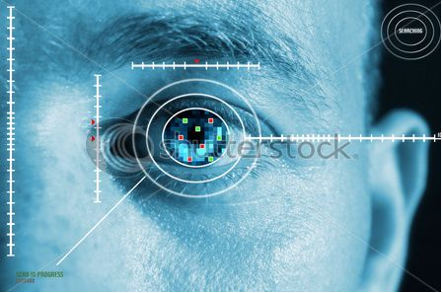
The iris is the best part of the body that can be used as identification because there are no documented iris infections and eye surgery on the iris is not done. The most reliable, durable and stable method of identification known to man is identification with iris. It's much safer, faster, safer and more accurate than testing for DNA. Sometimes identical twins don't have the same irises. Around 18 months after birth, the iris stays the same until five minutes after death.
IRIS Recognition-
Bank United of Texas was the first in the US to sell iris recognition technology on automatic teller machines, giving customers a less wallet and a password-free is the best way to out of an ATM. Several million citizens have been trained in iris recognition programs in several countries around the world for comfort reasons such as passport-free automatic border crossings, and national identity schemes are being implemented based on this technology.
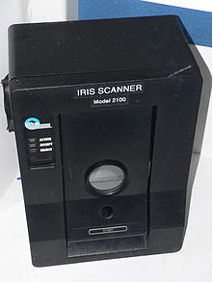
IrisScanner model 2100 iris scanner
Face recognition-
The main challenges facing the implementation of such a model are to maintain the period spent in the verification process to a negligible amount, enabling a suitable level of variability in the identity of a consumer relative to the picture of the database, and that credit cards that can be used at ATMs to withdraw funds are usually provided by organizations that do not have personal contact with the customer and hence. Since the program would only try to match two (and later, a few) separate images, it would be impractical to scan for potential compatible candidates through a large database. The method would be an exercise in matching trends, which would not take much time.
Security-
Initial ATM protection aim is making the ATMs physically invulnerable; they were essentially secure with dispenser mechanisms. ATMs are not only located near banks, but also in supermarkets, grocers and restaurants. ATMs are an easy and fast place to get money.
These are also transparent and available, so when you make transactions, it helps to be vigilant. For your own safety, adopt these general tips.
Keep your PIN confidential- Memorize your Personal Identification Number (PIN); do not write your identification number on your card or put it in your pocket or backpack. Choose your own number. Always offer your PIN over the line, even if a caller introduces himself as an employee of the bank or police officer. Nobody would contact you to get your details.
Conduct transactions in private- Stand directly in front of the ATM as you finish the transaction so that there is no opportunity for people standing behind you to capture your PIN and some account information. Likewise, fill out private slips of your deposit / withdrawal.
Don’t flash your cash- If you have to count your coins or notes, do it at the ATM and place your cash in customers wallet or purse before you step away. Avoid making withdrawals that are too growing. If you suspect you watched when you pass the ATM, go to a public area near to other people and ask for help if necessary.
Save receipt - customer ATM receipts have customers spending record that you can compare with customers monthly bank statement later. Contact bank in which account is present in short time of period, if you find any inconsistencies on your check. If you leave your receipt in ATM other can know how many money is present in your account, and how many you withdraw.
Guard your card- Don't offer your password or send your ATMs pin to friends or relative, or speak to friendly strangers about your bank account. If your card is missing then communicate your bank in short time.
Immediately report any crime to the police- If yot think money are deducted from your account you can contact police for security purpose.
Advantage of ATM with an eye-
- As facial recognition programming is more beneficial, the whole process will take less than 2 seconds as it can be quickly assembled for the Windows XP setting and the networking and storage facilities are already in place.
- The system works as well as at night for consumers wear glasses or contact lenses. There is no need for special lighting. The camera often contains no pulse whatsoever. Iris scanners are much more reliable to capture images, faces and fingerprints as compare to high-tech ID systems available.
- The iris is the best part of the body that can be used as an indicator as there are no documented iris infections and eye surgery on the iris is not done.
- It's far cheaper, quicker, healthier and more accurate than searching for DNA. Even the same twins don't have the same irises. The iris stays the same between 18 months from birth and 5 minutes from death.
Disadvantage of ATM with an eye-
- Iris scanners are much more costly than other biometrics, passwords card security systems
- Recognition of iris is very hard if customer stand far from ATM machine can’t scan iris. There is a risk of substitution or disability in the fingerprinting process. Researchers defined 250 unique features of each individual's iris, opposed to about 40 for fingerprints.
Conclusion
ATM model that is more robust with the use of facial recognition software to provide protection. We also try keeping the performance of this ATM network to a greater degree by maintaining the time passed in the verification procedure to a marginal amount. One might argue that having a third party's image compromised would have far less dire consequences than the account information itself. Therefore, since almost all ATMs videotape customers involved in purchases, it is not a large jump to assume that banks are already building a database of their consumer photos, even they are not automatically clustered with account information.
Reference
[1] ATM with an eye by Sonal
[2] An ATM with an EYE by Henry Ifeanyi

[3] Recognition Technique for ATM based on IRIS Technology by Vikram Kulkarni, Laxmi narsimha rao and C.Krishna Reddy
[4] Automated teller Machine with advance security by Suraj Naik
[5] Face Recognition as a Biometric Security for Secondary Password for ATM Users. A Comprehensive Review by Lusekelo Kibona
[6] ATM Security using eye and facial recognition system by sakshi shrimal and nishant shrimal
[7] ATM Transaction by Yogesh kumawat and Manish Dubey
[8] ATM Security using Iris Recognition Technology and RFID by Sonakshi Bhaga, Vasudha Singh and Niteeka Khajuria
Artificial Intelligence Driven Driver Monitoring System
Amar Raghunath Mali¹ and Pournima Bhangale²
Student¹ and Head², Department of Information Technology, V. G.Vaze College of Arts, Science and Commerce, University of Mumbai, Mumbai
Abstract
Nowadays, road accidents hold a large share in causing deaths. Most of the times, the vehicle driver’s distractions and tiredness are the cause of the accidents. If we could devise some way to make the Driver aware about his lack of attention in driving, then we can bring down the number of fatalities caused by accidents. This paper aims to analyze the usage of Artificial Intelligence to develop a Driver Monitoring System that can detect human emotions through facial and vocal expressions and then scrutinize the details and alert the Driver about the distraction which would help in reducing road accidents and thereby save lives.
Index Terms – Artificial Emotion Intelligence, Azure Cognitive Services, Deep Learning, Driver Distraction, Driver Monitoring, Face API, Facial Emotion Detection, Language Understanding, Machine Learning, Vocal Emotion Detection, Voice API
NOMENCLATURE
AI - Artificial Intelligence
API - Application Programming Interface
GPS - Global Positioning System
JSON - JavaScript Object Notation
LUIS – Language Understanding
SDK - Software Development Kit
WHO - World Health Organization
1.0 INTRODUCTION
Humans convey their emotions through facial expressions, body language, gesture and voice modulations which are all various forms of non-verbal communication. Artificial Emotional Intelligence or Emotion AI involves technology that detects human emotions. Such Emotion AI technology could be applied to create a variety of Systems which would take actions based on the human emotion analysis. One such application of Emotion AI is the Driver Monitoring System. The Driver Monitoring System will be an Emotion AI based system that can detect emotions and devise ways to generate alerts to make the Driver aware about distractions while driving.
2.0 SCOPE OF DRIVER MONITORING SYSTEM
Road accidents are becoming the main reason for deaths among the young and working population, thus developing into a major concern throughout the world. As per the WHO, road accidents have taken the lives of about 1.2 million and have also caused permanent disability to around 50 million people each year. Road crash has become the tenth major reason of death over the past decade and will most probably become the fifth reason for causing deaths by the year 2030. India also has a major share in the global road accident morbidity and mortality rates.
Nearly sixteen lives are lost per hour due to road accidents in India. India has lost around 1.3 million lives to road accidents. Also, about 5.3 million people were severely disabled.
As per WHO, driver’s lack of attention is the major factor which caused most of the road crash fatalities. According to The United States Department of Transportation, driver distraction is the most hazardous driver action which has increased tremendously with the introduction of mobile phones. Any action which averts attention from driving is termed as distraction. Using a mobile phone, drinking or eating, talking, reading, etc. fall under distractive actions. Of these actions, using mobile phones is the biggest contributor to distraction.
Therefore, prevention of Driver distraction is of utmost importance to ensure road safety so as to prevent the loss of precious lives and Artificial Intelligence can be put to use to avoid Driver distractions. Applying AI, we can create a Driver Monitoring System which would help to understand human emotions and alert the driver about distractions while driving and thereby help in reducing the most major cause of road accidents. To create a better Driver State Monitoring system, we should target to detect the Driver’s emotions by analyzing facial and vocal expressions to properly detect the cause and level of distraction. Microsoft Azure provides Cognitive Services APIs which utilize the strengths of machine learning and includes Vision, Speech and Language APIs which together can be put to use to build a reliable Driver Monitoring System. The aim is to create a SDK which can be run on an embedded system used in the vehicle and it would detect Driver distraction levels and provide vocal suggestions to alert the Driver.
3.0 BUILDING DRIVER MONITORING SDK
The Driver Monitoring System should be designed to target the below points:
Monitor levels of Driver fatigue-
The System should be able to detect the level of tiredness of the Driver and send out alerts which could be either an audio or display alert.
Monitor levels of Driver distraction-
The System should capture Driver drowsiness, lack of attention, and such other factors that show distracted Driver behavior and provide appropriate alerts and suggestions.
Address semi-autonomous vehicle handoff challenge-
The System should be capable of detecting situations when it has to take control over the vehicle whenever the Driver is distracted or drowsy and then pass the vehicle control back to the Driver when he is alert and engaged.
Driver’s emotion detection can be done using both Facial and Speech APIs from Azure Cognitive Services.
3.1 FACIAL EMOTION DETECTION
The System should be able to monitor the Driver’s levels of distraction and tiredness. This could be done by analyzing emotions conveyed through facial expressions to determine the extents of driver distraction caused by physical and mental attention diversion caused by extreme emotions, drowsiness, etc. The standard webcam or any optical sensor can be made use of to record the Driver’s facial expressions and we could perform near-real-time analysis on frames taken from the live video stream to identify expressions, emotion and reactions of the Driver.
3.1.1 VISION API
The Microsoft Azure Cognitive Services Vision API includes the Face API which provides algorithms that can perform detection, recognition and analysis of human facial expressions in images. The Face API includes the Face recognition feature which recognizes human faces within an image and gives the rectangle coordinates for the different expression locations on the face. Each recognized face in an image correlates to a faceRectangle field in the API response. This pixel coordinate set for the left, top, width, and height marks the recognized face position. These coordinates help to get the location of the face and along with its size. The faces are mentioned in descending order of size in the API response.
The Face API uses the face landmarks to detect emotions. Face landmarks are a group of easy-to-find areas on a face, such as the eyebrows, the nose tip or the pupils. There are 27 predetermined landmark areas by default.
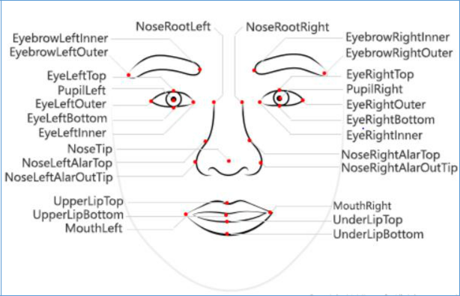
The Face API can capture a list of face-related properties. The following properties can be detected:
Age - The projected age which is mentioned in years of a specific face.
Blur - The extent to which the face is blurred in the image. This property is a value between zero and one. It also provides a rating of high, medium, or low.
Emotion - A series of emotions with their confidence score for the face. Normalization of the Confidence scores over the range of emotions is done so that the overall score adds up to one. The emotions returned are happiness, sadness, neutral, anger, contempt, disgust, surprise, and fear.
Exposure - The extent to which the face has exposure in the image. This property has a value between zero and one. It also provides a rating of overExposure, goodExposure or underexposure.
Facial hair – This property gives the projected facial hair presence and length for the detected face.
Gender – This property gives the projected gender of the detected face where the values are genderless, female, or male.
Glasses – This property indicates if the detected face is with eyeglasses where the values are Swimming Goggles, ReadingGlasses, Sunglasses, and NoGlasses.
Hair – This property indicates the type of hair of the detected face. This property indicates if the hair is visible or if baldness is present, and what the color of the hair is.
Head pose – This property defines the orientation of the face in 3D space. This property is described by the roll, yaw and pitch angles in degrees. This value lies in ranges -180 degrees to 180 degrees, -90 degrees to 90 degrees and -90 degrees to 90 degrees, respectively.
Makeup – This property indicates if the face has put on makeup. This property returns a Boolean value for lipMakeup and eyeMakeup.
Noise – This property detects the amount of visual noise detected on the face. This property gives a value between zero and one and rating of high, medium or low.
Occlusion – This property indicates if there are objects which are blocking areas on the face. This property returns a Boolean value for mouthOccluded, foreheadOccluded, and eyeOccluded.
Smile – This property indicates the level of smile expression on the detected face. This property returns a value between zero for face without smile and one for a face with proper smile.
To develop the Facial Emotion Detection System to perform analysis on frames taken from live video, the below basic components will be involved:
Acquire frames from the camera - Capture Driver’s actions on camera and then extract frames from the video.
Select which frames to analyze - From the extracted frames, detect the important frames based on the range of distinct actions involved.
Submit these frames to the API - Send the frames to the API for analysis. A queuing approach could be used to send the frames and using threading to process items from the queue. With the queuing approach, it can be guaranteed that each response is processed, in the actual proper order, without reducing the System’s maximum frame-rate.
Consume each analysis result that is returned from the API call: The results from the each frame analyzed by the API could be used to detect appropriately the driver distraction by contains an emotion object which contains scores for each detected emotion such as contempt, anger, disgust, fear, happiness, neutral, surprise and sadness. The results are returned in JSON format as below:
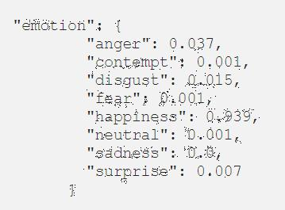
These scores combined with other face attributes like Head Pose, Occlusion, etc. can be used to develop Deep learning algorithms to properly identify Driver distraction and fatigue levels and further alert the Driver using audio or display outputs providing appropriate instructions to suggest precautionary measures to the Driver.
3.2 VOCAL EMOTION DETECTION
Driver’s speech can be analyzed to detect distraction caused while driving. The microphones can be used capture speech when the Driver starts speaking and we can construct a System which can discover the Driver’s emotion. For detection of the Driver’s emotions or distraction levels, we will use Azure’s Speech to Text SDK which would convert the Driver’s speech from audio to text. We will then use LUIS provided by Microsoft Azure to facilitate detection of emotions using the converted texts. Finally, we can predict the level of distraction from the matched texts.
3.2.1 SPEECH TO TEXT SDK
The Speech to Text SDK recognizes audio coming from microphone, or other real-time audio sources which can stream or from a pre-recorded audio file and convert it into text in the preferred language. This SDK supports conversion to text in many different languages. The Speech to Text service makes use of the Universal Language model by default. This model is deployed in the Azure cloud and was trained using data owned by Microsoft. It's optimal for conversational and dictation scenarios.
The Speech SDK can be used for audio to text conversion as it provides access to the functions of the Speech Services, making it easier to develop speech-enabled software. Below are the features provided by the Speech SDK:
- Transcribe short utterances (<15 seconds) which only supports the last transcription result.
- Continuous transcription of long utterances and streaming audio (>15 seconds) which supports interim and last transcription results.
The Speech SDK can be customized as needed with data so as to avoid barriers in speech recognition like vocabulary, talking style and noise. Be it Microsoft's default model or a customized model, we need to train the speech-to-text system appropriately so as to achieve greater accuracy in predications. We can train the model using human-labeled text arrangement or related text. The data within the model together with real-time audio data are used to teach the model so that it can identify phrases, names, words, acronyms and other feature-specific terms. We can achieve accurate and improved emotion detection by providing more feature-specific (data which is related to what Drivers will speak and what we expect to identify) datasets.
The speech recognition involves the below steps:
[1] Take as input the Speech audio from the microphone.
[2] Start speech recognition and return appropriate response after a single utterance is identified. The termination of a single utterance is detected when there is silence at the end of the speech or until few seconds of audio is run through the system for conversion to text.
3.2.2 LUIS
LUIS is an API service hosted on the Azure cloud which employs custom machine-learning intelligence to a user's spoken, natural language text to forecast the complete meaning, and extract important, detailed information. LUIS is intended to recognize valuable data in speech. LUIS also deduces user goals (intents) and extracts valuable data from sentences (entities). An intent represents an action the user wants to execute. An intent is a goal or purpose conveyed in a user's utterance (an utterance is a text which taken from the user’s speech which is to be interpreted). We can make use of LUIS for detection of human emotions through their speech.
A LUIS application includes a feature-specific natural language model. We can extend the prebuilt model by adding custom information as required so as to make the System more efficiently recognize the intents.
LUIS involves many predefined feature models which include prebuilt entities, utterances, and intents. We can use the prebuilt entities if we don't want to use the intents and utterances from the prebuilt model. Prebuilt domain models consist the complete design and help to get started with making use of LUIS. LUIS allows to identify custom entities and intents by making use of entities deduced through machine-learning.
The Driver can use whatever terms while speaking and his speech would be converted to text in the specified language. The converted text can then be passed to LUIS which would then map the text to the already declared intents. This can help to arrive at conclusions on what the Driver’s actions are and if those actions mean that he is distracted. We can capture different utterances for each intent so as to teach LUIS extraction of entities and intents from the Driver' speech. It is important to continually train LUIS on new utterances so that the machine-learned intelligence can perform proper predictions.
We need to collect and define utterances that we think the user will provide. We need to include utterances which mean the same thing but are constructed in a range of different ways. We should define a series of intents that map to actions users would execute. LUIS comes with certain prebuilt intents which we can use and also add custom intents as per need. When LUIS is sent an utterance, it posts back the first intent for that particular utterance.
For example, we may define the following intents to detect if the Driver is talking on the phone:
Intents | Utterances
TalkingOnPhone | “Hi”  “Hello”  “Good Morning”
Such an intent returned from the LUIS service can be used to detect that the Driver is talking over the phone and may be distracted and can be alerted.
A combination of Facial and Vocal emotion detection can be used to conclude if the Driver is distracted or tired. After proper analysis of the emotional data collected, appropriate action can be performed to make the Driver aware about his lack of attention or to take control of the Vehicle. The System thus, will measure facial expressions of emotion and use Deep learning algorithms to classify the human expressions. A combination of these expressions are mapped to human emotions to detect Driver distractions. Similarly, the human speech is analyzed to arrive at conclusions of what the Driver’s speech conveys and detect his lack of attention while driving.
9.0 CONCLUSION AND FUTURE SCOPE
The Driver Monitoring System thus developed will be able to unobtrusively measure in real-time complex and nuanced emotional and cognitive states from face and voice. The System will then arrive at different levels of Driver distraction and thereby alert the Driver using Sound or Display mechanism. This would greatly help in reducing road accidents caused by non-attentive drivers. The System relies on fetching data from the Cloud based API in real-time , so it may cause delays in processing and alerting the Driver .So, we could devise alternative data analysis mechanisms where the data required to conduct analysis can be kept locally in the System which would reduce the delay in firing alerts.
REFERENCES
Journal References
[1] Nidhi Sharma and V. K. Banga , “Drowsiness Warning System Using Artificial Intelligence”, World Academy of Science, Engineering and Technology, International Journal of Social, Behavioral, Educational, Economic, Business and Industrial Engineering Vol:4, No:7, 2010.
Web References
[1] https://www.bbvaopenmind.com/en/technology/artificial-intelligence/ai-systems-dealing-with-human-emotions/
[2] https://dzone.com/articles/practical-use-cases-of-facial-emotion-detection-us
[3] https://azure.microsoft.com/en-in/services/cognitive-services/
[4] https://azure.microsoft.com/en-in/services/cognitive-services/directory/vision/
[5] https://azure.microsoft.com/en-in/services/cognitive-services/directory/speech/
[6] https://azure.microsoft.com/en-in/services/cognitive-services/directory/lang

Big Data Technologies and the Opportunities on the Market
Priyanka Sonawale¹ and Dr. Hiren Dand²
Student¹ and Head², Department of Information Technology, Mulund College of Commerce, University of Mumbai, Mumbai
ABSTRACT
Big Data is a field that treats approaches to analyze extract data, or generally manage informational collections that are excessively huge or complex to be managed by traditional information handling application software. Data with numerous cases (lines) offer more statistical power, while information with higher multifaceted nature (sections) may prompt a higher bogus revelation rate. Big Data has gained much attention over the years because of the IT industry and academics. In the digital computing world the data, information are collected at rapid rate to process those data. Currently billions of people are using the internet, and over millions of people are using smartphones. Over the year in the future those rates are predicted to increase and the predicted data production will be increased. The information is shared and transferred at a greater speed on the wireless network the volumn of the data is increased and in turn the speed of growth of the market will be increased. Though due to the fastest growth of the data production and analysing the data it increases the risk and numerous challenges such as quick development of data, move speed, various information, and security. Today the big data and it’s technologies are still in the inception stage. Consequently, this investigation widely reviews and orders the different qualities of Big Data, including its inclination, definitions, fast development rate, volume, the board, examination, and security. This research proposes the oppurtunity the Big Data techonologies povides to improve the market.
Index Terms: Big Data, Big Data Technologies, Market Opportunities, Apache Hadoop, Big Data Challenges.
Nomenclature
UFDs-User Defined Functions
NoSQ-Not only SQL
RDBMS-Relational Database Management System
HDFC-Hadoop Distributed File System
1.0 Introduction
The present universal public exceeds 7.2 billion, and more than 2 billion of these individuals are using Internet in day to day life. Moreover, 5 billion people are using diverse cell phones, as indicated by McKinsey. Because of this innovative transformation, many individuals are producing huge measures of information or data through the extended utilization of such devices. Specifically, those devices produce a lot of diverse or mixed data that are either structured or unstructured. This is known as Big Data. Huge Data is described by three angles:
- The data are innumerable,
- The information can't be sorted into ordinary social databases, and
- Information are produced, fixed, and prepared rapidly.
Large Data is promising for business application and is quickly expanding as a section of the IT business. It has produced significant interest for different fields, including the production of medicinal services machines, banking exchanges, online networking, and education. Generally, information is put away in a profoundly organized configuration to boost its educational substance. In any case, current information volumes are driven by both unstructured and semistructured information. Subsequently, start to finish handling can be obstructed by the interpretation between organized information in social frameworks of database the board and unstructured information for examination.This study offers:
- A complete survey of massive information technologies;
- A discussion of the technologies for analysis and management of the large Data;
- An list of the problems and challenges connected with the massive information.
This paper explains basic ideas and describes the information volume, it describes the opportunities, and challenges; and concludes the paper.
2.0 Background
Big data can be described by the following characteristics:
Volume
Volume in big data means the dimensions of the data. Volume refers to the amount of data generated through websites, portals, and online application. Volume encompasses the available data that are out there which need to be assessed for relevance.
Velocity
Velocity in big data is the speed in which the big data are generated and the speed at which the data needs to be processed. If the data is not processed at the required speed, it loses its significance. Due to data streaming in form of social media sites, sensors, and monitoring it is important for organization to speedily process data both when it is on move and when it is static.
Variety
The information created from different gadgets and sources pursues no fixed organization or structure. Contrasted with content CSV or RDBMS information shifts from content documents, log records, gushing recordings, photos,and different other unstructured organization.variety is about the capacity to characterize the approaching information into different classifications.
Veracity
It is the all-encompassing definition for huge information, which alludes to the information quality and the information esteem. The information nature of caught information can change extraordinarily, influencing the precise investigation.
Source | Production
Youtube | Users transfer 100 hours of new recordings every moment. Each month, more than 1 billion novel clients get to YouTube. Over 6 billion hours of video are observed every month, which compares to nearly 60 minutes for each individual on Earth.
Facebook | Every moment, 34,722 Likes are enrolled  100 terabytes (TB) of information are transferred day by day.  Currently, the site has 1.4 billion clients  The site has been converted into 70 dialects.
Twitter | The site has more than 645 million clients The site produces 175 million tweets for each day
Google | The site gets more than 2 million hunt inquiries for every moment  Consistently, 25 petabytes (PB) are handled
Tumblr | Blog owners publish 27,000 new posts per minute
Instagram | Users share 40 million photos per day
WordPress | Users upload 3,125 new photos per minute Bloggers publish near 350 new blogs per minute
LinkedIn | 2.1 million groups have been created

3.0 Big Data Technologies
The main components and network of big data as follows:
• Techniques for investigating information, for example, A/B testing, AI and characteristic language handling
• Big information advancements, similar to business insight, distributed computing and databases
• Visualization, for example, outlines, charts and different showcases of the information.
To extricate information from Big Data, different models, programs, virtual products, durable goods and advancements have been structured and proposed. They attempt to guarantee progressively exact and dependable outcomes for Big Data applications. Be that as it may, in such condition, it might be tedious and testing to pick among various developments. Truth be told, numerous parameters ought to be considered: innovative similarity, sending unpredictability, cost, effectiveness, execution, unwavering quality, backing and security dangers.The Multidimensional data can be represented as OLAP Data Cubes. Array Database system provide the memory storage and high level query support on mathematical data type.Apache Hadoop, NoSQL, MongoDB are the data integration tool which allows big data analysis.
Apache Hadoop
Apache Hadoop is an outstanding Big Data innovation that has a significant supporting network. It has been intended to maintain a strategic distance from the low execution and the unpredictability experienced when preparing and breaking down Big Data utilizing customary advancements. One primary preferred position of Hadoop is its ability to quickly process huge informational collections, because of its parallel groups and disseminated document framework. Truth be told, not normal for conventional advances, Hadoop don't duplicate in memory the entire far off information to execute calculations. Rather, Hadoop executes undertakings where information are put away. In this way, Hadoop calms system and servers from an impressive correspondence. Another bit of scope of Hadoop is its capacity to run programs while guaranteeing adaptation to internal failure, ordinarily experienced in appropriated condition. To ensure that, it avoid information misfortune by reproducing information on servers. The power of Hadoop platform is based on two main sub-components : the Hadoop Distributed File System (HDFS) and the MapReduce framework.
HBase
HBase is a conveyed non social database based on the highest point of HDFS. It empowers quick record queries (and updates) for enormous tables. HBase inside places the information in listed "StoreFiles" that exist on HDFS for fast queries. HBase is worked for Low Latency tasks. HBase gives access to single lines from billions of records.
HDFC
HDFS is a dispersed document framework fitting to store huge records. HDFS is certifiably not a broadly useful document framework. It doesn't give quick record query in documents. HDFS stores enormous documents (gigabytes to terabytes in size) crosswise over Hadoop servers. HDFS is appropriate for High Latency tasks cluster handling. Information is principally gotten to through MapRe-duce.
NoSQL
While the customary SQL can be adequately used to deal with enormous measure of organized information, we need NoSQL (Not Only SQL) to deal with unstructured information. NoSQL databases store unstructured information with no specific mapping. Each line can have its very own arrangement of segment esteems. NoSQL gives better execution in putting away enormous measure of information. There are many open-source NoSQL DBs accessible to study enormous Data.

4.0 Opportunity on the Market
As indicated by McKinsey, the viable utilization of Big Data benefits economies and introduces another flood of gainful development. Benefiting from important information past Big Data is the essential focused system of current ventures. New contenders must have the option to pull in representatives who have basic aptitudes in taking care of Big Data. By outfitting Big Data, organizations increase numerous favorable circumstances, including operational efficiency, informed strategic direction, improved customer service, new products, and new customers and markets.

4.1 Marketing opportunity
Marketing Decisions Process is very complex. Different choice are available to decision maker which result in multiple objectives and countless alternative actions. The marketing strategy aim to initiate, strengthen, intensify, and preserve overtime their relationship between a company and its stakeholders, represented primarily by its customers and involves the analysis, planning, execution, and evaluation of the activities carried out to pursue these objectives. Relational marketing become popular in late 1990 increasing customer satisfaction to get competitive advantage. The increased flow of information and the introduction of e-commerce have enabled global comparison customers can use Internet to compare features, prices and opinion on products and services offered by various competitors. The number of competitors using advanced techniques for analysis of marketing data has increased. The systematic gathering of sales transaction provide a large amount of data that can be transformed into knowledge and then into effective and targated marketing actions.

4.2 Challenges
It is easy to get caught up in the hype and opportunity of big data. However one of the reason big data is so underutilized is because it may also present challenges. One survey found that 55% of big data projects are never completed. As more and more data is gathered, digitized, and moved around the globe the policy and compliance issue become more and more important. Accessing data for consumption is a challenge for big data projects. Some of the data may be available to the third party and gaining access can be a legal contractual challenges. New tools and techniques built specifically to address the need of big data must be leve lagered, rather than trying to address the aforementioned issues through legacy system. The inadequacy of legacy system on one hand and lack of experienced resources in new technologies is a challenge.

5.0 Conclusion
This paper concludes the fundamental concept of Big Data and it’s technologies. This concept include the importance or role of big data in today’s technologies. Big Data is everywhere and it can help organization any industry in many way. he massive knowledge has become too complicated and too dynamic to be ready to analyze and manage with traditional data tool. Regardless of the significant advancements in Big Data field, we can see through our examination of different innovations, that many weaknesses exist. More often than not, they are identified with embraced designs and methods. In this way, further work should be done in a few zones, for example, information organization, domain explicit devices and platform tools so as to make cutting edge Big Data infrastructure. Consequently, mechanical issues in numerous Big Data zones can be additionally contemplated and establish a significant research topic.
APPENDIX
Nawsher Khan discusses about improvement to upgrade the productivity of information executives who have concocted the information life cycle that uses the innovations and phrasings of Big Data. The phases in this life cycle incorporate collection, filtering, analysis, storage, publication, retrieval, and discovery. Every one of these stages (on the whole) convert crude information to distributed information as a critical angle in the administration of logical information.
REFERENCES
- Nawsher Khan, Ibrar Yaqoob, Ibrahim Abaker Targio Hashem, et al., “Big Data: Survey, Technologies, Opportunities, and Challenges,” The Scientific World Journal, vol. 2014, Article ID 712826, 18 pages, 2014.
- "Siddharth Singh, Survey on Big Data Using Data Mining". International Journal of Engineering Development and Research. 2015.
- D. Che, M. Safran, and Z. Peng, “From Big Data to Big Data Mining: challenges, issues, and opportunities,” in Database Systems for Advanced Applications, pp. 1–15, Springer, Berlin, Germany, 2013.
- K. Douglas, “Infographic: big data brings marketing big numbers,” 2012,
- O'Driscoll, J. Daugelaite, and R. D. Sleator, “'Big data', Hadoop and cloud computing in genomics,” Journal of Biomedical Informatics, vol. 46, no. 5, pp. 774–781, 2013.
- M. Loukides, “What is data science? The future belongs to the companies and people that turn data into products,” An OReilly Radar Report, 2010.
- D. Acharjya, K.P. Ahmed, A survey on big data analytics: challenges, open research issues and tools Int. J. Adv. Comput. Sci. App., 7 (2016), pp. 511-518

Improvement of chatbot by human factor methodology
Anup Sharma¹ and Dr. Rajendra B. Patil²
Student¹ and Head², Department of Information Technology, S.K Somaiya College of Science, Arts & Commerce, Department of Information Technology, University of Mumbai, Mumbai
Abstract
The development and inescapability of the Internet gives chances to new kinds of interchanges between customers and service providers. One such technology is a chatbot: a computer program that simulates a human discussion empowered by the Internet. Chatbots are at present utilized for an assortment of reasons, from day by day climate forecasts to ordering pizza! In this paper we present the examination of chatbot advancements for an industry accomplice to better their inside correspondence process between field specialists and designers. Usage of this innovation will mechanize the professional to-design correspondence process and therefore will bring about a significantly more proficient framework. Our group followed a human elements building procedure where we analyzed diverse chatbot stages (IBM, Pandora, Self-advancement Kit) by means of convenience testing. Client input was determined methodicallly from a wide scope of clients and ease of use of a few stages was tried utilizing an intellectual walkthrough and the information was evaluated utilizing a System Usability Scale (SUS). Most of the members in this examination study (eight out of 10) favored IBM's Watson. This stage got a normal SUS score rating of 81.9 out of 100.
1.0 INTRODUCTION
Numerous organizations are incorporating chatbots into their sites to give better client experience. This means that a great many individuals can speak with your image without a person on the opposite end, in general sparing the organization time and cash.so, if a company decides to implement a chatbot on their website, how do they know what kind of chatbot would be the most useful to them? Chatbots are made utilizing computerized reasoning (AI), which is the calculation behind its capacity to impersonate a human discussion. There are two types of AI that are right now being utilized alongside this innovation: AI(ML) and profound learning (DL). Per an article composed by Michael Copeland on the NVIDIA site, ML utilizes rules to program a chatbot and is restricted as far as changeability. The innovation must be constantly checked on the grounds that it is just as brilliant as it is modified to be. The procedure of AI is like that of information mining. Both frameworks scan through information to search for designs. Be that as it may, rather than separating information for human perception - as is the situation in information mining applications - AI utilizes that data to identify designs in information and alter program activities as needs be. DL is the more current type of ML that is getting progressively well known, yet it is a lot increasingly hard to actualize. In DL, a bot utilizes neural systems that were created dependent on the comprehension of how our minds work. However, not at all like an organic cerebrum where any neuron can interface with some other neuron inside a certain physical separation, these fake neural systems have discrete layers, associations, and headings of information spread. [1]
Regardless of what type of realizing the chatbot utilizes, the essential capacity of a chatbot is to serve the client. The route in which they are used can change between encouraging human correspondence to totally trading the requirement for people to speak with one another by any means. The objective in actualizing chatbot innovation is to as a matter of first importance spare an association time and cash. The most testing undertaking for the association will be to choose what kind of chatbot meets their requirements the best, regardless of whether it be the utilization of AI or the fuse of profound learning as well. This will at last rely upon what the chatbot will be utilized for and how much cooperation the organization needs the chatbot to have with the client.
2.0 PROBLEM IDENTIFICATION
A significant media transmission organization in the United States wanted an increasingly proficient strategy for correspondence between their field professionals and architects. They accepted this would best be unraveled with the utilization of a chatbot. Our task was to give this organization a suggestion of a chatbot innovation and structure for their interior correspondence framework. To assess the ease of use of this innovation, we adopted a human variables strategy to this issue and structured a unique research concentrate to figure out which chatbot stage clients favored the most for regular use.
We structured an exploration study that would incorporate client interviews, ease of use testing sessions with verbally process conventions, and studies/surveys. To assist us with accomplishing our target, we looked at IBM's Watson, Pandora's Pandorabot, and our own special Verbot from an accessible self-advancement pack. We customized these basic chatbot stages to react to yes or no inquiries with enchantment eight-ball-style answers. This would empower the members in this examination to concentrate on the convenience and human components viewpoints related with the stage, rather than assessing each chatbot on the exactness of its answers. In light of our outcomes, we had the option to suggest a userpreferred stage. In this paper, we report our strategy and results and give suggestions on how a organization ought to embrace a chatbot to help potential future adopters.
3.0 METHODS
An ease of use test was directed to assess the convenience of three chatbots: IBM's Watson, Pandora's Pandorabot, and Verbot; a chatbot we created from an accessible self-advancement unit. Every colleague Texas A&M University's Collaborative Institutional Training Initiative (CITI) preparing and confirmation course and the task got IRB endorsement to empower us to direct this examination on human subjects.
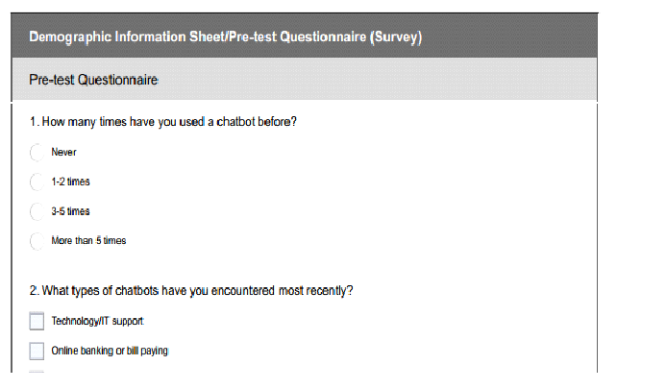
Figure-1: Pre-test Questionnaire
3.1 PARTICIPANTS
Research shows that ease of use testing with only eight members discloses about 80% of significant ease of use issues [2]. A sum of ten participants, with a mean period of 25.5 and standard deviation of 5.74, consented to participate in this unique research study. With an end goal to broaden the scope of client experience and viewpoint, we decided to incorporate changing quantities of college understudies, graduate/P.H. D. understudies, and staff from the Texas A&M University people group.
3.2 PROCEDURE
After we accumulated socioeconomics data from the members, we solicited that each from them sign an assent structure expressing that they enabled us consent to video and additionally sound record their chatbot session. At that point, we started by requesting that every member answer a progression of pre-test questions deliberately intended to assist us with encouraging investigate every client's assumptions viewing subjects, for example, what sort of shading plan the client discovered all the more outwardly engaging (Would you like (1) a shading plan commonly thought to conjure unwinding/stress help, or (2) a progressively energetic shading plan?). Similarly, we asked concerning whether every client would like to associate with an energized portrayal of the talk administration, or symbol. The pre-test poll is appeared beneath in Figure 1.
Next, we developed our post-test questionnaire and a modified System Usability Scale (SUS) to assess usability of the different chatbot platforms. In particular, we asked participants to verbalize their responses to the questions and justify their answers. The post-test questionnaire is shown below in Figure 2.
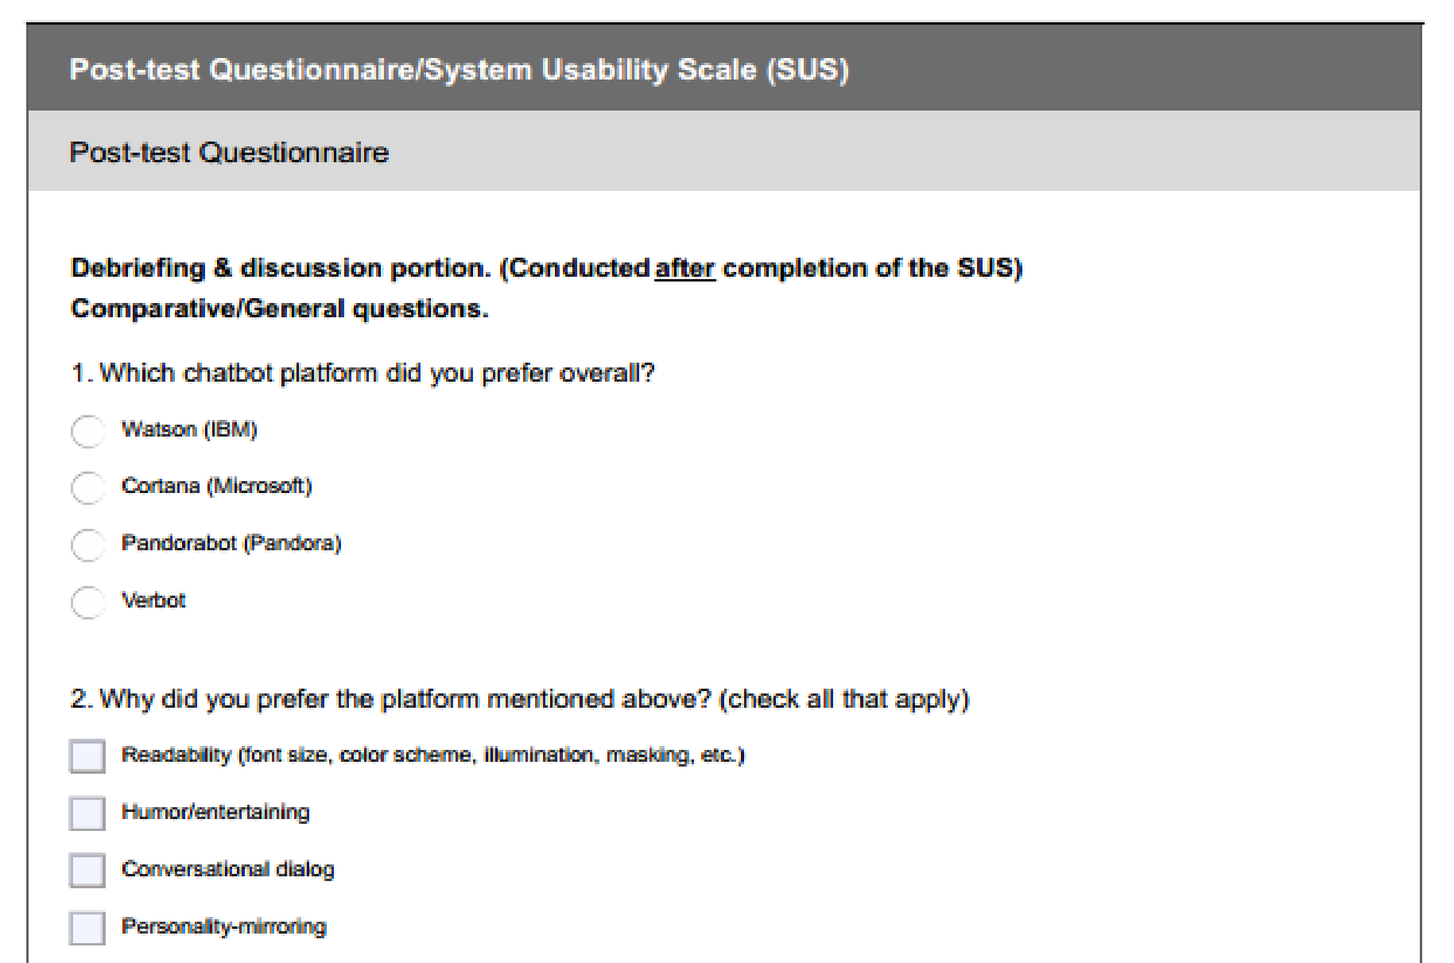
Figure-2: Post-test Questionnaire
We calculated the SUS score of each of the participant’s preferred chatbot platform so that we could quantify this data and make side-by-side comparisons. The SUS questions were asked with a rating of 1 to 5 with 1 representing “strongly disagree” and 5 representing “strongly agree”. The ten SUS questions are shown below:
- I think that I would like to use this Chatbot frequently.
- I found the platform unnecessarily complex.
- I thought the platform was easy to use.
- I think that I would need the support of a technical person to be able to use this Chatbot.
- I found the various functions in this platform were well integrated.
- I thought there was too much inconsistency in this platform.
- I would imagine that most people would learn to use this Chatbot very quickly.
- I found the platform very cumbersome to use.
- I felt very confident using the Chatbot.
- I needed to learn a lot of things before I could get going with this Chatbot.

4.0 RESULTS AND DISCUSSION

4.1 PRE-TEST QUESTIONNAIRE
We found before we had even started directing these sessions that a great many people, whenever given the chance, would be bound to call an organization's administration delegate on the telephone instead of endeavoring to utilize a mechanized talk administration to discover answers to their inquiries. We took a survey to figure out which parts of this innovation were basic to how easy to understand this online help was seen. Most clients concurred that conversational exchange, the degree of amusingness showed and how engaging a chatbot was, and the capacity of a chatbot to adjust to a client's discourse designs, jargon, and so on (normally alluded to as character reflecting) were fundamental factors in deciding if a client imagined that they could profit by utilizing this innovation. The pre-test poll likewise uncovered that while a great many people would depict their past chatbot experiences to be sure generally, scarcely any had given a lot of thought with respect to how they felt this mechanized help had performed crosswise over various circles of usefulness. Consequently, this was the main open door a significant number of these members needed to create explicit inclinations with respect to this innovation. An absence of past information end up being a helpful factor in this examination, as it added to the consistency and the legitimacy of our outcomes.

4.2 INTERACTION WITH CHATBOTS
Eight out of ten members picked Watson as their favored stage while two clients picked Pandorabot and not one of the ten clients selected for Verbot. Most members discovered IBM's Watson to rank the most elevated as far as comprehensibility and visual intrigue, while Watson and Pandorabot attached in the class to figure out which of the three was the most engaging. Watson and Pandorabot were both adulated for their sharp shading difference. This factor was viewed as more ergonomically gainful, and hence better as far as meaningfulness for the client.
Most clients differ in the assessment of Pandorabot and Verbot's symbols. A few clients guaranteed that on an expert level, if this innovation were to be utilized in regular interchanges among specialists and designers, a straightforward visit window would do the trick. Others, in any case, said that the utilization of a symbol made the innovation more easy to use by enabling the client to have an all the more engaging collaboration with the talk administration. It was clear, given their reactions, those clients overwhelmingly wanted to collaborate with Pandorabot's symbol, as opposed to cooperating with Verbot. Six of the ten members expressed that Verbot's monotone voice and its slack accordingly time gave clients the feeling that the stage was too mechanical when reacting to questions. These members asserted that they didn't appreciate the sentiment of conversing with a PC. Then again, a lion's share of particpants enjoyed Pandorabot on the grounds that they guaranteed it had a significant level of human-like usefulness, because of the way that its voice sounded less automated, notwithstanding giving progressively silly reactions. As it were, Pandorabot was more qualified to engage the client.
IBM's Watson chatbot stage had no symbol, had differentiating hues, and utilized an AI calculation just as a cloud-based database. One member in our examination talked top to bottom about how Watson's feeling of apparent knowledge was felt in the exactness of the appropriate response and that it made the client progressively sure and happy with utilizing this innovation. This factor likewise added to the stage being seen as progressively solid, which thinks about well the organization executing the chatbot. Another member proposed that the stage ought to incorporate a method for giving criticism to the client with an end goal to "close the circle" of correspondence. In a perfect world, this chatbot ought to have the option to learn and alter its reactions for the situation that it gives the client poor input. The stage ought to likewise include the chatbot's capacity to gain from these encounters, so as not to commit similar errors again later on. It was in like manner proposed that the stage ought to unmistakably characterize the limits of its usefulness; for instance, it ought to determine to the client toward the start of a discussion that this specific chatbot is just fit for addressing yes or no inquiries stated by the client.
In any case, different recommendations for the plan of this stage fused an assortment of members' reactions to keep the client connected with and inspired by the discussion, remembering tips for its utilization of jargon, expressing, exchange, and so forth. One client communicated a craving for the organization to incorporate a reference number for the discussion or substitute telephone number toward the start of a talk session, which would be amazingly useful in the event of specialized troubles, for example, a system detachment or should the stage flop generally. Moreover, the organization ought to guarantee that clients are not being required to give their own data a repetitive number of times. This burden is baffling for clients and may prompt a poor cooperation that might impact the client's choice to buy administrations or potentially items from a contending organization later on.
The primary discussion among the members in this investigation was in whether it was more easy to use to embrace a stage like Watson, which doesn't utilize activity and voice usefulness, or whether it was smarter to utilize a stage, for example, Pandorabot or Verbot that would keep the client engaged and connected with the innovation. Demographically, educators were among those that reliably favored an increasingly proficient inclination involvement in Watson and that found the utilization of symbols to advance a feeling of unprofessional quality in an organization's innovative capacities. It was likewise said that the combination of an energized portrayal of the talk administration diminished the human-like part of the innovation. There was not a single noteworthy connection in sight between college understudies versus graduate understudies in a client's inclination of whether to incorporate this component.

4.3 SYSTEM USABILITY SCALE (SUS)
We calculated the SUS score of each of the participant’s preferred chatbot platform so that we could quantify this data and make side-by-side comparisons. We adopted Brook’s [3] equations to derive the numerical value of each user’s individual chatbot session score. The equations we used to calculate this value are shown below:
For items 1, 3, 5, 7, 9:
Sum1 = score value - 1 (1)
For items 2, 4, 6, 8:
Sum2 = 5 - score value (2)
SUS score = 2.5 * (sum1 + sum2) (3)
In light of the qualities got from this condition, we had the option to look at every one of these three stages as far as ease of use. This estimation gave us a framework to evaluate ease of use as though it were an element fit for being estimated. The score of 68% has been utilized widely in the writing as the convenience limit for intelligent innovations (i.e., PC applications and sites). We utilized a progressively preservationist edge of 70%.
Joining every member's individual SUS score and conveying these qualities related to their separate stages, we had the option to impartially measure the convenience of these three chatbot stages. Singular members scored the ease of use of Watson's foundation with estimations of 100, 57.5, 77.5, 92.5, 75, 90, 80, and 82.5. Pandorabot was granted individual ease of use scores of 92.5 and 85, which was illustrative of the two out of the ten all out members who picked it as their favored stage by and large. So as to contrast Watson and Pandorabot's foundation with figure out which of these chatbots the members saw as more easy to use, we needed to consolidate the individual scores from every session to get by and large numerical qualities. In general, Watson scored 81.9 on the ease of use scale, while Pandorabot scored an estimation of 88.8. While Pandorabot accomplished a superior generally speaking score, we should recognize that this worth was determined by taking just two members' reactions into thought. Watson, then again, earned its score dependent on the reactions of an aggregate of eight members, which established most by far of our populace of clients. We along these lines credit this disparity to the factual variety in these reactions, given their population size.

5.0 CONCLUSION
A huge media transmission organization gave us the chance to suggest a chatbot innovation and stage plan that we accepted the organization ought to embrace to help interior correspondence inside the association. This innovation would principally serve to streamline correspondence between organization's professionals in the field and designers back at the office. We moved toward this issue with the choice to structure and lead a unique research study to break down framework ease of use with an accentuation on human components designing. An ease of use test was led to look at the ease of use of three chatbot stages. For the motivations behind this exploration study, we assembled criticism from ten members, at that point continued to rate this input utilizing a System Usability Scale (SUS). The outcomes demonstrated that by and large, IBM's Watson was seen to be the most easy to use stage. Watson scored a normal SUS score of 81.875 out of 100, while Pandorabot scored a 88.75 out of 100. Verbot was not doled out a SUS score because of the way that not one of our ten members picked for this stage. While Pandorabot scored higher on the framework ease of use scale, 80% of our members favored Watson's foundation. The factual variety among these members' reactions was credited to an essentially little populace of these members picking Pandorabot. The outcomes propose that IBM's Watson speaks to the innovation best lined up with our human variables investigation. Watson had an apparent insight, an oversimplified climate, and was picked by 80% of our members.
The genuine utilization of a chatbot will spare an organization time and at last lead to monetary benefit on account of the undertakings it can take on and the capacity to enable specialists to commit their time towards different errands. As the knowledge and innovation of chatbots develop, chatbots will have the option to take on an ever increasing number of obligations.

REFERENCES
- Copeland, By Michael. "The Difference Between AI, Machine Learning, and Deep Learning?" The Official NVIDIA Blog. N.p., 29 July 2016. Web. 06 Oct. 2016.
- “How Many Test Users in a Usability Study?” [Online]. Available: https://www.nngroup.com/articles/how- many-test-users/. [Accessed: 08-Jan-2017].
- Jordan, B. Thomas, I. L. McClelland, and B. Weerdmeester, Usability Evaluation In Industry. CRC Press, 1996.
- "Sam, the virtual politician". Tuia Innovation.
- Wellington, Victoria University of (December 15, 2017). "Meet the world's first virtual politician". Victoria University of Wellington.
- Wagner, Meg. "This virtual politician wants to run for office". CNN.
- "Talk with the first-ever robot politician on Facebook Messenger". Engadget.
- Prakash, Abishur (August 8, 2018). "AI-Politicians: A Revolution In Politics". Medium.
- SAM website
- Jump up to:a b Amy (2015-02-23). "Conversational Toys – The Latest Trend in Speech Technology". Virtual Agent Chat. Retrieved 2016-08-11.
- NAGY, EVIE. "USING TOYTALK TECHNOLOGY, NEW HELLO BARBIE WILL HAVE REAL CONVERSATIONS WITH KIDS". Fast Company. Retrieved 18 March 2015.
- Oren Jacob, the co-founder and CEO of ToyTalk interviewed on the TV show Triangulation on the TWiT.tv network
- "Artificial intelligence script tool".

Usual Capital Preservation plus Harvest Administration using Expert Systems
Yadav Antima Kamlesh¹ and Dr. Hiren Dand²
Student¹ and Head², Department of Information Technology, Mulund College of Commerce, University of Mumbai, Mumbai
Abstract
This paper helps us to recognize how expert systems for harvest administration can help out during usual capital preservation. This is completed throughout openhanded an summary of the category of usual capital with importance on Stream and soil capital , relating briefly five knowledgeable organizations established for handling cucumber, orange, bottle green, and wheat, and elucidation how the recommendations that optimize the productivity relative to the farming inputs will lead to ecological preservation as it will be assured that no extra inputs will be provided such as Stream, fertilizers and pesticides lacking a revisit in the yield. The paper also responds to the problem regarding the combination with different kinds of software and presents how result creators at dissimilar ranks can use harvest administration expert systems.
Keywords: Usual capital, Harvest administration, Preservation, Expert systems.
1.0 Introduction
The Expert system has huge importance in Artificial intelligence. The Result- creation capability of a anthropological system is emulated by the expert system, which is also known as the computer system. Basically the skilled system is has been designed, for the humans to solve a difficult complex related problems by reasoning which are through the bodies of knowledge. These problems are solved by using the rules of if-then, rather than using the conventional procedural code respectively.
As the expert system was firstly introduced in the year of 1970 and later on it was proliferated in the year 1980. This paper describes a case study in developing Harvest Administration Expert Systems and how this relates to the soil and Stream preservation. The paper consists of 5 Sections. The first section gives a summary of the grade of usual capital with importance on Stream and top soil resources.
The next unit defines momentarily the five skilled organizations established so distant for handling cucumber, orange, lime, and wheat. The third Unit chats how exhausting these skilled organizations will support in preserving Stream and soil. The fourth unit answers to the question regarding the combination with different types of software.
The fifth unit defines how result creators at dissimilar stages can usage harvest administration expert.
2.0 The Usual capital
The usual capital preservation has two mainly aspects. The first one is pertinent to the administration of these properties on macro level consideration, such as controlling or managing the expansion of development the urban area in order to lose farming land. The second one is troubled with administration of these properties on micro side by side consideration such as adding or managing organic composts to the soil. In next Subdivisions, we will consider now only the grade of the Stream and land resources because as they are the two main resources which are related to our work on harvest administration of expert systems.
2.1 Stream Resources
As we know that the Stream is unique of scarcest resources, since its supply is nearly fixed in nature and Stream demand for different sectors is continuously increasing population. The Stream provide can be top secret into three main categories: Surface Stream, Ground Stream, and Waste Stream reuse after treatment either from growing drainage or familial usage. The River Nile is individual of principal sources of surface Stream, since it provides with more than 95% of its 55.5 billion.
There are the two main sources of ground Stream. The first one is Valley and Delta crushed Stream. This is not only an additional resource of administration, since it is been re-energized by Nile and extra irrigation Stream. The entire storing of its aquifer is around 500 billion with a regular salinity of 700 ppm.
The annual rate of an abstraction of ground Stream for local, industrialized, and growing can used was predictable at 2.6 billion m3 in 1990. The second most ground Stream source is the Non-renewable deep desert ground Stream. The major part of this source comprises the aquifer in the spaghetti western desert. The investigation of beginning estimates indicate an total ground Stream storing in the spaghetti western desert is about 40,000 billion m3 with salinity changing between 300 and 800 ppm respectively. The Ground Stream is also available in all the numerous aquifers in Sinai, but there is less information about them to been mentioned.
The extraction rate from deep desert ground Stream was in the year 1990 and was estimated at 0.5 billion. The portion of the drainage Stream reuse depends on the quality of drainage Stream in terms of its salinity and contamination from municipal, manufacturing, and farming effluents. The major amount of the drainage Stream reuse in year 1990 for irrigation was estimated at 4.9 billion m3 respectively.
As the result, the result-makers worried with Stream resource administration are challenged by how to sustain equilibrium the limited Stream supply with an growing Stream demand for the opportunity purpose, because we all know that Stream is the one of most major constraint for land expansion to satisfy food self-sufficiency. The expected Stream demands for year 2000 are 69.4 billion m3 whereas the expected Stream resources are 74.0 billion m3 taking into reflection the usage of farming drainage Stream, treated municipal sewage Stream, and ground Stream. Another challenge is how to reduce the Stream contamination resulting from using biochemical composts and insecticides.
2.2 Land Resources
After Stream, land is the one of the most important regulating feature for an sustainable farming growth. The entire cultured land is about 7.4 million feddans (1 sedan = .42 acre = 1.04 acres) or single 3% of the entire land range. Due to dry environment, growing depend on mostly on irrigation by the River Nile Stream. Furthermost of these land are focused in Nile Gorge and Delta sections. The parts lying external the Nile basin - retreats of New Valley and Mediterranean seaside lands excluding Sinai are somewhat rain nourished or wet with ground Stream. Cultivated lands are open in two classes: Ancient Land and Fresh Land. Ancient Lands refer to plots along Nile Valley and Delta areas that are dampened straight from Nile River. These plots have remained under the farming for a lengthy period of interval. It is actual rich and its soils are muddy silt and clay mud.
The issues of old farming land losses, either in quantity (land withdrawn to non-farming use) or quality administration (land quality degradation is mainly due to soil Stalinization and Stream logging because of an inefficient drainage system) and limitation of Stream resources for expanding the land area are the one of the major constraints for sustainability of land resources and consequently satisfying food self-sufficiency for the growing residents speedily.
3.0 Harvest Administration in Skilled Organizations
The skilled organizations presence established are mostly for the harvest administration. The principal idea of these enlargement efforts is the Central Laboratory on behalf of Farming Skilled Organizations within the Growing Research Center (ARC), Ministry of Growing and Land Reclamation (MOGLR). Five professional organizations are presently being established for five harvests: Cucumber, Wheat, Orange, Lime, and Tomato.
The next subdivisions define the mechanisms or subsystems common to harvest administration expert systems namely: Site Assessment, Seedling Production, Cultivation Preparation, Growing Practice Administration, and Disorder Diagnosis, and Remediation.
3.1 The purpose of this subsystem was to make one of these results
The spot is faultless for farming, a set of handling operations has to be functional earlier farming, it is achievable to farming but you consume to monitor a set of commendations, or the spot is not appropriate for farming. This subsystem is very valuable to be finish before any conference because if a farmstead is not fit for farming, around would be no requirement to go to some additional subsystem like analysis, for example. This subsystem was established using NEXPERT/Item (N expert, 1988). An Arabic description was also established for this subsystem.
3.2. Sapling Manufacture
This subsystem was established for Cucumber seedlings. It has six functions: spores farming, mass media research, eco-friendly development issues switch, analysis, behavior, and defense. This subsystem was developed using EXSYS shell (EXSYS, 1989).
3.3. Cultivation Ground work.
This subsystem was established for Cucumber and alternative one was established for Wheat. The core unbiased of these subsystems remains to provide advice about the pre-cultivation actions in the manufacture phase. The outcomes of this subsystem are a fixed of farming processes. Specific of these processes are different to a definite condition, and the different unchanging processes. However, the description of these monotonous actions was established very beneficial for beginner farmers. The subsystem established for Cucumber used NEXPERT/Item explosive (Next pert, 1988) while the single for Wheat was settled by monotonous project general job by the software design language Small Talk.
3.4. Growing Practice Administration.
This subsystem was established for Orange, and Cucumber. Two new subsystems are presently actuality established for Wheat, and Lime . The core unbiased of such schemes is to produce an irrigation, pollination, and protective operations schedules. The farming and pollination timetable contains the Stream amount, irrigation break, nutrient amount, and request intermission.
These outcomes are based on measureable thinking relatively than experiential thinking. The defensive actions timetable includes the preventive operations such as growing practices operations, and preventive biochemical spewing. The dual subsystems for Orange, and Cucumber were established using NEXPERT/Item shell and presently are actuality transported to a awareness image language constructed on matters and logic example. This language was established in CLAES (ESICM, 1992).
3.5. Disorder Analysis & Remediation.
This subsystem was developed for Cucumber and presently is being developed for Wheat, and Orange. The core neutral of this subsystem stands in the direction of classify the source of an experimental syndrome, its harshness, and before suggest the suitable remediation. The operator can check straight the remediation portion if the effect of the syndrome is identified for him. However remediation portion, in this situation, authenticates the reason agreed by the handler earlier charitable the remediation advice. The subparts or subsystem for Cucumber be there applied using KROL
4.0 Outcome of Using Skilled Organizations on Stream and Soil Preservation
This unit defines how the custom of knowledgeable organizations can give to the Stream and soil preservation.
As mentioned here above, there are dual difficulties incrustation result makers to conserve Stream resources namely: the efficient utilization of Stream resources, and the pollution resulting from the procedure of biochemical composts and insecticides. About soil preservation, there are twofold key difficulties viz. the inner-city growth and the soil poverty resultant from extreme usage of composts and additional bad farming practices.
Therefore, the core involvement of skillful organizations for soil and Stream preservation is to handover the farming practices according to certain strategy or a combination of strategies namely: environmental sustainability, economical sustain and/or social sustainability. In the expert systems we have built so far, we were concerned with economic sustainability taking into consideration the environmental sustainability in the second place. In other words, we were trying to acquire the recommendations that optimize the output relative to the farming inputs.
As a consequence, environmental preservation will be achieved as we will guarantee that no extra inputs will be provided such as Stream, fertilizers and pesticides without a return in the yield. In demand to estimate the schemes, an estimation method was realistic by making archetypal suitcases and dispenses them to three dominion specialists in a positive field.
Each subsystem remains connected to extra than single department. For ex. in the remediation sub-system, we devise three specialisms: herb pathology, entomology, and sustenance. So nine specialists have joined in the authentication of this subsystem. For all field, an assessor was nominated to unseeingly asses the reactions of three human specialists and the professional system.
After the upgrading took place, the dominion proficient contributed in the growth, the evaluator, and the dominion specialists contributed in the assessment lit self-possessed with the information expert to chat the estimation outcomes till they got to a agreement. The scale recycled for the assessment was three for outstanding, two for good, one for satisfactory, and zero for improper.
5.0 Impact of Deploying Cucumber Expert Systems.
The growth of such skilled organization goals at giving the agriculturalists respectable facility at the extra time offices, as fragment of the assignment of MOA, and henceforth the nationwide manufacture will rise and environment will be conserved. This resolve central tortuously to disbursing off the growth price. Though, the presentation payment can be restrained in positions of the rise of cucumber harvest and the decrease of manufacture price in the investigation positions where cucumber is civilized for research, in MOA by way of this crop of these places is sold.
Another measurement of the application payoff is the decrease in using chemicals and hence conserve environment which is the main issue of this paper. During the last year, experiments were conducted in six sites: El-Bousily, El-Noubaria, Toukh, El-Haram, ElDouki and Mariot, for two purposes: first, to validate the system in the field, and to measure the impact of using the system.
The trial was showed by choosing double channels: single was to be cultured by CUPTEX deprived of whichever obstruction from the growing engineer or some expert, and the further one remained to be sophisticated as normal, this is a under control channel. The results have been found positive in support of using the field prototype. In this paper, we will present the results related to using chemical which affects the environment.
We have used the cost in order to sum up all the fertilizers and pesticides used, otherwise we should give a diagram for each chemical as it does not make sense to add the quantities of different chemicals. The cost is an indicator of the increase or decrease of using the chemicals in general. Figure 2 summarizes the results. It should be noticed that the overall usage of fertilizers has decreased from LE475.46 to LE356.52 which represents a decrease of 25 % approximately and the usage of pesticides has decreased from LE 1152.99 to LE 1108.44 which represents a decrease of 4 % approximately.
If we take the total cost, we will find that it has decreased from 1628.45 to 1464.96 which represent a decrease of 10% approximately. This reduction in using chemicals did not affect the yield but in country, the yield price has increased from LE 3921 to LE 4786 which embodies a growth of 22% approximately. If we revenue the ratio between the total cost of the chemicals used and the yield, price we can find that this ratio has decreased from 0.415to 0.306 with a percentage decrease of 26 % something like. This decrease can be interpreted as the reduction in chemicals used to produce the same yield.
6.0 Integration of Expert Systems with Other Software:
6.1. Integration with GIS
Although in Farming Expert Systems and DSS the interface with GIS provide a good visualization, our expert systems has no interface to a complete GIS package using sophisticated user interface like ARC/INFO or any other ready-made GIS supportive environment.
It has an interface to a simple data base that includes necessary data for soil, Stream and climate. This database is not complete; we incrementally add data whenever necessary, i.e. when the system is to be delivered to a new location. We are aware that integrating ES with GIS will provide good visualization, but we have been faced with three problems:
1) The high price of GIS package
2) The problems we will face when integrating our expert system developed in Prolog
3) The runtime license for the GIS package.
Our system is made to be given to the extension offices and to growers free of charge at the beginning for testing and evaluation. We cannot pay for to do that if a ready-made package is purchased. Therefore we are intending to investigate building our GIS package with the customized limited facilities to suit our application in the future.
6.2. Integration with Data Base
Data Base technology is single of the fields that widely varieties usage of computers. It is the heart of a few information systems to be developed within any organization. In growing, information systems have been used, as in any other discipline, in administration, research, finance, and other areas.
At some sites where expert systems may be needed, information system may be there before. So, it might be essential to mix the skilled organization with the operational surroundings, mainly if the figure wanted by the skilled organization is portion of a current databank.
If nearby is no earlier in sequence structure in any place, we saw that skilled organizations need databank to stock fixed data of a exact plantation in demand toward used by the conclusion machine of the skilled organization, otherwise the system has to ask the user each time he/she runs the system to enter these data. For sure, this is inconvenient to the user who is, in our system, the extension worker giving advises to several growers who may have more than one cultivated area.
Although one may claim that this difficulty can be cracked by simply keeping these data on a file and retrieve them when needed, this state is false since Handling the set of documents for every farmsteads, memorize the term of every single agricultural estate file, retaining the mix of the information vile with the databank, and other aims need the procedure of a information and databases administration system.
7.0 Result Makers as Expert Systems Users
The developed expert systems can be recycled by result makers at different levels: operation level and planning level. On the operation level, the extension workers in the village, district, and/or governorate can use the system to support him in making his result in giving the appropriate advice to the growers.
On the planning level, the result makers can use the expert system to predict the needs of Stream, fertilizers, and pesticides for a given harvest in the region given the area cultivated in such a harvest. This produced info is very main for altered manipulators: the dealers, the businessman, and the distributers of these things.
The top level administration at the Ministry of Growing are also interested in this type of information to plan for the harvest rotation cycle and measure the inputs and outputs for each harvest. Additional type of presentation is the estimate of the harvest given a reproduction exemplary related with the skilled organization. The calculation of profit can help the result makers in conclusive the quantity to be trade in progress, if some, and later take essential activities.
8.0 Conclusion
There is a local R&D effort going to develop more expert systems for other commodities in addition to maintaining the developed ones. Continuous research is being conducted to enhance the tools we have developed and also enhance the knowledge base and interfaces of the expert systems.
A specialized Lab has been institutionalized within the Growing Research Center to be responsible for providing the extension services, and growers with computerized packages ( expert systems) to be used in addition to the manual package provided by the research centers. This specialized Lab is called Central Lab. for Farming Expert Systems. Our current users are the extensions and growers. Right now we have five systems deployed in 16 locations.
The studies so far proved that using the expert systems in cucumber production under plastic tunnel has increased production and in the meantime reduced the usage of pesticides. The Hardware used in our study was 486 based machine running DOS, and Windows. We used different languages and tools. The programming languages we used are Prolog, C, C++, and Small Talk. The tools used are EXSYS, NEXPERT/OBJECT, LEV
All commercial shells except CLIPS, need a runtime license for expert systems developed on top of them. Therefore, we ended to use our own shell developed on top of Prolog. The problem we faced is the user interface and data base interface development. The user interface was solved by developing it in C and liked to Prolog.
The database interface was firstly solved in the similar method but later on we used the database of Prolog itself. The Prolog we are using, SICSTUS, is not running in Windows environment and this is causing a problem right now in porting the expert systems developed to run in a window environment which becomes a defector standard. However, the SICSTUS developers announced that it will be available soon on Windows.
Expert systems for harvest administration can be recycled as result support tools at different result maker's levels. They are now used by the result makers at the operation level and we are planning to let them be used at the planning level.
References
- Rafea,A.,Warkentin,M., Ruth, S.(1991).
- An Expert System for Cucumber Production in Plastic Tunnel. Proceedings of the World Congress on Expert Systems, Florida-USA
- Rafea,A., El-Dessoki, A., Nada, S., and Youssef, M.(1992).
- An Expert System for Cucumber Production Administration under Plastic Tunnel, Proceedings of the First International Conference on Expert Systems and Development (ICESD-92), MOALR, Cairo- Egypt.
- Rafea,A., El-Azhari, S., Ibrahim, I., Edrees, S., Mahmoud, M.(1995).
- Experience with the Development and Deployment of Expert Systems in Growing. Proceedings of IAAI-95 conference, Montreal-Canada.
- Ritchie, J.,Godwin, D., Otter-Nacke,S.(Ed.)(1985).
- CERES Wheat, a Simulation Model for Wheat Growth and Development. College Station, Texax: Texas A&M University Press.
- Salah, A., Rafea, A., and Mohamed E. (1992).
- An Expert System for Citrus Cultivation Feasibility. Proceedings of the First International Conference on Expert Systems and Development (ICESD-92), MOALR, Cairo- Egypt.
- Salah, A., Hassan,H., Tawfil,K.,Ibrahim,I.,Farhat,H.(1993). CITEX:
- An Expert System for Citrus Harvest Administration. Proceedings of the Second National Expert Systems and Development Workshop (ESADW-93), MOLAR, Egypt.
- EXSYS (1989), EXSYS professional: Advanced Expert System Development Software. Technical Manual, EXSYS Inc., NM-USA.

FUTURISTIC UTILITY VEHICLE
Aditya Dilip Sudrik¹ and Pournima Bhangale²
Student¹ and Head², Department of Information Technology, V. G.Vaze College of Arts, Science and Commerce, University of Mumbai, Mumbai
ABSTRACT
Let’s go straight to the point - Due to increase in population and customer satisfaction automobile industry is producing lots of car , since our India is popular for growth in population rank, the cars and other vehicles are increasing day by day which indirect results in traffic problems, road problems, pollution-the leading factor and also uber,auto-rickshaw and Ola which directly affects the whole ecosystem of our India. Therefore,i came out with a solution of solar and hydro-powered vehicle with a fully AI system controls .Since I’m talking about this concept -I will not start with a history or wikipedia info,your lot smarter of getting it from google. I only want to give you a brief idea of my own innovation . Today if a researcher want’s to study the vehicles population and pollution growth it will be very hectic and stressful because everyday day the number is changing like a stock market which can’t be controllable. This whole vehicle’s outside body will be built with a thin sheet of solar panels with case encloser(solid tough material) which will prevent from damaging also I want to mention that this vehicle is EV(Electric Vehicle) so the vehicle is hybrid tech like Lamborghini Sian and roughly like Hyundai’s new Nexo .The vehicle will have aerodynamic design and duo-fueled tank which means there will be two tanks for storing Hydrogen Gas Since the car has a backup of Solar therefore there will be no worries of slowing down ur speed adrenaline. I previously mentioned that the vehicle is AI built , therefore the vehicle will switch automatically from eco(Solar)mode to hydro-mode .There is no need to stress out which mode to drive Caroli(AI) is there to handle itself also there is new radar system with the help of Caroli for gestures in infotainment,Screen Reader Access and lots other little stuffs like Car Parking detector.The fuel-cell tank will be for Converting hydrogen gas to vaporising out with a filter manager also car has a relay backup circuit of Solar Powered with Caroli Switching Algo which will help to keep pump on of engine.Also the whole infrastructure from vehicle start to AC on will be powered through two elements hydrogen gas and solar energy.Screen Reader is there for easily swiping multiple tasks on-front board with the help of gestures. The vehicle will be having SOS emergency accident alert system which will be handled again by Caroli it will raise a call and also will provide airbags for preventing from accident. The car’s music system,AC control,Steering Adjustment,Auto-shift,Lights Control and Seats adjustment will be handled by Caroli’s Organising Algo by taking a training algorithm and data from user’s access . The Car will detect the temperature and will adjust according to user’s data input. The Car will have futuristic technology i.e. Door handles and Car Start Access will be by means of FingerPrint Scanner for security needs. Every material in a car will be sturdy and robust with beautiful touch of texture and with a erogonomic look . A user can access a car details with the use of smart connect for a basic overview like location of car,Fuel Consumption History and Car Parking Management . Fuel Consumption History will give u a day’s routine/month’s routine of when the car should be fueled and also will provide user a nearest fuel station locator. Car Parking Management will help the car to park itself via remote control i.e. our own mobile , user can also get alerting call for anti-thefting security.The car infotainment is compatible with both iOS and Android also there are Wifi , NFC and Bluetooth connectivity . If you have not registered under driving licensed then there is no need of driving school it seems pretty like autopilot then stop for a second there will be our company’s pilot which will pick u,locate u and drop u wherever u want and whenever u want but you will be not alone there will be other customers also with u .The Car is basically meant for commercial use therefore you will have to pay as per your services and also there will be no other taxes and GST’s.Enjoy the ride but don’t harm the ecosystem is our main motive. The vehicle will have emergency exit which will help the passengers to get out of the car if any circumstances occur. The vehicle will have roof-panel which can be set manual-mode or auto-mode.In automode caroli will handle the roof opening/closing system as per the temperature adjustment inside the vehicle to balance it.This vehicle will have spacious comfortable cabin with great space, seats adjustment, steering wheel adjustment and ambient of lights which will be handle by carolis ecosystem from users data or else there is a manual-mode for setting directly by user . Caroli will also suggest some recommendations according to collaborative filtering tech .
INTRODUCTION
In today’s day to day life we are coming across huge varieties of cars like classic sedan,rocky suv,mid-tier hatchbacks and hardy off-roader with a very innovative features and functions also with a new brands it sounds like what’s great ? but are we aware of manufacturing of cars ,increasing on daily basis ? ,For only a single customer or for a family is leading to tremendous growth in pollution and various numbers of problems.Half of the cars are dusting in junkyard which are not even recycled.Today’s automobile production is slow down in India . Why is it so ? Did anyone think about it for a single minute ?-Yeah there has been various factors like GST and blahblah-blah…..but I don’t want to go further in detail for reasons my main motive is how to stop growth in pollution and also keep the life of people healthy by keeping safe and clean environment with vehicle usability.
CONCLUSION
The vehicle can be used by customer as a part of vehicle’s pilot if anyone want to enjoy the pick and drop services and ride , the best part is company is ready to pay if there will be increase in chains , but if u want to be a part of it u will have to register it and take a training from our company. The vehicle will be survived as utility vehicle i.e. pay as per use basis . The main fight is that how it will survive in today’s market race ? since there are lots of auto-rickshaws,ola and ubers, but we are ready for making a collaboration with Ola and uber to take a ride with our vehicle as simple as that no-one is in loss . What about rickshaw drivers we will xchange their rickshaw with our vehicles by explaining main objectives and functionalities.The main benefit is anyone can become a part of member with our futuristic look to environment .
REFERENCES
- Penalty for Fuel Economy— System Level Perspectives on the Reliability of Hybrid Electric Vehicles During Normal and Graceful Degradation Operation IEEE Systems Journal, 2008.
- Trip-Based Optimal Power Management of Plug-in Hybrid Electric Vehicles, IEEE Transactions on Vehicular Technology , 2008.
- Optimal Control of Hybrid Electric Vehicles Based on Pontryagin's Minimum Principle, IEEE Transactions on Control Systems Technology,2011
- The research on the algorithm of maximum power point tracking in photo voltaic array of solar car , Xiujuan Ma ; Yude Sun ; Jiayu Wu ; Shiqiang Liu, IEEE Vehicle Power and Propulsion Conference, 2009
- Deep Learning for Self-Driving Cars: Chances and Challenges ,Qing Rao ; Jelena Frtunikj, IEEE/ACM 1st International Workshop on Software Engineering for AI in Autonomous Systems (SEFAIAS, 2018
- Evaluation on Car-Following Models Based on Real Data
Wenhuan Ai ; Xiaochao Dang ; Dawei Liu ; Guozhi Zhang ; Yong Li ,10th International Conference on Measuring Technology and Mechatronics Automation (ICMTMA), 2018 , IEEE
- Autonomous Cars: Research Results, Issues, and Future Challenges,Rasheed Hussain ; Sherali Zeadally,IEEE Communications Surveys & Tutorials Year: 2019 | Volume: 21, Issue: 2|IEEE.
- Deep Traffic Light Detection for Self-driving Cars from a Large-scale Dataset,Jinkyu Kim ; Hyunggi Cho ; Myung Hwangbo ; Jaehyung Choi ; John Canny ; Youngwook Paul Kwon, 21st International Conference on Intelligent Transportation Systems (ITSC),2018 | IEEE

Application of AI in Railway Management System
Pradyumn R. Tiwari¹ and Prakash Patil²
Student¹ and Head², Department of Information Technology, K. J. Somaiya College of Arts, Science and Commerce, University of Mumbai, Mumbai
Abstract
In this modern world of technology, we see the application of AI everywhere. The application of AI starts from home appliances to industrial uses. Now, let’s discuss the application of AI in RMS. As, it
has a need in our highly populated country. In India, because of some technical faults or other mechanical faults in RMS, sometimes it may happen that, the railway tracks maybe broken from some place and
people's don't have any idea about it then many people lose their life and as a result, other lose their trust from railway department. In this article, I had developed an idea to overcome these problems. This paper provides a way by which the railway system can be managed and many accidents which can happen due to technical faults can be decreased. To prevent the breakage of railway tracks a basic logic gate can be fitted between the two tracks and the output signal can be connected to the railway signal, so that when the tracks will break from a place it can be identified by railway signal which emits red light and the accidents can be minimized. Also, the train delay can also be minimized.
Index Terms - AI in railway, Railway faults, Artificial Intelligence, Railway Safety, Railway Management System, Train accidents, Train delay.
NOMENCLATURE
AI- Artificial Intelligence. RMS- Railway Management System. Emits- To provide.
1.0 INTRODUCTION
The Indian Railways is managed by a railway minister but all the employees working in railway are government employees. India has a huge railway network with nearly 7,500 railway stations. In the economic year 2017-18, Indian Railway manages 8.26 billion passengers and gets revenue of near to 2.0 trillion INR. India is a highly populated country and has longest network of railway routes so that the passengers can go to their destination from any place. Also, the railway stations which are junctions have more complex railway network with high frequency of trains. So, to manage this railway system it is become a difficult task for the employees of railway. Many systems are designed everyday for managing railway tracks, train delay, etc. To help the managers working in Railway I had decided to work on this paper. Now a day’s Indian Railways are using AI for managing tracks maintenance. According to news released by Economic Times, the AI which can diagnose the condition and check the railway tracks will be used to repair and improve the punctuality of trains. According to the official, use of AI will ensure that minimum 90% of trains will run on time. The main objective of this paper is to clarify and ensure that the transportation system of Indian Railway is become safe and provides no risk to the passengers and the outer environment. AI based machines can be used, which predicts the life of tracks and improve the quality. In the next session I will discuss the methods which can be used to check the breakage of railway tracks and after that the future scope will be discuss. And finally the conclusion can be made.
2.0 METHODOLOGY
If we consider the railway safety terms then there are mainly two major safety processes viz. ‘Safety Management Process’ and ‘Safety Development Process’. The safety management process is again classified into three categories 1.Organization of Extension, 2.Coordination and monitoring and 3.Configuration management. These are the main processes that handle the railways system. Now, the method which I want to introduce in this article is very simple and the entire person who knows about the basic building blocks of logic gates can easily understand what I want to tell. Now, take the AND gate and connect it in such a way that it's one input is joint on the left end of backward track and the other input is joint on the right end of forward track and fit the AND gate between the joints of two tracks. To prevent the current flow from the railway tracks introduce the inputs of AND gate into the thin cemented pipe.
2.1 Working Principal
In this method a series of wires are connected which are insulated by the cemented pipe. All the time electric currents flows from the wires and the AND gate takes one input from left and other input from right. The output of AND gate may connected to the railway signal. For better performance the output maybe connected to an alarm. In this method, when one track will break then the electric currents stop flowing and the gate will get one input as 0 and hence it produces output as 0 which can trap by alarm and signal. When the railway driver will hear that alarm and red signal he stops the train and passengers can be prevented.
3.0 RESULTS
3.1 Comparison of Indian railways with the Great Britain railways
Great Britain has a railway network of 15,799 Km. As compared to India it has very small network. The total ridership is 1.718 billion passengers. In India the maximum permissible speed of a train is 160 kilo meters per hour and in Britain it is 300 kilo meters per hour. India has more than four times the length of the operational routes than Britain. Indian railways also handle around six times the number of passengers handled by the Britain rail system [3].
As per the rail safety in both the countries the Great Britain has 0.74 deaths per billion passenger kilometres while India has 2.74 deaths per billion passenger kilometres.
Total number of railway accidents per decade
It has been observed that, there is a gradual decrease in total number of railway accidents for each decade. Number of accidents from the (decade 1) to (decade 2) were decreased by 37.79%, from the (decade 2 to decade 3) they were decreased by more 12.63%, from the (decade 3 to decade 4) they were decreased by more 32.45%, from the (decade 4 to decade 5) they were decreased by more 56.19% and number of accidents from the (decade 5 to 2017) were decreased by more 65.13 %. [6]
On the basis of the idea that I am provided in above discussion it can be resulted that the system of railway can be handled easily, the life of railway employees that are working on railway tracks and the life of passengers can be saved, railway passengers can feel safe journey and also the delay of trains can be minimized. This system may decrease the vacancy of trackman but may also increase the life of people.
4.0 CONCLUSION AND FUTURE SCOPE
This research paper provides one more application of Artificial Intelligence (AI) which can be used in railway management system; in short it provides a way to handle the railway system. By using the technique discussed in this article, the life of many passengers can be saved. As, many times when the trackman is busy in track analysis, by mistake they are hit by trains then that problem can also be reduced. The working of railway system will become more efficient, train can run on time, speed of trains can be increased, also more faster trains can run on the tracks.
5.0 REFERENCES
Research Paper References
[1] Title, Abstract and Keywords,(online), www.Springer.com
[2] AI for Indian Railways,(online), ai4bharat.
[3] Contribution of AI to Risk Assessment of Railway Accidents, Springer Research Paper.
[4] An AI based High-speed Railway Automatic Train Operation System Analysis and Design, IEEE Research Paper.
[5] Research and Analysis on the Top Design of Smart Railway, iopscience research paper.
[6] Use AI to Create Trains with Brains, analyticsindiamag research paper.
[7] Recent applications of big data analytics in railway transportation system,Researchgate.
[8] Application of neural networks in evaluation of railway track quality condition, Researchgate.
Preventive Measures To Stop Banking Fraud - Cyber Security
Bhushan Ashok Karane¹ and Dr. Hiren Dand²
Student¹, Department of Information Technology, Vikas College of Arts, Commerce and Science, University of Mumbai, Mumbai
Head², Department of Information Technology, Mulund College of Commerce, University of Mumbai, Mumbai

Abstract

This article is a conceptual paper that indicates one of the important electronic crimes in bank. One of the most important aspects in the Indian Banking sector is to make banking transactions free from Electronic crime. The Indian industry is itself opens to numerous crimes once it's connected to a network. The Purpose of study is to represent increasing conceptual framework of the bank crimes occurred in bank namely ATM fraud, Credit card fraud and Money Laundering. The study that indicates one of the important electronic crimes in banks. Security fears exist inside the minds of shoppers, some explicit involved square measure the threats of pharming, phishing, enticed leak of non-public info like Identity thefts, pharming etc.

The Study found that Electronic crime may be reduced from the banking dealings by applying the updated technology and appointing reliable officers and devices. This paper is an endeavour to look at the results of electronic crime within the Indian banking sector.

Introduction

In the gift globalizes state of affairs, information technology is that the most vital and contentious term. It is the foremost powerful technology that is quick, fast and correct altogether sectors. Increased use of data and communication technology (ICT) like computers, mobile phones, Internet, and other associated technologies are the routes which gave emergence to lot of constructive work as well as destructive work.

Electronic crime started throughout the amount of 1960‟s within the sort of “Hacking”. In the amount of 1970‟s presence of pc introduced new crimes as pc crimes within the sort of privacy violation, phone tapping, trespassing and distribution of illicit materials. Then, later within the amount of 1980‟s electronic systems crime emerges within the sort of software system piracy, copyright violations and introduction of viruses. The extent of damage after 1980‟s increased due to the highly sophisticated electronic systems. These electronic crimes gave a wider impact on the Indian market, international market, Banking sector and alternative areas additionally. Therefore, presently electronic crime became a significant subject of concern worldwide.

Review of Literature

From above article we can wiped out the world of Electronic crime or Cyber-crime or pc crime. In above research some of the pertinent literature available scanned which are got from various papers, articles and Reference books and subjects with the topic which studied that the work have been administrated within the space of Electronic crime by many researchers.

BBC NEWS (27 March 2015) -Losses from on-line banking fraud rose by forty eighth in 2014 compared with 2013 as customers progressively conducted their monetary affairs on the net. The rise is because of increased use of laptop malware and con-artists tricking customers out of private details. Online crimes largely occur from the nuisance came from amateur hackers. This paper appearance at the info of on-line crime and plenty of issues. Problems that banks and police forces face in dominant the normal enforcement. The analysis of this paper show that vital enhancements area unit attainable within the means handling on-line fraud and to check the net crime it's urged that to understand its economic perspective.

Methodology
The conception of Electronic Crime may be an important facet. Since new info is out there in AN unbiased manner it's typically unacceptable to discover crime on the idea of that info. Technology has emerged because the lifeblood in nowadays Indian Banking sector whether or not personal. With the introduction of “Electronics” within the industry many issues are emerged as Hacking and stealing of information, Failure of ATM’s, Money laundering, Credit card theft.
Computers, Internet and other electronic medium are the commanding information tools to make possible immediate exchange and distribution of data, images and materials.
Viruses and worms are pc programs that have an effect on the storage devices of a pc or network, that then replicate info while not the data of the user.
Spam emails
Spam emails are unsolicited emails or junk newsgroup postings. Spam emails square measure sent while not the consent of the receiver probably making a good vary of issues if they're not filtered suitably.
Trojan
A Trojan is a program that appears legitimate. However, once run, it moves on to find positive identification info or makes the system additional at risk of future entry. Or a Trojan might merely destroy programs or knowledge on the magnetic disc
Denial-of-service (DoS)
DoS occur when criminals attempt to bring down or cripple individual websites, computers or networks, often by flooding them with messages.
Malware
Malware is software package that takes management of any individual’s pc to unfold a bug to different people’s devices or social networking profiles. Such software package may be accustomed produce a larva web a network of computers controlled remotely by hackers, called herders to unfold spam or viruses.
Scareware
Using worry ways, some cyber criminals compel users to transfer sure software package. While such software package is typically conferred as antivirus software package, when a while these programs begin assaultive the user’s system. The user then has got to pay the criminals to get rid of such viruses
Phishing
Phishing attacks square measure designed to steal a person’s login and positive identification. For instance, the phisher can access the victim’s bank accounts or assume control of their social network.
Fiscal fraud
By targeting official on-line payment channels, cyber attackers will hamper processes such as tax collection or make fraudulent claims for benefits.
State cyber attacks
Experts believe that some government agencies may additionally be victimization cyber-attacks as a brand new means that of warfare. One such attack occurred in 2010, when a computer virus called Stux net was used to carry out an invisible attack on Iran’s secret nuclear program. The virus was aimed toward disabling Iran’s metallic element enrichment centrifuges.
Carders
Stealing bank or MasterCard details is another major cyber-crime. Duplicate cards are then used to withdraw cash at ATMs or in shops.

Summary
Electronic crimes are genus of crimes, through computers and its networks.
The ATM frauds not solely cause loss to banks however they additionally undermine customers' confidence within the use of ATM’s. The nature and extent of preventive measures to be adopted can, however, depend upon the requirements of the respective banks.
The regulative framework should additionally take under consideration all the connected problems like development of e-money, right to privacy of individual. International law and international co-operation can go a protracted manner during this regard.
Safety Tips for Online Secure Transaction:
- If the network isn't properly secured- avoid on-line banking, shopping, entering credit card details, etc. Check your on-line account of times and check that all listed transactions area unit valid
- Never ever click on a link- Be extraordinarily cautious of e-mails posing for counsel they might be phishing e-mails from fraudsters. Do not click on link given in an exceedingly spam e-mail.
- Always delete spam-delete spam e-mails like a shot and empty the trash box to forestall clicking on an equivalent link accidentally.
- Beware of lotteries- please watch out for lotteries that charge a fee before delivery of your prize. Do not answer lottery messages or appeal the numbers provided within the text messages.
- Check if the web site is secure- whereas employing a MasterCard for creating payments on-line, check it if website is secure as the CVV will also be required for online transactions, is printed on the reverse of credit card. Do not offer photocopies of either side of the MasterCard to anyone. It can be missing used by the fraudsters for online purchases.
- Notify your bank/credit card issuer - if you do not receive the monthly credit card statement on time, if a credit card is misplaced or lost, immediately inform to your bank/ credit card issuer.
- Do not share bank credentials publically or over phone

Results

It is always necessary to take some preventive measures to prevent banking transactions from banking frauds and other threats. For this, the following suggestions can be made.
- Make sure with a protection program that gives power over cookies that forward information back to Web sites.
- Make sure web servers in a row public site are physically separate and individually confined from in-house corporate network.
- Bring into play latest anti-virus software, operating systems, Web browsers and email programs.
- Place firewall and develop your content off line.
- Forward credit card information just too safe and sound web sites.
- If Web site serves up active content from a database, consider putting that database behind a second interface on your firewall, with tighter access rules than the interface to your server.
- Systematically confirm out the site to business regularly.
- Don’t forget to verify out the site you are doing business carefully.
- Don’t transmit credit card information to unfamiliar sites.
- Don’t reveal password with other people

Conclusion

The investigation has given an outline to the idea of E-saving money by talking about profoundly different digital wrongdoings, distinguished explicitly in the managing an account division. The Saving money framework is the soul and spine of the economy. Data Innovation has turned into the foundation of the saving money framework. It gives an enormous help to the regularly expanding difficulties and managing an account necessities. By and by, banks can't consider presenting money related item without the nearness of Data Innovation. Anyway Data Innovation has an unfavorable effect too on our managing an account division where wrongdoings like, phishing, hacking, falsification, bamboozling and so on are submitted. There is a need to avert digital wrongdoing by guaranteeing validation, recognizable proof and check procedures when an individual goes into any sort of saving money exchange in electronic medium. The development in digital wrongdoing and intricacy of its examination strategy requires proper measures to be embraced. It is basic to expand the collaboration between the partners to handle digital wrongdoing. As indicated by National Wrongdoing Records Agency it was discovered that there has been a tremendous increment in the quantity of digital violations in India in recent years.

At last it can be concluded that to eliminate cyber-crime from the cyber space is not a possible task but it is possible to have a regular check on banking activities and transactions. The only promising step is to create awareness among people about their rights and duties and further making the application of the laws more stringent to check crime. There is a need to bring changes in the Information Technology Act to make it more effective to combat cyber crime.

Acknowledgement
My sincere thanks to all teaching professors of the Information Technology of the MSC.IT Part 1 for their encouragement and whole hearted support for this project.
Also thanks for valuable feedback and knowledge from the reference book and journal.

References

[1] Cyber-crime and judicial perspective with special reference to bank frauds - by Dr. P Ashok Kumar

[2] Prevention of Cyber Crimes and Fraud Management - by Indian Institute of Banking and Finance

[3] Assante, M., Tobey, D. (2011, February 4th). Enhancing the Cybersecurity Workforce.
[4] ATE Centers and National Science Foundation. (n.d.). ATE Centers Impact Report.
[5] A Cybersecurity Agenda for the 45th President. (2017, January 5).

[6] Security Enhanced Applications for Information Systems -Edited by Christos Kalloniatis.
[7] Yasaitis, C., LeGrand, M. (2016, July 5th). Cybersecurity: A Top Priority for Airline Boards.
A Survey on Cooperative Mobile Robotics
Pratiksha D. Maurya¹ and Pournima Bhangale²
Student¹ and Head², Department of Information Technology, V. G. Vaze College of Arts, Science & Commerce, University of Mumbai, Mumbai
Abstract
At present, numerous methods and methodologies are being recycled in cooperative mobile robotics such as CEBOT, ACTRESS, SWARM, and GROFER. At hand be there a massive amount of information related to those methods and methodologies which are covered up with some journals and discussions. But, due to the nonappearance of an organized analysis, the researchers are facing problems to obtain that knowledge. It delivers a hard understanding that how cooperative mobile robotics is working and which method and methodology are valuable for them. Now this paper, a systematics investigation is discussed which states the features of each method and methodology of the cooperative mobile robotics. This paper also defines the examples of in effect technologies to each group for good understanding about the different methods and methodologies of cooperative mobile robotics. Keywords: Mobile robotics; cooperative mobile robotics; communications technologies; geometric problems; applications
1.0 INTRODUCTION
Robotics is an arena of manufacturing that deals with robots and study related to it. Robots are the artificial programmable strategies, whose stroke must be deliberate controlled over encoding and its communication with neighboring should be without human interference. Also, its emotive performance can be changed by “programming”. Intellectual and clever robots can move positively in safe communication with an unclear neighboring. These days, dependence of automobile built-up manufacturing is always swapping from human to robots on the assemblage lines. Robots with high accurateness and rapidity are used for fusing and painting purpose, but flexibility is problem with these kind of robots [1]. In order to understand the manufacturing robots, these robots have at least five parts i.e. Sensors, Control, Actuators and Communal Actuators or Arms while others robots use effectors and artificial intelligence to reach flexibility. Currently, usage of robots for military organizations is the major anxiety to save human’s life in loud out many dangerous operations that cannot be controlled manually by the militaries. Thus, different military robots are being exploited by military organizations.
Daksh, PackBot, Marc boat are rare of them which are commonly used in the military organizations. Over-all motors are the first to familiarize robots. Unmated was the world's first robot installed on manufacture line by General motor. Shakey, Stanford Research Institute (SRI International) was the first institute to progress the first mobile intelligent robot between 1966 and 1971 .Shakey is the mobile automaton with cameras and trace Radars. . Great Remote Processers are used to controller Shakey. It browbeaten on progress in computer visualization, language dispensation and development to recognize orders and direct its personal actions. Mobile robots are machineries which are capable of moving freely and have markedly extensive working area usually, they achieve a mission such as search, scrubbing, observing and mission that are unsafe for a human to achieve. The major example is the Defaces Explorer, which was mainly deliberate to wander on the surface of Defaces. Mobile machines are actual major for these types of procedures. Machines that can complete mobile responsibilities with the help of piloting wheel, tracks or limbs are called mobile automation.
2.0 Types of Mobile Robots:
Rolling robots: These types of robots are providing with piloting wheel so that they can travel everywhere. The main limit of such robots is that they are useful in uniform zones only.
Walking robots: To over whelm the restraint of developing robots, mobile robots originated into production, they were used in pitiless land. Typically robots with 4 limbs are used in this variety.
Single robot: In its dwelling of existence talented, the development of corporative robot is still has spatially imperfect.
Cooperative Robots: This type of robots can be well-known by its cooperative conduct. Its device may be measured also by the fashionable, structure of the communication, requirement of the mission allocated or through the communication dynamics of the agent behavior. Cooperative performance is usually defined as the performance of agents in an organization having various agents. Obliging robots are able to support (Contribute) with the other robots of equal or diverse architectures or robots with human operators to jointly perform common tasks are referred as cooperative robots. Now this paper, we have conferred how dissimilar skills and methods have remained practical to dissimilar cooperative mobile robotics laterally by a relative training. We have similarly defined some difficulties confronted by the mobile robotics in their expedition. With this impartial, we have prearranged this paper as follows: In segment 2, we have defined a literature review connected to the dissimilar mobile robots and several methods functional in this arena. In segment 3, we have termed the literature review founded on some infrastructures among the cooperative mobile robots. In segment 4, we have defined the literature review based on some technical pressures in cooperative robots. In segment 5, we have defined the regular difficulties confronted by the cooperative mobile robots. In segment 6, we have conferred some applications of cooperative mobile robots and in segment 7, we accomplish our paper with an upcoming scope of the study.
2.1 RELATED RESEARCH STUDY
In this segment, we have defined dissimilar mobile robots and the methods used in this arena. Rolled robots [2]: For provided that gesture controls are the best technique to fix so. Controls can be of some scope having three to four steering wheel. In three wheeled robots, two steering wheel are at one lateral to deliver power and one for constancy. For avoiding the robots to blunder four and six wheeled robots are presented. Use of often diverse energy engines are the benefit to the robots. Essentially used to deliver power. Rare main benefits are typically low price, informal design. Followed robots [2]: A standard design advantages of followed done by rolled vehicles are that they have huge surface area in interaction with the hard surface of earth .which uses much inferior force each unit area on the earth. Robots have a huge and incessant surface area in trace with the crushed which sidestep slip that strength take place with the controls. Consistently dispersed heaviness assistances the robots to challenge a diversity of shells. Motorized design and building of robots are incomplete to the paths are the difficulties of this type of robots. Legged robots [3]: Legged type robots domineeringly move in usual lands. The robots uses the dissimilar device for dissimilar foots. These robots can effortlessly change in uneven lands by variable their limbs shape. These types of robots have fewer interaction with the crumpled since of limbs and weapons. This ran to less control ingesting, some of the limits of these types of robots are little speed, and devices are heavy since they essential huge numbers of actuators. Utmost of the work in cooperative mobile robotics arena has been complete in two approaches: deliberate cooperation and swarm-type collaboration [4]. In swarm-type method, a numerous number of simple bodily robots are ignorant of each other's activities [9]. Equivalent nature occupations such as categorization mailing and gathering rock examples on Defaces are achieved by robots employed on swarm-type method. Cooperation is employed composed of humble bodily robot for shared purpose or welfares. Swarm method basically board to design rules for each robots occupied collectively .Such that each communication with the nearby produce internationally obligatory conduct. In Intentional cooperation, an actual rare number of advance robots are used h. In this method each and every robots are part data and they are alert of each other gesture and act and usages this info to achieve their job to finest such as employed on space position and touching equipment [10]. To reach predefined goal line of the robots every humble bodily robot interrelate with the setting or automata of its type. Cooperation can be definite on local and global stages, in swarm method worldwide cooperation happens. In deliberate cooperation methods [18], the rational or best order is used. Matric [9] well-defined the possibility of obvious collaboration as one agent execution activities to reach profits of another agent’s impartial. In variation, implicit cooperation is an approach to self-centered incentive that supports an agent to reach its personal aim, but also have an importance on the surroundings that help other agents to reach to their goals as fine. Matric [9] showed a trial he took twenty alike robots and uses swarm method. In execution homing behavior Swarm approach increases organization in the middle of the robots. The significances of her three trial cases are as tracks: uninformed living, informed living, and intelligent living. In case of uninformed uses an old-style group method in this method robots are not incapable to notice the actuality of other robots and interference caused by other robots. In this method, robots consume a huge amount its time evading crash with other robot. In case of knowledgeable each and every other robot is able to notice the attendance other robot. This help to devote fewer time in evading accident and more on time homing. In case of intellectual, robots are able to find the any other robot with in 36inch range and it work on the thickness of population around it and make it effort to evade the accident and provide the separation to each robot. In this method robots have better sympathetic among them personality which help in collaborating one another in implementation of the task and decrease the time ingesting. Also, it uses a same intentional collaboration method on two six legged box-assertive robots. It is likened with a single robot method and two non-cooperating robots. Hale ET. al. [19] rummage-sale both intentional cooperation and swarm method in a stone gathering experimental. Robots of dissimilar type used in this research, robots of two dissimilar type are used: effort components, which accrued stones and support units, which approved vigor to the work units. The work units used implied collaboration (swarm), whereas the maintenance units used explicit collaboration (intentional). Kube and Zhang [21] a collection of box assertive robots were unprotected to a similar swarm method and replicated follow –the-front-runner task .Each robot push the container as this is only owed to lone robot and it springs its hundred percent to push but essentially numerous are working on the similar task of pushing the container. For evading the robots to hit each other meddling avoidance algorithm is used. For evading robots to success each other from back side gesture sensor are used. Hut in ET. al. [21] used varied intentional collaboration method in two equivalent tests: survey and plotting. Track -the -front-runner task, in her these tests have five characteristic—three robots, a map producer, and a border is used. Although the robots are similar, the final organization is varied.
3.0 Various Techniques in the Field of Cooperative Mobile Robotics CEBOT (Cellular Robotics System): It has a dispersed and ranked construction which is stimulated by cellular group of organic components. There are “master cells” in CEBOT ladder which are synchronized by subtask. Master cells are capable to interconnect amongst each other. Studies connected to communiqué supplies are done on CEBOT construction. Several methods are proposed to decrease the same by creation the cells more intellectual. The method of independent robot unit delivers method for scheming of procedures which allows the robotic units to realize their tasks. The system is collected of a number of together, comparatively complex tasks. None of the dominant supervisor, shared recollection and synchronous clock are used in organization. Dependability, self-organize and self-repair are the potentials that designate the creation of the organization. This is identified as Cellular Robotic System or CRS. The inadequacy in theoretic outline for handling spread robotic system was the motive for selecting this problematic [24]. Cellular Robots theory, abundant research of T. Toffoli and N. Margolus, has been a problematic in applying it to the definite robotic systems until now. The importance of developed a theoretic foundation for CRS is for scheming and building CRS approach. Self-organization of robotic units is vital in several applications. Carrying out responsibilities under dominant control is impractical and unfeasible, in many circumstances. There were numerous reasons why the answer to the problem of CRS has not been created. The first problem was dispersed computing theory, another was cellular automata. A system accomplished of self-organization spoil himself in makeover the problem slightly than discovery out new mathematical methods within present examples. If it is announced, then greatest of the other possessions can also be inferred
3.1 ACTRESS (Actor-based Robot and Equipment Synthetic System): ACTRESS, an independent and dispersed robot organization, containing of multi-robotic elements. It was essentially designed as upkeep robot system. Its main determination is to progress technology used in mixtures of multiple robotic elements. It is applicable in upholding and confusing tasks in the confined situation such as underwater, natural disaster, bio manufacturing, space and reward. The aim for establishing the formation of ACTRESS was based on the Universal Modular ACTOR Formalism which delivers a computational model in dispensation of information and formalism. Actor is a thing used in on behalf of data structures, control structures and communication passing among them. In equivalent processing, formalism is used. The ACTRESS is calm of a set of robots which may or may not have dissimilar structures and purposes. The ACTRESS is dependable, extensible, supple, efficient and flexible. Dependability of ACTRESS can be attained by substituting the empty robots in the case of distress. Individually robots can performance independently, spreading ACTRESS is informal in usual conditions. The broadcast between any robots is expected in the ACTRESS. The ACTRESS is elastic, as it agreements not only with any modification of requirements, but also simplifies the application. Multiple robots can realize their responsibilities equivalent. Manifold tasks can be reached by arbitrary combinations of robots. As the ACTRESS contains any robots and gear, it is adaptive for current facilities. The stratified protocol is provided in the ACTRESS as when the robots act self-sufficiently, it is only required to record the state of other robots with infrequent communication. However, when a robot performs a task cooperating with other robots, it is required to portion the control signals with even communication. In ACTRESS, communication arrangement, protocol used in the communication, should be defined in organization control amongst multiple robots. Some communication approaches are like ad hoc scheme are previously reported [23]. There are two kinds of procedures used for message, formation of connection with pledge of information transmission and other for classifying and perceiving the content of communicated data. The message protocol necessity be adaptable with the LAN protocol considering that the ACTRESS comprises the communication between computers. OSI (Open System Interconnection) Orientation Model is an over-all framework of computer networks, where tree-like construction with some layers is defined [24]. The construction of the data associate justly healthy to one of robot languages, which take as a ranking of information level, thing level, and task level [25]. A new system using micro mouse and a micro mouse stimulator was done, and proper artificial system was originate. Considering the new results, practical development of robotic components and the upsurge in kinds and numbers of the components were the upcoming problems.
3.2 SWARM [26]: The word swarm intelligence first invented [23] as a “buzz word” for meaning a branch of cellular robotic systems. Swarm robotics is the application of swarm intellect to multi-robot systems. It stresses on physical personification of the elements and truthful connections among the elements and among the elements and the surrounding. As each Jim et al, SWARM is a dispersed system having a huge number of independent robots inhabiting one or two-dimensional environments and execution responsibilities such as design collection and self-organization. SWARM intellect is “a property of organizations of not at all intelligent robots showing collectively intelligent conduct” [27]. It has a dispersed architecture, with no differentiation among memberships [27], where two dissimilar types of robots were used. Communication takes place by each cell responding to the state of its nearest neighbors. Examples include huge-scale displays and distributed sensing [27]. Swarm robotic systems are suitable for the tasks that are connected with the state of a space. Environmental monitoring (or tracking the well-ness) of a lake, would create a good area of application. It delivers the aptitude for immediate discovery of dangerous events, like leaking of chemical accidentally. There are two main advantages of sensor networks that can be careful as powerless swarm robotic systems. First, competence to "focus" on the location of the problem by triggering its members towards the basis of the problem. This will let the swarm for restricting and classifying the nature of the problem. Second, it can collect itself by forming a cover that could block the escape.
3.3 GOFER: Caloud et al. in 1990 and LePape in 1990 used the GOFER construction for the examination of dispersed problem. Multiple mobile robots with traditional AI method were used in an interior environment. For providing a worldwide view for the tasks that are to be performed and for the message of the robots there was a system named as dominant task preparation and scheduling system (CTPS) was used. To crop a plan structure (template for an instance of a plan) and to inform all obtainable robots of the unsure tasks was the part of CTPS. Task delivery algorithm similar the Agreement Net Protocol [29] is used to discovery out roles for robots. Tasks allocated are achieved by using normal AI planning methods. The GOFER architecture was used by two physical robots for responsibilities like box-pushing, and wall-tracking in a strip. Many problems concerning the design of non-conflicting device system, man-robot and robot-robot communication systems and protocols, eventuality-accepting gesture control, millirobot gesture planning, multi-robot task preparation and scheduling raised throughout the process. The hardware of GOFER contains of a 12-inch diameter mobile base and border modules. The three-wheeled two DOF mobile base is armed with two DC motor, four 6V gel-cell series and an 8-bit microcomputer for low-level control. The base has a belt-driven synchro-drive device allows the base to interpret and rotate self-sufficiently. The general multi-robot organization should be “task able” i.e. it should receive task descriptions which specify what the users want to do somewhat than how to do. Now, there are three robots that are providing with odometric, touch and ultraviolet proximity sensors which can achieve simple errands such as pushing a box, following walls in a strip and next each other. The present version of the planning and implementation system is written in COMMON-LISP. All the experiments are did on a DEC-3100 workstation [30] with the help of a simulant designed to simulate movements of independent agents.
4.0 Communication between co-operative mobile robots
Clear and understood communication is used in obliging tasks [8]. Explicit message take place with the twenty separate purpose of transmission a message, such as speech, growls, signs, or radio transmissions. Implicit communication is anxiety to as indirect organization of communication in biology [9]. It rises through an information of the response of other movements—a "through the world" method.
A. Related work showing communication among robots: implicit message was used by Dadios and Maravillas [10] in a team of two soccer playing robots. Fuzzy logic is comprised into robotic algorithms which gives the idea that humans communicate in non-exact way. For implicit communication an above camera is used by together robots, but the robots are not allowable to explicitly connect with each other. In paralleling, the robots are well-organized of passing and gunfire the ball into a goal in the being of contrary party which are represented by stationary problems. Explicit message was used by Asama ET. al. [11] in hitting laptops, provided with wireless modems, on to each mobile robot. It was an in elevation cost and huge method which permit a huge quantity of data such as global maps, to be approved and processed. Simsarian and Matarić [12] as well used explicit message. They equipped two box-pushing robots with radio communication. Along through each robot’s sensory data, they send “my turn, your turn” messages. They can effectively push a box in the way of an affecting infrared-emitting source. These types of communication were not well beached in certain surroundings. Arkin and Diaz [13] seek to resolve this subject in a multi-robot study mission with a limit that the robots need last line-of-sight.
4.1 TECHNOLOGICAL CONSTRAINTS IN COOPERATIVE ROBOTS:
Possibility of application of obliging multiple robotics has been incomplete due to some restraints. For modeling of agents, we require well-organized sensors to unite; if these are not good enough for the application then they cause refusal of such robots. On the other hand, hardware is additional issue on which these robots are disallowed for coming in repetition. Due to these problems, some molds have been haggard to make these robots to come in repetition. The main problematic in obliging mobile robotics was to distinguish between dissimilar agents, to resolution such subject’s academics used radio message [7].
4.2 GEOMETRIC PROBLEMS FACED BY COOPERATIVE MOBILE ROBOTS: Meanwhile multiple robots can change and interrelate with the nearby there are some glitches they have to face during the gesture. Resource battle: When there is an appeal for a single reserve to be used by multiple robots, the problematic of reserve conflict arrives. With multiple robots employed together there is a need to share capitals such as space, communication station, objects. This sharing can be attained by some of the basic methods such as wireless LAN, transmission etc. Traffic control problem can be secret into three types: (i) restricted track, (ii) multiple choices for robots to choice the track (iii) multiple choices with central traffic control. These can prevent conflict between robots [14]. Asama et al. [15] resolves resource conflict by defining simple protocols that give priority, based on presentation. Yuta and premvuti[16] overwhelmed this matter by, ending the robots at the connection and representative the no. of robots and their path. If a deadlock seems, priority is set to free the deadlock. Track-planning: Planning out routes that do not cross with each other while interrelating with one added. Latombe [17] classification says that there are two types of preparation: “centralized planning” where preparation takes into version all robots where as a “decoupled planning” is preparation of tracks for each self-governing robot. This type of preparation is divided into two: (i) prioritized planning which deliberates single robot at a time affording to the global priority and (ii) Path planning which deliberates the configuration of space- time properties.
4.3 APPLICATIONS OF COOPERATIVE MOBILE ROBOTICS: The scales of applications of mobile robots is huge. It consists of agrarian robot applications, physical transport in sweatshops, warehouses, hospitals, indoor and outdoor safety system, record confirmation, dangerous physical treatment and its cleaning, underwater applications, and many army applications. Traffic control: When more than one mediator is complicated in a mutual environment, they incline to colloid. To resolve such problems road traffic rules, communication design or importance should be at anxiety. In other words, pathway planning should be complete, taking into thought the environment and the agents complicated. For doing so, we need to adapt the group structural design of the agents. We can decrease the cost of the designing; avoid crash and impasses in the system. Attaining collision-evasion behavior is the resolution of collision avoidance among many robots [5]. Box-pushing: Task distribution, fault-tolerance and learning are the core focus of the work of [7].This method of obliging operation of large objects can be reached, without admitting robots about to each other [6]. Foraging: In this method, robots are made to gather all the objects thrown in the environment. This task can be performed by each robot independently. By using cooperative robot technique we are testing to achieve a performance gain.
5.0 CONCLUSION
We have surveyed the theoretical bases in research in cooperative mobile robotics field. Mechanism and methods used in this field are surveyed in our work. We have also originate methodical constraints that have shaped a borderline in the upcoming research in the area of obliging mobile robotics. We have documented some applicable disciplines to obliging mobile robotics which endure to provide the reveling concept of cooperative mobile robotics, Such as distributed artificial intelligence. In upcoming, we will work on a detailed review related to the dissimilar features of mobile robots.
ACKNOWLEDGEMENT
Authors would like to fast the thankfulness to the Research Mentors of Ascender Knowledge Management Services Pvt. Ltd. for their remarks on a previous form of the document. Though, any errors are our personal and should not dull the standings of these respected persons.
REFERENCES
[1] Siegwart, R., Nourbakhsh, I. R., & Scaramuzza, D. (2011). Introduction to autonomous mobile robots. MIT press.
[2] Bruzzone, L., & Quaglia, G. (2012). Locomotion systems for ground mobile robots in unstructured environments. Mechanical Sciences, 3(2), 49-62.
[3] Machado, J. T., & Silva, M. F. (2006, April). An overview of legged robots. In International symposium on mathematical methods in engineering. Ankara, Turkey: MME Press.
[4] Arkin, R. C., & Bekey, G. (Eds.). (2013). Robot colonies. Springer Science & Business Media.
[5] Brooks, R. (1986). A robust layered control system for a mobile robot. IEEE journal on robotics and automation, 2(1), 14-23.
[6] Sen, S., Sekaran, M., & Hale, J. (1994, October). Learning to coordinate without sharing information. In AAAI (pp. 426-431).
[7] Dudek, G., Jenkin, M., Milios, E., and Wilkes, D. 1993. Taxonomy for swarm robots. In IEEE/RSJ IROS, pp. 441–447.
[8] Parker, L. E. (2000). The current state of the art in distributed autonomous mobile robotics. In Distributed Autonomous Robotic Systems 4 (pp. 3-12). Springer Japan.
[9] Matarić, M. J. (1995). Issues and approaches in the design of collective autonomous agents. Robotics and autonomous systems, 16(2-4), 321-331.
[10] Dadios, E. P., & Maravillas, O. A. (2002). Cooperative mobile robots with an obstacle and collision avoidance using fuzzy logic. In Intelligent Control, 2002. Proceedings of the 2002 IEEE International Symposium on (pp. 75-80). IEEE.
[12] K. T. Simsarian and M. J. Matarić, Learning to Cooperate using two six-legged mobile robots, In Proceedings of the 8th European Conference on Machine Learning, 1995.
[14] Grossman, D. D. (1988). Traffic control of multiple robot vehicles. IEEE Journal on Robotics and Automation, 4(5), 491-497.
[17] Arkin, R. C., & Bekey, G. (Eds.). (2013). Robot colonies. Springer Science & Business Media.
[18] Jennings, J. S., Whelan, G., & Evans, W. F. (1997, July). Cooperative search and rescue with a team of mobile robots. In Advanced Robotics, 1997. ICAR'97. Proceedings., 8th International Conference on (pp. 193-200). IEEE.
[19] Halme, A., Jakubik, P., Schonberg, T., & Vainio, M. (1993, November). The concept of robot society and its utilization. In Advanced Robotics, 1993. Can Robots Contribute to Preventing Environmental Deterioration? Proceedings, 1993 IEEE/Tsukuba International Workshop on (pp. 29-35). IEEE.
[20] Hung, H., Sood, N., & Sreenath, K. (2016, October). Determining Minimum and Maximum Number of Agents Required for Planar Cable-Suspended Aerial Manipulation. In ASME 2016 Dynamic Systems and Control Conference (pp. V002T23A008V002T23A008). American Society of Mechanical Engineers
[21] Fukuda, T., & Nakagawa, S. (1988, April). Dynamically reconfigurable robotic system. In Robotics and Automation, 1988. Proceedings., 1988 IEEE International Conference on (pp. 1581-1586). IEEE.
[22] Beni, G., & Wang, J. (1993). Swarm intelligence in cellular robotic systems. In Robots and Biological Systems: Towards a New Bionics? (pp. 703-712). Springer Berlin Heidelberg.
[23] Kohonen, T. (1988). An introduction to neural computing. Neural networks, 1(1), 3-16.
[24] Shin, K. G., & Bonner, S. (1982). A comparative study of robot languages.
[25] Bonabeau, E., Dorigo, M., & Theraulaz, G. (1999). Swarm intelligence: from natural to artificial systems (No. 1). Oxford university press. [
[26] Hackwood, S., & Beni, G. (1992, May). Selforganization of sensors for swarm intelligence. In Robotics and Automation, 1992. Proceedings., 1992 IEEE International Conference on (pp. 819-829). IEEE.
[27] Wang, J., & Beni, G. (1988, August). Pattern generation in cellular robotic systems. In Intelligent Control, 1988. Proceedings., IEEe International Symposium on (pp. 63-69). IEEE.
[28] Wang, J., & Premvuti, S. (1995, May). Distributed traffic regulation and control for multiple autonomous mobile robots operating in discrete space. In Robotics and Automation, 1995. Proceedings., 1995 IEEE International Conference on (Vol. 2, pp. 1619-1624). IEEE. [29] C. Le Pape, (1990) Stimulating Actions of Autonomous Agents. [30] Nilsson, N. J. (1984). Shakey the robot. SRI INTERNATIONAL MENLO PARK.

DEEP WEB i.e. (DARKNET) USING TOR BROWSER
Yadav Rahul Radheshyam¹ and Dr. Hiren Dand²
Student¹ and Head², Department of Information Technology, Mulund College of Commerce, University of Mumbai, Mumbai
ABSTRACT
The word “deepweb” is used to indicate a class of content on the Internet which, for different real-world reasons, is not search by web engines. Among the not the same strategies in place to dodge search engine crawlers, the most proficient for mean actors are called “darknets.” Darknets refer to a class of nets that aim to assurance anonymous and undetectable access to Web content and privacy for a site.
While deepweb has frequently remained unbeatably linked with The Onion Router (TOR Browser), in this research paper, swe are introducing different other networks that security anonymous and untraceable access- the most well-known darknets and another top-level domains, too so-called “rogue TLDs.” We studied how users use these linkages to interchange things and inspected the markets obtainable in the deepweb, sideways with the things existing.
Due to a big variety of goods and chattels available in these markets, we absorbed on those that glowed the maximum awareness from cybercriminals and related their values with the equal period of range found in old-fashioned Internet underground media. 1.0 INTRODUCTION Before getting in the darkside of the deep web, let's speedily route through the better points of the World Wide Web (WWW).
WWW is an info interstellar where booklets and other web resources are identified by URLs, interlaced by hypertext links, and can be retrieved via the Networks. The WWW was created by English technologist Tim Berners- Lee in 1989. He inscribed the first principal of web browser in 1990. The WWW is now frequently known as the Web.
The World Wide Web was chief to the growth of the Data Phase and is the major tool billions of people use to relate on the net. Web pages are mostly script forms formatted and explained with Hypertext Markup Language. In addition to structured script, web pages may contain images, video and software modules that are rendered in the victims web browser as comprehensible pages of hypermedia content. Rooted hyperlinks license handlers to route between web pages.
Many web pages by mutual theme, a mutual domain name, or individually, or both may be called a website. Website content can mostly be providing by the producer or can be collaborating where users contribute content. Websites may be commonly instructive, largely for entertainment, or largely for profitable purposes.
1.1 World has two sides to everything?
All in this world has two sides, a good side and a bad side. It depends on us which side do we use. The similar method the net also has two sides. The good side of the web services- The Surface Web and the bad side of the web services-The Deep Web.
The Surface Web
The surface web is that part of the net which is eagerly available to the over-all public and which is traceable through your common search engines- Google, Yahoo and Bing, etc. The surface web is made up of non-dynamic pages. Non-Dynamic pages do not depend on a database for their pleased.
They exist in on a server waiting to be rescued, and are mostly html files whose contented never changes. Any modifications are made straight to the html code and the new kind of the page is uploaded to the server. Thus, any orientation to Surface Web will be stating to mutual websites, that is, websites whose domains or URLs end with .com, .org, .net, or like similarities, and whose contented does not need any superior conformation to access.
The most-commonly example used to distinguish the dimension of the surface web and the deep web is the image of an iceberg. The portion which can be seen to us on the upper is the size of the surface web, whereas the unnoticed portion of the iceberg is the deep web. This cannot be traced by your normal web browsers or search engines.
1.2 Now, So what is the Deep Web?
The deep web is that portion of the net which is unknown and cannot be traced through normal web browsers and search engines. The Deep Web mentions to unknown concept behind HTML methods. In command to get to such contented, a user has to execute a form idea with effective input data. The word Deep Web get up from the point that such info was supposed to be outside the range of search engines.
The Deep Web is also supposed to be the largest source of planned data on the Web and hence retrieving its contents has been a long standup challenge in the data organization community
1.3 So now, how do to use the Deep Web?
The Deep web is terrifying place, but opening it is really simple. All we want to do is download and install the Tor browser. Tor is a free package that lets you link to web pages incognito.
This makes it very difficult for anyone to track/trace your net path action if you follow the right securities. Many deep web groups can only be unlocked through the Tor network, since they are created on obscurity, privacy. Web pages on the Tor net tend to be undependable, often going down for hours, days, or forever.
They can quite be slow to load as well, since Tor is routing your joining through other people's PC's to protect your privacy. While Tor are for Android and iOS, these are not safe and not suggested. Likewise, Tor add-ons for other browsers are not safe and are usually not maintained by the Tor association.
1.4 Now, what goes on in the Deep Web?
Purchasing and marketing of drugs Purchasing and marketing of arms and ammo Contact to hiring killers Buying of fake documentation/IDs Reporters use the deep web as a base to source 'inside' evidence Orders on how to faultlessly cook a woman Occupation of child pornography Running of live torture Experimentations on humans Contact to management data. These are objective several of the things you will catch on the deep web.
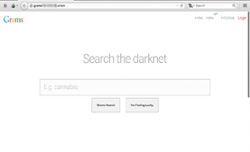
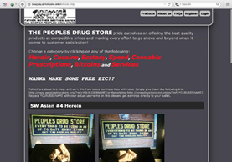
Conclusion
The deep web, mostly darknets such as TOR, denotes a practicable way for mean actors to chat goods, legally or illegally, in an unidentified way. In the paper, we steered an analysis of different networks that guarantee unspecified and undetectable right of entry to deepweb contented. Our results suggest that, at present, the core system that shows marketable actions for cybercriminals is TOR.
Where-as the deepweb has proved to be identical purposeful for hosting botnets. Servers and interchange stock such as drugs and weapons, old-fashioned cybercrime goods and chattels (i.e., malware and exploit kits) were less famous. Suppliers suffer from lack of standing caused by increased inconspicuousness.
Somehow, presence undetectable grants drawbacks for a supplier who cannot easily found a trust connection with consumers unless the market allows for it. However, the deficiency of noticeable activities in unusual deepweb networks does not essentially mean a real lack of such. In fact, in contract with the principle stirring the deepweb, the actions are basically harder to spot and detect.
Note that since a heavy feature for markets is critical mass, it is somewhat doubtful for them to long for such a high side by side of surreptitiousness unless the importance, should they be exposed, is satisfactorily plain (e.g., child manipulation images). In such personal belongings, locations may only come online at definite times, have a short-term space of exchange, then disappear again, making them more hard to inspect.
However, the deepweb has the probable to host a more and more high number of malicious services and activities and, appropriately, it will not be long previously new great markets appear. As such, safekeeping investigators have to continue watchful and find new ways to spot future malicious services to deal with new wonders the instant they appear.
REFERENCES
• Su Xiaoke, Zhao Lei, Huang Qingsong, "An Iterative-based Query Route on the Deep Web", Journal of Yunnan Nationalities University, vol. 16, no. 1, pp. 66-68, Jan. 2007. •
• Extance, Andy. “Bitcoin and Beyond.” Nature 526 (2015): 21-23. Web. 11 Jan. 2016. • Kushner, David. “The Dark Net.” Rolling Stone 5 Nov. 2015: 50-57. Web. 11 Jan. 2016.
• McCormick, Ty. “The Darknet: A Short History.” Foreign Policy Jan. 2014: 5-10. Web. 11 Jan. 2016.
• Greenberg, Andy (18 March 2015). "The Dark Web's Top Drug Market, Evolution, Just Vanished" https://www.wired.com/2015/03/evolution-disappeared-Bitcoin-scam-dark-web/. <https://www.wired.com/2015/03/evolution-disappeared-Bitcoin-scam-dark-web/>. Retrieved 4 July 2015.
• Cox, Joseph (1 February 2016). "Study Claims Dark Web Sites Are Most Commonly Used for Crime"<https://motherboard.vice.com/read/study-claims-dark-web-sites-are-most-commonly-used-for-crime>. https://motherboard.vice.com/read/study-claims-dark-web-sites-are-most-commonly-used-for-crime. Retrieved 20 March 2016.
• Raghavan, Sriram; Garcia-Molina, Hector (September 11–14, 2001). "Crawling the Hidden Web".
• Wright, Alex (February 22, 2009). "Exploring a 'Deep Web' That Google Can't Grasp". The New York Times. Retrieved February 23, 2009.
How India Will become Cashless?
Asmita Gajanan Ranpise¹ and Dr. Rajendra B. Patil²
Student¹ and Head², Department of Information Technology, S.K Somaiya College of Arts, Science and Commerce, Univeristy of Mumbai, Mumbai
Abstract
This paper studied the mentality of people on how India will become cashless. The data was gathered by using questionnaire and observed using simple technique of percentage method. Responses from people showed that cashless economy will help the government keeping trace of black money, forged (fake) money, reduce robbery that is related with cash, helps in enhancing economic growth when people of the country use digital payment modes. Everyone from the small merchant to neighboring vegetable vendor is accepting digital payment solutions. Slowly India is going from cash to cashless state. A cashless is a financial state in which all the transfer of funds are completed using cards and digital methods. Major challenges that can obstruct the execution of the strategy are cyber insecurity, high illiteracy rate, thinking or thoughts of people, lack of straightforwardness & regulation in digital payment system. It will help in developing the country.
Keywords: cashless economy, fake currency, digital payments, money laundering, corruption.
1.0 Introduction
What is cashless economy: The word itself tells us that “no cash” or “less cash”. Cashless word also describes that financial transactions that do not include money in form of banknotes rather it is done via internet. As all transactions are taking place through internet, government will get each and every record of these transactions. There will be no black money and forged money which can help in economic growth of the country. Government encourages the people for doing cashless transactions like internet banking, mobile banking, Ru-pay cards these are means and technology of digital payments.
1.1 Benefits of Cashless India
- Reduced Maintenance Costs: The amount of money mandatory in printing cash, it storage, transportation, distribution and recognizing forgery (fake) currency is huge. In digital payments there is no need of cash, so its maintenance is reduced.
- Transparency in Transactions: Redundant to say, electronic commerce or plastic money every time leaves a digital impenetrable values for both the taxpayer (customer) and the tax collector (government). It will restrain generation of black money.
1.2 Modes of Digital Payments
Banking cards | Credit cards and debit cards offer customers more security, ease and authority than other payment method. These cards provide 2 step verification for safe and secure payments (i.e., secure PIN and OTP).
Unstructured Supplementary Service Data (USSD) | USSD mechanism implements on the creative payment service *99#. This service provides mobile banking transfers, in which mobile data facility is not needed for using USSD based mobile banking.
Aadhar Enabled Payment System (APES) | APES provide service of online financial transfer at PoS through Bank Mitra of whichever bank using the Aadhar verification.
Unified Payments Interface (UPI) | UPI is a system that has many bank accounts into one mobile application. Every Bank has its own UPI App.
Mobile Wallets | A technique to use cash in digital format. We can link our banking card details in our mobile to mobile wallet application or we can transact money to mobile wallet online. For example, Paytm, Mobikwik.
Internet Banking | This technique is also called as online banking, virtual banking or e-banking. It is an electronic payment system that permit customers of a bank conduct a variety of transactions using website.  Various types of Internet Banking are:  1. National Electronic Fund Transfer (NEFT)  2. Real Time Gross Settlement (RTGS)  3. Electronic Clearing System (ECS)  4. Immediate Payment Service (IMPS)
Mobile Banking | Mobile banking uses software, usually known as an app, it is a service offered by a bank that validate its customers to conduct various types of financial transactions distantly using mobile phone or tablet.
2.0 Literature Review
Preeti Garg & Manvi Panchal (2017): Examined that most of the people literally have positive attitude about cashless transactions and effectiveness of cashless economy as it helps to oppose against corruption, money hiding but one major problem in the process of cashless economy in India is the internet crime and unauthorized access to primary data.
Dr. Venkateshwararao Podile & P. Rajesh (2017): In this paper an attempt is made to examine the public view in India about cashless transactions and the aim is also made to recognize the provocation faced by them during their transactions. There are questionnaire on cashless economy from these questionnaire the critical value is taken by solving each question and conclusion is taken in form of percentage.
3.0 Research Methodology
The survey is conducted to gain information on Cashless economy of India. The survey was mainly based upon primary data. Survey method is used for collecting data with the help of questionnaire .The responses from the people were collected and analyzed using the simple percentage method.
3.1 Analysis and Interpretation
Table-1: Knowledge of cashless concept to people
 |  | Frequency | Percentage
Do you know about India’s Cashless Economy? | Yes | 56 | 88.9
 | No | 2 | 3.2
 | Maybe | 5 | 7.9
 | Total | 63 | 100
 |  | Frequency | Percentage
Cashless Economy should be initiated in India | Yes | 49 | 77.8
 | No | 7 | 11.1
 | Maybe | 7 | 11.1
 | Total | 63 | 100
The above table shows that about 88.9% people have heard about cashless economy. And people are taking interest in cashless economy as 77.8% people wants that cashless economy should be initiated. Some people are not sure of their thoughts that cashless economy should be initiated or not.
Table-2: Advantages of cashless economy
 |  | Frequency | Percentage
Cashless economy would reduce risk of fake currency | Yes | 44 | 69.8
 | No | 5 | 7.9
 | Maybe | 14 | 22.2
 | Total | 63 | 100
Cashless economy can reduce corruption |  | Frequency | Percentage
 | Yes | 39 | 61.9
 | No | 8 | 12.7
 | Maybe | 16 | 25.4
 | Total | 63 | 100
 |  | Frequency | Percentage
Cashless economy can increase economic growth | Strongly Agree | 16 | 25.4
 | Agree | 32 | 50.8
 | Undecided | 11 | 17.5
 | Disagree | 4 | 6.3
 | Strongly Disagree | 0 | 0
 | Total | 63 | 100
 |  | Frequency | Percentage
It would prevent money laundering (hiding) | Yes | 34 | 54
 | No | 7 | 11.1
 | Maybe | 22 | 34.9
 | Total | 63 | 100
In above table, 68% people believe that cashless can reduce the fake currency of India. About 61.9% people believes that it can reduce corruption, 25.4% people believe that economic growth can be increased, 54% people believes that money laundering can be prevented by cashless economy.
Table: 3 Challenge’s with cashless economy
 |  | Frequency | Percentage
Cybercrime will be increased by cashless economy | Yes | 32 | 50.8
 | No | 13 | 20.6
 | Maybe | 18 | 28.6
 | Total | 63 | 100
 |  | Frequency | Percentage
Literacy is required in cashless economy | Yes | 48 | 76.2
 | No | 4 | 6.3
 | Maybe | 11 | 17.5
 | Total | 63 | 100
 |  | Frequency | Percentage
Internet fraud will increase after cashless economy | Strongly Agree | 21 | 33.3
 | Agree | 20 | 31.7
 | Undecided | 16 | 25.4
 | Disagree | 6 | 9.5
 | Strongly Disagree | 0 | 0
 | Total | 63 | 100
 |  | Frequency | Percentage
Transparency and efficiency is needed in cashless economy | Strongly Agree | 25 | 39.7
 | Agree | 31 | 49.2
 | Undecided | 4 | 6.3
 | Disagree | 3 | 4.8
 | Strongly Disagree | 0 | 0
 | Total | 63 | 100
As in above table, 50.8% people that cybercrime will be increased, 76.2% people think literacy is required for cashless economy. 33.3% people believes that internet fraud will also increase. 39.7% people thinks transparency and efficiency is needed.
Table: 4 People use which method for buying things
 |  | Frequency | Percentage
What do you use while buying things | Debit Card/Credit Card/ATM/Master Card | 22 | 34.9
 | Mobile Wallet like PayTM, Google Pay, Amazon Pay, Phone Pe | 21 | 33.3
 | Mobile Banking | 3 | 4.8
 | Internet Banking | 3 | 4.8
 | Cash | 14 | 22.2
 | Total | 63 | 100

As seen in above table, 22.2% people use cash, 34.9% people use Cards, 33.3% people use Mobile apps and various types of wallets, and 4.8% people also use mobile and internet banking facilities.
4.0 Conclusion
From the above analysis, it occurs that most of the people literally consent with the government on the effectiveness of cashless economy as it helps to oppose against corruption, money hiding but one major problem in the process of cashless economy in India is the internet crime and unauthorized access to primary data. Therefore it’s essential to support and boost Internet Security from defense against online fraud. Large number of people in the population is still illiterate living in rural areas. For easy execution of cashless system in India, the subsequent measures are recommended. Government should bear transparency and capability in e-payment system, approaches used by government and RBI to motivate the people for cashless transactions by recommending mobile wallets and cards. Government should take an initiative for the illiterate people and in rural areas time to time for making them aware of benefits of electronic payments by conducting a financial literacy campaign. By introducing cashless economy, there should by high internet speed, the apps should not give an error message frequently .i.e. server is down, etc., ATM’s should also work properly.
Journal References
[1] Preeti Garg, & Manvi Panchal, “Study on Introduction of Cashless Economy in India 2016: Benefits & Challenge’s”, IOSR Journal of Business and Management (IOSR-JBM), Vol.19, Issue 4, April 2016.
[2] Dr. Venkateshwararao Podile, & P. Rajesh, “Public Perception on Cashless Transactions in India”, Asian Research Consortium, Vol. 7, Issue 7, July 2017.
[3] Dr. Rashmi Gujrati “India’s march towards faceless, paperless, cashless economy”, International Journal of Commerce and Management Research, Vol. 3, Issue 6, June 2017.
[4] Dr. C Dhanalakshmi,” A conceptual study on cashless economy: Digital India”, International Journal of Commerce and Management Research, Vol. 4, Issue 6, November 2018.
[5] Shamsher Singh and Ravish Rana,” Study of Consumer perception of Digital Payment Mode”, Journal of Internet Banking and Commerce, Vol. 22, Issue 3, December 2017.
[6] Richa Goel, Seema Sahai, Anita Vinaik, Vikas Garg,” Moving From Cash to Cashless Economy: - A Study of Consumer Perception towards Digital Transactions”, International Journal of Recent Technology and Engineering (IJRTE), Vol. 8, Issue 1, May 2019.
[7] Rachna, & Singh, P.,” Issues and Challenges of Electronic Payment Systems”, International Journal for Research in Management and Pharmacy, 2(9), 25-30, December 2013.
Website References
- http://cashlessindia.gov.in/digital_payment_methods.html
- http://www.managemnetstudyguide.com/cashless-economy-pros-and-cons.html
- http://en.m.wikipedia.org/wiki/Digital_currency
- http://en.m.wikipedia.org/wiki/E-commerce_payment_system

A Research on Content Management System an Effective Tool for Today’s Organization
Yougendra M. More
Student, Rohidas Patil Institute of Management Studies
Abstract
The research aims to study the role of content management system (CMS) and its increasing importance in today’s organization. The rapidly developing technology has provided various online software platforms used for developing a website. The research aims to compare various effective tools for content management like Joomla, WordPress and Drupal which are widely used. The study focuses on the various tools and analysis based on the features, functionality, performance, flexibility etc.
The research focuses on the various security issues of content management system and helps individuals or organization to select an appropriate CMS tool for creating, managing and constantly updating website.
Keywords: content management system, technology, software platforms, Joomla, WordPress, Drupal, website.
INTRODUCTION
CMS is increasingly being used by organizations due to its user friendly features or functioning. It helps in publishing the content, manage the working and easily designing a website based on customized contents. Managing, maintaining, constantly updating website and deciding on the delivery of information that is relevant to remain in competition is crucial as well as important for firms operating in various sectors.
CMS is free software which is used by the developers to build and easily update website. It involves creating, organizing, collecting and structure information which is gathered from various sources which could be saved, published, updated constantly.
LITERATURE REVIEW
(Manoj Kumar Srivastav, Asoke Nath, March 2016)This research focuses on two important elements of managing content: Content Management Application (CMA) and Content Delivery Application (CDA). Research here helps in understanding that WCMS can be divided into three stages. Maintenance and dealing with vast amount of data in financial management in CMS can be studied as a future scope.
(Sudhanshu Naithani, Abhishek Kaushik, September 2016) It aims to show the comparison between different CMS and prepare a conceptual framework. Content Management products are analyzed, compared and evaluated by using a special table which highlights the actual functions of the products.
(Vimal Ghorecha, Chirag Bhatt, August 2013) It offers a survey of some methods of PHP comparisons and evaluating studies of CMS. The survey helps in determining the strengths, drawbacks, features etc.
(Sanjeev K Sunny, March 2008) This research helps to give a solution to selection among various CMS and which solution would work best for an organization. It evaluates the popular open sources and reduces the difficulty.
(Jose Manuel Caro, Maria Dolores Cano, 2018) It explains the analysis of security to the website and what could be done to avoid errors. Web CMS is selected with regards to what is required, visual overview and functions. The benefits and various problems of each solution and understand complex CMS.
OBJECTIVE OF THE RESEARCH
- To compare and evaluate various CMS tools.
- To study the functionality, performance, flexibility of CMS.
- To analyze various selection option.
- To focus on the security issues.
- To highlight the application of each software.
- To study the benefit and opportunity cost of selecting a CMS.
RESEARCH METHODOLOGY
The research is a secondary research which involves deep study of various CMS software like Joomla, Drupal and WordPress which are popularly used in various organizations. Analysis of various research papers and surveys related to the comparisons between popular content management software on the basis of performance, speed, features and basic skills required in dealing with each tool.
FUNCTIONING OF CMS
Content Management System deals with programming language, templates, dashboard and a database. It involves identifying the content or data which is required to be published on the website. A basic layout or architecture is required to for structuring the content and segmenting the information as per the importance and relevance.
The Management takes out decisions of storing the content and managing the data for further use and creating backups. The data is then published in various forms like blogs, newsletters, emails and printable documents. The main aim is to provide benefits to customers with the fastest possible ways to deliver services.
ADVANTAGES OF USING CMS
CMS is most widely in use due to its ease of accessibility and benefits that helps in smooth functioning of the company.
- Easy page creation
- Import web links in CMS
- Content Formatting, file uploading
- User friendly interface
- Easy to modify or delete
- Add or create new templates
- Easy management of website
- Easy workflow of content to users
COMPARISON
All the CMS software offers great features to customize, manage security of data and easy to use. A comparison is done to analyze the popularity and worldwide usage of each CMS.
- Cost – Cost for is the almost the same for all but the additional development cost in Drupal is more.
- Themes – WordPress offers 4000 plus themes while Joomla 1000 plus and Drupal 2000 plus. Skills Required – WordPress is easy to learn as compared to Joomla which is moderate and Drupal being advanced.
- User friendly – WordPress is more user-friendly as compared to Joomla and Drupal.
- Security- Drupal offer high security, medium in WordPress and Joomla is lower in comparison.
- Flexibility – WordPress and Joomla are more flexible as compared to Drupal as it is used more for its technical expertise feature.
- Plugins – WordPress has 50k plus plugins while Joomla has 7.5k plus and Drupal 35k plus.
- Ranking – WordPress ranks 1st while Joomla is 2nd and Drupal is 3rd.
- Number of Downloads – The approximate downloads of CMS WordPress 140 million, Joomla 30 million and Joomla 15 million.
- SEO – The Search Engine Optimization is excellent in WordPress, good in case of Drupal and basic in Joomla.
CHALLENGES
There are various security challenges for using CMS and the most common concern is stated in comparison to all the software
- Confidentiality of Data – the amount of data used in CMS is huge as an unauthorized person can access to the data
- Phishing – use of forms and spam mails can be a threat to the confidentiality
- Data manipulation – violating data integrity like Structured Query Language injection
- Code execution, run programs or scripts on web servers
- XSS attack which inserts malicious code into the website and it leads to access of users sensitive data
FINDINGS
The popular CMS has been evaluated and the findings for the same are depicted below:
Drupal: Drupal as a software has helped various organizations to develop blogging platform, interactive community site or a static site. Various site configurations can be done using Drupal’s core module. It has the ease and scalability of growth of website from a small set of users to an enterprise
Joomla: Joomla is commonly used CMS software which can be used by anyone to make modifications as per their own use. It can be used by anyone but it lacks classification. For creation of a page the sections and subsections needs to be added.
WordPress: WordPress open source blogging tool with plug-in architecture and a template system. It is a self-hosted blogging tool used by millions and it is highly relied on peer support. It takes time for beginners as basic knowledge of HTML and CSS is required.
SUGGESTIONS & RECOMMENDATIONS
- All the CMS offers similar functions but ultimately the scenarios in organization will determine the requirement of capabilities which will make one of the three options as the best fit for the firm.
- If looking for more advanced software Drupal might be the best choice and if an easier learning is required Joomla cloud be the perfect choice. WordPress is most user friendly as compared to Joomla and Drupal.
- WordPress is recommended for a corporate website or small business and best for simple blogging. Joomla is mostly used for social networking sites and E-commerce. Drupal is technically advanced which is good those who are more into technicality.
- Security is important to prevent it regular backups and usage of new updated versions is required so as to prevent any kind of attacks which hamper the security and data privacy.
- The open source software would provide add on features and benefits that proves the best CMS for an enterprise but ultimately the management decides the business requirement to select among the CMS based on the above recommendations.
SCOPE OF THE STUDY
CMS gained lot of attention, as it is good for companies to reduce the overall cost of managing the website. The software has reduced the efforts and it is more likely to develop as the technology advancement takes place. The world is changing at a fast speed and the usage of information technology is changing, so “Content is the King” – which is important factor in todays era. The people rely more on what is provided on the website, CMS is acknowledged within various organizations and hold huge importance in future.
CONCLUSION
CMS helps in fast delivery of content to the visitors or users which are interested in the products and services. There are various strengths and weaknesses for all the software. The best selection depends on the current trends in the market along with the type of data and information that will be conveyed through the website. There is scope of major changes and development of services offered by the CMS based on the changing customer requirements and technological advancements.
REFERENCES
- Manoj Kumar Srivastav, Asoke Nath, “Web Content Management System” Issue 3, Volume 3, March 2016.
- Sudhanshu Naithani, Abhishek Kaushik, “Evaluation and Comparison of the Conceptual Framework of CMS” Vol. 8, September 2016.
- Vimal Ghorecha, Chirag Bhatt, “A Guide for Selecting Content Management System for Web Application Development” Volume 1, Issue 3, August 2013.
- Sanjeev K Sunny, “Evaluation of Open Source Content Management System: A Comparative Study” March 2008.
- Jose Manuel Caro, Maria Dolores Cano “A Comparative Study of Web Content Management Systems” 2018.

